*“Flock Talk”*

***Franklin First Church of God***

***Inspirational Newsletter***

**Issue One of 2018 NEWS AND VIEWS FROM THE PEWS January 2018 \_\_\_\_\_\_\_\_\_\_\_\_\_\_\_\_\_\_\_\_\_\_\_\_\_\_\_\_\_\_\_\_\_\_\_\_\_\_\_\_\_\_\_\_\_\_\_\_\_\_\_\_\_\_\_\_\_\_\_\_\_\_\_\_\_\_\_\_\_**

Find Friends Who Build You Up

By Rick Warren

Do not be misled: ‘Bad company corrupts good character’ **(1 Corinthians 15:33 NIV)**

Let’s agree upfront that God wants you to have non-believers as friends. God wants you to love everyone, show kindness to everyone, and be able to help everyone. If you don’t have any non-Christian friends, you won’t be around anyone who needs to hear the Good News.

But your best friends should be Christians. They should be strong believers.

It’s always easier to pull people down than to pull them up. That’s why you must make sure the people you hang out with the most are moving you in the right direction. They should be building you up rather than tearing you down.

Where do you want to be in 10 years? What kind of person do you want to be? Tell me two things about you and I can tell you where you’ll be without even knowing you. Tell me the people you’re spending your time with and what you’re reading. Those two factors will determine your future.

The Bible teaches us, “Do not be misled: ‘Bad company corrupts good character’” (1 Corinthians 15:33 NIV).

Your friends are too important to pick by chance. You must be intentional. That’s why you need a church home. Get to know people at church. Build relationships. Join a small group.

Or start a group! Gather some Christian friends from your office or your neighborhood to study the Bible together during lunch. You need Christian friends. Do what it takes to build those relationships

*\*\*\*\*\*\*\*\*\*\*\*\*\*\*\**

Greater love has no one than this: to lay down one’s life for his friends.

(John 15:13)



*JANUARY BIRTHDAYS*

1 Steven Haney 12 Beverly Potter

4 Cathy Bell 12 Jessica Smith

6 Joanne Cardy 14 Sheree Dunlap

7 Sondra Sensenbach 20 John Doyle

8 Renee Cranmer 22 Jason Smith

9 Bob Muse 26 Emma Reitz

9 Nevaeh DeLong 27 Samuel Muse

11 Job Greenman 29 Abraham Montgomery

30 Ed Eckel

\*\*\*\*\*\*\*\*\*\*\*\*\*\*\*\*\*\*\*\*\*\*\*\*\*\*\*\*\*\*\*\*\*\*\*\*\*\*\*\*\*\*\*\*\*\*\*\*\*\*\*\*\*\*\*\*\*\*\*\*\*\*\*\*\*\*\*\*\*\*\*\*\*\*\*\*\*\*\*\*\*\*\*\*\*\*\*\*\*\*\*\*\*\*\*\*\*\*\*\*\*\*\*\*\*\*\*\*\*\*\*\*\*\*\*\*\*

**ANNUAL CONGREGATIONAL BUSINESS MEETING**

 Our Annual Congregational Business Meeting will be held on ***Wednesday, January 31, 2018, at 7:00 p.m.*** at the Church. All financial reports must be turned in by Sunday, January 14, 2018. The Auditors will meet on Saturday, January 20, 2018. All information for the Annual Report must be turned in by Sunday, January 21, 2018. Copies of the Annual Report will be available on Sunday, January 28, 2018.

………………………………………………………………………………………………………………………

IN MEMORY

Two special people from our Church passed away recently – Eileen Yingling and George Stewart. They will be missed very much by their Church family. Eileen was a sweet lady who willingly worked hard, but always behind the scenes. George could have a gruff exterior sometimes, but he was really a sweetheart. He shared his woodworking skills with the Church on many occasions and helped out when he could. They both were Christians, and we are certain they will have their reward in Heaven. We thank God for their lives, their Christian witness, and their friendship through the years.

“Let not your heart be troubled; you believe in God, believe also in Me. In My Father’s house are many mansions; if *it were* not *so,* I would have told you. I go to prepare a place for you. And if I go and prepare a place for you, I will come again and receive you to Myself; that where I am, *there* you may be also. [John 14:1-3](https://www.biblegateway.com/passage/?version=NKJV&search=John%2014:1-3) [NKJV](https://www.biblegateway.com/versions/index.php?action=getVersionInfo&vid=50)

*A Note From Our Pastor*

Dear Flock,

A new year; a new month; a new day. “This is the day which the Lord hath made; we will rejoice and be glad in it.” Psalm 118: 24. We are glad in each day God gives to us.  No matter what happened yesterday or last month or last year, today is a new day.  Regardless of the situations of tomorrow, or next month or next year, God has given us this day. Thank God for today and live it for His glory.

The first Thursday of 2018 is the time the Elders of the First Church of God of Franklin meet. Ask God to direct them in serving the church. Ask God to grant wisdom in responding to the Good Samaritan Fund requests. Contributions to the Good Samaritan Fund can be given by marking the church offering envelope “other” column with Good Samaritan Fund.

Men and women are invited to begin the New Year in Bible study with others. Thursday, January, 4th is the date for the two studies to meet at seven o’clock in the evening. Tom Shiner, Jr. and Sonya Mullen are the leaders to the groups.

The Budget Committee will be meeting on Saturday, January 6, at ten o’clock in the morning. The committee will prepare a budget for the church for 2018.

KID’S CLUB will be meeting the second and fourth Monday in January. Elementary aged children are to be accompanied into the social room before four-thirty and picked up inside the church at six-thirty. The children experience a game, Bible lesson, craft, meal and music.

The Administrative Council of the church will be meeting on Tuesday, January 9, at seven o’clock in the evening. We are grateful for the leadership of Tom Shiner, Jr. as the Council President.

The Worship Cell is meeting on Saturday, January 13, at nine o’clock in the morning. They will select music for our worship of God for February and March.

All ministries of the church are to submit their financial books to the audit committee by Sunday, January 14. A report of the audit will be included in the published Annual Report to the church.

We will be ministering to the residents of The Caring Place on Wednesday, January 17, starting at seven-fifteen in the evening. Singing and scripture reading will be the order of the night. Let me know that you will participate.

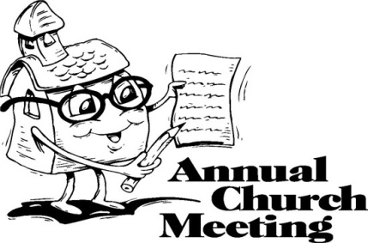Reports of the 2017 activity are due the Communication Cell from each of our church ministries on Sunday, January 21. The annual reports will be compiled as the Annual Report of the church.

The Annual Business Meeting of the First Church of God of Franklin will take place on Wednesday, January 31, starting at seven o’clock in the evening. The Annual Reports should be read prior to the meeting with opportunity during the meeting for corrections or discussion.

Your  Shepherd,

Pastor Jim

**Prayer Requests**:

Those in mourning: Joan King Family, Steven Daugherty Family, Eileen Yingling Family, Jack White Family, Mike Rodemoyer Family, Robin Keener Family, Carl Fox Family, George Stewart Family, James Alcorn Family, Louise Shreffler Family, Patricia Hays Family, Jean Harlan Family

Dot Myers

Pat McNutt

Military

Paul

Gayle

Sally Reed

President Trump

Cindy Bennett

Kristen Aylesworth

Safety in travels

Travis Semrau

Frank Gillan

Cindy McGill

Jim Woodworth

Those fighting addictions

Victims of terrorists

Victims of bullying

Sallie Woodworth

Denny Montgomery

Alex Brink

Becca Brink

Ed Shiner

Wilbur’s sister – health issues

Larry Henderson, Jr.

Ellen Simpson

Karen Dean

Charlotte Dittman

Upcoming Budget meeting

Upcoming Auditors meeting

The Nominating Committee

Those suffering with colds, flu & viruses

Homeless

Those affected by wildfires in California

Firefighters

Hazel Kean

Nancy Barger

Judy & Ed Eckel

Gladys Finefrock

Virginia Beatty

Sondra Sensenbach

Pastor

Tom Shiner, Jr.



**Praises:**

Missi Jolley’s ablation was successful

Safety in travels

The way God takes care of all of our needs

God’s gift of salvation

Christian family and friends

Denny Geib reported his shoulder is feeling better

Lance arrived safely in Oklahoma

The musicians in our Church

Jim Woodworth is out of the hospital

Children’s Christmas Program

Answered prayers – Wilbur’s niece quit smoking approximately 8 weeks ago

**FOOD PANTRY**

**C:\Users\Pam\AppData\Local\Microsoft\Windows\Temporary Internet Files\Content.IE5\VOUNIKBQ\MCFD01224_0000[1].wmf**Our Church’s Food Pantry is used to assist people from our Church and community when they find themselves needing some help providing food for their families. The winter months can be especially difficult with higher gas and electric bills. If you are able to keep the food pantry stocked with non-perishable food items (check those expiration dates) or if you are able to make a monetary donation to the food pantry, it would be greatly appreciated.

If you are in need of items from the food pantry, or if you know of someone who is in need, please let Pastor Jim know.

++++++++++++++++++++++++++++++++++

**ALTAR FLOWERS**

Anyone wishing to place an order for altar flowers, please contact Joanne Cardy. Flowers can be placed in memory or in honor of someone, on a special occasion, or “just because”. Two altar vases only cost $16.00. Once you order them, they are yours to take home after the morning worship service.

*Special thanks to Joanne Cardy for the beautiful display of poinsettias on the altar for Christmas Sunday and Christmas Eve. Thanks to everyone who ordered poinsettias.*

*Thank you to everyone who helped decorate the Church for Christmas. Your efforts are greatly appreciated.*

++++++++++++++++++++++++++

GOOD SAMARITAN’S FUND

Donations are accepted at any time for our Church’s **Good Samaritan Fund**. The monies in this Fund are used to help people from our Church family who are in need.

++++++++++++++++++++++++++



2018

KIDS CLUB

We met on December 4th with 8 kids, 1 teenage helper, and 8 adults present. Pam Jolley taught the lesson. On December 18th we had 10 kids and 7 adults present. Tom Shiner, Sr., taught the lesson. In January we will be meeting on January 8th and 22nd  from 4:30 to 6:30 p.m.

 At each meeting we play games – Four Corners, Fill the Stocking and The Saran Wrap Candy Ball. The kids have a lot of fun playing these games. We have a Bible lesson, taught by different adults from the Church each week. These lessons are very important since some of the children do not attend church on a regular basis, if ever. We make crafts, like ornaments for the Social Room Christmas tree, Christmas presents for their parents or grandparents, and crafts to help them remember Biblical principles – Jesus Love Me; God is Love; Focus on Jesus; God Made You and Me; Bee Like Jesus, etc. We also say a blessing and eat supper together. After supper, we sometimes play another game or do a coloring page and then go to music time. It is a very full two hours. The leaders of Kids Club hope and pray that this time will instill some Bible truths in these children that they will never forget.

Thanks to everyone for their support of Kids Club – through financial contributions, teaching lessons, supplying desserts, bringing children to the meetings, and for all of the prayers.

Happy New Year from Kids Club!!!!!



My Bad!!!

 On Christmas Eve, I made a blunder during the candle lighting part of our service. Many of you witnessed this, and have shamed me into putting something in the Flock Talk about it. I lit my candle from my son, Kevin’s, and quickly turned to tap Amy Leichliter on the arm so she could light her candle from mine. In my haste, unbeknownst to me, my candle went out. So when Amy and I put our candles together, there was no flame. How embarrassing!!! So, I relit my candle from Kevin’s and then *slowly* turned to Amy, who was able to light hers from mine. I kept thinking there must be a good moral to this story, like: “You cannot spread your light to others if it is not shining”. So, keep those lights shining – far and wide; bright and bold!!!!! It is my New Year’s resolution to not let my light be extinguished again!!!!!!!

(Pam J)

**Happy New Year everybody!!!!!!**

Children’s Christmas Program

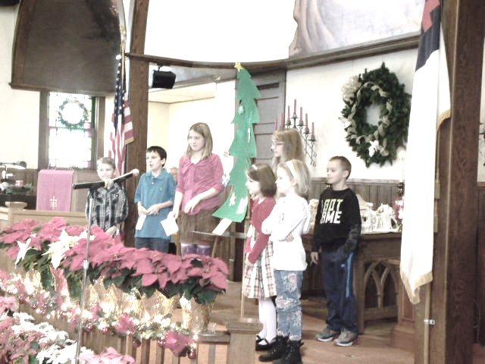 On December 17, 2017, the Children of our Church presented their Christmas program during our morning worship service. Diane Montgomery was the director of the program. She was assisted by Heather Hutchinson. There were eight children who participated in the program: RaeLynn Montgomery, Joseph Cranmer, Jaci Clark, Sean Hutchinson, Rebecca Hutchinson, Abraham Montgomery, Silas Montgomery, and Sylvia Westbeld.

The children read or recited information about the origins of Christmas ornaments. Then they “hung” an ornament on their tree. After all the ornaments were on the tree, the children sang some Christmas carols.

Thank you to Diane, Heather and all the children for this program. We appreciate the time and effort it took to put this program together. You all did a great job!!!

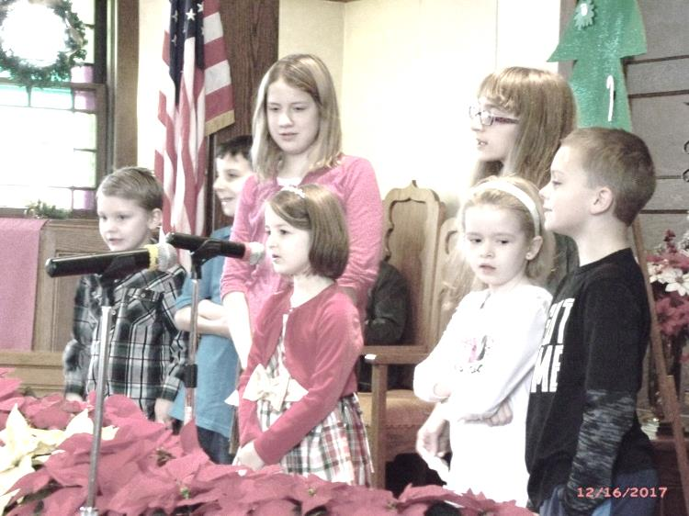 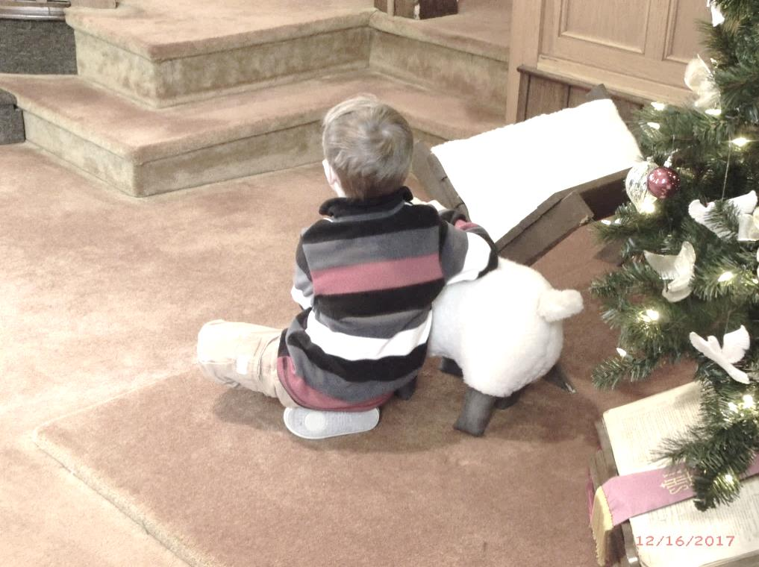

Abe, Joseph, RaeLynn, Sylvia, Rebecca, Jaci, Sean Silas, the Shepherd

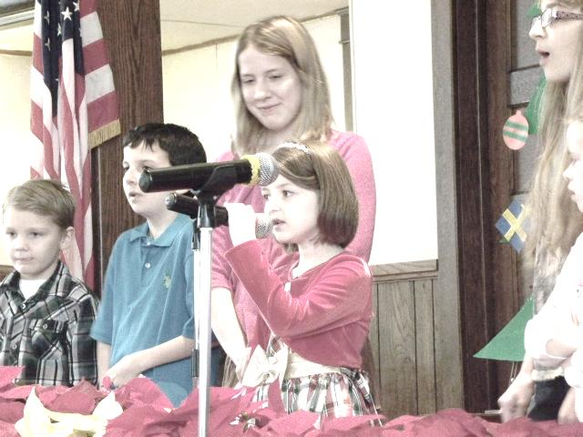 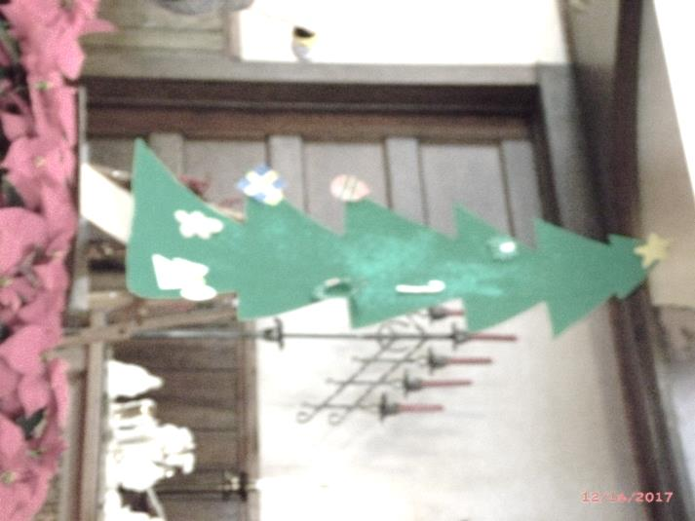

CHRISTMAS DINNER 2017

The Church’s Christmas Dinner was held on December 2, 2017. Skip Curran made all the arrangements for the dinner. Joe Gionti was the caterer. The dinner was delicious as in past years. Tom Shiner, Jr., made presentations of gifts and cards. Nick Nasibyan presented a musical program after the dinner, which was enjoyed by everyone who attended.

