“Flock Talk”

***Franklin First Church of God***

***Inspirational Newsletter***

Issue Nine of 2017 NEWS AND VIEWS FROM THE PEWS September 2017

**\_\_\_\_\_\_\_\_\_\_\_\_\_\_\_\_\_\_\_\_\_\_\_\_\_\_\_\_\_\_\_\_\_\_\_\_\_\_\_\_\_\_\_\_\_\_\_\_\_\_\_\_\_\_\_\_\_\_\_\_\_\_\_\_\_\_\_\_\_\_\_\_\_\_\_\_\_\_\_\_\_\_\_\_\_\_\_\_\_\_\_\_\_\_\_\_\_\_**

## Don’t Wait To Obey God

**BY RICK WARREN — MAY 21, 2014**

“*I will hasten and not delay to obey your commands.*” (Psalm 119:60 NIV)

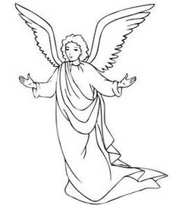 When the angel appeared to Joseph in a dream, he told Joseph, “Do not be afraid to take Mary home as your wife, because what is conceived in her is from the Holy Spirit” (Matthew 1:20b NIV). So that’s what Joseph did. “When Joseph woke up, he did what the angel of the Lord had commanded him and took Mary home as his wife” (Matthew 1:24). He didn’t hesitate; he just did it.

There is a refreshing immediacy to Joseph’s relationship with God. When God said it, Joseph did it.

If you believe God loves you and you want to live a life of obedience in response to His love, then this is how you should respond. Living in immediate obedience to God is a kind of life that breathes with excitement and joy.

I’ve had the opportunity to meet a lot of great men and women of faith from around the world. They are all different from each other, but there is one thing they all have in common: When they sense God saying to do something, they don’t hesitate. They step out and do it.

First John 5:3 says, “This is love for God: to keep His commands. And His commands are not burdensome.” So if something God asks you to do feels like a burden, what’s wrong? Usually it’s procrastination. When we don’t act right away, it becomes harder to do the longer we wait. But when we do what God says, the most refreshing freedom will come into our lives.

What is God calling you to do? Is it a phone call you need to make? An action you need to take?

Whatever it is, write it down right now, tell God you’re willing to do it, and ask Him to give you the strength you need to make it happen.

**FOOD PANTRY**

C:\Users\Pam\AppData\Local\Microsoft\Windows\Temporary Internet Files\Content.IE5\VOUNIKBQ\MCFD01224_0000[1].wmf Our Church’s Food Pantry is used to assist people from our Church and community when they find themselves needing some help providing food for their families. If you are able to keep the food pantry stocked with non-perishable food items (check those expiration dates) or if you are able to make a monetary donation to the food pantry, it would be greatly appreciated.

If you are in need of items from the food pantry, or if you know of someone who is in need, please let Pastor Jim know.

**\*\*\*\*\*\*\*\*\*\*\*\*\*\*\*\*\*\*\*\*\*\*\*\*\*\*\*\***

**ALTAR FLOWERS**

 Anyone wishing to place an order for altar flowers please contact Joanne Cardy. Flowers can be placed in memory or in honor of someone, on a special occasion, or “just because”. Two altar vases only cost $16.00. Once you order them, they are yours to take home after the morning worship service.

\*\*\*\*\*\*\*\*\*\*\*\*\*\*\*\*\*\*\*\*\*\*\*\*\*\*\*\*\*\*\*\*\*\*\*\*\*\*\*\*\*\*

GOOD SAMARITAN FUND

 Donations are accepted at any time for our Church’s Good Samaritan Fund. The monies in this Fund are used to help people from our Church family who are in need.

\*\*\*\*\*\*\*\*\*\*\*\*\*\*\*\*\*\*\*\*\*\*\*\*\*\*\*\*\*\*\*\*

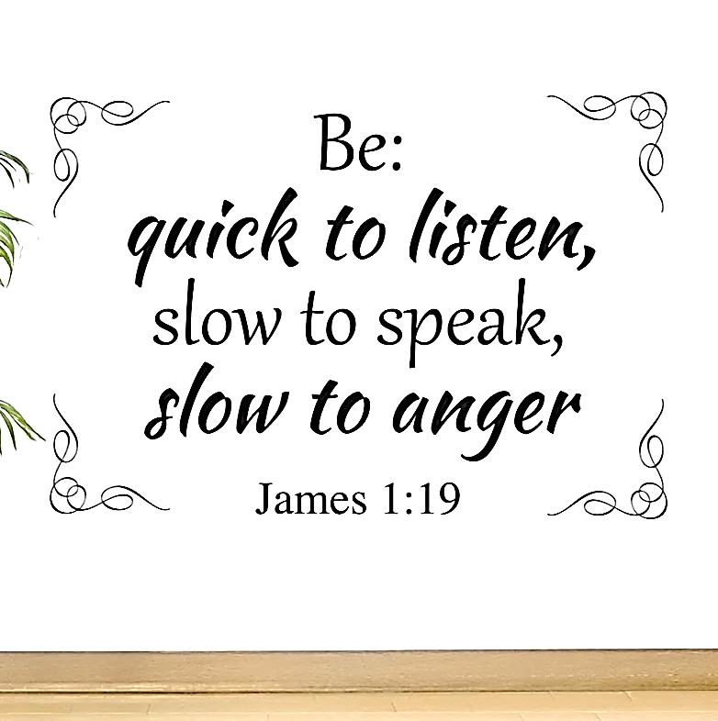

SEPTEMBER BIRTHDAYS

5 Dan Kearney 15 Janet Murdoch

6 Aaron Dunlap 17 Barry Walters

7 Monique Byers 19 Bonnie Boyd

8 Tara DeLong 20 Jessica Shook

9 Deb Staab 23 Kay Kaster

9 Garry DeLong 26 Pat Dilley

9 Larry DeLong 26 JoAnn Tombly

9 Harry Curran 29 Joy McMasters

13 Jim Ashbaugh 30 Amy Jeffries

13 Mike Master

SEPTEMBER ANNIVERSARIES

13 Larry and Tara DeLong

**……………………………………………………………**



September 10, 2017

September 11, 2017

September 22, 2017

A Note from Our Pastor

Dear Flock,

That which I predicted in last month’s Flock Talk has come into being. School is restarting! The teachers and staff have been in the school buildings for weeks now. Preparations are in order for the students. Now off they go. We are praying for each one that enters those school buildings the blessing of God. Pray for the Christian teachers, staff and students. Pray that they may influence others to see and know God. They can be missionaries in their buildings.

We too want to be God’s hands sharing the hope and the dream. Wherever we are, we are an ambassador for God. Share God’s love with the family. Share the love of God with our neighbors. Share God with those at the store. Share God with everyone.

Our Elders are meeting again after a summer break. They are gathering in the social room on Thursday, September 7th at six-fifteen. Speak with them regarding the concerns for the good of the church.

The Men’s and Women’s Bible studies resume on Thursday, September 7th at seven o’clock in the evening. The Men’s study is led by Tom Shiner, Jr. and meets in the social room. The Women’s study is led by Sonya Mullen and meets in the former parsonage dining room. Let them know that you are participating. Both of these Bible Studies will meet on the first Thursday of each month at 7:00 p.m.

The Worship Cell will be selecting music for our worship of God on Saturday morning September 9th. They will meet at nine o’clock. Suggestions of music can be given to them before the meeting.

Grandparents Day is September 10th. We will recognize the grandparents in the Sunday morning worship. Grandparents are encouraged to be present with their grandchildren. Grandchildren are urged to invite their grandparents.

Tuesday morning Bible study resumes on September 12th at ten o’clock. We are

studying the life of Christ during the planned ten weeks ending on November 14th. Enter the building by using the ramp entrance into the former parsonage dining room.

The Administrative Council will meet again on Tuesday evening, September 12th at seven o’clock in the evening in the social room. Reports from each of the ministries of the church are to be in each Council member’s mail slot by Sunday September 10th.

PRAISE SUNDAY is September 17th. Although each time we gather is a time of praise of our God, this Sunday will emphasize praise. Most of the order of worship will be singing and scripture reading that conveys praise of our God. Come let us praise the LORD!

The Safe Sanctuary training make-up date is set as September 23rd. Those desiring to volunteer in our children and youth ministries must receive this training each year to maintain a compliance status. Let me know that you will be in attendance.

CHILDREN’S SUNDAY is September 24th. The Devine Family will be with us for the Sunday morning worship. Mom, Dad and the children will lead us in worship that day. The children will worship with the adults in the sanctuary. A second offering for the ministry of the Devine family will be received during the worship.

As those who belong in school return, I urge you that belong to God, return to worship and Bible study. Each child of God is to worship Him with others in the family. Each one needs to learn and grow. We need to minister in His name as well.

Your Shepherd,

Pastor Jim



SAFE SANCTUARY TRAINING

The annual Safe Sanctuary Training session was held on Saturday, August 5, 2017, in the Social Room of the Church. Pastor Jim opened in prayer. He reviewed the Safe Sanctuary Policy. He specifically discussed the definitions used in the policy, the clearances that are required and how to get them, and that we are all mandated reporters of suspected/alleged child abuse. We then watched the video from Church Mutual on the subject.

Present were: Diane Montgomery, Judy Shiner, Dan Kearney, Becky Kearney, Tom Shiner, Jr., Sonya Mullen, Megan Mullen, Becca Mullen, Pamela Leichliter, Sally Reed, Nancy Muse, Nancy Barger, Hazel Kean, Heather Hutchinson, Char Metzger and Pam Jolley.

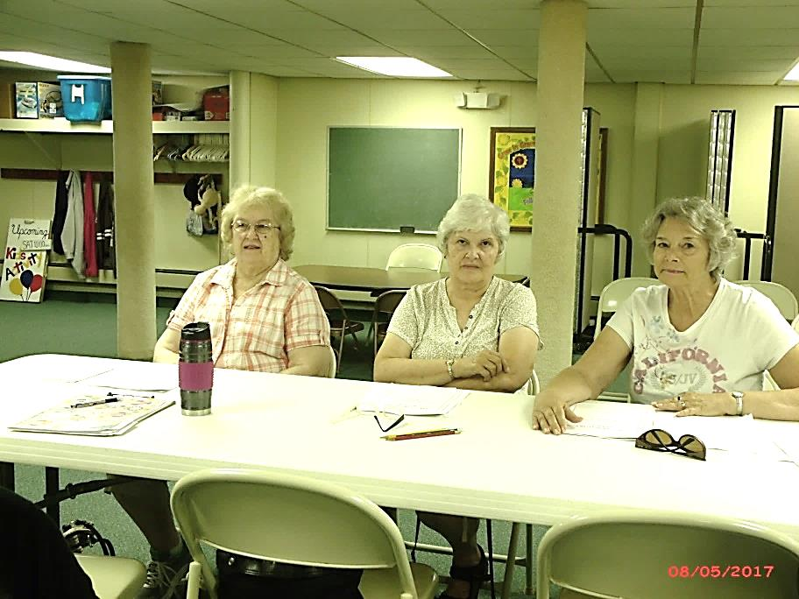

Judy Shiner, Sally Reed, Pamela Leichliter

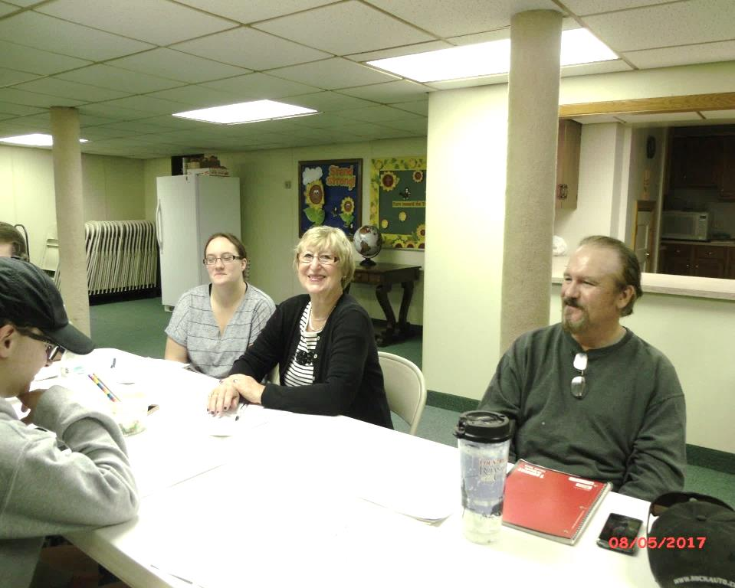 Heather Hutchinson, Nancy Muse, Tom Shiner, Jr.

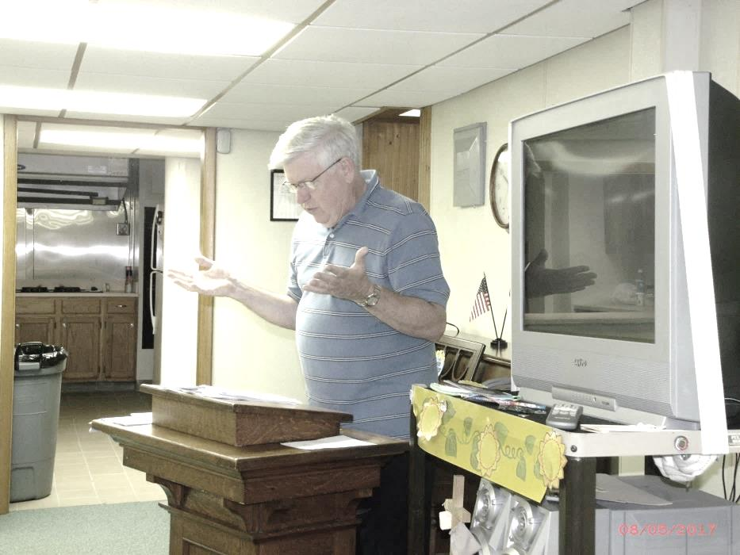

Pastor Jim

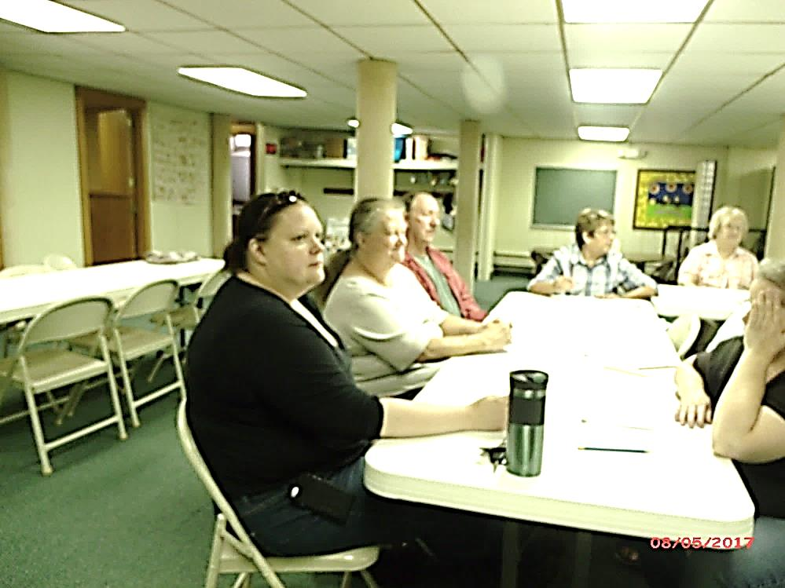Hazel Kean, Nancy Barger, Dan Kearney, Becky Kearney, Judy Shiner and Char Metzger

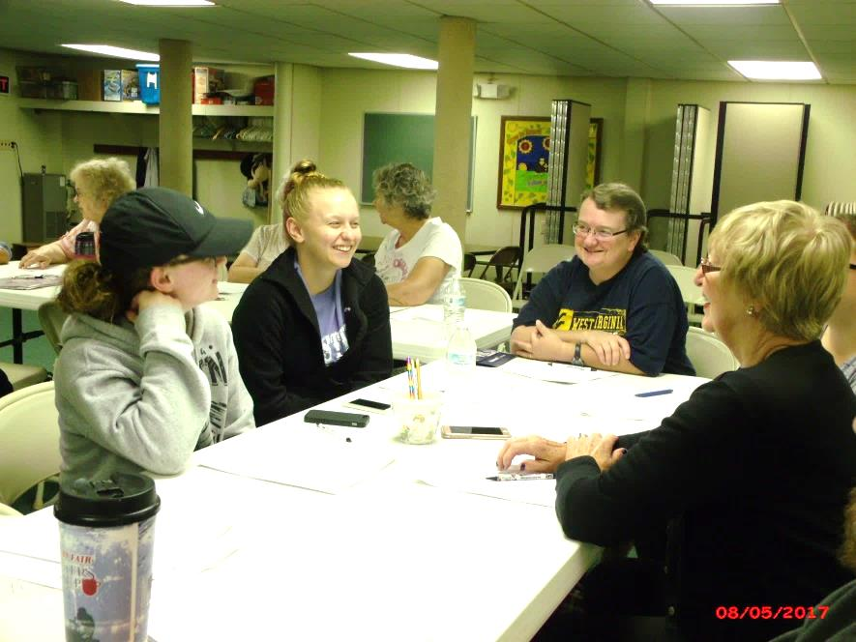 Becca Mullen, Megan Mullen, Sonya Mullen,

Nancy Muse

**Lessons Of Obedience**

Read: [1 John 2:1-11](http://www.biblegateway.com/passage/?search=1+John+2%3A1-11)

*This is the love of God, that we keep His commandments.* —[1 John 5:3](http://www.biblegateway.com/passage/?search=1+John+5%3A3)

When young Mikey came home after Sunday school, his mother asked him what he had learned that morning. His quick reply spoke volumes: “Obedience . . . *again!*”

Although I’m many years older than Mikey, I agree that obedience to God is a lesson that we must, sometimes reluctantly, learn over and over again.

Oswald Chambers wrote: “The Lord does not give me rules, but He makes His standard very clear. If my relationship to Him is that of love, I will do what He says . . . . If I hesitate, it is because I love someone I have placed in competition with Him, namely, myself.”

When we are obedient, we show God that we love Him and have more faith in Him than we do in ourselves. Arthur W. Pink said that love is “a principle of action, and it expresses itself . . . by deeds which please the object loved.” To obey God means to relinquish what we want and to choose to do what *He* asks.

God requires the obedience of His followers, and Jesus placed great importance on it. He asked, “Why do you call Me ‘Lord, Lord,’ and not do the things which I say?” (Luke 6:46). And He issued this challenge: “If you love Me, keep My commandments” (John 14:15).

*To say we follow Jesus Christ   
Without attempting to obey   
Reveals our lack of faith that He   
Will lead us right in every way. —Sper*

**Obedience to God is an expression of our love for God.**

UPDATED

CHURCH DIRECTORIES

I have been working on updating our Church Directory with current addresses, phone numbers, and e-mail addresses for everyone who is attending our Church. It is my hope to distribute these Directories in September. If you have not been contacted, please get in touch with me. Pam Jolley – home phone – 432-7847; cell phone – 657-6877 – e-mail – [pjolley@gmail.com](mailto:pjolley@gmail.com). Thanks!! ☺

**NEW ADDRESS**: Tom & Joanne Cardy

228 Congress Hill Road

Franklin, PA 16323

(814) 518-5556

~~~~~~~~~~~~~~~~~~~~~~~

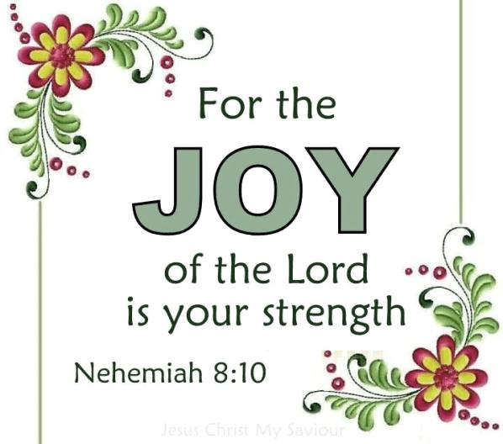

~~~~~~~~~~~~~~~~~~~~~~~

**19**My dear brothers and sisters, take note of this: Everyone should be quick to listen, slow to speak and slow to become angry, **20**because human anger does not produce the righteousness that God desires.

James 1:19-20



*Kids Club Kick Off*

The Kick Off for Kids Club will be held on September 18, 2017,

from 4:30 to 6:30 p.m.

All children in Kindergarten through Sixth Grade are welcome to join us.

We will be playing games, learning how to *“Bee” Like Jesus*, doing crafts, eating supper, and having lots of fun.

Come join us!!!

Our Church’s Mission Statement reads as follows:

*“For* *the glory of God, we shall reach out to others, as living witnesses with Christ and His word as our example; and we shall seek to build up one another in the faith.”*

Prayerfully consider ways we can live out our Mission Statement on a daily basis. How can we reach out to others? How can we build up one another in the faith?



This year the Women’s Bible Study will be led by Sonya Mullen. They will meet on the first Thursday of each month at 7:30 p.m. in the former parsonage.



The Men’s Bible Study, led by Tom Shiner, Jr., will also be meeting on the first Thursday of each month at 7:30 p.m. They will meet in the church’s social room.



The Tuesday morning Bible Study will be led by Pastor Jim. They will begin their studies on Tuesday, September 12, at 10:00 a.m. in the former parsonage. Their study will be for ten (10) consecutive weeks, ending on November 14.

~~~~~~~~~~~~~~~~~~~~~~~~~~~~~~~~~~~



PRAISES

* Hazel was thankful for the visits from friends and family for her house warming party
* Gloria was thankful her daughter was visiting during her vacation
* We are thankful for the many musicians who provide music, instrumental and vocal, for our worship services
* Travis has been back to Church since his accident
* Safety in our travels
* Travis is thankful the power of prayer is real – thank God!!
* JoAnn Twombly is home and doing well
* Cara broke her arm – we are thankful that she does not require a cast, just a sling
* Greta Foster is out of the hospital after her surgery and is doing well
* Sallie has completed her chemo treatments and now will be getting radiation – she has a good attitude considering all that she has been through

\*\*\*\*\*\*\*\*\*\*\*\*\*\*\*\*\*\*\*\*\*\*\*\*\*\*\*\*\*\*\*\*\*\*\*\*\*\*\*\*\*\*\*\*\*\*\*\*\*\*\*\*

Children’s Department of

Sunday School

The children of the Sunday School worked on a service project on August 20. They made “Breakfast in a Bag” by putting oatmeal, powdered milk, raisins, and sugar in a baggie. Then for breakfast the person just adds one cup of hot water and squishes the bag several times to mix it all together. The children made several bags, which were delivered to Travis Semrau by Pat and Cara Dilley.

Diane Montgomery, the Children’s Department Superintendent, says she has more ideas for service projects for the children to do in the future.

CONCERNS

* The Shirley Robinson family
* Francis Moore family
* Sandy Turner Neil
* Sal Hoover
* Travis Semrau
* Bobbi Latchaw
* Greta Foster
* Sallie
* Victims of terrorism
* Sondra Sensenbach
* Joy McMaster
* Pat & Larry McNutt
* Deb Staab
* Jack White
* Dick Swavey
* JoAnn Twombly
* Beau
* The Currans will be travelling overseas
* Unspoken requests
* Bible Study Leaders: Sonya Mullen, Tom Shiner, Jr., and Pastor Jim
* Elders
* Administrative Council
* Kids Club Leaders
* Christian Missionary Alliance Church – searching for new pastor
* Our Pastor
* Teachers and staff of the school districts
* ABC Life Center
* Mustard Seed Mission
* Positive attitudes – be encouraging and loving, not negative and judgmental
* The homeless
* Those seeking jobs
* Those with marital problems
* The Weyand Family
* Sue

Romans 12:11-13 (NIV)

11Never be lacking in zeal, but keep your spiritual fervor, serving the Lord. 12Be joyful in hope, patient in affliction, faithful in prayer. 13Share with the Lord’s people who are in need. Practice hospitality.