“Flock Talk”

Franklin First Church of God
Inspirational Newsletter

Issue Eight of 2017 NEWS AND VIEWS FROM THE PEWS August 2017
__________________________________________________________________________________________________
We Have An Anchor!”
By Stephen Weber

“We who have fled to take hold of the hope offered to us may be greatly encouraged. We have this hope as an anchor for the soul, firm and secure” (Hebrews 6:19).
The anchor serves a ship much like the parking brake serves a car, but it also holds symbolic meaning for the believer. Contemplate this thought-provoking quote, “In order to realize the worth of the anchor, one needs to feel the stress of the storm.” Faith is put to the test and best demonstrated during the deepest of trials.
How thankful we should be for the blessed anchor of hope we have in Jesus! This anchor is firm and secure. Hebrews 6:19 is the only place in the Bible where the word “anchor” is used figuratively.
Believers all throughout the ages have received assurance in their hearts as they consider the security an anchor provides in the midst of battering storms. I am so gripped by the early part of the Bible verse, “We who have fled to take hold of the hope offered to us may be greatly encouraged.” This hope is what the believer has “fled to take hold of.” The worldly sources of hope are temporal and short sighted. The hope Jesus offers is the only true and lasting source of hope. Once we firmly take hold of this hope we are indeed “greatly encouraged.”
Hope, as used in the Bible, is not a wishful thought but a confident expectation of absolute certainty. The Holman Bible Dictionary offers this insight: “Hope is the confidence that what God has done for us in the past guarantees our participation in what God will do in the future.”
There are two qualities to this anchor of hope that may seem similar in the English, but indeed express two complimentary truths. It’s as if the Holy Spirit wants to make it absolutely clear to us just how dependable this anchor is! The two words, firm and secure, have a different focus. The first is outward, the second inward.
I want to encourage you to take hold of the anchor that is immovable. It will weather the worst storm. Truly, this anchor of hope we have in Jesus Christ is firm and secure! Rest in this blessed assurance. Perhaps you’re in that wind-tossed storm right now. Or there may be a storm on the horizon. God and His Word provide the steady anchor and sure foundation. Today let us focus on the immutable God, whose Word has promised: “You will keep in perfect peace him whose mind is steadfast, because he trusts in You. Trust in the LORD forever, for the LORD, the LORD, is the Rock eternal” (Isaiah 26:3, 4).
Daily prayer: Father, help us not to resent the storms of life or be fearful of their effects. Much like we prepare for a ravaging storm by anchoring valuables to a firm foundation, help us to anchor our hearts in the firm foundation of Your Word that will help us to withstand the testings and trials of life that are certain to come our way. Even as a ship is proven to be seaworthy over its lifetime, may our faith be proven trustworthy as we hold onto You, the Anchor for our soul. Amen.

FOOD PANTRY

Our Church’s Food Pantry is used to assist people from our Church and community when they find themselves needing some help providing food for their families. If you are able to keep the food pantry stocked with non-perishable food items (check those expiration dates) or if you are able to make a monetary donation to the food pantry, it would be greatly appreciated.
If you are in need of items from the food pantry, or if you know of someone who is in need, please let Pastor Jim know.

****************************
ALTAR FLOWERS
Anyone wishing to place an order for altar flowers please contact Joanne Cardy. Flowers can be placed in memory or in honor of someone, on a special occasion, or “just because”. Two altar vases only cost $16.00. Once you order them, they are yours to take home after the morning worship service.

+++++++++++++++++++++++++++++++

GOOD SAMARITAN FUND

Donations are accepted at any time for our Church’s Good Samaritan Fund. The monies in this Fund are used to help people from our Church family who are in need.

AUGUST BIRTHDAYS

1 Jill Hovis 15 Skip Curran
6 Leslie Smith 15 Kaleb Dilley
7 Gary Eckel 15 Floyd Dunlap Jr
9 Jeremy Kradel 17 Eileen Yingling
11 Kathy Muse 17 Zachary Rodgers
11 Rob Guy 22 Rebecca Hutchinson
14 Pamela Leichliter 24 Joseph Cranmer
14 Terry Benson 25 Hanna Magee
29 Kayla Murdoch
~~~~~~~~~~~~~~~~~~~~~~~~~~~~~~~~
AUGUST ANNIVERSARIES

1 Pastor Jim & Pamela Leichliter
1 Rob & Kathy Muse
4 Greg & Heidi McCachren
6 Craig & Kristin Clapsaddle
10 Job & Janet Greenman
25 Robin & Karen Twombly
25 Jim & Rachel Ashbaugh

~~~~~~~~~~~~~~~~~~~~~~~~~~~~~~~~~~~~

MARK YOUR CALENDARS:

All volunteers who work with children (Nursery, Sunday School, Jr. Church, Kids Club, VBS, etc) –

There will be a meeting on
Saturday, August 5, 2017,
at 10:00 a.m. in the
Church Social Room to review our
Safe Sanctuary Policy.
This meeting is MANDATORY for ALL volunteers who work with children in our Church.

Mark your calendar now and plan to attend.

**************************

Note From Our Pastor

Dear Flock,

Before long school will resume and the ministries of the First Church of God of Franklin that were on summer break will restart too. ALL volunteers of our children and youth ministries must attend an hour training class offered on Saturday, August 5th at ten o’clock in the morning. Our Safe Sanctuary policy requires ALL children and youth ministry volunteers to receive this training each year. New volunteers must attend this training also.
We will minister to the residents of the Caring Place on Wednesday evening August 16th in the chapel of their facility. Let me know that you will participate and arrive before the seven-fifteen starting time of an hour of music and scripture reading.
Thank you for ministering to Travis Semrau. We have provided a walker, shower chair, meals, transportation, visits, conversation and prayer. That is only what I am aware that we have done. God is doing a great healing in Travis. Continue to minister and pray. He has much more healing to go.
Another ministry in which we are involved is conducting Bible studies at the addiction facilities in the area. Each month a NIV New Testament will be given to each participant from the facilities involved in the Bible study and a complete Bible to those desiring one. Pray that God will be honored in the lives of every participant in the Bible study.
Another thank you is given to the Trustees for their efforts in cleaning the social room each time the water has come in. With the rain of last month, they have cleaned the social room multiple times.
I am grateful to God for the pleasure of serving as the pastor of the First Church of God of Franklin. As we continue, I ask your prayer for wisdom and guidance from our God.

Your Shepherd,
Pastor Jim

Prayer Requests

Gary Baker Family
Penny Adams Family
Brenda Abraham Family
Richard Bartlett Family
Simons Family
Dr. Kirtland Family
Ginny Weltner Family
Barbara Kirtland
Jack White
Bryson, D.J., Phillip, Kate
Navajo Mission
Renee Cranmer
Julie Moore
Emma Reitz
Frank Vendetti
Josh Harbaugh
Jim Rila
Cinda Sterner
Mustard Seed Mission
ABC Life Center
Travis Semrau
Lonnie Wilkins
McMechen Church of God
Shannon McQuaid
Freda Thurau
Fall Planning for our Church ministries
Mark Hutchinson
Bob Burkhardt
Ron VanZandt
Char’s friend is in The Caring Place
The unemployed
The homeless
Those dealing with marital/family strife
Those struggling with addictions
Stopping human trafficking
Families moving into new houses

Praises

Successful business trip – Thanking God who always provides for our needs
Vacations – time spent with family & friends
Answered prayers
Inspiring music in our worship services
VBS
Kathi Clark is retiring
Church Picnic

Our annual Outdoor Worship and Church Picnic were held on Sunday, July 23, 2017, at the Miller-Sibley pavilion. The worship service started at 10:30 a.m. with 47 people in attendance. Pastor Jim led the worship service, and Tom Shiner, Jr., was our song leader.
The picnic began at noon with 53 people in attendance. Thank you to everyone who provided food and/or beverages for the picnic. Diane Montgomery organized games and crafts for the children. The adults enjoyed playing Bingo.
Thank you to everyone who organized and helped out with this event.

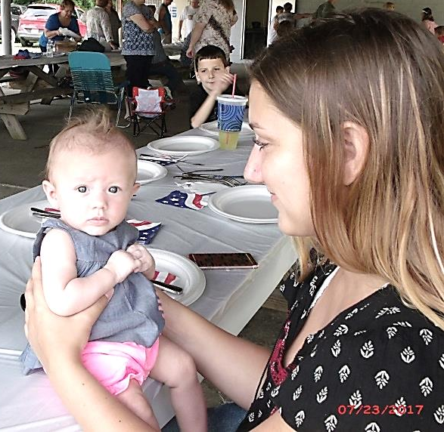
Our Youngest Attendee this Year
Shae Eichholtz
(with her big sister, Audrianna)

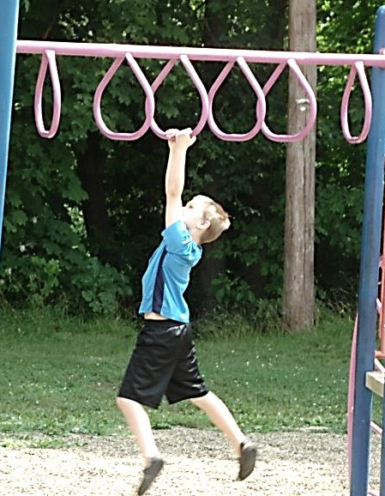
Sean

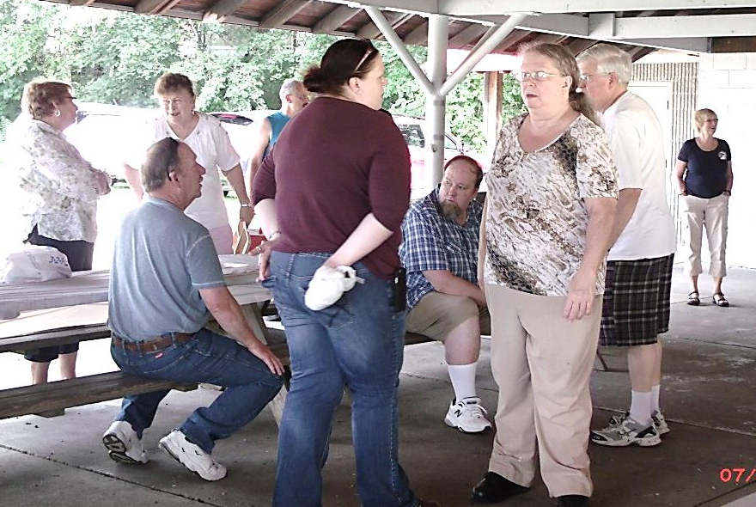
Lots of friendly chit-chat!
Becky Kathy, DeWayne
Dan, Barry, Pastor Jim,
Hazel and Nancy
(Nancy Muse in the background)

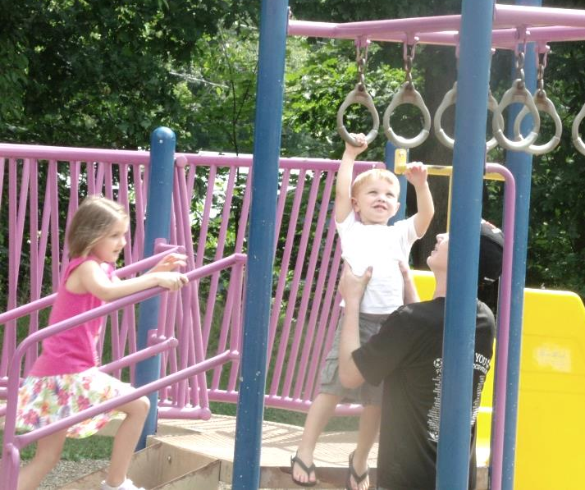
Sylvia, Silas, Rex

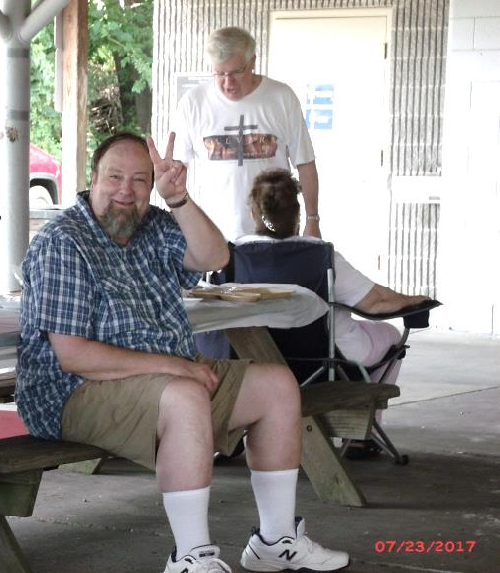
Barry
Cathy, Pastor Jim
Vacation Bible School
(Photos by Tom Shiner, Jr.)
(Report by Diane Montgomery)

Our Church’s one-day Vacation Bible School was held on Saturday, June 24, 2017. The theme for the VBS was ‘God Bless America – Part 2’. Diane Montgomery and Hazel Kean were the directors. They were assisted by Megan and Becca Mullen, Tom Shiner, Jr., Nancy Barger, and Pastor Jim.

There were 17 children present. They participated in music, crafts, lessons, skits, lunch, and games. They presented the special music on Sunday, with two members of the U.S. Army Honor Guard present.

Thank you to everyone involved in VBS and making it a fun time of learning for the children.

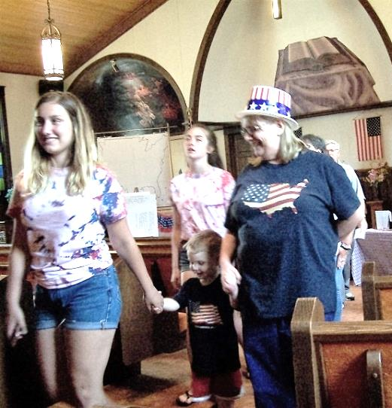

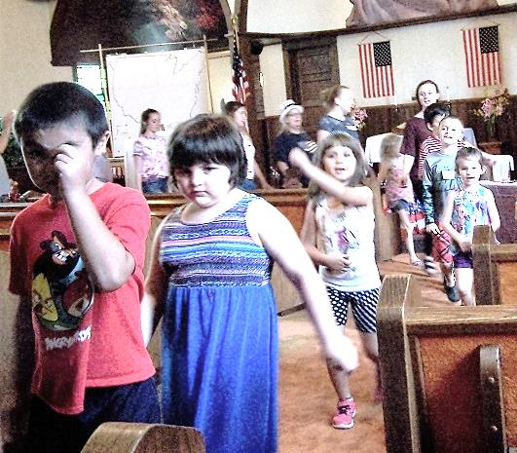

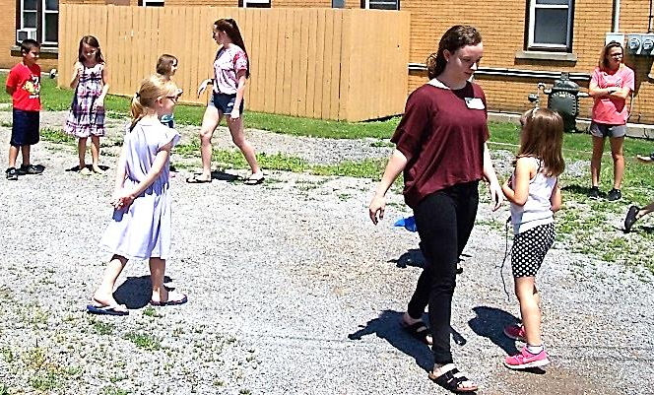

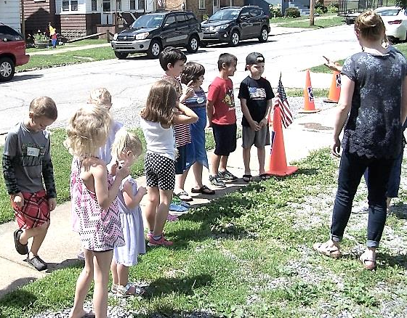

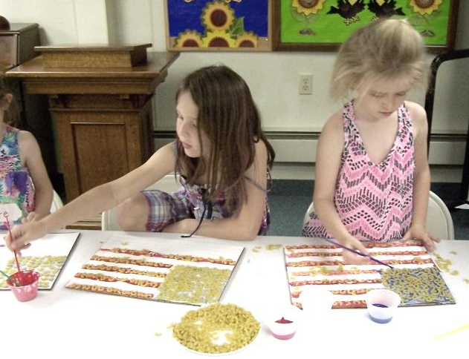

More VBS Pictures

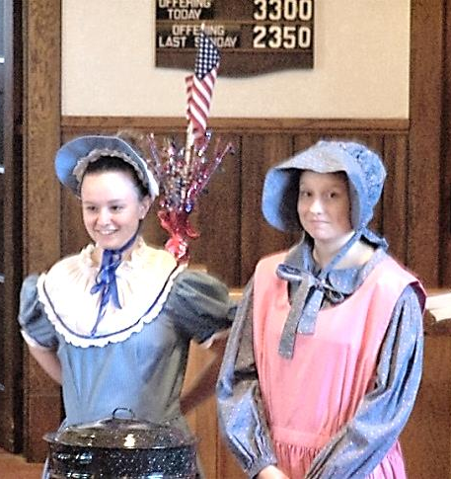

More Church Picnic Pictures

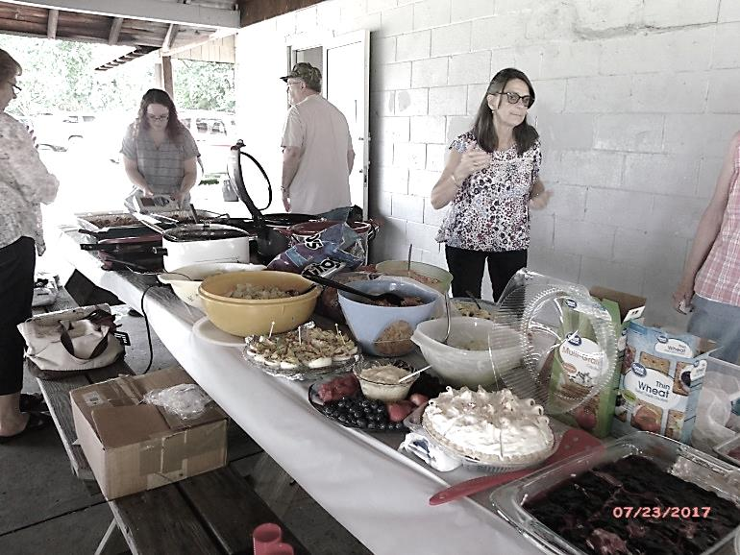
The picnic is just about ready!!
Heather, John, Pat D.

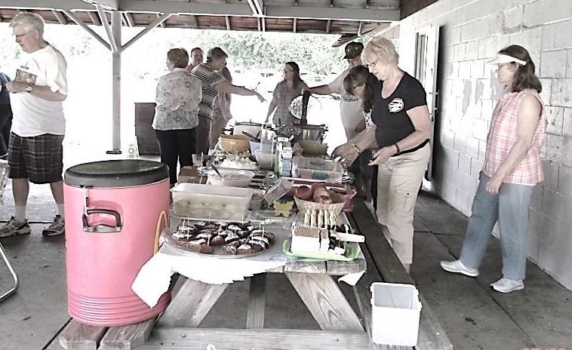
Pastor Jim
Becky, Pamela, Skip, Heather
Gloria, Nancy, Pat D., John

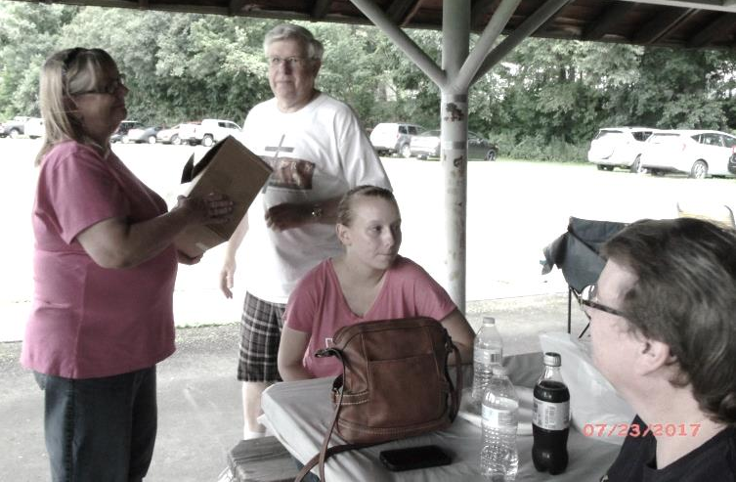
Diane, Pastor Jim, Megan, Sonya

Senior Fellowship Class

When the Senior Fellowship Class was discontinued earlier this Spring, it was decided that the money in the checking account would be sent to Cross Cultural Missions. There was a balance of $570.65. It was originally thought that the entire amount would be sent and divided among several missionary families.

Church treasurer, John Doyle, suggested that the account be kept open so that in the future if it was needed it could be used again. Therefore, $100 was sent to each of the following five missionary families:

Douglas & Anna-Karin Molgaard - Sweden
Gordon & Annie Avey - Brazil
Caleb & Christina Acosta - Spanish speaking Churches
John & Toni Thumma - Southwest USA Indian Reservations
David & Kenda Kapaku - Maui, Hawaii

All the financial records were turned over to John Doyle, with a balance of
$70.65 in the Senior Fellowship checking account.

Supporting missions has been one of the goals of the Senior Fellowship Class, and it certainly has been fruitful to be able to do so.

Bob Muse
Class Treasurer

~~~~~~~~~~~~~~~~~~~~~~~~~~~~

THANK YOU TO:

- Dan Kearney – cleaning up the Social Room when it is flooded by all the rain we have had this Summer
- Pat Dilley – planting, watering, and weeding the pretty flowers by the ramp
- Dan Kearney and Skip Curran – cleaning up the area between the ramp and the elevator – it looks so much better now
- Tom Shiner, Jr., - he fills in whenever and wherever he is needed
- Diane Montgomery and Hazel Kean (plus many others) – Directors of this year’s VBS

****************************

Cranberry, Franklin,
Oil City and Rocky Grove
all start on:
Tuesday, August 29th

ABC LIFE CENTER

If you still have your baby bottle, please return it as soon as you can. If you are not able to donate at this time, please return the bottle anyway. The bottles are reused each year, and it cuts down on their cost if they don’t have to buy a lot of bottles each year. Donations to the Center are accepted at any time.

Please keep the ABC Life Center and its staff in your prayers. They provide a great service to our community and the families who seek their help.

+++++++++++++++++++++++++++++++
HAZEL & NANCY’S INVITATION

Join us for a housewarming party!!
Sunday, August 13, 2017 – starts at 1:00 p.m.

We will be having a picnic - we’ll supply the meat and drinks – feel free to bring a covered dish to share and a comfy lawn chair if you’d like!! Please RSVP (814-425-1215) by August 1st. We can’t wait to see everyone!!! ~~

From: Hazel Kean and Nancy Barger

+++++++++++++++++++++++++++++++++++++++

MY ANCHOR HOLDS
I have journeyed through the long dark night
Out on the open sea, by faith alone
Sight unknown; and yet His eyes were watching me
The anchor holds
Though the ship is battered
The anchor holds
Though the sails are torn
I have fallen on my knees as I face the raging seas
The anchor holds in spite of the storm
I've had visions, I've had dreams
I've even held them in my hand
But I never knew they would slip right through
Like they were only grains of sand
The anchor holds
Though the ship is battered
The anchor holds
Though the sails are torn
I have fallen on my knees as I face the raging seas
The anchor holds in spite of the storm
I have been young but I'm older now
And there has been beauty these eyes have seen
But it was in the night, through the storms of my life
Oh, that's where God proved His love for me
The anchor holds
Though the ship's been battered
The anchor holds
Though the sails are torn
I have fallen on my knees as I face the raging seas
The anchor holds in spite of the storm
I have fallen on my knees as I face the raging seas
The anchor holds in spite of the storm
Songwriters:
LAWRENCE CHEWNING, RAY BOLTZ

Thank You Notes to our Church:
Kaleb Dilley sent this letter to the Church:

To Everyone at my Church,

Thank you for the opportunity to go to Camp Sonrise Mountain last week. I had a great time! I especially liked the Christian Music. That’s the kind of music I want to listen to the majority of my time now.

What made me feel comfortable there was the counselors reaching out to us campers with their testimonies. I hope to someday give my testimony to maybe help other kids like that.

I sure hope I can go again next year.

Thank you very much,

Kaleb Dilley

****************************************

Rex Montgomery would like to thank the Church for paying his camping registration/fees so he could attend camp again this summer.

~~~~~~~~~~~~~~~~~~~~~~~~~~

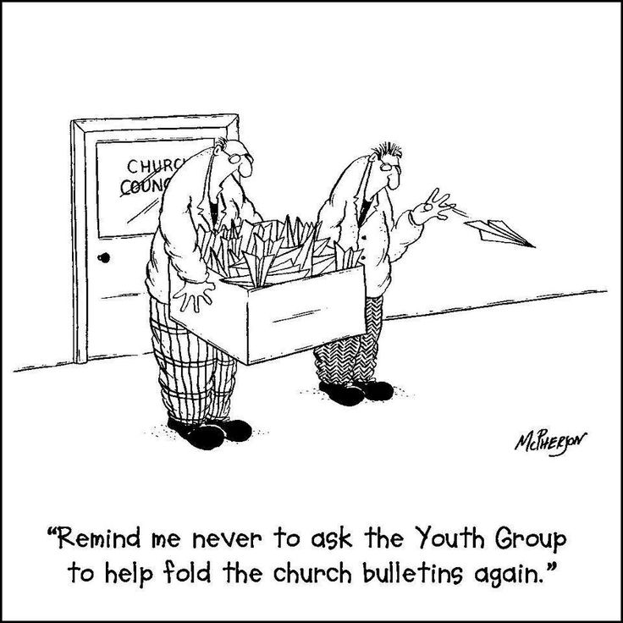
“Remind me never to ask the kids to help fold the church bulletins again.”

NEEDED

At this time our Church is in need of Nursery workers during Sunday AM Worship. Volunteers should be in compliant status with our Safe Sanctuary Policy. If you are willing to serve in the Nursery, please contact Pamela Leichliter. If you are not in compliance with that Policy and would like to be, please see Pastor Jim.

We are also in need of Jr. Church leaders. These leaders should be in compliant status with the Policy, too. If you are interested in leading Jr. Church once a month, please see Judy Shiner.

Diane Montgomery is looking for a Sunday School teacher for the Children’s Department. Teachers should be in compliant status with the Safe Sanctuary Policy. If you are interested in teaching a children’s Sunday School class, please contact Diane Montgomery.

Please prayerfully consider these needs. If you feel God is leading you to serve in any or all of these areas, please contact the persons listed above.

~~~~~~~~~~~~~~~~~~~~~~~~~~~

