 *“Flock Talk”*

***Franklin First Church of God***

***Inspirational Newsletter***

­­

Issue Five of 2017 NEWS AND VIEWS FROM THE PEWS May 2017

**\_\_\_\_\_\_\_\_\_\_\_\_\_\_\_\_\_\_\_\_\_\_\_\_\_\_\_\_\_\_\_\_\_\_\_\_\_\_\_\_\_\_\_\_\_\_\_\_\_\_\_\_\_\_\_\_\_\_\_\_\_\_\_\_\_\_\_\_\_\_\_\_\_\_\_\_\_\_\_\_\_\_\_\_\_\_\_\_\_**

*A Mother's Love*

(Taken from: www1.cbn.com)

The first Mother’s Day was celebrated in West Virginia in 1912. Mothers were to be recognized as an important part of our culture and lives. The heart of a mother is like a rare jewel. They love their children during the worst and best of times.

Yet all mothers are not the same. Author and speaker Patsy Clairmont says, “Normal is just a setting on your clothes dryer.” We are all different. She shared that as women we may “struggle, fail, start over, and celebrate.” But we are mothers who can love unlike any other person.

A familiar mother’s day poem written in the early 1900’s is:

**M** is for the Many things she gave me,   
**O** means only that she's growing Old.  
**T** is for the Tears she shed to save me,  
**H** is for her Heart of purest gold.  
**E** is for her Eyes with love light shining,  
**R** means Right and Right she'll always be.

Put them all together, they spell MOTHER.   
A word that means the world to me.

God created families and gave mothers a unique place in that unit. We can love, give of ourselves, cook, clean, wash clothes, put Band-Aids on scrapes … be the first one up in the morning or the last one down at night. We juggle a lot of things including raising children, working at jobs, managing a home, and sometimes finding time for ourselves.

Each day is a new beginning of what lies before us. We have destiny, purpose, and the

power to do and be all that we are called to be. Nothing can stop us except ourselves. As mothers, we need to find the strength to face each day knowing that God loves us. This scripture seems to be written just for mothers.

“If you have any encouragement from being united with Christ, if any comfort from his love, if any fellowship with the Spirit, if any tenderness and compassion, then make my joy complete by being like-minded, having the same love, being one in spirit and purpose. Do nothing out of selfish ambition or vain conceit, but in humility consider others better than yourselves. Each of you should look not only to your own interests, but also to the interests of others." Philippians 2:1-4

Our children need that unselfish love of a mother. We as mothers need to love our mothers too. Long life is promised to all who show honor to them.

“Children, obey your parents because you belong to the Lord, for this is the right thing to do. "Honor your father and mother." This is the first commandment with a promise: If you honor your father and mother, "things will go well for you, and you will have a long life on the earth." Ephesians 6:1-3

Mothers make up a crucial part of our lives. So whether it is a Hallmark card, dinner out, hug, or a kiss on the cheek, we should show we care. It is so important to give our love to these dedicated women in our lives and don’t take them for granted.

“Dear children, let's not merely say that we love each other; let us show the truth by our actions.”[I John 3:18](http://bible.cbn.com/ContentView.aspx?book=62&sc=3&sv=18&ev=18&phrase=I%20John%203:18)

May Birthdays

4 Taylor Haney

6 DeWayne Hutchinson

9 Rachel Ashbaugh

12 Bernard Magee

12 Sean Hutchinson

18 Shauna Eichholtz

23 Barry Mullen

23 Tia Cover

26 Rob Linn

C:\Users\Pam\AppData\Local\Microsoft\Windows\Temporary Internet Files\Content.IE5\CAN0H82S\MC900434399[1].wmf

May Anniversaries

6 Floyd & Debbie Dunlap

31 Andrew & Meggan Curran

C:\Users\Pam\AppData\Local\Microsoft\Windows\Temporary Internet Files\Content.IE5\Q4REPGNX\MC900026831[1].wmf

C:\Users\Pam\AppData\Local\Microsoft\Windows\Temporary Internet Files\Content.IE5\VOUNIKBQ\MCFD01224_0000[1].wmf**FOOD PANTRY**

Our Church’s Food Pantry is used to assist people from our Church and community when they find themselves needing some help providing food for their families. The winter months can be especially difficult with higher gas and electric bills. If you are able to keep the food pantry stocked with non-perishable food items (check those expiration dates) or if you are able to make a monetary donation to the food pantry, it would be greatly appreciated.

If you are in need of items from the food pantry, or if you know of someone who is in need, please let Pastor Jim know.

++++++++++++++++++++++++++++++++++

**GOOD SAMARITAN FUND**

Donations are accepted at any time for our Church’s Good Samaritan Fund. The monies in this Fund are used to help people from our Church family who are in need.

~~~~~~~~~~~~~~~~~~~~~~~~~~~~~~~~

**ALTAR FLOWERS**

Anyone wishing to place an order for altar flowers, please contact Joanne Cardy. Flowers can be placed in memory or in honor of someone, on a special occasion, or “just because”. Two altar vases only cost $16.00. Once you order them, they are yours to take home after the morning worship service.

Thank you, Joanne, for getting the palms for Palm Sunday. The flowers looked very pretty for Easter Sunday!



~~~~~~~~~~~~~~~~~~~~~~~~~~



~~~~~~~~~~~~~~~~~~~~~~~~~



Dear Flock,

The Tuesday morning Bible study has resumed and will continue through May 16th. Join in the series titled: “Being Totally True When You’re In The Pew” at ten o’clock each week in the former parsonage dining room.

Also, the Tuesday morning prayer walks are happening through May 16th. We leave the former parsonage dining room at eleven o’clock and return by noon after walking and praying around a block near the church building.

The Men’s and Women’s Thursday evening Bible studies will be held May 4th at seven o’clock. Tom Shiner, Jr. and Nancy Barger continue to lead these two studies.

 Baby Day is May 7th. Families with babies are encouraged to be present in the worship of God. Ky Landon Rivera and Remington Laine Rivera will be dedicated to the Lord during the morning worship service.

The Administrative Council of the church will meet on Tuesday evening May 9th at seven o’clock. The Ad Council usually does not conduct meetings June through August. Reports to the Ad Council members are to be in their individual mail slots by May 7th.

The Worship Cell will be selecting music for worship at their meeting on Saturday, May 13th at nine o’clock in the morning.



Mother’s Day is May 14th. A video of pictures of us with our moms will be shown during the worship service. Join with mothers in worship that Sunday. Invite your mom and praise Jesus together.

 We are supporting the ABC Life Center fund raiser, Baby Bottle Boomerang. Baby bottles will be given out on Mother’s Day and are to be returned on Father’s Day. Fill the bottles with cash or check and support life and the ABC Life Center ministries. Members of our church are involved in this ministry. Ask Diane Montgomery, Patty Dilley, Becky or Dan Kearney about their involvement.

We will minister at the Caring Place on Wednesday evening May 17th. Let Tom Shiner, Jr., know that you want to participate in this ministry to the residents of the Caring Place. Grove Manor Corporation, an agency of the A.R.C. is the owner of the facility.

Joe and Renee Cranmer will serve as our delegates to the Allegheny Region Conference in session on Saturday and Sunday, May 20, 21. Pray for each of the delegates present.

Communion will be observed during the worship of God on May 28th. Prepare in advance to receive the bread and cup in remembering the sacrifice of our Lord Jesus.

Your Shepherd,

Pastor Jim





KIDS CLUB

We held meetings on 4/3 and 4/10 to finish up our year. Pam Jolley taught the lesson at both meetings. We did our “Review Game” at the last meeting. It is always exciting to see how much the kids have learned. As always we played games, made crafts. At our last meeting we had a special treat for supper – we got to make ice cream sundaes!!!!

Special thanks to our “Kids Club Kitchen Crew”

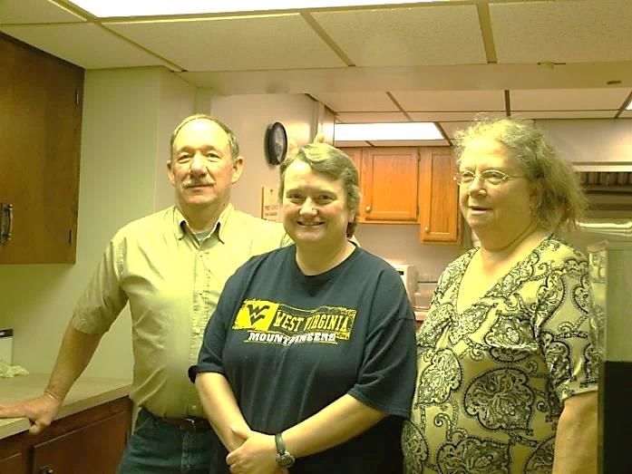

Dan Kearney, Sonya Mullen, Nancy Barger

AND . . . Our photographer for Facebook

Hazel Kean

AND . . . Our Kids Club Leaders

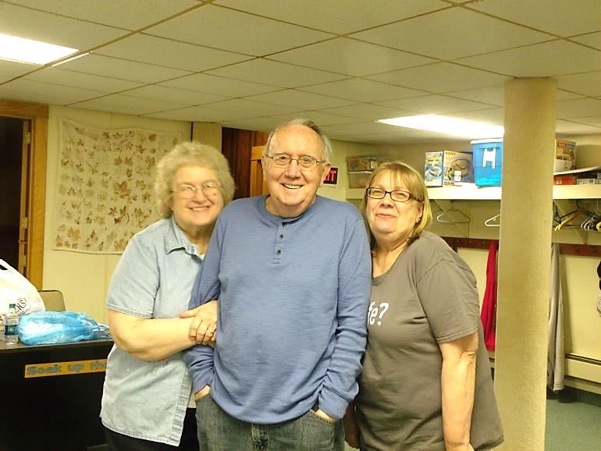

Judy and Tom Shiner, Diane Montgomery

**AND . . . THE KIDS!!!!!**



Cara, Jaci, and Lexi

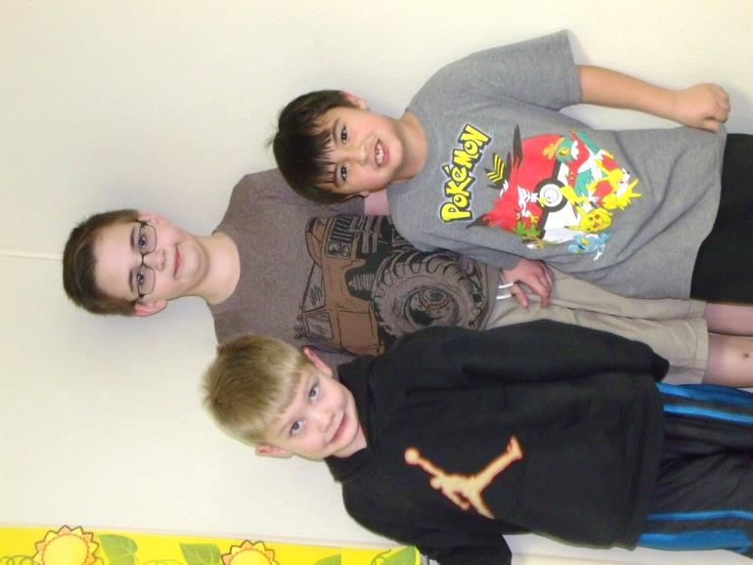

Abe, Ethanyal, Lucas

Absent from the pictures: Caroline, RaeLynn, Zach, Tyler, Joseph, and Bristol

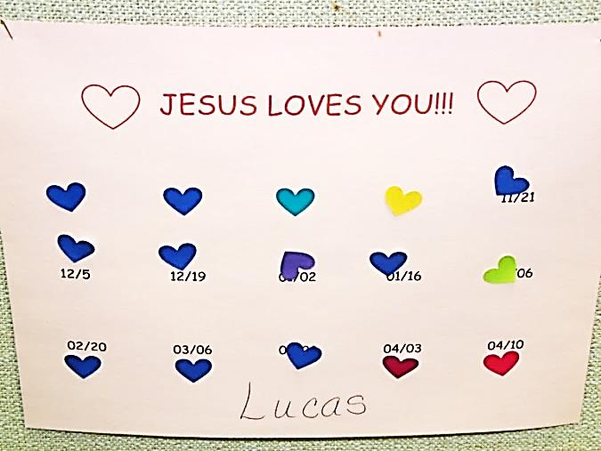

LUCAS HAD PERFECT ATTENDANCE!!!!

KIDS CLUB – continued

Our Staff this year:

LEADERS: Judy Shiner, Diane Montgomery, Pat McNutt

HELPERS: Tom Shiner, Sr., Pam Jolley

KITCHEN: Dan Kearney, Nancy Barger, Sonya Mullen

TEACHERS: Pastor Jim, Tom Shiner, Sr., Tom Shiner, Jr., Diane Montgomery, Nancy Barger, Cathy Bell, Becky Kearney, Pam Jolley

PHOTOGRAPHER FOR FACEBOOK/WEBSITE: Hazel Kean

TREASURER: Michael Curran

7TH GRADE HELPERS: Autumn Rodgers, Christina Bullard, Alyssa Shick, Kaleb Dilley, Terry Ace

 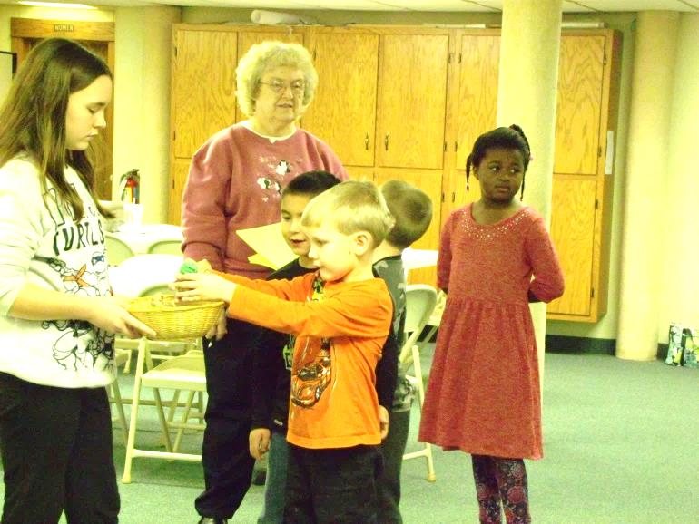

Terry and Autumn – former Kids Club kids

who came and helped out at a couple

of meetings this year

We are so thankful for all the people who helped with Kids Club this year!! Everyone was more than happy to help wherever they were needed.

We are planning to start up again in September. Watch for our sign on the corner of 7th and Liberty Streets!!!

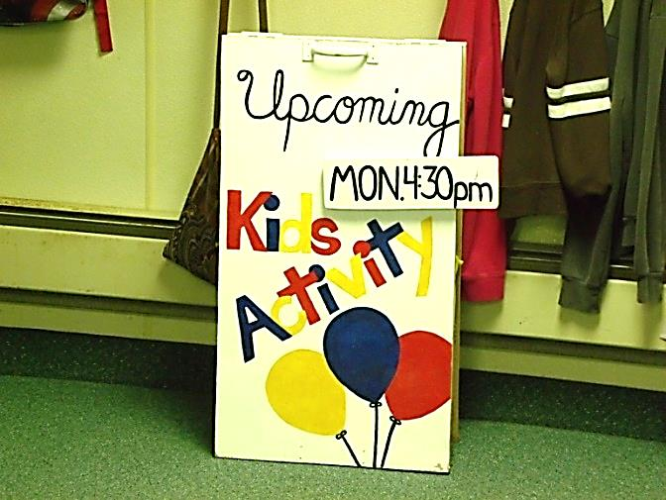

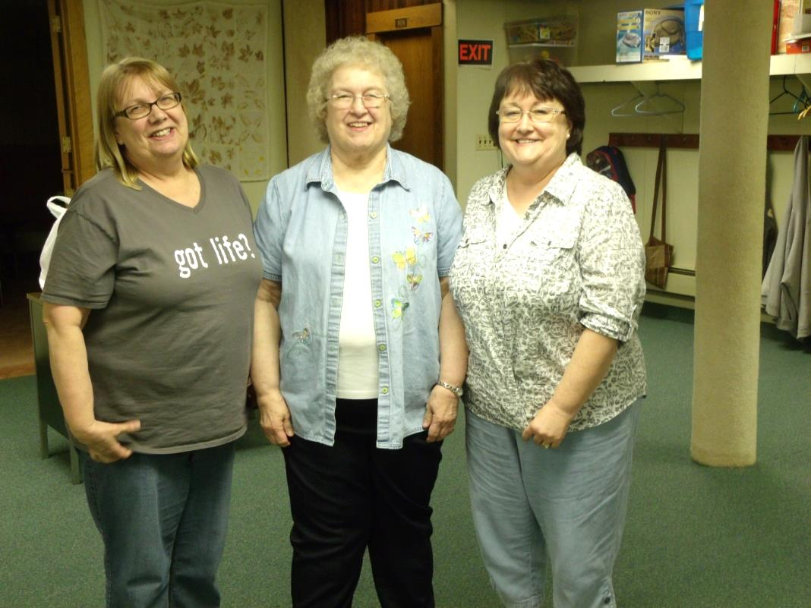

Diane, Judy and Pam say:

Thank You for a great year of Kids Club!!! See you in September!!

---------------------------

See you in Church this Summer:

- Every Sunday -

9:30 – AM Worship/Jr. Church

11:00 – Sunday School

Saturday, 6/24/17,

10:00 a.m. to 4:00 p.m.

Vacation Bible School



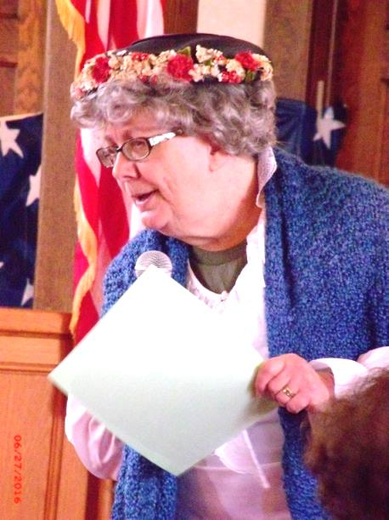

Remember this lady from last year’s Vacation Bible School? I wonder if she’ll be joining us again this year.

Come to VBS on Saturday, June 24th,

from 10:00 to 4:00 to find out!!!







~~~~~~~~~~~~~~~~~~~~~~~~~~~~~~~~~~~~

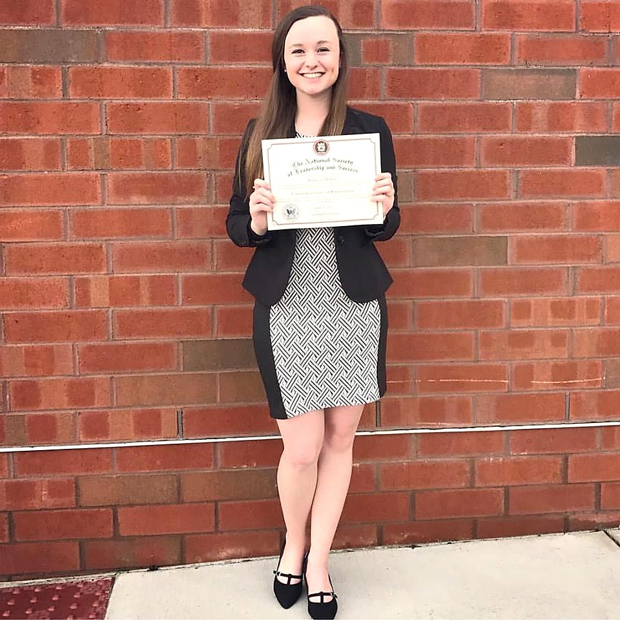

Becca Mullen was inducted into

Clarion's chapter of the

National Society of Leadership and Success.

She was also sworn in as the

Membership Outreach Chair!

~~~~~

Congratulations Becca!!



As I was talking to Becca about this information, she told me that Joe Cranmer was also inducted into the National Society of Leadership and Success –

Congratulations Joe!!!





Audrianna Montgomery with her new baby sister,

Shae Isabella, who was born on April 6, 2017.

Shae is also welcomed into the family by her Mom, Heidi, her brothers, Abe and Silas, and her grandparents, Denny & Diane Montgomery.





All info for the June 2017 Flock Talk

is due on May 21, 2017. Thanks!!!





Mother's Dictionary of Meanings

Dumbwaiter: One who asks if the kids would care to order dessert.

Feedback: The inevitable result when the baby doesn't appreciate the strained carrots.

Full Name: What you call your child when you're mad at him.

Grandparents: The people who think your children are wonderful even though they're sure you're not raising them right.

Independent: How we want our children to be for as long as they do everything we say.

Puddle: A small body of water that draws other small bodies wearing dry shoes into it.

Show Off: A child who is more talented than yours.

Sterilize: What you do to your first baby's pacifier by boiling it, and to your last baby's pacifier by blowing on it and wiping it with saliva.

Top Bunk: Where you should never put a child wearing Superman jammies.

Two-Minute Warning: When the baby's face turns red and she begins to make those familiar-grunting noises.

Whodunit: None of the kids that live in your house.



*NEW MEMBER OF OUR CHURCH*

*Catherine Bell*

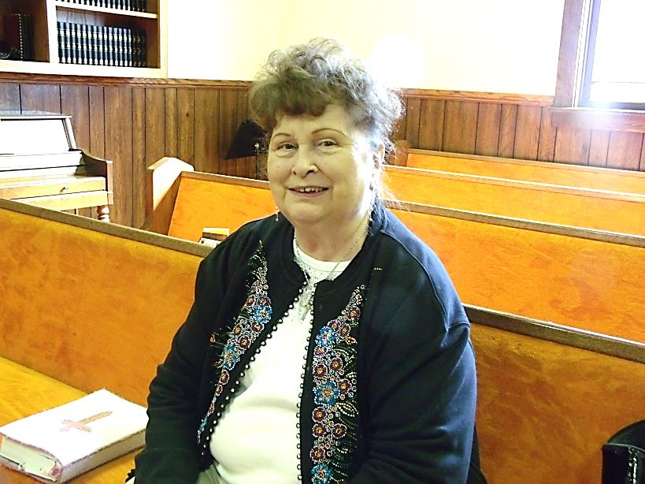

Cathy Bell became a member of our Church on April 9, 2017. She has attended our Church for several years.

Cathy teaches Sunday School, has taught at Kids Club, serves as a Greeter, she is on the Missions Team and she is a Nursery worker. She also served on the Nominating Committee.

When asked what her favorite hymn was, she said she likes them all, but she would pick “Amazing Grace” as a favorite.

One of her favorite memories of the Franklin First Church of God is attending services with her brother, Gene Hutchinson. She also said she is glad her nephew and his family are attending our Church now – DeWayne and Heather Hutchinson and their children, Rebecca and Sean.

God Bless You as you continue serving Him at the First Church of God!!!

~~~~~~~~~~~~~~~~~~~~~~~~~~~~

***1 Peter 4:9-NIV***

***10****Each of you should use whatever gift you have received to serve others, as faithful stewards of God’s grace in its various forms.****11****If anyone speaks, they should do so as one who speaks the very words of God. If anyone serves, they should do so with the strength God provides, so that in all things God may be praised through Jesus Christ. To Him be the glory and the power for ever and ever. Amen.*

Sharing Our Praises

Denny & Dianes new granddaughter – Shae Isabella

Pat Master’s new great-granddaughter – Sophia Grace

Cathy Bell became a new member of our Church

Hazel Kean – purchasing her first house

Denny Geib – thankful for the people in Franklin who have been embracing Lance

Larry McNutt – eye surgery went well

God’s provision for our forgiveness

Answered prayers

Jerry Hanna is doing better

Christian friends

Spring weather

Changing of the seasons

Good people who God sends to help us out

Children of the Church

Godly mothers and grandmothers

Sharing our Concerns

Pat McNutt – blood clot

Dick Swavey – injuries from a fall

John Abraham – brain bleed

Delores Davison – back surgery

Colleen Karns - stroke

Diane Whitton - surgery

Anna

Jane – broken arm

Jerry Hanna

Fred Lepley – brain tumor

Larry McNutt – another eye surgery

Bryson

Phillip

DJ

President Trump

Military

Victoria – knee problem

Jeff Clark

Pat Reynolds

Jeffrey Krable

Concerns - continued

Bryleigh Geiman – seizures

Robin Michaels

Herb – cancer

Marlene Walbourn

Sal Hoover – cancer

Safety in travels

Help in overcoming addictions

Roy Lehman

Gladys Finefrock

Eileen Yingling

Virginia Beatty

Sondra Sensenbach

Wilma Sutley

Jessica Bookwalter family

Chuck Ziegler family

Chuck Karns family

Ed Warner family

Bill Trypus family

Grace Learning Center has to relocate

Salvation Army is closing

ABC Life Center – Baby Bottle Boomerang Fund Raiser

Administrative Council

Missionaries

Mustard Seed Mission

Emmaeus House

Salvation Army

Bible Study leaders

Winebrenner Theological Seminary professors

Camp Sonrise Mountain as they prepare for this summer’s youth camps

Rex Montgomery – attending camp in June

Students graduating from College in May and High school graduates in June