*“Flock Talk”*

***Franklin First Church of God***

***Inspirational Newsletter***

**Issue Six of 2017 NEWS AND VIEWS FROM THE PEWS June 2017 \_\_\_\_\_\_\_\_\_\_\_\_\_\_\_\_\_\_\_\_\_\_\_\_\_\_\_\_\_\_\_\_\_\_\_\_\_\_\_\_\_\_\_\_\_\_\_\_\_\_\_\_\_\_\_\_\_\_\_\_\_\_\_\_\_\_\_\_\_**

Father's Heart

by [Martha Noebel](http://www1.cbn.com/profiles/noebel-martha)

I would like to take a few moments to share with you about your Father's heart toward you. Yes, I am referring to your Heavenly Father. "For God so loved the world that he gave his one and only Son, that whoever believes in him shall not perish but have eternal life" John 3:16

That's a lot of love. God loves us so much. The sins of this world have lead us to places we should not be going, doing things we should not be doing, and encouraging us to say things we should not be saying. But God's love is so great that no matter what the sin, He sent His Son to die for us so that we can be forgiven and made whole. Someone had to pay the price; blood had to be given as a sacrifice. God sent Jesus, the only sinless one, to be the payment for our sins. He did this by giving His life as a ransom for our sins.

We have seen great fathers in this world. The story of the father who pushed, pulled, and carried his son through a triathlon is a great example. He swam 2.5 miles, cycled 125 miles through hot lava fields, and concluded by running 26.2 miles with his son. You see, he loved his handicapped son so much. His son's dream was to be in this contest. The father's heart was to meet that need for and with his son. No, they were not in first place or even second place, but they did finish just under the deadline. The father ran the race with the son.

Our Heavenly Father is running the race with us. We are all in a race. If we have asked Jesus, God's Son, into our hearts and to forgive us our sins, then we are pressing on to win the prize. "I press toward the mark for the prize of the high calling of God in Christ Jesus" Philippians 3:14

I also was thinking about the pastor of Dayna Curry and Heather Mercer. Their pastor certainly showed the heart of a father for these two young women as they were held prisoners in Afghanistan. He went overseas to help in any way he could. I think he was there for several weeks praying for them and trying to assist the best way he could. I was touched as I heard that story. He showed a very big heart for these two missionary women.

God's heart is so big for us. His love is so awesome. He wants only what is best for us. Our Father in heaven has a very big heart for us. He cares, wants us to be healed, cleansed from our sins, in right relationship with Him and others around us, and on our way to heaven. He has a wonderful place for us to go.

I pray that you can feel His heart of love for you today -- the heart of a true loving, gentle, and kind Father.

~~~~~~~~~~~~~~~~~~~~~~~~~~~~~~~~~~~~~~

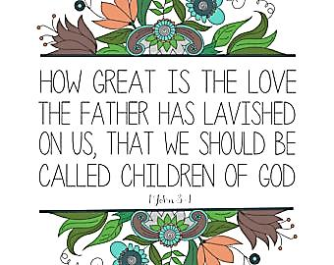



Dear Flock,

Our Summer schedule has resumed. Many of our ministries are on vacation for the Summer. We must remember that we do not vacation from God. He is always present and we must always recognize Him. Join in Sunday morning at nine-thirty to worship God together and at eleven o’clock to study the Bible in a Sunday School class.

We express a big THANK YOU to Nancy Barger for her leading the Women’s Bible Study. She will not resume this leading of the Bible Study this Fall. Again, THANK YOU, Nancy.

Another big THANK YOU is extended to Nancy Muse for teaching the Senior Fellowship Sunday School class for many years. She has decided not to resume this responsibility. THANK YOU, Nancy. All adults are encouraged to participate together in the Adult Bible Study class that meets in the rear of the church sanctuary and is taught by Cathy Bell.

Father’s Day is June 18th and we will honor fathers during the Sunday morning worship of God and with cake being served during the fellowship time following worship. Join with your dad in worship, and dads invite the children to join you .

The baby bottles for ABC Life Center are to be returned on Father’s Day filled with cash or a check. Thank you for supporting this effective ministry in our community.

Vacation Bible School will be held on Saturday, June, 24th from ten o’clock in the morning until four o’clock in the afternoon. Contact Diane Montgomery to volunteer, and bring children to this one day Vacation Bible School.

We will observe communion during the Sunday morning worship of God on June 25th. Come prepared to receive the bread and the cup in a worthy manner.

Camp Sonrise Mountain Youth Camp is scheduled for June. Kaleb Dilley and Rex Montgomery are registered for camp. Pray for them, the other campers and all the staff.

Your Shepherd,

Pastor Jim





**Sunday, July 23, 2017**

Miller-Sibley Pavilion

10:30 – Outdoor Worship Service

Noon – Picnic

(No services at the Church)

Casual dress

Bring your own chair if you want –

picnic tables are available for seating.

Bring your own table service

and food to share.

There will be games for all ages.

Don’t miss this opportunity

for fellowship, food, friends, family, &

LOTS OF FUN!!!!



*June Birthdays*

3 Sally Reed 12 Kay Curran

4 Autumn Rodgers 17 Daniel Eckel

5 Heidi McCachren 23 Tyler Twombly

5 Betty Wyant 23 Ricky Warehime

10 Audrey Sherlock 24 Tom Cardy

11 Sherry Licht 28 Pastor Jim

\*\*\*\*\*\*\*\*\*\*\*\*\*\*\*\*\*\*\*\*\*\*

*June Anniversaries*

14 Bob & Nancy Muse

26 Don & Kim Clark

28 Howard & Virginia Weltner

29 Larry & Pat McNutt



**FOOD PANTRY**

C:\Users\Pam\AppData\Local\Microsoft\Windows\Temporary Internet Files\Content.IE5\VOUNIKBQ\MCFD01224_0000[1].wmf

Our Church’s Food Pantry is used to assist people from our Church and community when they find themselves needing some help providing food for their families. If you are able to keep the food pantry stocked with non-perishable food items (check those expiration dates) or if you are able to make a monetary donation to the food pantry, it would be greatly appreciated.

If you are in need of items from the food pantry, or if you know of someone who is in need, please let Pastor Jim know.



GOOD SAMARITAN FUND

Donations are accepted at any time for our Church’s Good Samaritan Fund. The monies in this Fund are used to help people from our Church family who are in need.

**ALTAR FLOWERS**

 Anyone wishing to place an order for altar flowers, please contact Joanne Cardy. Flowers can be placed in memory or in honor of someone, on a special occasion, or “just because”. Two altar vases only cost $16.00. Once you order them, they are yours to take home after the morning worship service.



ABC Pregnancy Center

Fundraiser

The ABC Pregnancy Center is holding its annual Baby Bottle Boomerang fundraiser. It started on Mother’s Day and runs through Father’s Day. This is their biggest fund raiser every year. If you have not done so already, pick up a baby bottle, place your donation – cash or check made out to ABC Life Center – in the bottle and return it on Father’s Day.

If you have any questions, please contact Becky Kearney who is the organizer of this event at our Church. All donations will be greatly appreciated.





First Day of Summer –

June 21, 2017

One Day Vacation Bible School

The Franklin First Church of God will be hosting a One-Day Vacation Bible School on Saturday, June 24, 2017, from 10:00 a.m. to 4:00 p.m. Children of all ages are welcome. Children under 5 years of age must be accompanied by an adult. The theme for the VBS will be “God Bless America – Part 2”.

Tell all the kids you know – family, friends, neighbors, etc., - about Bible School. There will be music, games, lessons, crafts, food, and lots of fun!!!!



\*\*\*\*\*\*\*\*\*\*\*\*\*\*\*\*\*\*\*\*\*\*\*\*\*\*\*\*\*\*\*\*\*\*\*\*\*



Cranberry – 6/6/17

Franklin – 6/2/17

Oil City – 6/6/17

Rocky Grove – 6/6/17

Keep an eye out for the kids riding bikes and crossing streets as they enjoy their Summer Vacation!!!!

HAPPY FATHER’S DAY!!!



The father of a righteous child

has great joy;  
    a man who fathers a wise son

rejoices in him.

*Proverbs 23:24 (NIV)*



A Reminder for Dads



I am the Flag

by Ruth Apperson Rous

I am the flag of the United States of America.

I was born on June 14, 1777, in Philadelphia. There the Continental Congress adopted my stars and stripes as the national flag.

My thirteen stripes alternating red and white, with a union of thirteen white stars in a field of blue, represented a new constellation, a new nation dedicated to the personal and religious liberty of mankind.

Today fifty stars signal from my union, one for each of the fifty sovereign states in the greatest constitutional republic the world has ever known.

My colors symbolize the patriotic ideals and spiritual qualities of the citizens of my country.

My red stripes proclaim the fearless courage and integrity of American men and boys and the self-sacrifice and devotion of American mothers and daughters.

My white stripes stand for liberty and equality for all.

My blue is the blue of heaven, loyalty, and faith.

I represent these eternal principles: liberty, justice, and humanity.

*(This is an excerpt of the*

*“I am the Flag” patriotic writing.)*



*Flag Day -- June 14th*



*~~~~~~~~~~~~~~~~~~~~~~~~~~~~~~~~~~~*

Cross Cultural Missions

In the latest issue of *The Missionary Signal* there was an article recognizing the   
“Top 25 in CCM Designated Giving for 2016”. The Franklin First Church of God was among the churches on the list.

Pastor Jim read a letter to the congregation from Cross Cultural Ministries thanking us for our designated giving.

We appreciate the generous contributions from the Donagene DeLong Estate which were specifically designated to go to missions.



Continue to pray for all the missionaries who are serving our God and sharing the good news of salvation through Jesus Christ all over the world.



*Sonya, Megan, Barry*

CONGRATULATIONS

to Megan Mullen!!!

She graduated on May 13, 2017, from Clarion University of Pennsylvania. She graduated Summa Cum Laude with a Bachelor’s Degree in Early Childhood and Special Education. She attained a 4.0 GPA.

She will start her employment with Child Development Centers on May 22, 2017. Again, congratulations Megan and best wishes as you begin your career in teaching!!!!



Congratulations to **Jessica Shook**, daughter of Carla Graham and Ray Shook, granddaughter of Pat and Larry McNutt, who graduated Summa Cum Laude from Slippery Rock University.

Congratulations to **Tyler DeLong**, son of Larry and Tara DeLong, who graduated from Franklin High School. He also graduated from the Protective Services class at Venango County Vocational Technical School.

CHILD DEDICATION

May 7, 2017

*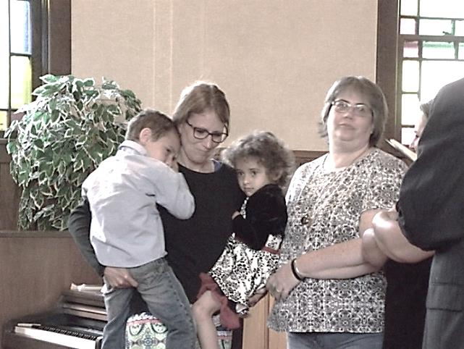*

*Ky, Grandma, Remi, Aunt Audrey*

*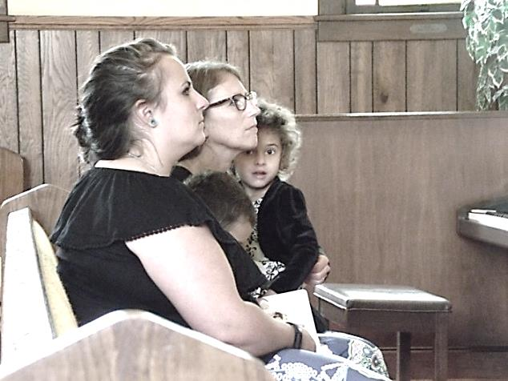*

*Mom, Ky, Grandma, Remi*

Ky and Remi Rivera were dedicated to the Lord on Sunday, May 7, 2017.

### *The Little Children and Jesus*

**13**People were bringing little children to Jesus for Him to place His hands on them, but the disciples rebuked them. **14**When Jesus saw this, He was indignant. He said to them, “Let the little children come to me, and do not hinder them, for the kingdom of God belongs to such as these.**15**Truly I tell you, anyone who will not receive the kingdom of God like a little child will never enter it.” **16**And He took the children in His arms, placed his Hands on them and blessed them.

*Mark 10:13-16*

*Thank You to . . .*

1. Sonya Mullen - for a wonderful power point presentation for Mother’s Day.

2. Nancy Muse – for her years of service as a Sunday School teacher.

3. Nancy Barger – for her service as Women’s Bible Study leader.

4. Diane Montgomery - for leading in the recognition of babies on Baby Sunday.

5. Hazel Kean – for keeping our Facebook page and our website up-to-date with information about our Church.

6. Joe and Renee Cranmer – for being our representatives to the ARC Annual Conference Sessions.

\*\*\*\*\*\*\*\*\*\*\*\*\*\*\*\*\*\*\*\*\*\*\*\*\*\*\*\*\*\*\*\*\*\*\*\*\*\*\*

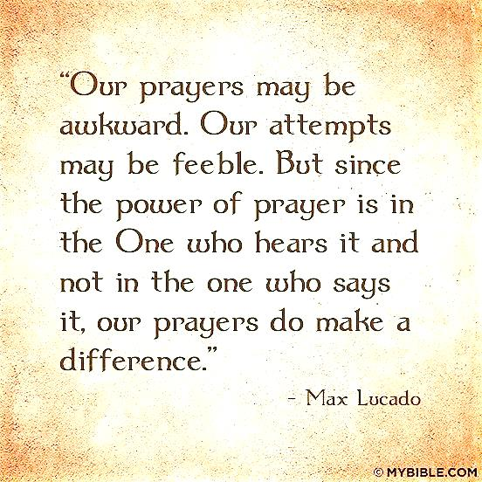

***Men’s Picnic***

The men of the Church will meet on Thursday, June 1, 2017, at 6:00 p.m. at Tom and Judy Shiner’s house – 348 Pinoak Drive in Franklin for their annual picnic.

Everyone is asked to bring food to share. Table service, meat and beverages are provided.

If you have any questions, talk to Tom Shiner, Jr.

*~~~~~~~~~~~~~~~~~~~~~~~~~~~~~~~~~*

*HAPPY FATHER’S DAY, DAD*

A Dad is a person  
who is loving and kind,  
And often he knows  
what you have on your mind.

He's someone who listens,  
suggests, and defends.  
A dad can be one  
of your very best friends!

He's proud of your triumphs,  
but when things go wrong,  
A dad can be patient  
and helpful and strong

In all that you do,  
a dad's love plays a part.  
There's always a place for him  
deep in your heart.

And each year that passes,  
you're even more glad,  
More grateful and proud  
just to call him your dad!

Thank you, Dad...  
for listening and caring,  
for giving and sharing,  
but, especially, for just being you!  
Happy Father's Day

*Author Unknown*



*Prayer Requests:*

Iva McMullen Family

Roy Lehman Family

Eric O’Neil Family

Colleen Karns

Fred Lepley

Meryle Aylesworth

Marlene Aylesworth

Woman who hit Denny’s car

Renee

Judy Burk

Joyce Scott

John Abraham

Nate Cardy

Dick Swavey

Paul

President Trump

Bible School

Church Camp

Strengthen marriages

Safety in our travels

*Praises:*

Christian friends and families

Christian teachers in the public schools

Larry’s eye surgeries went well

Youth Leader Training sessions

Choir Concert – Methodist Church

Baptist Church – Concert

Megan’s graduation

Answered prayers

## His Part; Our Part

Read: Joshua 1:1-9

*Arise, go over this Jordan . . . . I will not leave you nor forsake you. —*[*Joshua 1:2,5*](http://www.biblegateway.com/passage/?search=Joshua+1%3A2%2C5)

Whenever the Lord assigns us a difficult task, He gives us what we need to carry it out. John Wesley wrote, “Among the many difficulties of our early ministry, my brother Charles often said, ‘If the Lord would give me wings, I’d fly.’ I used to answer, ‘If God bids me fly, I will trust Him for the wings.’”

Today’s Scripture tells us that Joshua was thrust into a position of great responsibility. No doubt the enormity of the challenge before him made him tremble with fear. How could he ever follow such a great leader as Moses? In his own strength it would be impossible to lead the people into the Promised Land. But along with the marching orders, the Lord gave him an assuring promise: “I will not leave you nor forsake you” (Josh. 1:5). Then He said, “Have I not commanded you? Be strong and of good courage; do not be afraid, nor be dismayed, for the Lord your God is with you wherever you go” (v.9). Such reassurances were the backing Joshua needed.

If God has given you some special work to do that frightens you, it’s your responsibility to jump at it. It’s up to the Lord to see you through. As you faithfully do your part, He will do His part.

*I’ll go where You want me to go, dear Lord, O’er mountain or plain or sea; I’ll say what You want me to say, dear Lord, I’ll be what You want me to be. —Brown*

**Where God guides, God provides!**

(Our Daily Bread, April 2009)