*“Flock Talk”*

***Franklin First Church of God***

***Inspirational Newsletter***

**Issue One of 2017 NEWS AND VIEWS FROM THE PEWS January 2017 \_\_\_\_\_\_\_\_\_\_\_\_\_\_\_\_\_\_\_\_\_\_\_\_\_\_\_\_\_\_\_\_\_\_\_\_\_\_\_\_\_\_\_\_\_\_\_\_\_\_\_\_\_\_\_\_\_\_\_\_\_\_\_\_\_\_\_\_\_**

***How to Find Peace in a Troubled World***

By Ronnie Campbell

We live in a world that’s full of war, fighting, and turmoil. It doesn’t take much imagination to see that people are hurting, filled with anxiety and lack of hope. Even among God’s people, we see our brothers and sisters in Christ around the world being persecuted for their faith. Is it even possible to find peace in such a world? Christians believe the answer to that is “yes.”

In the Gospel of John, Jesus has this to say to His followers... *I have told you these things, so that in me you may have peace. In this world you will have trouble. But take heart! I have overcome the world (John 16:33, NIV).*  Jesus knew that after He returned to the Father, those who followed Him were going to face many trials and persecutions, and so He encouraged them to find peace in Him.

Often in life, we try to find peace and comfort in all sorts of things, whether it’s in our friends, family, sports, technology, food, or popularity. But nothing will satisfy us and give us the kind of peace that Jesus promises. People let us down. Things fail and go wrong. The world with all that’s in it is only temporary. But God never leaves us nor forsakes us (Deuteronomy 31:6 and Hebrews 13:5). God loves us so much that He sent Jesus to save us from a life full of sin and death and to provide us with abundant life—a life that can only come through a relationship with God (Jn 17:3).

There’s going to be times in life when we find ourselves full of anxiety and worry. But that’s not what God wants for us (Matthew 6:25-34; Philippians 4:6). He wants us to have peace. So what do we do when we find ourselves worrying or being anxious?  Paul, one of Jesus’s followers, gives us some steps for dealing with anxiety (Philippians 4:4-13):

Rejoice in the Lord (Phil 4:4)

Be thankful (Phil 4:6)

Take your requests to God (Phil 4:6)

Change our thinking (Phil 4:8)

Learn to be content (Phil 4:11-12)

Get our strength from Jesus (Phil 4:13)

If anybody had reason to worry, it was Paul. When he wrote this letter to the Philippians, he was in a Roman jail because of his faith in Jesus. Paul encouraged the Philippians to follow his example. He found his peace in Jesus. He knew that even in his darkest time while in prison, Christ was there with him and gave him the strength that he needed (2 Timothy 4:16-18). When we trust in God for our peace, it goes beyond anything we can imagine. God’s peace will protect us and keep us strong in Him (Phil 4:7).

*JANUARY BIRTHDAYS*

1 Steven Haney 14 Sheree Dunlap

4 Cathy Bell 20 John Doyle

6 Joanne Cardy 22 Jason Smith

7 Sondra Sensenbach 25 George Stewart

8 Renee Cranmer 26 Emma Reitz

9 Bob Muse 27 Samuel Muse

9 Nevaeh DeLong 29 Abraham Montgomery

11 Job Greenman 30 Ed Eckel

12 Beverly Potter

12 Jessica Smith

\*\*\*\*\*\*\*\*\*\*\*\*\*\*\*\*\*\*\*\*\*\*\*\*\*\*\*\*\*\*\*\*\*\*\*\*\*\*\*\*\*\*\*\*\*\*\*\*\*\*\*\*\*\*\*\*\*\*\*\*\*\*\*\*\*\*\*\*\*\*\*\*\*\*\*\*\*\*\*\*\*\*\*\*\*\*\*\*\*\*\*\*\*\*\*\*\*\*\*\*\*\*\*\*\*\*\*\*\*\*\*\*\*\*\*\*\*

**ANNUAL CONGREGATIONAL BUSINESS MEETING**

Our Annual Congregational Business Meeting will be held on ***Wednesday, January 25, 2017, at 7:00 p.m.*** at the Church. All financial reports must be turned in by Sunday, January 8, 2017. All information for the Annual Report must be turned in by Sunday, January 15, 2017. Copies of the Report will be available on Sunday, January 22, 2017.

………………………………………………………………………………………………………………………

BABY/CHILD DEDICATION

On Christmas Sunday, George and Monique Byers, brought their children, Mason and Malayah, to be dedicated to God. “Train up a child in the way he/she should go, and when they are old they will not depart from it.” Proverbs 22:6 God bless the Byers’ family!!

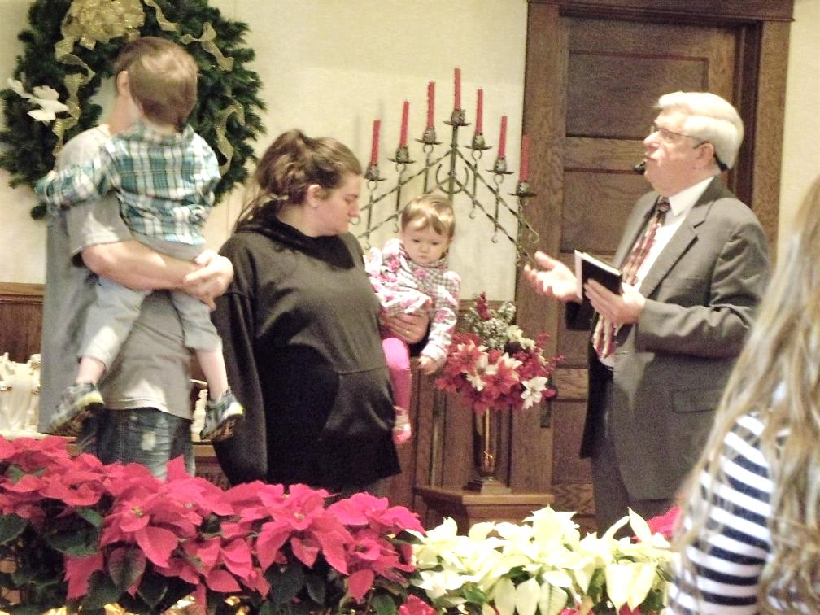 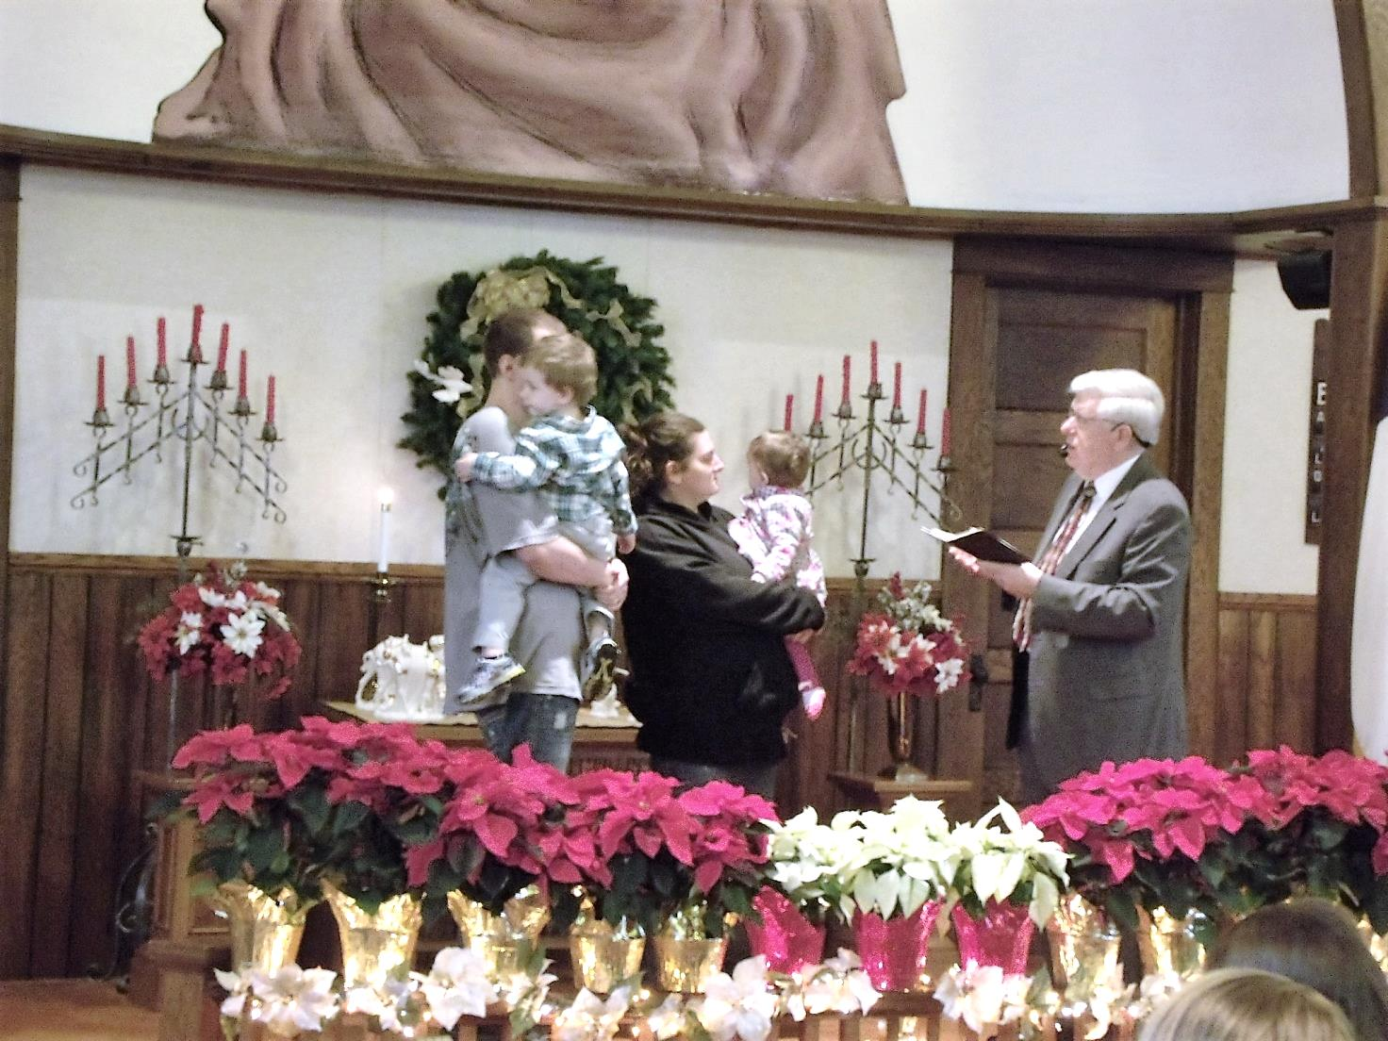

*A Note From Our Pastor*

Dear Flock,

Happy New Year! We begin another year, 2017, with excitement and joy. We anticipate all the LORD has in store for us. With God’s help we will accomplish all that He has planned for us.

Thank you for your giving in 2016. You blessed Pamela and me with a card and Christmas gift at the church dinner. You have prayed for us throughout the year. God has brought our ministries together and continues to bless our cooperative work.

I also thank you for the extra efforts through the Advent season. Many joined in the added emphasis of ministry for Christmas. Thank you, Nancy Muse and Tom Shiner, Jr. for singing in the Christmas Eve worship. Thank you, Elders, for the serving of communion. Thank you Worship Cell for the planning of the music throughout the season. Thank you, Joe Cranmer, for preaching the Christmas Eve message.

Sunday School classes will not meet on January 1st. Attend the nine-thirty Sunday morning worship together as a family and begin the new year in worship of our God.

Another good habit is the study of the scriptures. The Men’s and Women’s Bible Studies will meet the first Thursday of January at seven o’clock. Join the men or women on the fifth of January and each first Thursday of the month in study.

KID’S CLUB will meet on January 9th and 23rd. Please note the schedule change and ensure that the elementary age children of your family and neighborhood will be in KID’S CLUB in January. I thank the staff for their efforts in leading KID’S CLUB and assisting in the children’s participation in the presentation of Christmas Around the World during worship in December.

The Worship Cell will be meeting on Saturday morning January 14th at nine o’clock to select worship music for February and March. Pray the Holy Spirit’s guidance for them as they choose the music.

The children of the church will sing during the worship of God on Sunday January 22nd. A children’s sermon will be presented before they go to Junior Church.

Our annual business meeting will be held on Wednesday, January 25th at seven o’clock in the evening. All ministries of the church are to submit written reports and their financial books for auditing.

As Paul wrote in 2 Thessalonians 3: 13, I also say to you: “And as for you, brothers and sisters, never tire of doing what is good.”

Your Shepherd,

Pastor Jim

~~~~~~~~~~~~~~~~~~~~~~~~~~~~

**Romans 15:13 (NIV)**

**13**May the God of hope

fill you with

all joy and peace

as you trust in Him,

so that you may

overflow with hope

by the power of

the Holy Spirit.



*Christmas Dinner*

*12/3/16*

Our Church’s Christmas Dinner was held on Saturday, December 3, 2016, at 6:00 p.m. The meal was catered by Joe Gionti. He has been catering our Christmas dinners for many years – as usual it was delicious. Tom Shiner, Jr., made presentations of thank you cards and gifts. He presented a gift to the Pastor also.

A musical program was presented by Mike Burkhardt, which was enjoyed by everyone. Mike played the organ, piano and harmonica. He also chose two “volunteers” from the audience to help him out with one of his songs – Tom Shiner, Jr., and John Doyle. He played several carols, and we all sang along.

It was a great evening of fellowship, food and good music! Thanks to Skip Curran for making all the arrangements.

~~~~~~~~~~~~~~~~~~~~~~~~~~~~~~~~

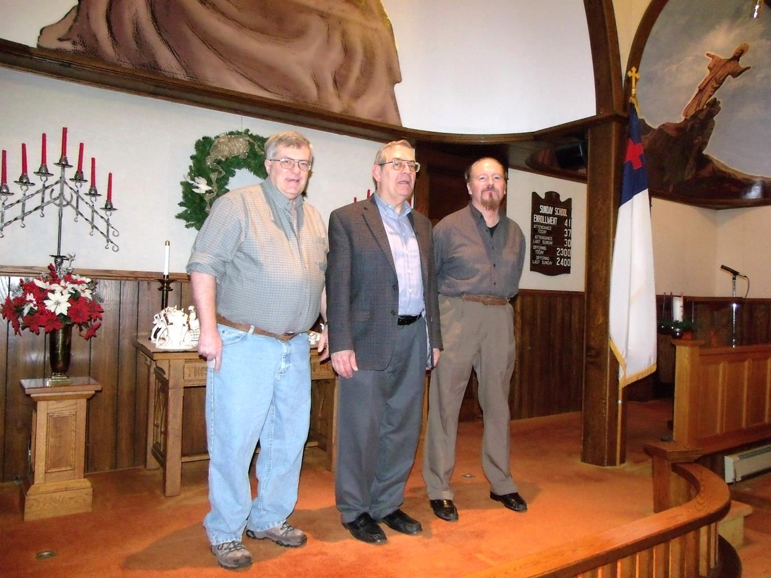

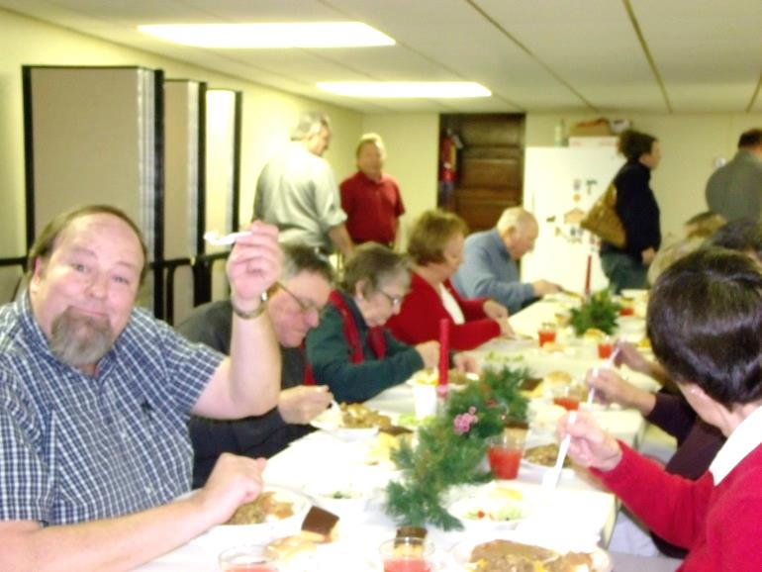



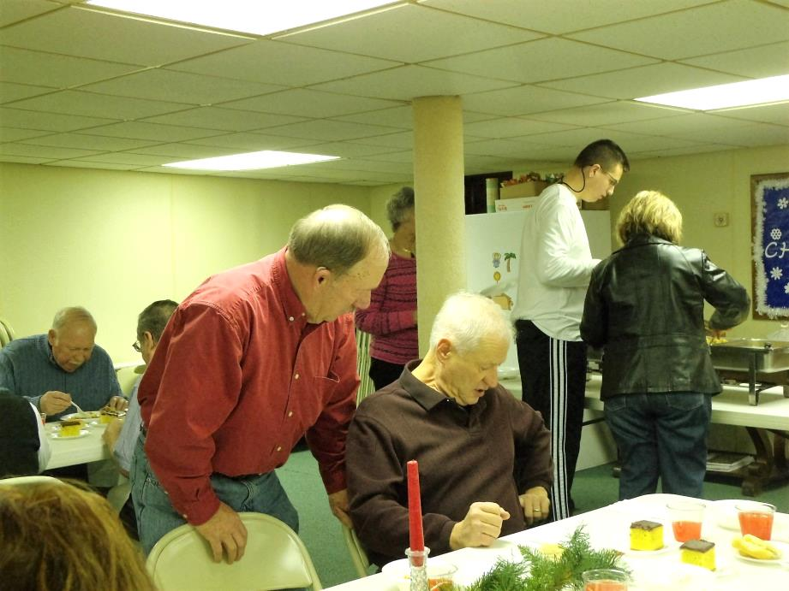

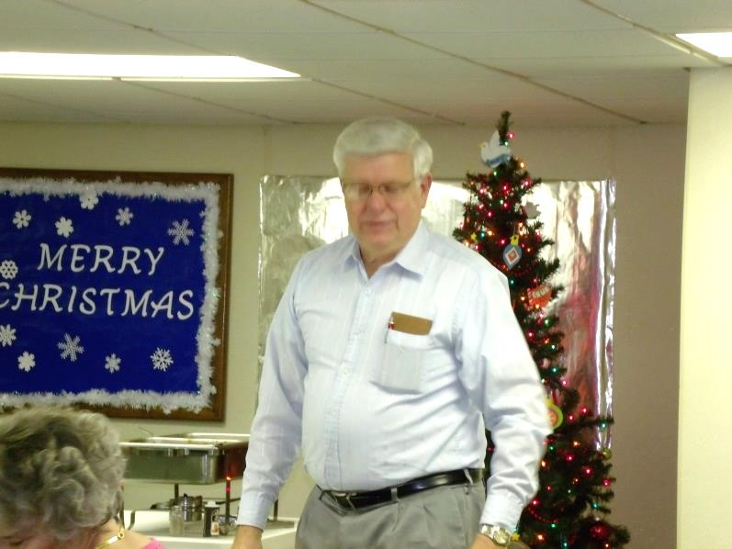

*Children’s Christmas Program*

The children of the Church presented a Christmas program on Sunday, December 18, 2016 during our morning worship service, entitled: *Christmas Around the World*. Special thanks go out to Diane Montgomery for directing the program. She was assisted by Judy Shiner, Tom Shiner, Jr., Pamela Leichliter, Char Metzger, and parents of the children.

Russia RaeLynn Montgomery

Hawaii Rebecca Hutchinson

Brazil Sean Hutchinson

Sri Lanka Cara Dilley

China Abraham Montgomery

France Joseph Cranmer

Africa Kye Rivera

Holland Jaci Clark

Narrator Audrianna Montgomery

Soloist Diane Montgomery

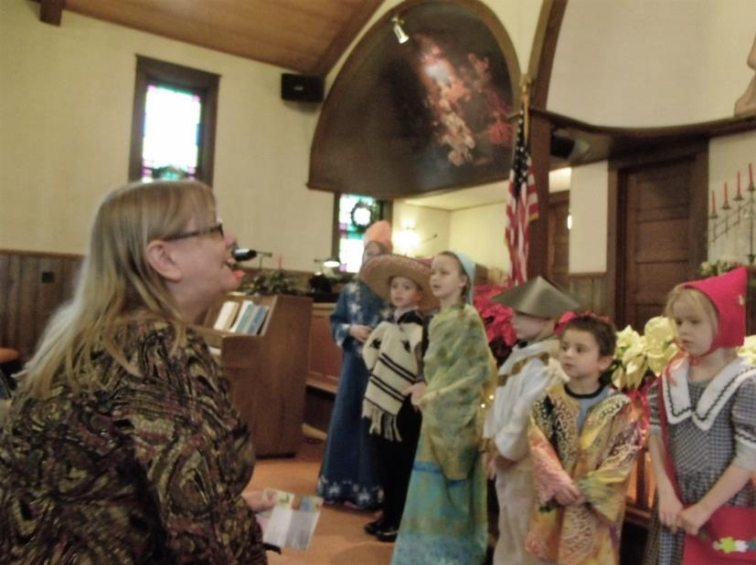

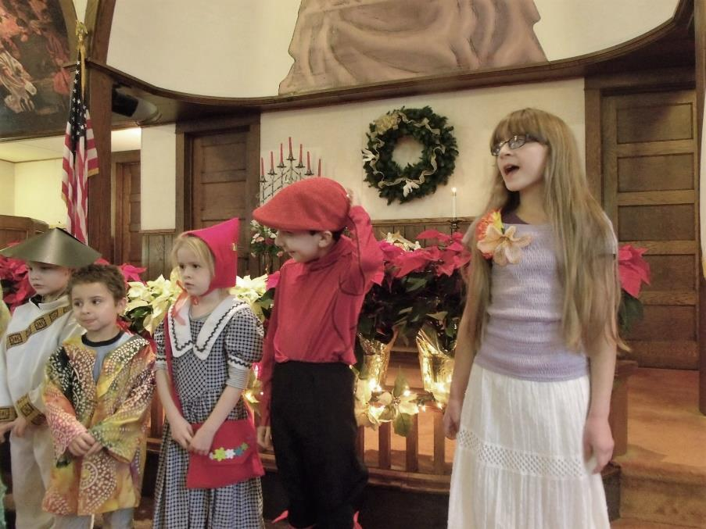

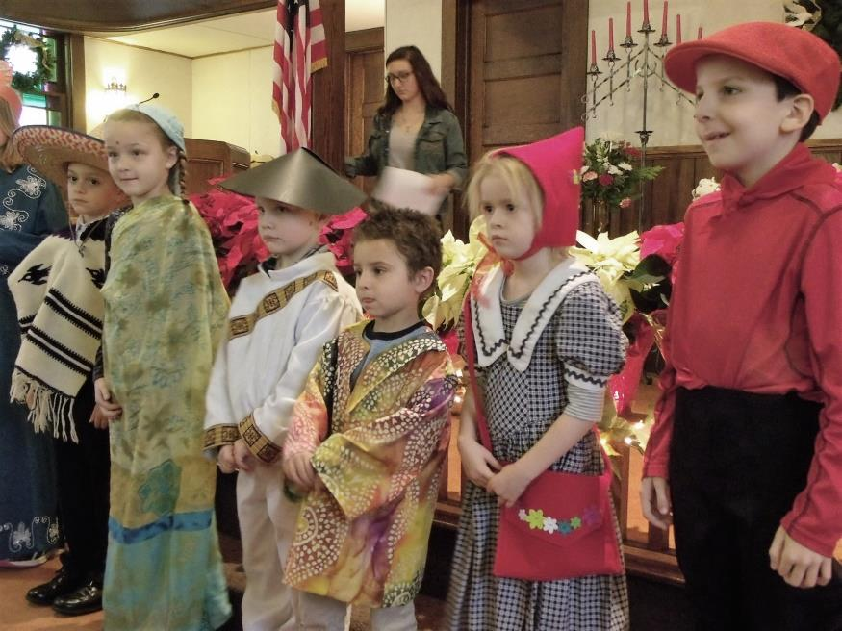

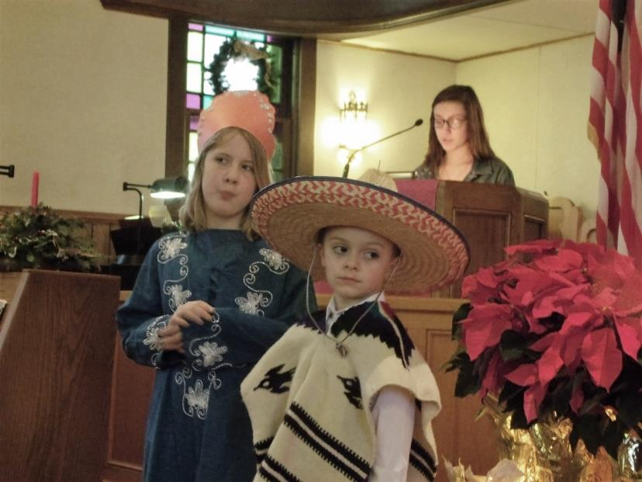

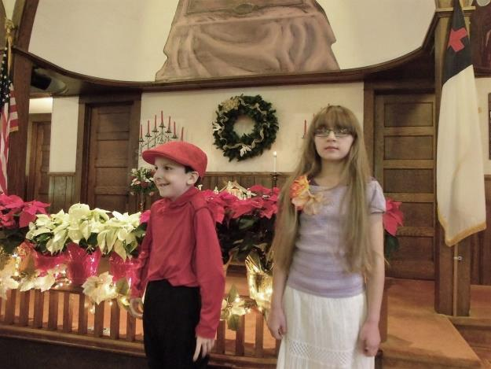

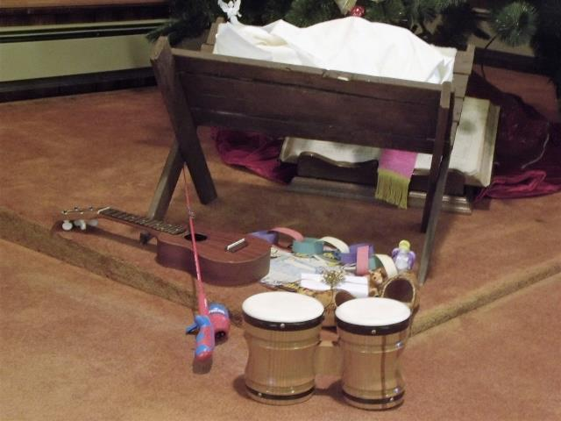



Thank God for:

The children who presented their program on 12/18, Christmas Around the World

The leaders of the children’s ministries

The gift of salvation

Our families and friends

Sally sold her house

Neighbors who lend a helping hand

Answered prayers

Emma’s mole was benign

Lance and his joy at Christmas

Being restored to good health

Safety in travels

Four generations under one roof

celebrating Christmas

The many acts of kindness and charity we

witnessed during the Christmas season

Ron likes his new job and things are going well

Our Pastor

The way God provides for us

**



The Paul (Bud) Lepley Family

The Andrew O’Neil Family

The John Hoover Family

The Ron DeWoody Family

The Ray Sloss Family

The Debbie Baker Family

The Tami Snyder Family

Nancy Kenemuth - cancer

Shawn Alden – more tests on his heart

Lee Blair

Sondra Sensenbaugh

Ed Shiner

Sal Hoover - cancer

Tom Karns – upcoming bone marrow transplant

Amy Leichliter

Mike McGuckin – house fire

Audrianna Montgomery – upcoming surgery

Kaleb West

Jackie Cokain

John Murray

Cathy’s daughter

Travelling mercies

The unemployed

The shut-ins

Those who experience depression during this time

of the year

The family we adopted for Christmas

Jean Kelsey

The McNutts

Lois Beatty

The VanZandts

Our Pastor

The Administrative Council

The upcoming Congregational Meeting

Peg Benson

Ed & Judy Eckel

Pat Master

Fred Lepley

Lisa’s mom

Joyce Scott

Terry Sloan

**FOOD PANTRY**

**C:\Users\Pam\AppData\Local\Microsoft\Windows\Temporary Internet Files\Content.IE5\VOUNIKBQ\MCFD01224_0000[1].wmf**Our Church’s Food Pantry is used to assist people from our Church and community when they find themselves needing some help providing food for their families. The winter months can be especially difficult with higher gas and electric bills. If you are able to keep the food pantry stocked with non-perishable food items (check those expiration dates) or if you are able to make a monetary donation to the food pantry, it would be greatly appreciated.

If you are in need of items from the food pantry, or if you know of someone who is in need, please let Pastor Jim know.

++++++++++++++++++++++++++++++++++

**ALTAR FLOWERS**

Anyone wishing to place an order for altar flowers, please contact Joanne Cardy. Flowers can be placed in memory or in honor of someone, on a special occasion, or “just because”. Two altar vases only cost $16.00. Once you order them, they are yours to take home after the morning worship service.

*Special thanks to Joanne Cardy for the beautiful display of poinsettias on the altar for Christmas Sunday and Christmas Eve.*

*Thank you to everyone who helped decorate the Church for Christmas. Your efforts are greatly appreciated.*

++++++++++++++++++++++++++

GOOD SAMARITAN’S FUND

Donations are accepted at any time for our Church’s **Good Samaritan Fund**. The monies in this Fund are used to help people from our Church family who are in need.

**Just One Request**

Dear Master for this coming year  
Just one request I bring:  
I do not pray for happiness,  
Or any earthly thing—  
I do not ask to understand  
The way Thou leadest me,  
But this I ask: Teach me to do  
The thing that pleaseth Thee.  
  
I want to know Thy guiding voice,  
To walk with Thee each day.  
Dear Master make me swift to hear  
And ready to obey.  
And thus the year I now begin  
A happy year will be—  
If I am seeking just to do  
The thing that pleaseth Thee.

--Unknown Author

++++++++++++++++++++++++++++++++++



[***Romans 12:18***](https://www.biblegateway.com/passage/?search=Romans+12:18&version=NIV) ***-*** *If it is possible, as far as it depends on you, live at peace with everyone.*

[***Ephesians 4:3***](https://www.biblegateway.com/passage/?search=Ephesians+4:3&version=NIV) ***–*** *Make every effort to keep the unity of the Spirit through the bond of peace.*

[***Hebrews 12:14***](https://www.biblegateway.com/passage/?search=Hebrews+12:14&version=NIV)*- Make every effort to live in peace with everyone and to be holy; without holiness no one will see the Lord.*

Encouragement for a New Year

by Arthur Schoonveld

**Scripture Reading —** [Joshua 1:1-9](https://bibles.org/eng-NIV/Josh/1/1-9)

"Do not be discouraged, for the LORD your God will be with you wherever you go."

[Joshua 1:9](https://bibles.org/eng-NIV/Josh/1/9)

On the first day of a new year many of us wish each other a "Happy New Year!" But as we begin a new year, we need more than a hopeful greeting from the people around us. We need to listen to what God told Joshua about 3,400 years ago. As Joshua was about to lead God's people into the promised land, he had reason to be afraid. He had an enormous task ahead of him, and he was well aware of the dangers that he and the people would soon be facing. He needed God's encouragement. A new year brings lots of questions: Will our health hold? Will our marriage last? Will I be able to hang on to my job? Will I get into the right school? Will I live to see the end of this year? Will the economy improve? Will there be a terrorist attack or some natural disaster that takes me or my loved ones? The Creator of the universe comes to us and says, "Don't be afraid; don't be discouraged." What happens in this coming year is not left to chance. God is in charge, and he promises to stay close: "The LORD your God will be with you wherever you go." Many years later, the Lord Jesus made the same promise when he said, "I am with you always" ([Matthew 28:20](https://bibles.org/eng-NIV/Matt/28/20)). That's the reason we can wish each other a "Happy New Year!"

***Prayer:***

*Father in heaven, thank you for the gift of a new year and for your promise to stay with us. We ask for your guidance and wisdom each day. In Jesus' name we pray. Amen.*

 \*\*\*\*\*\*\*\*\*\*\*\*\*\*\*\*\*\*\*\*\*\*\*\*\*\*\*\*\*\*\*\*\*\*\*\*\*\*\*\*\*\*\*\*\*\*\*\*\*\*\*\*\*\*\*\*\*\*\*\*

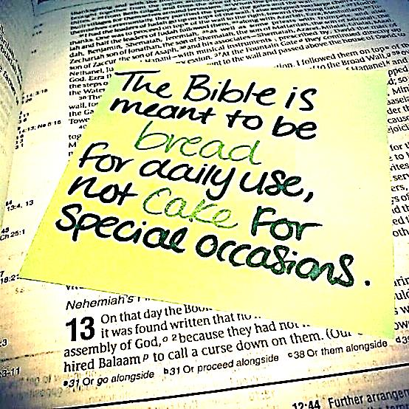

Be always at war with your vices,

At peace with your neighbors,

And let each New Year

Find that you are a better man.

~~Benjamin Franklin

\*\*\*\*\*\*\*\*\*\*\*\*\*\*\*\*\*\*\*\*\*\*\*\*\*\*\*\*\*\*\*\*\*\*\*\*\*\*\*\*\*\*\*\*\*\*\*\*\*\*\*\*\*\*\*\*\*\*\*\*