“Flock Talk”

Franklin First Church of God
Inspirational Newsletter

Issue Twelve of 2016 NEWS AND VIEWS FROM THE PEWS December 2016

Trust Him
When Joseph woke up, he did what the angel of the Lord had commanded him and took Mary home as his wife. - Matthew 1:24

Imagine waking up one morning, and being expected to do something out of the ordinary... something that went against your logical thinking... something that just seemed bizarre.
That is exactly what happened to Joseph. Here was a respectable man, a man who was righteous, and had a good grip on reality. A man who just found out his wife was pregnant, and it wasn't his child.
Can you imagine? How would you feel if you found out your wife was pregnant, and you knew for a fact it wasn't your child... wouldn't it crush you? Wouldn't it turn your world upside down? Imagine how Joseph felt when he heard this news...
Of course, Joseph, being the respectable and just man that he was, knew that the logical thing was to divorce Mary... In fact, he was even planning it out, so that he could divorce her without causing her public humiliation... (Matthew 1:19)
This doesn't really sound like the story-book start for a king, let alone for the savior of man. But it does sound similar to the things we face in our lives, doesn't it? We plan everything out, and we have such a firm grasp on our lives, and then all of a sudden something BIG happens.
Maybe we were planning on that big promotion, only to find out that we were fired instead. Or maybe struggling with finances, unsure of how you are going to make it... and then you find out your wife is pregnant! Illnesses, Accidents, and other unexpected events quickly turn our world upside down, and leave us lost... looking for a logical way out... Just like Joseph.
And even though Joseph seemed to have it all planned out, God still sent an angel to him, and asked one thing of Joseph. He asked Joseph to trust Him, to believe that Mary being pregnant was God's plan for them both. He asked Joseph to trust that He would take care of them.
Of course the end of the story is one of the most amazing, and most publicized events in the world today. A story where Joseph not only finds himself trusting God by staying with Mary, but trusting Him when Jesus was born in a stall... in a lowly manger; and even trusting God with the life of his family as they fled to Egypt.
Sometimes things happen, and no matter what we do, they only seem to get worse. Just like Joseph, we face one thing after the other... And just like Joseph, God asks us one thing... To Trust Him.
He asks us to believe that He will take care of us, and that He will provide for us... that no matter how "weird" or hard things get, He has a plan for us. And if we trust Him, just like Joseph, He will lead us to glory. (Psalm 138:8)

(Taken from www.simpledevotions.org)
FOOD PANTRY

Our Church’s Food Pantry is used to assist people from our Church and community when they find themselves needing some help providing food for their families. If you are able to keep the food pantry stocked with non-perishable food items (check those expiration dates) or if you are able to make a monetary donation to the food pantry, it would be greatly appreciated.
If you are in need of items from the food pantry, or if you know of someone who is in need, please let Pastor Jim know.
~~~~~~~~~~~~~~~~~~~~~~~~~~~~~~~~~~~~~~~~ ALTAR FLOWERS
Anyone wishing to place an order for altar flowers please contact Joanne Cardy. Flowers can be placed in memory or in honor of someone, on a special occasion, or “just because”. Two altar vases only cost $16.00. Once you order them, they are yours to take home after the morning worship service.

*****************************************************
GOOD SAMARITAN FUND

Donations are accepted at any time for our Church’s Good Samaritan Fund. The monies in this Fund are used to help people from our Church family who are in need.

*******************************************

DECEMBER BIRTHDAYS

3 Judy Eckel
3 Christian Twombly
5 Gladys Finefrock
6 Heather Hutchinson
7 Joe Cranmer
8 Heidi Montgomery
12 Riley Curran
14 Philip Murdoch
15 Rachel Wingert
21 Kevin Eckel
22 Andrew Curran
24 Alex Clapsaddle
29 Mike Burkhardt

DECEMBER ANNIVERSARIES

15 Denny & Diane Montgomery

~~~~~~~~~~~~~~~~~~~~~~~~~~~~~~~

THE WAY in a manger.

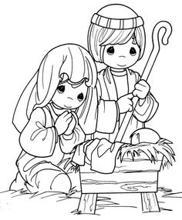

JESUS our Savior!

A Note From Our Pastor

Dear Flock,

Fall Fest was a great time of meeting residents in our community. Approximately eighty people joined us at the Franklin Area School District Administrative gym for two hours of games and refreshments. Thank you for supporting this outreach through giving of your time and finances. Follow up is being done to encourage the attendees at Fall Fest to become involved in other ministries that we provide.
A special thank you is given to each who helped to decorate the sanctuary for the Advent season. I enjoy the greenery and hearing the Advent reading as the candles of the wreath are lit.
The Thursday evening Men’s and Women’s Bible Study meets again on December 1st at seven o’clock. Tom Shiner, Jr. and Nancy Barger are the leaders of the two Bible Studies. You are invited to join.
The Church Christmas Dinner will be held on Saturday, December 3rd at six o’clock in the evening. The annual catered meal is enjoyed every year and this year Mike Burkhardt will present a musical program after the dinner.
The Giving Tree gifts for the family we are supporting at Christmas are due at the church on Sunday December 4th. Thank you in advance for providing for this family.
Kids’ Club will meet on the first and third Monday of the month at four-thirty in the afternoon for two hours. Elementary age children will play a game, hear a Bible lesson, make a craft, eat a meal and sing songs. Bring children into the social room before the starting time and pick them up at six-thirty.
Our Administrative Council meets the evening of December 13th at seven o’clock. Pray for our church leaders as they serve the Lord and this church.
Invite others to join you that day and learn how other people celebrate Christmas.
The Christmas Eve worship will begin at seven o’clock in the evening. Invite your family and friends to join you in worship. The offering is designated for missions. We will observe communion and sing carols in celebrating the birth of Jesus. Joe Cranmer will preach the sermon titled: “The Origin of the Candy Cane”.
Christmas Day worship begins at nine-thirty in the morning. A children’s dedication is planned and carols and a sermon. Encourage your family to join you in worship that day. NO fellowship time nor Sunday School will be held Christmas Day.

Your Shepherd,
Pastor Jim
^^^^^^^^^^^^^^^^^^^^^^^^^^^^^^^^

Sunday, 12/18/16
9:30 a.m.

^^^^^^^^^^^^^^^^^^^

First Day of Winter:
December 21, 2016

Our Church is “adopting” a family this Christmas. There is a Giving Tree at the front of the sanctuary with tags on it for each member of the family – Mom, Dad, and 4 children. There are several tags for each person. Feel free to take a tag, buy the requested gift, wrap it up, and bring it to the Church by December 4th. The tag on the gift should say who the gift is for, but not who it is from. Any questions, please see Nancy Barger.

____________________________________

New Landscaping

The new landscaping around the Church was contracted through Anderson’s Greenhouse by the Curran Family in memory of Gladys Orsega Eicholtz.

Christmas Dinner

Saturday, December 3, 2016, at 6:00 p.m. in the Church Social Room
Two choices of entrees: Turkey/Stuffing or Braised Steak
$10 per person
Caterer – Joe Gionti & Sons
Musical Program after the dinner by
Mike Burkhardt

Sign up, select your entrée, and pay
Skip Curran by 11/27/16

Christmas Eve Service

Our Christmas Eve service will be held on Saturday, December 24, 2016, at 7:00 p.m. Pastor Joe Cranmer will be the speaker that evening. Communion will be observed. The offering will be given to missions.

Christmas Day Service

Our Christmas Day worship service will start at 9:30 a.m. There will be no Sunday School or Social Time that day.

**************************
KIDS CLUB

The Kids Club met on 11/7 with 7 kids and 8 adults in attendance. Nancy Barger was our teacher. On 11/21 we had 7 kids and 6 adults. Pastor Jim taught the lesson. For fun we tried a new game – “Stuff the Turkey”.
One of the lessons that has been taught to the kids is the miracle where Jesus turned the water into wine. Recently there was a question on “Jeopardy” about this miracle – I’m sure most of our kids would have given the correct answer!!
The calendar sale is ongoing. We are using part of our proceeds of sale to purchase gifts for the 4 children on our Giving Tree.
In December we will meet on 12/5 and 12/19. The Children’s Christmas Program is 12/18.
In January we are changing the dates of our meetings to the second and fourth Mondays due to the holidays/no school. We will meet 1/9 and 1/23. In February we will be back to the first and third Mondays, 2/6 and 2/20.
Merry Christmas from your friends in Kids Club.

Don't Forget Jesus
Christmas is a special time
To reflect on Jesus Christ,
The wonder of His lowly birth
Brings meaning to our lives
There really is no other reason,
We celebrate this day,
The birth of God's precious Son
And the life, He willingly gave
But so much seems to distract us
In the busyness of our lives,
We lose our focus in all the happenings,
Not knowing, we leave out Christ
We lose sight of the true meaning
As we endlessly rush about,
Trying to find that perfect gift,
Seems to cloud our Savior out
We need to stop and reflect awhile,
Remembering our precious Lord,
His birth, His life and sacrifice
And all that He stands for
For though the world may celebrate,
It seems, though, for other reasons,
Let’s keep in mind that Jesus Christ
Is the true meaning of the season.

© By M.S.Lowndes

PRAISES

Nancy Barger is thankful for all the prayers while she was in the hospital
Ron VanZandt got a new job
Dennis Geib is thankful for the strength to keep up with Lance, who brings so much joy to his life
New baby
Safety in travelling
Good health
Answered prayers
Forgiveness
Salvation
Amazing grace
Christian friends
God’s love shown to us in the gift of His Son

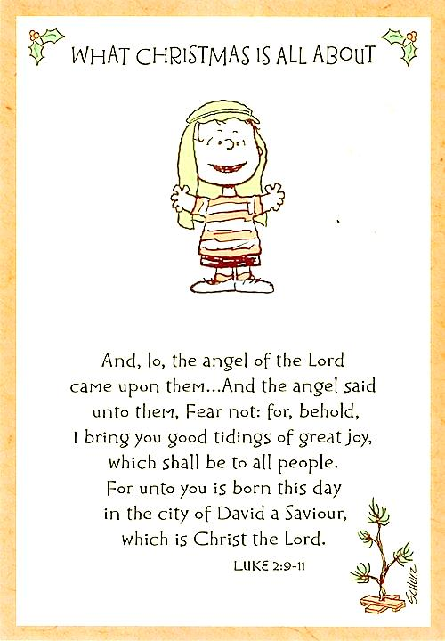

PRAYER REQUESTS

The Audrey Hutchinson family
Peg Benson
Alex Cardy
Jean Kelsey
Judy Eckel
Sondra Sensenbaugh
Gladys Finefrock
Eileen Yingling
Virginia Beatty
Ed Shiner
Pat Master
Mary Walters
Joyce Scott
Jim Ashbaugh
Rick Supak
David Gaston
Audrianna Montgomery
Nursing home residents
Nancy Kenemuth
Tami Snyder
Tom Karns
Lee Blair
Sal Hoover
Marlene Walbourn
The family on our Giving Tree
Pat & Larry McNutt
Unspoken requests
Government
Those travelling this holiday season
Police Officers and their families
Help us to be more charitable
The unemployed
Missionaries
Mustard Seed Mission
Emmaus House
Kids Club
Sunday School
Jr. Church
AM Worship services
Bible studies

Fall Fest
Photos by Tom Shiner Jr.

