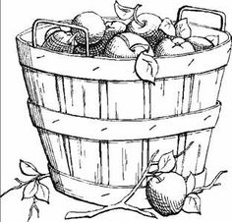“Flock Talk”

***Franklin First Church of God***

***Inspirational Newsletter***

Issue Nine of 2016 NEWS AND VIEWS FROM THE PEWS September 2016

**\_\_\_\_\_\_\_\_\_\_\_\_\_\_\_\_\_\_\_\_\_\_\_\_\_\_\_\_\_\_\_\_\_\_\_\_\_\_\_\_\_\_\_\_\_\_\_\_\_\_\_\_\_\_\_\_\_\_\_\_\_\_\_\_\_\_\_\_\_\_\_\_\_\_\_\_\_\_\_\_\_\_\_\_\_\_\_\_\_\_\_\_\_\_\_\_\_\_**

From Panic to Peace

By [Nancy McGuirk](http://proverbs31.org/devotions/devotion-author/nancy-mcguirk/)- Proverbs 31 Ministries

“So then faith comes by hearing and hearing by the word of God.” Romans 10:17 (NKJV)

Here I am, lying in bed, staring at the ceiling. No sleep. Body still, mind racing. Panic building. I forgot to. . . What if . . . . Why . . . When . . . Why does life seem darker at night? Not just literally. It’s as though Satan is waiting for me to be alone so he can begin the battle for my mind.

Recently I began to meditate on Philippians 4:6a: “Don’t worry about anything; instead, pray about everything” (NLT). Did the Apostle Paul really mean not to worry about anything? Is that even possible? Isn’t worry just part of human nature? Yes, worry is part of our human nature. Unfortunately when sin entered the world, emotions like worry did too. However, our fallen human nature always clarifies what being separated from God looks like. And it often looks like fear.

As God’s beloved children, we are called to faith, not fear. Faith says, “God is in charge of my life; I will trust Him, even when circumstances might suggest He’s not there. I believe God loves me and knows what is best for me.” Faith always crowds out fear. My heart longs to live in faith; however, at times this is difficult. But here’s the key: “Faith comes by hearing, and hearing by the word of God” (Romans 10:17). If I haven’t made time to hear from God through His Word, I find my prayers being more of a monologue of fear-based worry.

But when I make time to listen to God, I’m reminded of His promises and I become familiar with His voice. As a result, my prayers really do change from panic to praise. In bed at night, a dialogue evolves (no longer a monologue). When I turn to God with my concerns, I can hear His response. As John 10:27a tells us, “My sheep hear my voice, and I know them …” (ESV).

God’s Word reminds us to put the kingdom of God first and the things we need will be ours (Matthew 6:33, ESV). In other words, when I devote myself to God first, all the rest will sort itself out, and this brings peace.

What is most pressing in your life right now? Whatever that is, put God’s Word there instead. Replace worry with the truth of God’s love and power. Then we can trust that God will do as He says: “keep him in perfect peace, whose mind is stayed” on Him (Isaiah 26:3a, ESV). As I think about God’s promises, panic turns to praise, praise turns to peace and peace turns to a good night’s sleep. I begin to understand what Paul meant when he said, “Then you will experience God’s peace, which exceeds anything we can understand” (Philippians 4:7a, NLT).

It is possible to experience God’s peace. When we learn to cast our cares on God and trust Him to handle them, faith replaces fear. Worry sees problems, but faith sees the God who can handle the problems.

**FOOD PANTRY**

C:\Users\Pam\AppData\Local\Microsoft\Windows\Temporary Internet Files\Content.IE5\VOUNIKBQ\MCFD01224_0000[1].wmf Our Church’s Food Pantry is used to assist people from our Church and community when they find themselves needing some help providing food for their families. If you are able to keep the food pantry stocked with non-perishable food items (check those expiration dates) or if you are able to make a monetary donation to the food pantry, it would be greatly appreciated.

If you are in need of items from the food pantry, or if you know of someone who is in need, please let Pastor Jim know.

**\*\*\*\*\*\*\*\*\*\*\*\*\*\*\*\*\*\*\*\*\*\*\*\*\*\*\*\***

**ALTAR FLOWERS**

 Anyone wishing to place an order for altar flowers please contact Joanne Cardy. Flowers can be placed in memory or in honor of someone, on a special occasion, or “just because”. Two altar vases only cost $16.00. Once you order them, they are yours to take home after the morning worship service.

\*\*\*\*\*\*\*\*\*\*\*\*\*\*\*\*\*\*\*\*\*\*\*\*\*\*\*\*\*\*\*\*\*\*\*\*\*\*\*\*\*\*

GOOD SAMARITAN FUND

Donations are accepted at any time for our Church’s Good Samaritan Fund. The monies in this Fund are used to help people from our Church family who are in need.

\*\*\*\*\*\*\*\*\*\*\*\*\*\*\*\*\*\*\*\*\*\*\*\*\*\*\*\*\*\*\*\*

DONATION TO SENIOR FELLOWSHIP CLASS

Mrs. Joy McMasters made a donation to the Senior Fellowship Class to be designated to Church of God General Conference Cross Cultural Missions for mission work in India and Bangladesh.  Many thanks to Joy for her contribution.  It is greatly appreciated.

~~~~~~~~~~~~~~~~~~~~~~~

This poem was taken from a newspaper given to me by Dan Kearney, which is entitled, “The Bennett Valley News” – Northcentral Pennsylvania’s GOOD NEWSpaper. “And the Word of the Lord was published throughout all the region: - Acts 13:49.

God’s Light

Author Unknown

Lord, You are the light

This world desperately needs,

Let our lamps keep burning bright

So the lost may come to see

The light of your love

Burning brightly in our hearts,

Chasing away the darkness,

Revealing who You are

So Your glory may be seen

In everything we do

In our everyday happenings,

May our lives acknowledge You

No matter where you send us,

Whatever land we’re in,

May Your light pierce through the darkness

Penetrating deep within

To stir up deep desire

To truly see Your face

And come fully into Your light

And receive Your saving grace.



A Note from Our Pastor

Dear Flock,

September begins with Bible studies resuming. The **Men’s and Women’ Bible Studies** start September 1st at seven o’clock in the evening and continue each first Thursday of the month. Both studies are held in the church building. Tom Shiner, Jr. and Nancy Barger are the leaders. The women will be using the book, “A Woman After God’s Own Heart” and accompanying study guide. The **Tuesday morning Bible study** resumes on September 6th at ten o’clock. A study of the doctrines of the church will be held for twelve weeks. The “We Believe” booklet will be the guide as I lead this one hour study each week. This study is a must for church membership.

Our **Elders**, Larry McNutt, Tom Shiner, Jr. and Tom Shiner, Sr. will meet Thursday, September 6th at six-fifteen in the evening. Pray that our elders will know the Lord’s guidance.

**Communion** will be observed during the Sunday morning worship on September 4th. Come prepared to receive in a worthy manner the bread and cup in remembering the sacrifice of our Lord Jesus.

I invite you to join me in a **prayer walk** following the Tuesday morning Bible studies. At eleven-fifteen we will begin a walk on the sidewalks of our community. We will pause during the walk several times to pray for the needs of our immediate community. While weather permits we will continue to prayer walk. When unable to walk we will pray in the church building. Let us pray!

September 11th is known as Patriots Day in America. We know it as **Grandparents Day and Sunday School Promotion Day** also. Grandparents are encouraged to invite their grandchildren to church and Sunday School and grandchildren are urged to invite their grandparents. The grandparents will be recognized for their attendance. The Sunday School students will be promoted on that day as well.

Our church **Administrative Council** will resume meeting on the second Tuesday of each month on September 13th at seven o’clock in the evening. Reports to the Ad. Council are to be in member mail slots on Sunday September 11th and read before the meeting. Reports are to include May through August activity.

**Kids’ Club** will kick off the fall season on Monday, September, 19th at four-thirty in the afternoon. Elementary age children are invited to the social room for the two hours. They are to be accompanied by an adult to Kids’ Club and picked up inside the church building.

**Children’s Day** is September 25. The Devine Family will minister during the sermon time that morning. Invite children to attend and be blessed by this talented family.

Let’s get back to growing and worshipping the Lord together.

Your Shepherd,

Pastor Jim

~~~~~~~~~~~~~~~~~~~~~~~~~~

**God Will Take Care of You!!**

If God could close the

mouth of the lions for Daniel,

part the Red Sea for Moses,

make the sun stand still for Joshua,

open the prison for Peter,

put a baby in the arms of Sarah,

and raise Lazarus from the dead –

THEN He can certainly

take care of you!!

NOTHING you are facing today is too hard for Him to handle!! ~~~~~~~~~~~~~~~~~~~~~~~~

SEPTEMBER BIRTHDAYS

5 Dan Kearney 15 Janet Murdoch

6 Aaron Dunlap 17 Barry Walters

7 Monique Byers 19 Bonnie Boyd

8 Tara DeLong 20 Jessica Shook

9 Deb Staab 23 Kay Kaster

9 Garry DeLong 26 Pat Dilley

9 Larry DeLong 26 JoAnn Tombly

9 Harry Curran 29 Joy McMasters

13 Jim Ashbaugh 30 Amy Jeffries

13 Mike Master

SEPTEMBER ANNIVERSARIES

13 Larry and Tara DeLong

**………………………………………………….**



Patriot’s Day September 11, 2016



September 11, 2016



September 22, 2016

Diane Montgomery, Superintendent of the Children’s Department of the Sunday School, reminds us that 9/11 is Grandparents Day. Grandparents are special people in a child’s life. Many children are brought to Church by their grandparents.

Also, she wants us to mark our calendars that on 9/25, it will be Children’s Day at our Church. The Devines will be presenting a program during our AM worship service that day.

*Kids Club Kick Off*

The Kick Off for Kids Club will be held on September 19, 2016, from 4:30 to 6:30 p.m.

All children in Kindergarten through Sixth Grade are welcome to join us. We will be playing games, doing crafts, eating supper, and having lots of fun. Come join us!!!



**MAKE TIME FOR KIDS CLUB!!!**

:::::::::::::::::::::::::::::::::::::::::::::::::::::::::::::::::



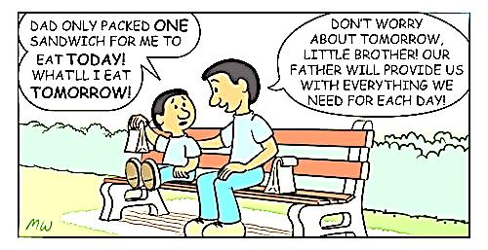

SAFE SANCTUARY TRAINING

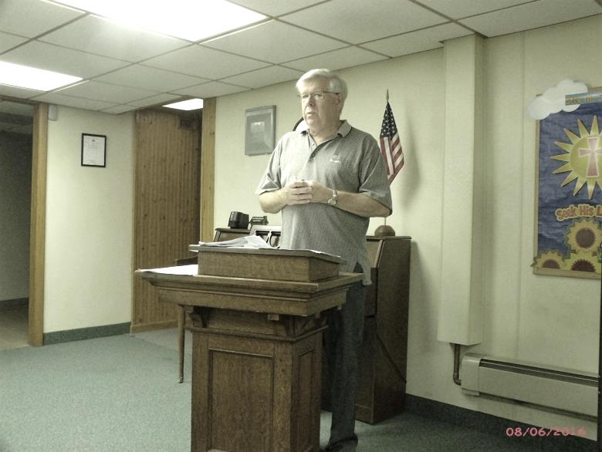 The annual Safe Sanctuary Training session was held on Saturday, August 6, 2016, in the Social Room of the Church.

Present were: Diane Montgomery, Audrey Sherlock, Tom Shiner, Sr., Judy Shiner, Dan Kearney, Tom Shiner, Jr., Sonya Mullen, Megan Mullen, Becca Mullen, Pamela Leichliter, Sally Reed, Pat Dilley, Nancy Barger, Hazel Kean, Renee Cranmer and Pam Jolley. Pastor Jim reviewed our Safe Sanctuary Policy and we watched the video from our church’s insurance company on the subject.

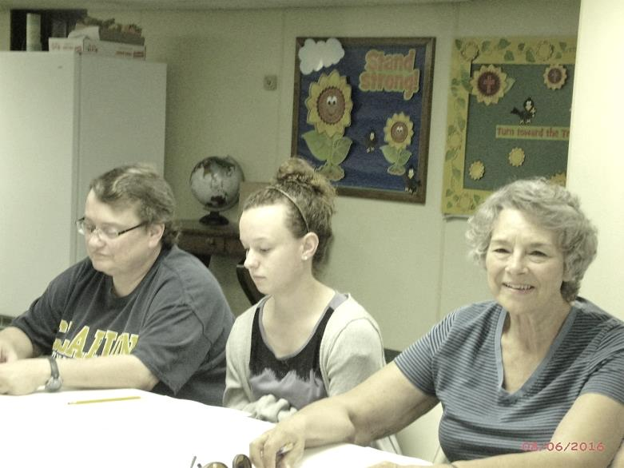

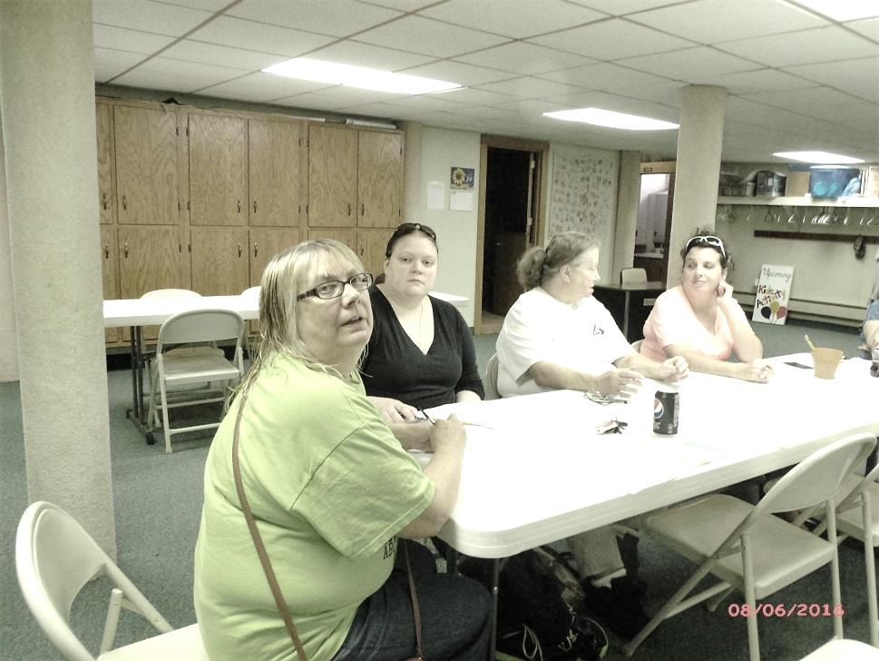

**Opportunities for Bible Study**

Bibles studies will resume in September at the First Church of God of Franklin. Several opportunities are available.  
  
**MEN'S BIBLE STUDY** will meet the first Thursday of each month starting September 1st at seven o'clock in the evening. Join the leader, Tom Shiner, Jr., in the social room of the church for a hour of study.  
  
**WOMEN'S BIBLE STUDY** will meet on the first Thursday of each month starting on September 1st at seven o'clock in the evening. Join the leader, Nancy Barger, in the former parsonage dining room for an hour of study. The book, "A Woman After God's Own Heart" written by Elizabeth George and the accompanying study guide will be used. The author offers disciplines we can follow to place ourselves before God so that He can do His work in our hearts. You'll find practical insights about what it means to follow God in every area of life.  
  
**TUESDAY MORNING** Bible studies will begin on September 6th at ten o'clock. We will meet in the former parsonage dining room. An hour of studying the doctrines of the church will occur each week for twelve weeks. The study guide, We Believe, will be used. This series is required for those who desire to become a member of the church. Others will benefit from this study in confirming the beliefs of the Churches of God, General Conference. Pastor Jim is leading this study.  
  
See you at Bible study.

\*\*\*\*\*\*\*\*\*\*\*\*\*\*\*\*\*\*\*\*\*\*\*\*\*\*\*\*\*\*\*\*\*\*

WEDNESDAY WORSHIP

September 14th at 7pm will be the first Wednesday Worship downstairs in the social room.   
 Wednesday worship is a place where Seekers and Christians alike can come and gather to worship the Lord with contemporary music. All gathering will be casual dress and will conclude in 60 minutes. This month's topic will be "Getting to know God". The format for this gathering will include:  Welcome and Greet, worship through song and praise, a biblical topic with discussion and a chance to leave with some new friends.

Stories of Kindness

(taken from the Reader’s Digest)

* “I Can Still Help” – As I walked through the parking lot, all I could think about was the dire diagnosis I had handed my patient, Jimmy: pancreatic cancer. Just then, I noticed an elderly gentleman handing tools to someone working under his stalled car. That someone was Jimmy.

“Jimmy, what are you doing?” I yelled out.

Jimmy dusted off his pants. “My cancer didn’t tell me not to help others, Doc”, he said, before waving at the old man to start the car. The engine roared to life. The old man thanked Jimmy and drove off. Then Jimmy got into his car and took off as well.

Take-home message: Kindness has no limits and no restrictions.

*Do to others as you would*

*have them do to you.*

*Luke 6:31 NIV*

***22****But the fruit of the Spirit is love, joy, peace, forbearance, kindness, goodness, faithfulness,****23****gentleness and self-control. Against such things there is no law.*

*Galatians 5:22,23 NIV*

***8****Then Peter, filled with the Holy Spirit,*

*said to them: “Rulers and elders of the people!****9****If we are being called to account today for an act of kindness shown to a man who was lame and are being asked how he was healed,****10****then know this, you and all the people of Israel: It is by the name of*

*Jesus Christ of Nazareth,*

*whom you crucified but whom*

*God raised from the dead,*

*that this man stands before you healed.*

*Acts 4:8-10 NIV*

Out & About in Our Community

Silver Cornet Band



The 160th Anniversary of Silver Cornet Band was celebrated on 8/4/16 in Franklin’s Band Stand Park.

Participants in the Band who attend our Church are Michael (Skip) Curran, Becca Mullen and Megan Mullen.

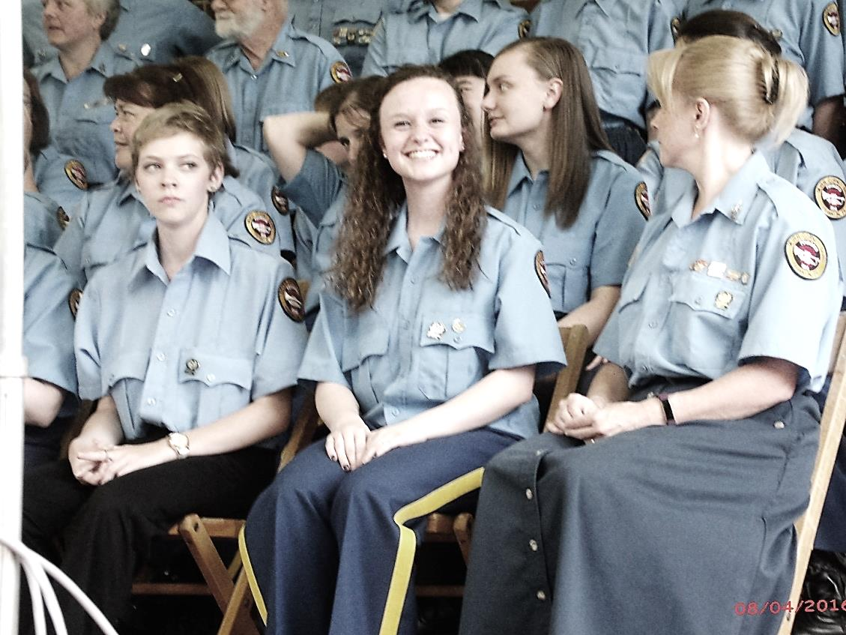.Becca

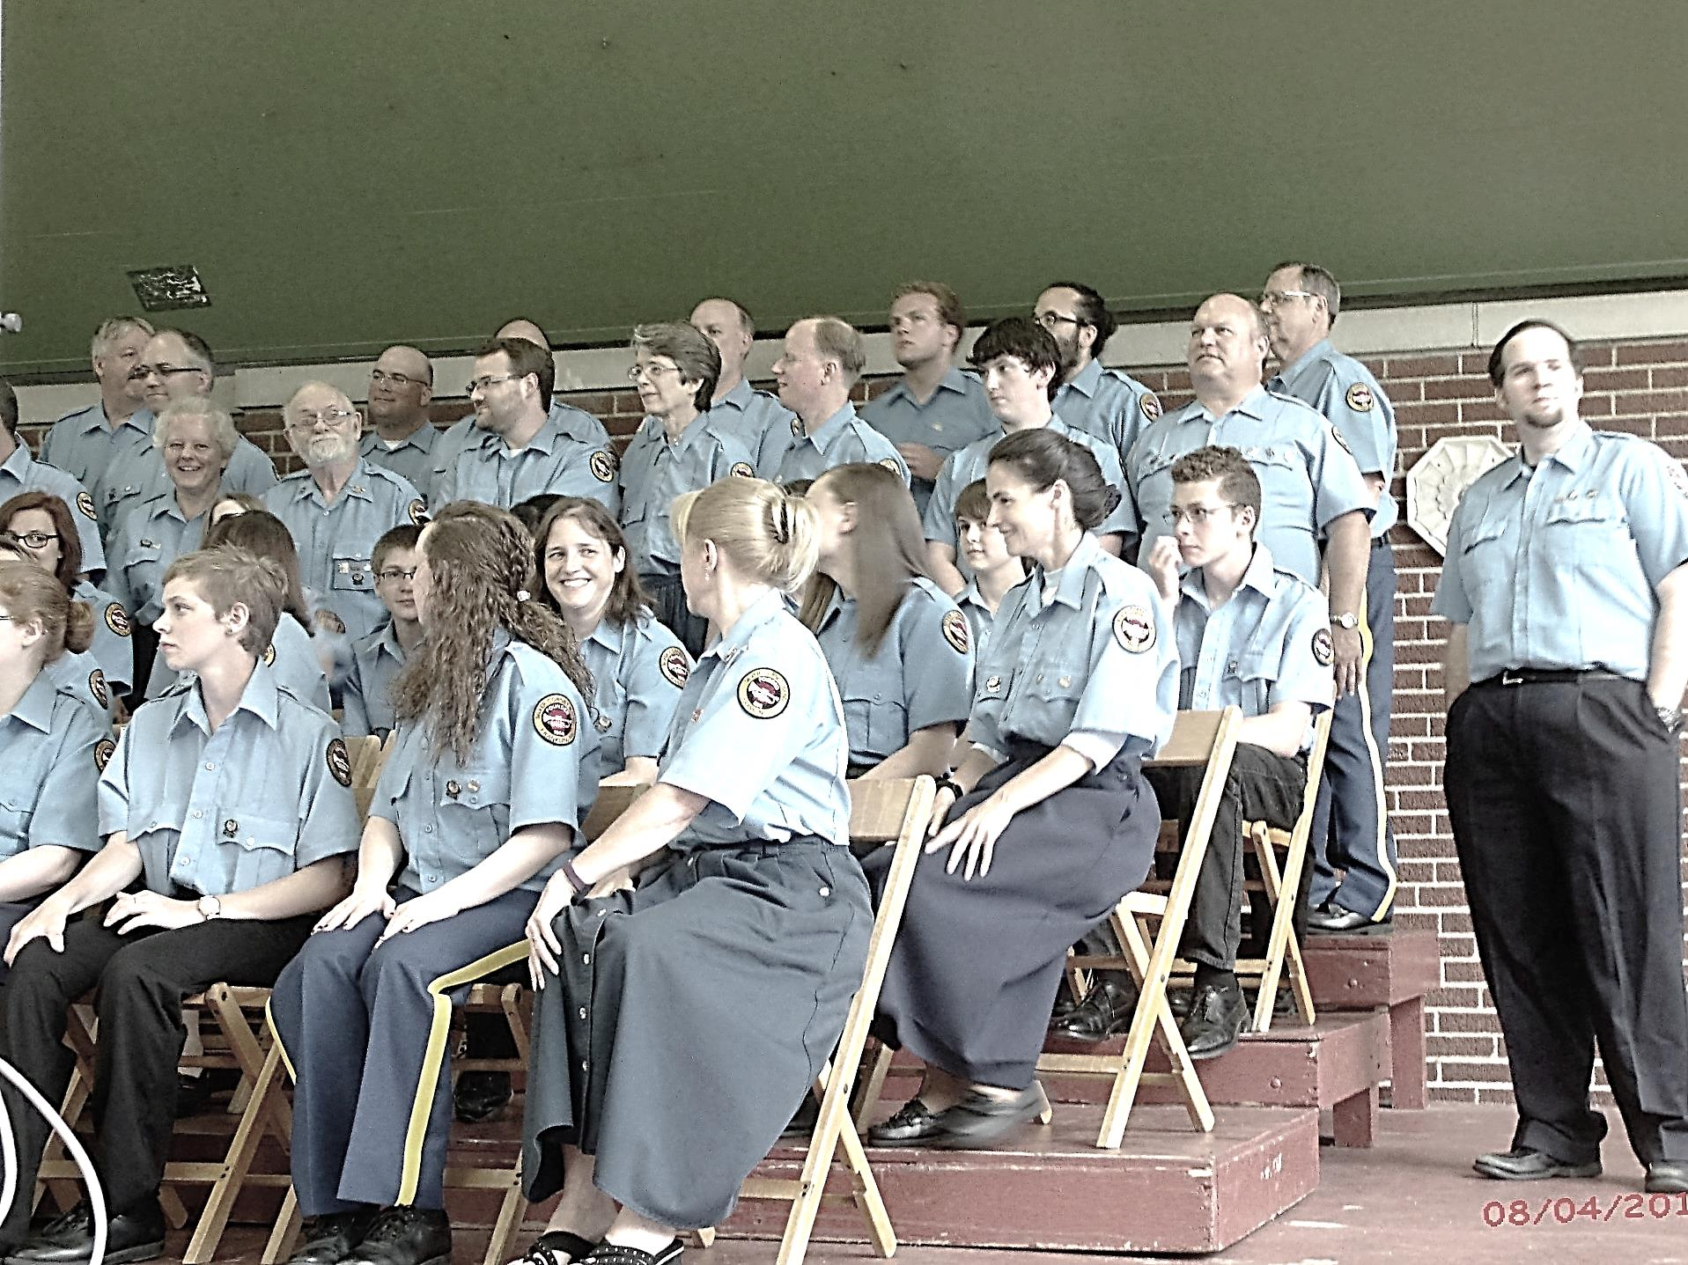 Skip



Prayer Requests:

The Barbara Shook Family

The Sharon Best Family

The Heckathorne Family

The Daniel Fritz Family

The Ron Master Family

The Bill Barnes Family

The Floyd Dunlap, Sr., Family

The Ed Shontz, Sr., Family

Bob Shiner

Dave Hummel

Nancy K – cancer

Peg Benson

Judy Eckel

Eileen Yingling

Virginia Beatty

Gladys Finefrock

Jean Kelsey

John Hutz

Sal Hoover

The start of a new school year

College students

Bible Study leaders

Kids Club

Administrative Council

Our Pastor

November elections

ABC Life Center

Mustard Seed Mission

Camp Sonrise Mountain

~~~~~~~~~~~~~~~~~~~~~~~~~~~~~~~

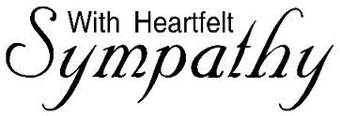

TO: The Ron Master Family

You continue to be in our thoughts and prayers.

*God is our refuge and strength, always willing to help in times of trouble* – Psalm 46:1

*Even though I walk through the darkest valley, You are with me* . . . Psalm 23:4

On The Wings of a Prayer

By Helen Steiner Rice

Just close your eyes and open your heart,

And feel your worries and cares depart.

Just yield yourself to the Father above,

And let him hold you secure in His love.

For life on Earth grows more involved,

With endless problems that can’t be solved,

But God only asks us to do our best,

Then He will take over and finish the rest . . .

So when you are tired, discouraged and blue,

There is always one door that is open to you.

And that is the door to The House of Prayer

And you’ll find God waiting to meet you there

And the House of Prayer is no further away

Than the quiet spot where you kneel & pray

For the heart is a temple when God is there

As we place ourselves in His loving care.

He hears every prayer and answers each one,

When we pray in His name – Thy will be done.

The burdens that seemed too heavy to bear

Are lifted away on the wings of a prayer.

