“Flock Talk”

Franklin First Church of God
Inspirational Newsletter

Issue Eight of 2016 NEWS AND VIEWS FROM THE PEWS August 2016
__________________________________________________________________________________________________

Keep Going!
Byron Bohnert – The Christian Broadcasting Network
My parents, grandparents, and I were on the road home from a family reunion. During our four-hour trip we encountered the worst thunderstorm I’ve driven through in a long time. The rain was so intense that we could only see a few feet in front of us. Other drivers were slowing down, putting on their flashers, and some were even stopping on the side of the road. Along with the heavy rain, the wind was also whipping against everyone’s vehicle. The experience was a little chaotic; however, I gained total peace from seeing how my dad, who was driving, reacted to the situation. There he was with his eyes fixed on the road while we were all frantically yelling stuff at him like, 'Pull over,' 'Slow down,' 'Watch out!'
Despite all the commotion, he kept on driving right through the storm. According to his thinking, he wasn’t going to stop and risk having a bad accident or getting stuck because of a few fearful passengers.
When we are going through a storm, it’s easy to want to quit. There is no reason to keep going when all the signs show the road ahead to be too dangerous. Or is there? Some people stop at the first site of adversity because they don’t think they have what it takes to survive the storm. When in all actuality God has infused us with every bit of strength we need. According to 2 Corinthians 3:5,
“We don't have the right to claim that we have done anything on our own. God gives us what it takes to do all that we do.” (CEV)
Even if you find yourself in a difficult situation like my dad and everyone is yelling at you to stop, don’t listen to them; listen to what the Lord is saying. He alone is the one who can help us refocus our attention, calm our anxiety, and steady our course. The beginning verse in Psalms 91 describes what happens for those of us who dwell in God’s secret place: “He who dwells in the secret place of the Most High shall remain stable and fixed under the shadow of the Almighty [Whose power no foe can withstand].” (Psalms 91:1, AMP)
Two words that really stick out to me in this verse are stable and fixed. Yes, it is possible to move forward in a storm and stand firm on the inside at the same time. Why? Because wherever we are in this world, we’re covered under the shadow of Almighty God. His shadow follows Him constantly just as our shadow follows us. We could go to the ends of the earth and still not escape the shadow that follows. David knew exactly where he was supposed to be in times of trouble. Crouching down in fear is not the proper place for men or women of God. We have to have the same boldness and resolve to pray as David did in Psalm 57:1, “Be merciful and gracious to me, O God, be merciful and gracious to me, for my soul takes refuge and finds shelter and confidence in You; yes, in the shadow of Your wings will I take refuge and be confident until calamities and destructive storms are passed.” (AMP)
So, it is a guarantee that storms will come and they will pass. But it is what we do in the middle of them that makes us victorious. And if fear tries to take over, we can just look to our Heavenly Father, and we will gain the peace we need to go through any storm.

FOOD PANTRY

Our Church’s Food Pantry is used to assist people from our Church and community when they find themselves needing some help providing food for their families. If you are able to keep the food pantry stocked with non-perishable food items (check those expiration dates) or if you are able to make a monetary donation to the food pantry, it would be greatly appreciated.
If you are in need of items from the food pantry, or if you know of someone who is in need, please let Pastor Jim know.

****************************
ALTAR FLOWERS
Anyone wishing to place an order for altar flowers please contact Joanne Cardy. Flowers can be placed in memory or in honor of someone, on a special occasion, or “just because”. Two altar vases only cost $16.00. Once you order them, they are yours to take home after the morning worship service.

+++++++++++++++++++++++++++++++

GOOD SAMARITAN FUND

Donations are accepted at any time for our Church’s Good Samaritan Fund. The monies in this Fund are used to help people from our Church family who are in need.

AUGUST BIRTHDAYS

1 Jill Hovis 15 Skip Curran
6 Leslie Smith 15 Kaleb Dilley
7 Gary Eckel 15 Floyd Dunlap Jr
9 Jeremy Kradel 17 Eileen Yingling
11 Kathy Muse 17 Zachary Rodgers
11 Rob Guy 24 Joseph Cranmer
14 Pamela Leichliter 25 Hanna Magee
14 Terry Benson 29 Kayla Murdoch

~~~~~~~~~~~~~~~~~~~~~~~~~~~~~~~~
AUGUST ANNIVERSARIES

1 Pastor Jim & Pamela Leichliter
1 Rob & Kathy Muse
4 Greg & Heidi McCachren
6 Craig & Kristin Clapsaddle
10 Job & Janet Greenman
25 Robin & Karen Twombly
25 Jim & Rachel Ashbaugh

~~~~~~~~~~~~~~~~~~~~~~~~~~~~~~~~~~~~

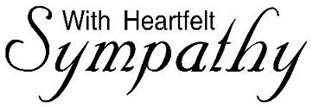
We extend our heartfelt sympathy to
the family and friends of
Jim Walbourn who passed away
on Monday, 7/25/16.
Jim was a member of our Church
for many years, and he will be missed.
As a Christian, we know he is
with his Savior now,
and he is walking those streets of gold.
~~~~~~~~~~~~~~
John 14:2-3King James Version (KJV)

² In my Father's house are many mansions: if it were not so, I would have told you. I go to prepare a place for you. ³ And if I go and prepare a place for you, I will come again, and receive you unto myself; that where I am, there ye may be also.

A Note From Our Pastor

Dear Flock,

The outdoor worship and picnic on July 10th was so enjoyable. Hearing the birds join us in singing praise to God caused me to know that God takes care of us all and we must praise Him. Keep on singing my brothers and sisters in Christ.
August brings with it the realization the fall startup of our ministries will arrive soon. Pray for the planning process of each of our ministries. Tuesday morning, men’s and women’s Bible studies will resume. A Sunday or Wednesday evening worship or Bible study is being considered.
Kid’s Club is planned to restart in October. Our Prayer Chain is being revised. Administrative Council will meet again in September. Pray for God’s direction in each of these ministries.
Training of all children and youth volunteers will take place in the church social room on Saturday, August 6th from ten to eleven o’clock. Those desiring to volunteer in the nursery, Sunday School, Junior Church, Kids’ Club or another ministry where children and youth are present must receive this training and be compliant with our church Safe Sanctuary Policy. Let me know that you will be in attendance.
We will minister to the residents of the Caring Place on Wednesday evening August 17th. Join in the singing and reading of scripture in the chapel of their facility.
Serve the LORD with gladness.
Your Shepherd,
Pastor Jim
----------------------------------------------------------------

DON’T FORGET

1. Let Pamela Leichliter know if you would want to be included on the Prayer Chain. You can receive the prayers requests by phone call or e-mail.

2. Please turn in the information sheets from the July Flock Talk to Pam Jolley ASAP. Even if none of your information has changed, please turn in the form. That way I can verify everything is correct. I have only received about a dozen so far. You can turn them in to me at Church or mail them to me at: 719 Wilson Ave, Franklin, PA l6323.

Thank you!!

Prayer Requests

The Charlie Brown Family
The Bob Prather Family
The Lori Blackhurst Family
Ron Master – now in Sugarcreek Station
Jim Walbourn Family
Police Officers
Cinda Sterner
Jean Kelsey
Sean Hutchinson
Pat Dilley’s brother
Our country
Fall activities
Unspoken requests
Judy Eckel
Eileen Yingling
Virginia Beatty
Sondra Sensenbach
Wilbur & Pat VanZandt
Larry & Pat McNutt
Diana Hoover

Praises

Bible School
Answered prayers
Christian friends and families
God’s blessings, guidance,
protection & provision
Salvation
Bold Christians who share their faith
ABC Baby Bottle Fundraiser

~~~~~~~~~~~~~~~~~~~~~~~~~~~~~

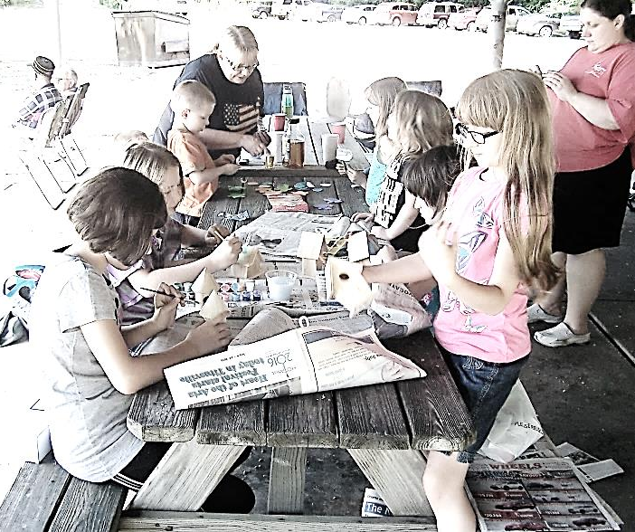
Craft Time at Church Picnic 7/10/16
Church Picnic

Our annual Outdoor Worship and Church Picnic were held on Sunday, July 10, 2016, at the Miller-Sibley pavilion. The worship service started at 10:30 a.m. with 54 people in attendance. Pastor Jim led the worship service, and Diane Montgomery was our song leader. The Sunday School teachers were recognized and thanked for their willingness to teach classes.
The picnic began at noon with 57 people in attendance. Thank you to everyone who provided food and/or beverages for the picnic. Diane Montgomery organized games and crafts for the children. The adults enjoyed playing Bingo.
Thank you to everyone who organized and helped out with this event.
(Thanks Tommy for sharing your photos!)

Water Balloon Fun

Pastor Jim
Bob & Barry

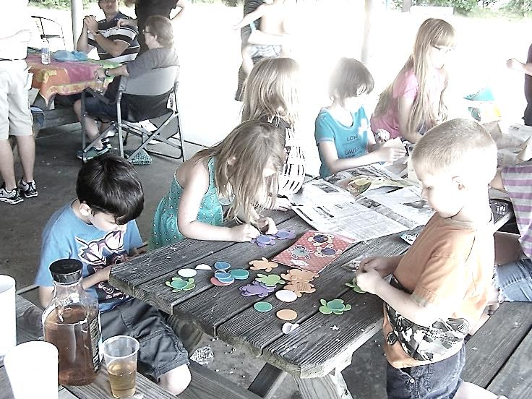
Crafts

Renee & Sonya

The Sr. Fellowship Class

The Senior Fellowship Class has been able to donate $300 from the class offerings that it receives each Sunday.

- Camp Sonrise Mountain received $100 toward it's cabin building fund,
- And $200 support was sent to the Cross
Cultural Missions for India and Bangladesh ministries.

Submitted by Bob & Nancy Muse

*******************************

Proverbs 31 Ministries
Submitted by Amy Warehime

“‘You don’t have enough faith,’ Jesus told them. ‘I tell you the truth, if you had faith even as small as a mustard seed, you could say to this mountain, “Move from here to there,” and it would move. Nothing would be impossible.’” Matthew 17:20 (NLT).

A small seed of faith planted in God’s power produces the impossible.
><> ><> ><> ><> ><> ><> ><> ><> ><> ><> ><>
Treasurer’s Report of
Our Giving to
Camp Sonrise Mountain

Beginning in January 2011 the Administrative Council voted to give a monthly contribution to the Camp. As of the printing of the August 2016 Flock Talk, we have given $12,800.

The Camp began their “Dime a Day” fundraiser in 2013. We began receiving quarterly offerings in September 2013. We have given $3,896.59 to this fundraiser.

Information received from John Doyle, Treasurer

ABC LIFE CENTER

Becky Kearney reported that the Baby Bottle Boomerang fundraiser was very successful this year. She asked that if you still have your baby bottle that you return it to her as soon as you can. If you are not able to donate at this time, please return the bottle anyway. The bottles are reused each year, and it cuts down on their cost if they don’t have to buy a lot of bottles each year. Donations to the Center are accepted at any time.

Please keep the ABC Life Center and its staff in your prayers. They provide a great service to our community and the families who seek their help.

+++++++++++++++++++++++++++++++

Revelation 3:20

Behold, I stand at the door, and knock:
if any man hear my voice and open the door,
I will come in to him,
and will sup with him, and he with me.

WHAT ARE YOU WAITING FOR?
OPEN THE DOOR!!!

