*“Flock Talk”*

***Franklin First Church of God***

***Inspirational Newsletter***

**Issue Four of 2016 NEWS AND VIEWS FROM THE PEWS April 2016**

**You’re Shining for Jesus Wherever You Are**

[Holley Gerth](http://proverbs31.org/devotions/devotion-author/holley-gerth/)

“You are the light of the world. A town built on a hill cannot be hidden. Neither do people light a lamp and put it under a bowl. Instead they put it on its stand, and it gives light to everyone in the house. In the same way, let your light shine before others, that they may see your good deeds and glorify your Father in heaven.” Matthew 5:14-16 (NIV)

The news headlines drifted in from the living room as I sat at my desk. The story of yet another tragedy contrasted so sharply with what I was writing that I stopped, sighed and leaned back in my chair. A sense of despair washed over me. “Lord,” I silently prayed, “is there anything I can do about the darkness in this world? It seems so overwhelming.” I sensed a gentle whisper within my heart replying, “The only way to get rid of the darkness is to add more light.”

Darkness is the absence of light. Trying to go after it directly is like chasing your shadow. You can’t bag it up and throw it away. Only light is powerful enough to make the darkness disappear. During the Sermon on the Mount, Jesus made it clear that we are the light of the world. We are called to shine. But the light we share is not our own.

From the very beginning of creation, God has been the source of light both spiritually and literally. Genesis 1:2b-3 says, “Darkness was over the surface of the deep, and the Spirit of God was hovering over the waters. And God said, ‘Let there be light,’ and there was light” (NIV).

Imagine a world full of darkness. Then with four small words, light blazes forth. Every living thing in our world relies on light for its existence — plants, animals and people. The God who brought light to the world also brings it to our lives. As 2 Corinthians 4:6a says, “For God, who said, ‘Let light shine out of darkness,’ made his light shine in our hearts” (NIV).

Trying to shine on our own can be exhausting. Instead, we’re simply called to be closely connected to God and remain in Him. When we do, His light pours forth through us in powerful, brilliant ways that change the world. The ways we shine might not make the news, but they make even more of a difference than we can see.

Lord, thank You for being the light within us so we can shine brightly for the world around us. When it seems darkness is crowding in, use us to make a difference. We ask that You will help us share Your love, joy and peace. You are the hope we need and the One light that will never burn out, be overcome, or fade away.

In Jesus’ Name, Amen.

**TRUTH FOR TODAY:**

Daniel 12:3, “Those who are wise will shine like the brightness of the heavens, and those who lead many to righteousness, like the stars for ever and ever.” (NIV)

Isaiah 60:20, “Your sun will never set again, and your moon will wane no more; the LORD will be your everlasting light, and your days of sorrow will end.” (NIV)

**FOOD PANTRY**

**C:\Users\Pam\AppData\Local\Microsoft\Windows\Temporary Internet Files\Content.IE5\VOUNIKBQ\MCFD01224_0000[1].wmf**Our Church’s Food Pantry is used to assist people from our Church and community when they find themselves needing some help providing food for their families. The winter months can be especially difficult with higher gas and electric bills. If you are able to keep the food pantry stocked with non-perishable food items (check those expiration dates) or if you are able to make a monetary donation to the food pantry, it would be greatly appreciated.

If you are in need of items from the food pantry, or if you know of someone who is in need, please let Pastor Jim know.

++++++++++++++++++++++++++++++++++

**GOOD SAMARITAN FUND**

Donations are accepted at any time for our Church’s **Good Samaritan Fund**. The monies in this Fund are used to help people from our Church family who are in need.

++++++++++++++++++++++++++++++++++

**ALTAR FLOWERS**

Anyone wishing to place an order for altar flowers, please contact Joanne Cardy. Flowers can be placed in memory or in honor of someone, on a special occasion, or “just because”. Two altar vases only cost $16.00. Once you order them, they are yours to take home after the morning worship service.

++++++++++++++++++++++++++++++++

**Missionary Guest Speaker**

Dr. Stephanie Ashbaugh will be at the First Church of God of Franklin, 705 Liberty Street, Franklin, PA on Sunday, April 10th. She will be speaking during the 9:30 a.m. worship time. Stephanie recently returned from a mission trip to Sierra Leone, West Africa, as part of a group from her home church, CrossPoint United Methodist Church in Harrisburg, PA. Her church sponsors a village in central Sierra Leone through the UMC’s Sierra Leone Initiative, and they have been involved in rebuilding the village church, feeding the village during the Ebola crisis, sponsoring a Women’s Agricultural Project and assisting the village in various other ways as the need arises.

Stephanie and her husband, Roger MacNicol, started a scholarship fund to assist the children of the village in continuing their education beyond 6th grade and have also worked with their church to support both the UMC Elementary School in the village and the UMC Secondary School in a neighboring city in various ways. In addition to Sierra Leone, Stephanie has traveled to Kenya and Zambia with medical students from the Penn State College of Medicine’s Global Health Scholars program where she serves as an Assistant Professor in the department of Family and Community Medicine. Stephanie is the daughter of Jim and Rachel Ashbaugh and will be sharing stories from her experiences throughout Africa.

April Birthdays

2 Pam Jolley 12 Sonia Eckel

6 Craig Dilley 20 Bart Eckel

9 Amy Leichliter 24 Tom Shiner, Jr.

10 Larry McNutt 25 Nelson Best

11 Pat McNutt 28 Steve Murdoch

11 Bob Kradel 29 Audrianna

Montgomery

April Anniversaries

4 - Randy and Pam Jolley

6 - Barry and Sonya Mullen

11 - Harry and Kay Curran

15 - Jim and Janet Murdoch

15 - Terry and Dorothy Rodgers

23 - Bill and Bonnie Boyd

|  |  |
| --- | --- |
|  |  |
|  |  |
|  |  |
|  |  |
|  |  |
|  |  |
|  |  |
|  |  |



Other important days in April:

15th Tax Day

18th Last Day to file tax returns

22nd Earth Day

27th Administrative Professionals’ Day

29th Arbor Day

…………………………………………………………………………………………………………………………

DON’T FORGET:  Outdoor Worship & Picnic

Sunday, July 10, 2016

……………………………………………………………………………………………………….…………………





Dear Flock,

Our delegates to the Allegheny Region Conference sessions this year are Joe and Renee Cranmer. They are preparing for the sessions by registering and reading reports. They also will be our voice through the voting process during the sessions. Pray for them and all the delegates in their preparations.

Thank you for donating gas cards to be given to the family we supported at Christmas. The youngest child, Braxson, will be having surgery at Children’s Hospital in April. The collection of gas cards is complete.

We will receive the Adopt-A-Cabin offering for the rebuilding of cabins at Camp Sonrise Mountain on Sunday, April 3rd during the worship of God. This second offering received that day will include the cabin banks and donations placed in the offering plates.

Kids’ Club will meet the first and third Monday in April. The season will conclude with these meetings. Thank you, staff, for the ministry to elementary children and their families.

The Tuesday morning Bible studies will resume on April 5th at ten o’clock. The hour together each of the twelve weeks is titled: “Deepening Life Together” and is a study of Ephesians. Join these studies in the former parsonage dining room. The Sunday morning sermons will coordinate with the Bible studies.

The Men’s and Women’s Bible studies continue to meet on the first Thursday of the month. April 7th at seven o’clock is the next date of their gathering. All men and women are invited.

Dr. Stephanie Ashbaugh is the speaker for our worship of God on Sunday, April 10th. She will be telling us of her experience of ministering in Africa.

Communion will be observed during the Sunday morning worship of God on April 17th. Come prepared to receive the bread and cup in remembrance of Jesus’ sacrifice.

Your Shepherd,

Pastor Jim

**Kids Club**

In March we met on 3/7 with 10 kids and 7 leaders. Tom Shiner, Sr., was our teacher. He brought his prospecting bins – full of sand and treasures. The kids had fun prospecting for the treasures. Mr. Tom enjoys this activity as much as the kids do!! We also met on 3/21 with 8 kids and 7 leaders. Diane Montgomery was our teacher. Our craft was “Here’s Something to CROW About -– Christ Redeemed Our World!”

Thank you to everyone who has donated food for our dinners – we really appreciate it. These kids love to eat!!!

We will be meeting on April 4th. April 18th will be our last meeting. We will play our review game, present certificates and awards, make ice cream sundaes, and have lots of fun. All kids in Kindergarten through Sixth Grade are welcome to join us. Our meetings are held from 4:30 to 6:30 p.m.

Thank you to all the kids, leaders, helpers, supporters and teachers for making Kids Club a success – “Train up a child in the way he should go and when he is old, he will not depart from it”. Several of the kids who attend Kids Club have never been to church or do not attend church on a regular basis, so this an important outreach ministry of church.

**THANK YOU CARDS**

Recently our Missions Team sent contributions to some organizations, who responded with thank you cards, which are posted on our Church bulletin board: Kirtland Cancer Foundation and VARHA

VARHA also wrote that anyone interested in volunteering with their association should let them know. They would be happy to give a presentation or answer any questions. They would also be happy to offer a tour of their facility to anyone who might be interested. Their Executive Director is Jill Rhoads – phone number: 814-437-7433. Their website is [www.varhacenter.org](http://www.varhacenter.org)

The Kirtland Cancer Foundation also sent an information sheet about what their organization does, their criterion for applying for assistance; and college scholarship information. Their website is [www.kirtlandcancerfoundation.org](http://www.kirtlandcancerfoundation.org)

**ABC Life Center - Thank You**

We would like to thank all of our church friends who sponsored us for the ABC Life Center’s Bowling for Babies, which was held on Saturday, March 19. We had several bowlers of all ages and were able to raise money for this important ministry. Please consider giving to this Christian pro-life ministry. Donations are very much appreciated at any time.

Thank you again for your prayers and financial support.

Dan & Becky Kearney

Youth Sunday

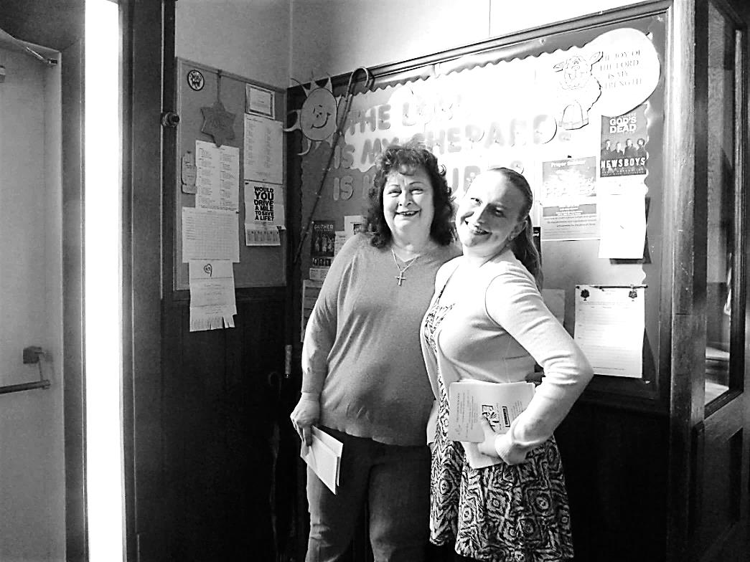 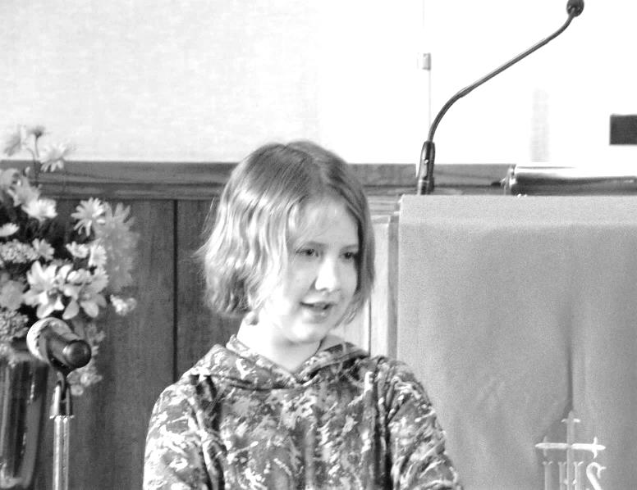 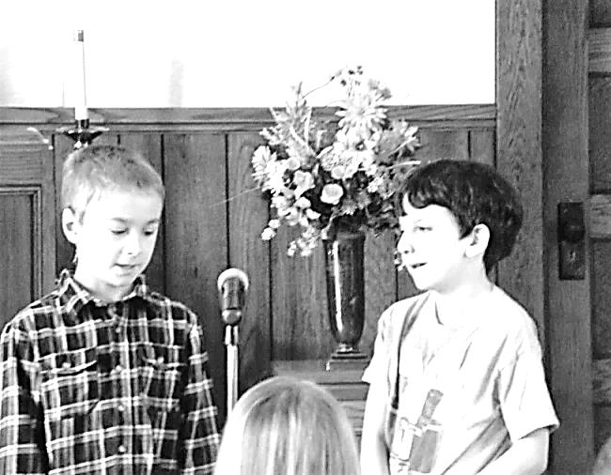

Greeters: Megan Mullen and a Special Music : Tyler Graham, Joe Cranmer

“recycled teenager” Cathy Bell and RaeLynn Montgomery

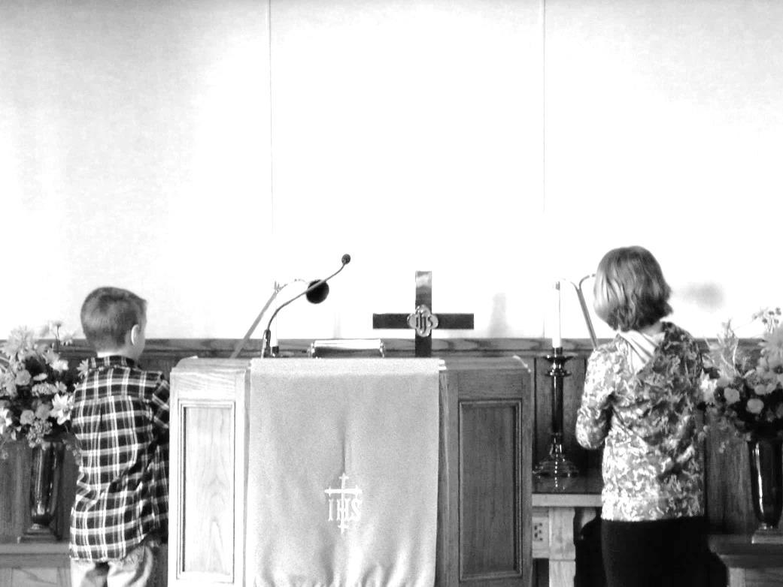 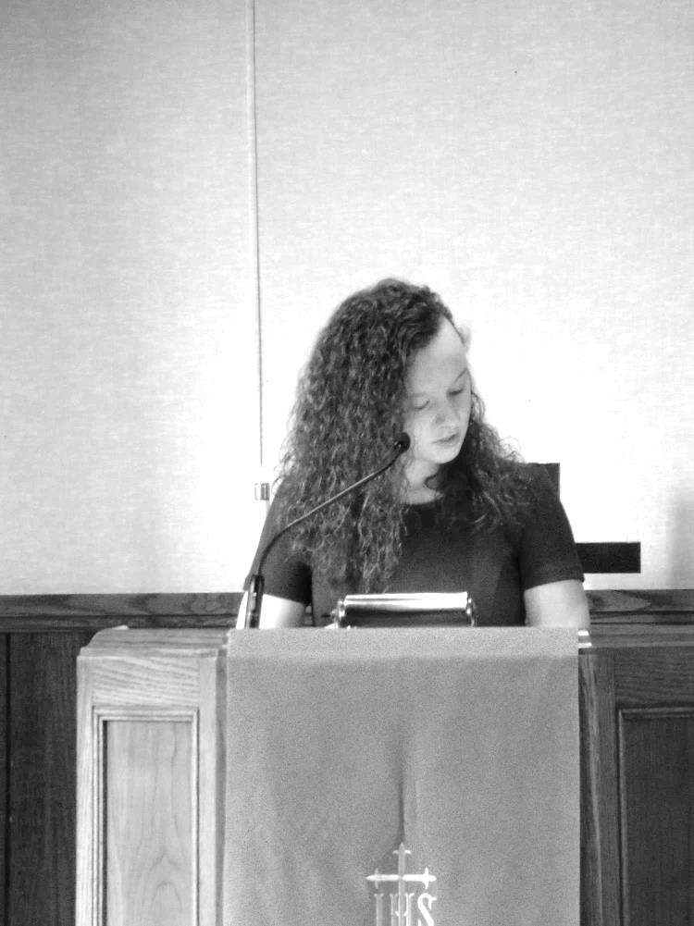

Acolytes: Tyler Graham and RaeLynn Montgomery Worship Leader: Becca Mullen

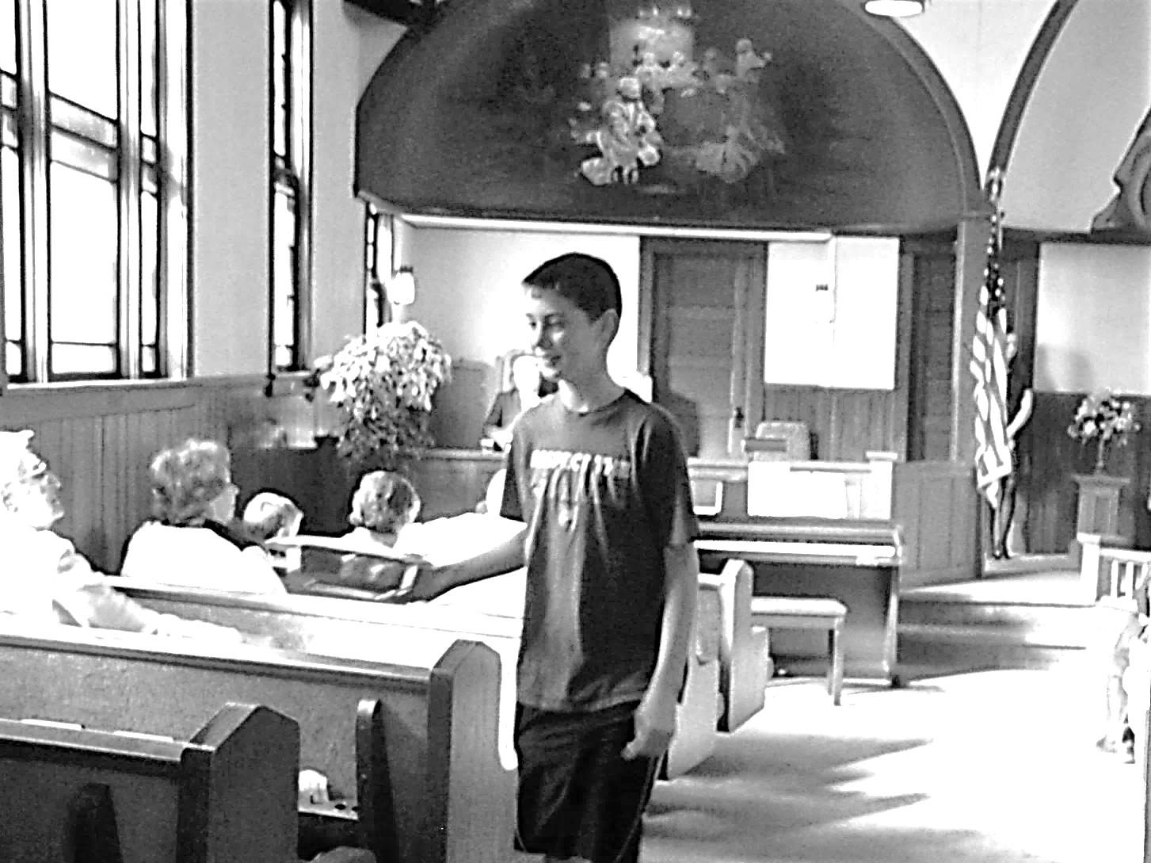

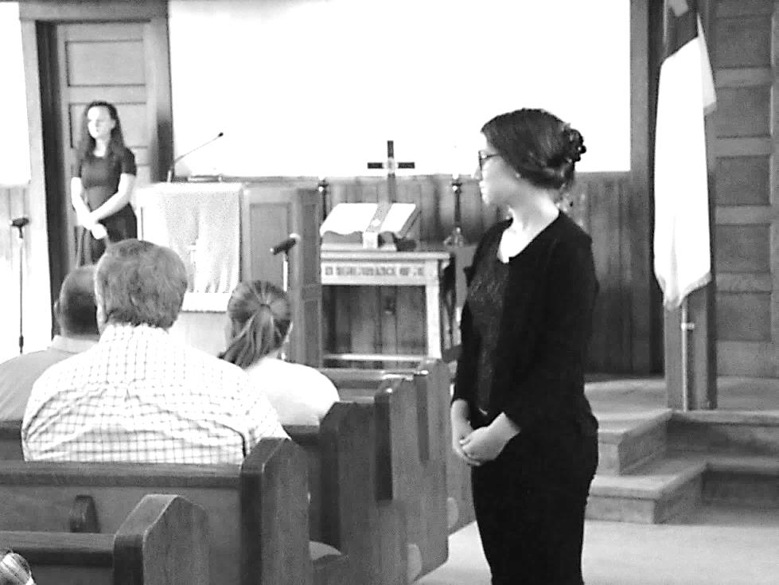 Usher: Rex Montgomery Usher: Audrianna Montgomery

Prayer Requests:

The Bill Mook Family

The Lois Best Family

The Garnet Wood Family

The Gail Humboldt Family

Judy Eckel

Jean Kelsey

Charlie Brown

Ron Master

Pat Master

Pat VanZandt

Peg Benson

Mary Slocum

Marcia Busch

Bruce Palmer

Joe Bean

Anita Leichliter

Braxson

Julie Westfeldt

Administrative Council

Sonya Mullen – upcoming surgeries in April

So many afflicted with flu, viruses, bronchitis,

pneumonia, colds, allergies, etc

Expectant mothers

Those in jail

Unemployed

Joy employees

Those dealing with addictions

ABC Life Center

Unspoken requests

Travelling mercies

A deeper relationship with Jesus

Sunday School

Glenn & Lois Beatty

Presidential election process

Difficult family situations

Lee Blair

# *A note of sympathy to the Lois Best Family - Matthew 5:4 (NIV) 4Blessed are those who mourn,  for they will be comforted.*

# *May God be with you in the days ahead, and may you be comforted with the wonderful memories you have.*

Praises:

Answered prayers

Cary Fry – successful surgery and recovery going well

Denny Geib is thankful that God is blessing his business

Nancy Jolley – good results from testing

Those couples celebrating wedding anniversaries

We are thankful for the youth and children who participated in Youth Sunday

Bible Study leaders

Christian friends and family

Miracles

Larry Henderson – home from hospital and recovering very well

Audrianna’s hip has healed – she was able to participate in the dance recital doing ballet

We are thankful for the way God can use us to bless others

Ed Eckel has recovered from his shoulder surgery

New Addresses: Amy Jeffries

George & Sherry Licht

19 Rockwood Avenue

Cherry Hills – Apt 205

Oil City, PA l6301

Note: Judy Eckel is now a patient at The Caring Place. She is recovering from surgery on a broken leg.

From the Daily Bread:

A visitor to a lighthouse said to the keeper, “Aren’t you afraid to live here with the storms and high winds constantly lashing the walls?”

“Oh, we have to be more concerned about those out on the sea,” the man replied. “We think only of having our lamps burning brightly and keeping the reflectors clear so that those in greater danger may be saved.”

*Philippians 2:3-4: (NIV) 3Do nothing out of selfish ambition or vain conceit. Rather, in humility value others above yourselves, 4not looking to your own interests but each of you to the interests of the others.*

We too are to be more concerned about others than we are about ourselves. Generosity and selflessness produce an abundant life of joy and rich reward. According to the Scriptures, if we give freely to others, we will receive abundant blessing.

As we focus our attention on giving refreshing help to the needy, we will be refreshed by the Lord.

**Service is working and giving, and not regretting the cost.**



