*“Flock Talk”*

***Franklin First Church of God***

***Inspirational Newsletter***

**­­**

Issue Five of 2016 NEWS AND VIEWS FROM THE PEWS May 2016 \_\_\_\_\_\_\_\_\_\_\_\_\_\_\_\_\_\_\_\_\_\_\_\_\_\_\_\_\_\_\_\_\_\_\_\_\_\_\_\_\_\_\_\_\_\_\_\_\_\_\_\_\_\_\_\_\_\_\_\_\_\_\_\_\_\_\_\_\_\_\_\_\_\_\_\_\_\_\_\_\_\_\_\_\_\_\_\_\_\_\_\_\_\_\_\_\_\_

# A Mother's Love

(Taken from www1.cbn.com/devotions)

The first Mother’s Day was celebrated in West Virginia in 1912. Mothers were to be recognized as an important part of our culture and lives. The heart of a mother is like a rare jewel. They love their children during the worst and best of times. Yet all mothers are not the same. Author and speaker Patsy Clairmont says, “Normal is just a setting on your clothes dryer.” We are all different. She shared that as women we may “struggle, fail, start over, and celebrate.” But we are mothers who can love unlike any other person.

A familiar mother’s day poem written in the early 1900’s is:

**M** is for the Many things she gave me,  
 **O** means only that she's growing Old.  
 **T** is for the Tears she shed to save me,  
 **H** is for her Heart of purest gold.  
 **E** is for her Eyes with love light shining,  
 **R** means Right and Right she'll always be.

Put them all together, they spell MOTHER.   
 A word that means the world to me.

God created families and gave mothers a unique place in that unit. We can love, give of ourselves, cook, clean, wash clothes, put Band-Aids on scrapes … be the first one up in the morning or the last one down at night. We juggle a lot of things including raising children, working at jobs, managing a home, and sometimes finding time for ourselves. Each day is a new beginning of what lies before us. We have destiny, purpose, and the power to do and be all that we are called to be. Nothing can stop us except ourselves. As mothers, we need to find the strength to face each day knowing that God loves us.

This scripture seems to be written just for mothers. “If you have any encouragement from being united with Christ, if any comfort from His love, if any fellowship with the Spirit, if any tenderness and compassion, then make my joy complete by being like-minded, having the same love, being one in spirit and purpose. Do nothing out of selfish ambition or vain conceit, but in humility consider others better than yourselves. Each of you should look not only to your own interests, but also to the interests of others.” Philippians 2:1-4

Our children need that unselfish love of a mother. We as mothers need to love our mothers too. Long life is promised to all who show honor to them. “Children, obey your parents because you belong to the Lord, for this is the right thing to do. Honor your father and mother. This is the first commandment with a promise: If you honor your father and mother, things will go well for you, and you will have a long life on the earth.”  Ephesians 6:1-3

Mothers make up a crucial part of our lives. So whether it is a Hallmark card, dinner out, hug, or a kiss on the cheek, we should show we care. It is so important to give our love to these dedicated women in our lives and don’t take them for granted.

“Dear children, let's not merely say that we love each other; let us show the truth by our actions.”[I John 3:18](http://bible.cbn.com/ContentView.aspx?book=62&sc=3&sv=18&ev=18&phrase=I%20John%203:18)

May Birthdays

1 Jacqueline Laing

4 Taylor Haney

9 Rachel Ashbaugh

12 Bernard Magee

16 Ron Master

18 Shauna Eichholtz

23 Barry Mullen

23 Tia Cover

26 Rob Linn

30 Jean Kelsey

C:\Users\Pam\AppData\Local\Microsoft\Windows\Temporary Internet Files\Content.IE5\CAN0H82S\MC900434399[1].wmfMay Anniversaries

6 Floyd & Debbie Dunlap

31 Andrew & Meggan Curran

C:\Users\Pam\AppData\Local\Microsoft\Windows\Temporary Internet Files\Content.IE5\Q4REPGNX\MC900026831[1].wmf

**FOOD PANTRY**

C:\Users\Pam\AppData\Local\Microsoft\Windows\Temporary Internet Files\Content.IE5\VOUNIKBQ\MCFD01224_0000[1].wmfOur Church’s Food Pantry is used to assist people from our Church and community when they find themselves needing some help providing food for their families. The winter months can be especially difficult with higher gas and electric bills. If you are able to keep the food pantry stocked with non-perishable food items (check those expiration dates) or if you are able to make a monetary donation to the food pantry, it would be greatly appreciated.

If you are in need of items from the food pantry, or if you know of someone who is in need, please let Pastor Jim know.

++++++++++++++++++++++++++++++++++

*Mother’s Day Concert*

Saturday, May 7, 2016

7:00 PM

First Baptist Church

In Franklin

Dennis Geib, Bailey Jones, Nick Nasibian

and several others will be performing

GOOD SAMARITAN FUND

Donations are accepted at any time for our Church’s Good Samaritan Fund. The monies in this Fund are used to help people from our Church family who are in need.

~~~~~~~~~~~~~~~~~~~~~~~~~~~~~~~~

**ALTAR FLOWERS**

Anyone wishing to place an order for altar flowers, please contact Joanne Cardy. Flowers can be placed in memory or in honor of someone, on a special occasion, or “just because”. Two altar vases only cost $16.00. Once you order them, they are yours to take home after the morning worship service.

Thank you Joanne for getting the palms for Palm Sunday and the flowers for Easter.

++++++++++++++++++++++++++++++++++++

Pam Jolley’s new e-mail is pjolley87@gmail.com

++++++++++++++++++++++++++++++++++++

Sierra Leone Fund Donations

Several asked how to contribute to the mission which Dr. Ashbaugh spoke about in April. The following should answer the question.  
 Anyone wishing to make donations to the Sierra Leone fund can send contributions to:  
  
 Cross Point UMC  
 430 Colonial Rd.  
 Harrisburg, PA 17109  
  
Designate: Sierra Leone Fund

You may designate further to:

\* Student Scholarship (high school or college) $100/yr. to fully sponsor a child for high school  
\*Teacher stipends  
\*Teacher University Scholarship  
\*School building fund (classrooms or repairs)  
\*Women’s Agricultural Project  
\*Support for Medical Clinic

\*Teacher University Scholarship  
\*School building fund (classrooms or repairs)  
\*Support for Medical Clinic

A Note From Our Pastor

Dear Flock,

We are able to minister in the nursing homes of our community. On Sunday, May 1st we will lead a worship service at two o’clock in the afternoon at Sugar Creek Station. Sondra Sensenbach, a member of the First Church of God of Franklin, is a resident there and a participant in these worship experiences. Join the church in this fruitful ministry.

The Kids’ Club ministry has concluded for the season. Thank you, staff, for your ministry to children. Families are encouraged to watch for other events in which children are served.

 The Tuesday morning Bible studies continue to meet at ten o’clock. We are studying the letter to the Ephesians. The May studies will focus on chapters three, four and five. Read each chapter and join the discussion.

The Deepening Life Together series of Sunday sermons are tied to the Tuesday morning bible studies. We are hearing from God through the sermons and the Bible studies. Don’t miss either.

Mothers will be honored on May 8th during and after our worship of God. Worship with mother that day.

Continue to pray for the Allegheny Region Conference sessions that will be held at our Mt. Pleasant church on May 12 and 13. Joe and Renee Cranmer are our lay delegates.

We will observe communion during the Sunday morning worship on May 15th.

Your Shepherd,

Pastor Jim





*We extend our sympathy to*

*the family and friends of F. Edwin "Ted" Bair who passed away on March 22, 2016 in Tennessee. His musical talents were*

*a gift from God that we all appreciated.*

*Play on, Ted, play on!!*

Submitted by Skip Curran

# I'm Free

Don’t grieve for me, for now I’m free  
I’m following the path God has laid you see.  
I took His hand when I heard him call  
I turned my back and left it all.

I could not stay another day  
To laugh, to love, to work, to play.  
Tasks left undone must stay that way  
I’ve now found peace at the close of day.

If my parting has left a void  
Then fill it with remembered joy.  
A friendship shared, a laugh, a kiss  
Oh yes, these things I too will miss.

Be not burdened with times of sorrow  
Look for the sunshine of tomorrow.  
My life’s been full, I savored much-  
Good friends, good times, a loved one’s touch.

Perhaps my time seemed all too brief  
Don’t lengthen it now with undue grief.  
Lift up your hearts and peace to thee  
God wanted me now; He set me free.

~Author Unknown

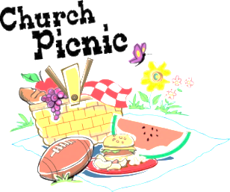Mark Your Calendars:

July 10, 2016

Miller-Sibley Pavilion

10:30 - Outdoor Worship

Noon – Picnic

Everyone is invited to join us for our Annual Outdoor Worship Service and Picnic.

Dress casually. Bring your own chairs if you wish. Picnic tables are also available for seating.

Each family is asked to bring their own table service and a tureen, salad, dessert or whatever your specialty happens to be, to share.

There will be games for all ages!

So, come and enjoy a day of outdoor worship and fellowship.

Any questions, please contact the Sunday School Superintendents, Pastor Jim and Diane Montgomery.

Hope to see you there!!!!!

><> ><> ><> ><> ><> ><> ><> ><> ><> ><>

Congratulations

☺**Tyler Delong**☺

Student of the Week at Vo-Tech

><><><><><><><><><><><><><><><><><><><

Congratulations

☺**Becca Mullen**☺

She was awarded a scholarship for her Freshman year at

Clarion University

><><><><><><><><><><><><><><><><><><><><



BIBLE SCHOOL

 Diane Montgomery is organizing a One-Day Bible School for Saturday, June 25, 2016. The Bible School will be held at our Church. The theme will be “God Bless America”.

There are several ways you can help out. They will need:

\*helpers to sit with the kids

\*patriotic decorations

\*help with crafts

\*lots of prayers

ALSO – Is anyone interested in doing something for the 4th of July parade?

AND – Is anyone able to take care of the nursery during Sunday School?

If you are able to help in any way, or if you would like more information, please see Diane Montgomery.

\*\*\*\*\*\*\*\*\*\*\*\*\*\*\*\*\*\*\*\*\*\*\*\*\*\*\*\*\*\*\*\*\*\*\*\*\*\*\*\*\*\*\*\*\*\*\*\*\*\*\*\*\*\*\*



Most of the schools in our area will be closing before Memorial Day weekend this year.

So keep an eye out for children

riding bikes and skateboards,

chasing balls into the street, etc.

Everyone have a safe, happy Summer.

\*\*\*\*\*\*\*\*\*\*\*\*\*\*\*\*\*\*\*\*\*\*\*\*\*\*\*\*\*\*\*\*\*\*\*\*\*\*\*\*\*\*\*\*\*\*\*\*\*\*\*\*\*\*\*\*\*

KIDS CLUB

Kids Club met on April 4, 2016, with 5 kids attending. Our lesson was a review of all previous lessons this year. Nancy Barger prepared and helped serve an “appreciation dinner” for Kids Club leaders, teachers, and helpers. Thank you so much Nancy!!!!!

We also met on April 18, 2016, with 9 kids attending. We held our annual “End of the Year Quiz”. It was exciting to see how well the kids did answering the quiz questions. Dessert for supper was “Make Your Own Ice Cream Sundae”.

Jaci Clark was recognized for Perfect Attendance! All the kids were given a certificate and treat bag. The leaders and helpers were recognized and given a small token of appreciation.

We want to thank everyone who supported the Kids Club with prayers, financial contributions, buying calendars, donating food, teaching lessons, and helping out in any way. Kids Club is a wonderful outreach ministry where children learn about God’s love and His plan for salvation.

 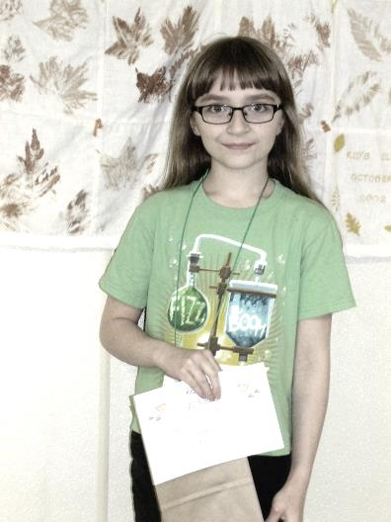

Jaci Rebecca

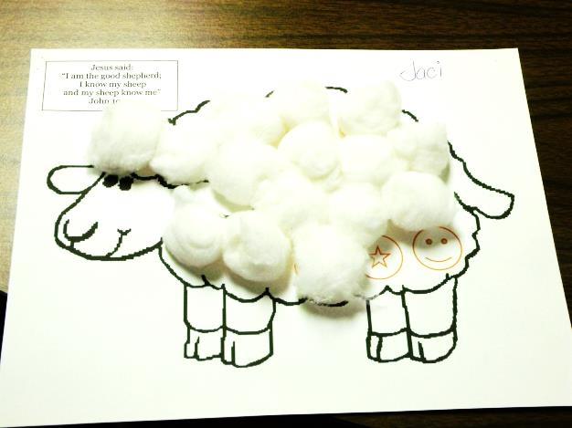

Jaci’s Perfect Attendance

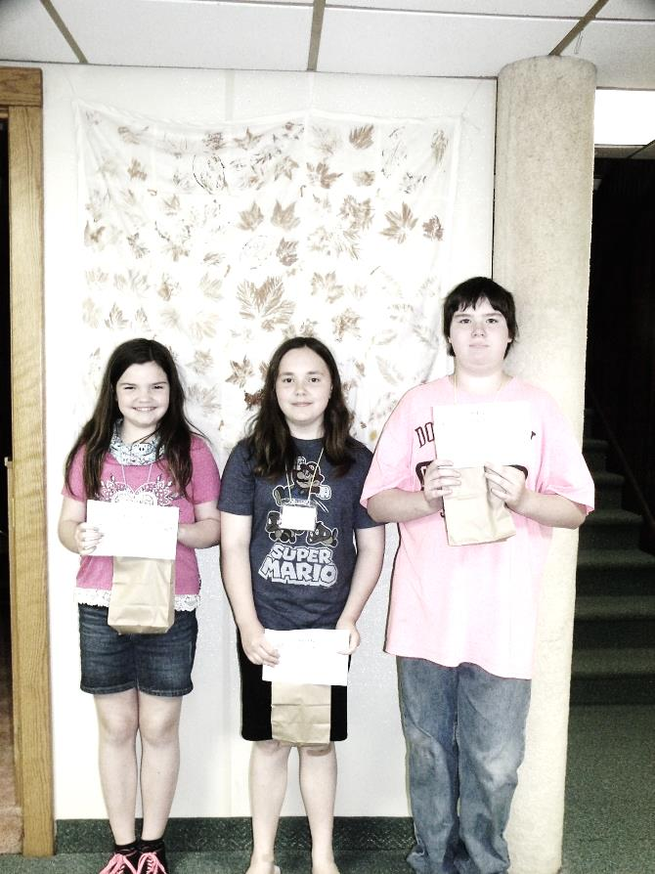

Christina, Autumn, Terry

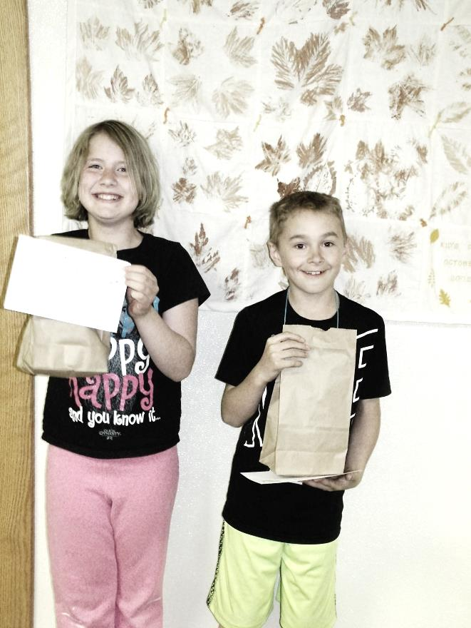

RaeLynn, Tyler

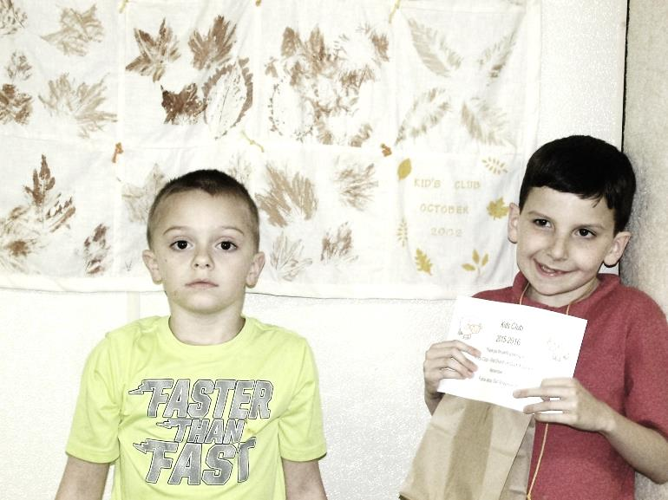

Sean, Joe

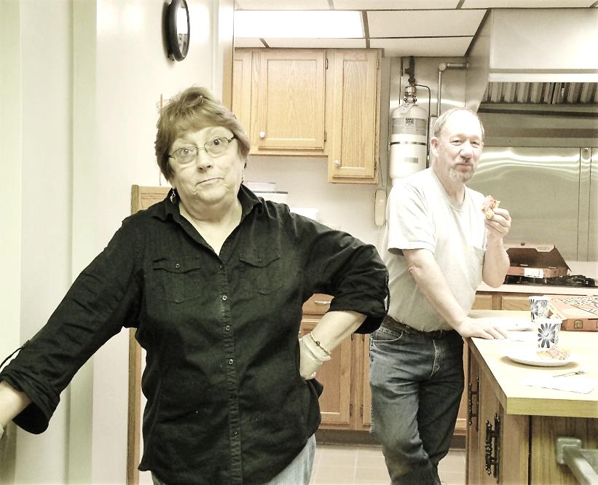

Becky & Dan

We love our “Supper Makers”



Remember!

**Psalms 105:4, 5 and 8**  
Seek the LORD, and His strength: seek His face evermore.  Remember His marvelous works that He hath done; his wonders, and the judgments of His mouth . . . He hath remembered His covenant forever, the word  which He commanded to a thousand generations.

Memorial Day is set aside to remember those who have fallen in our nation’s wars.  Sadly the day will pass and most of us will be so caught up in picnics, family gatherings, or outdoor projects that we won’t even give much thought to the real meaning of the day.  That’s too bad, because remembering does many things.  It brings me back to the reality of what actually happened.  It also encourages me to see the dedication of those who fought and died. Remembering stirs within me a sense of gratitude and appreciation, and it strengthens my resolve to do my part in serving God, country and others.

Throughout the Bible, God’s people are instructed to stop and recall what He did for them.  Psalm 105 is a song of remembrance of God’s goodness to His beloved ones.  It traces His direction, provision and protection through their history and the lives of Abraham, Isaac, Jacob, Joseph, and Moses.  As believers in the 21st century, we can look back over a much longer history and see how God’s plan has and is unfolding, and observe His incredible goodness to us.

Psalm 105:1-5 shows the natural progression of what happens when I pause to remember—I give thanks to Him and continue calling on Him.  I sing of Him, and talk with fellow believers of all He has done.  Then I must go tell others of His greatness.  When I stop to trace the work of God’s hand in my life and in the world around me, these things just come naturally.

But the key to being able to rejoice in the past is not found in counting the number of good things that have happened, but in remembering that God remembers!  I can rejoice because He never forgets His plan and He never forsakes His promises.  Even when life is tough and things don’t seem to make sense to me, I can rest assured that He is in control and He is working out His plan.  He has my best interest at heart.  Knowing this encourages and strengthens me, and pushes me to do my best to live for Him.

I encourage you, my friend, at this Memorial season, take time to remember.

Dear Father, help me daily to look back at Your faithfulness and praise You for being a God who remembers

By Ann Shorb  
©Copyright Ann Shorb, 2006

~~~~~~~~~~~~~~~~~~~~~~~~~



~~~~~~~~~~~~~~~~~~~~~~~~~



***A Mother’s Love***

A Mother’s love is something

That no one can explain.

It is made of deep devotion

And of sacrifice and pain;

It is endless and unselfish

And enduring come what may.

For nothing can destroy it

Or take that love away . . .

It is patient and forgiving

When all others are forsaking,

And it never fails or falters

Even though the heart is breaking . . .

It believes beyond believing

When the world around condemns

And it flows with all the beauty

Of the rarest, brightest gems . . .

It is far beyond defining

It defies all explanation -

And it still remains a secret

Like the mysteries of creation . . .

A many splendored miracle

Man cannot understand,

And another wondrous evidence

Of God’s tender guiding hand.

By Helen Steiner Rice

***Children of the Church***

***Special Music – Easter Sunday***

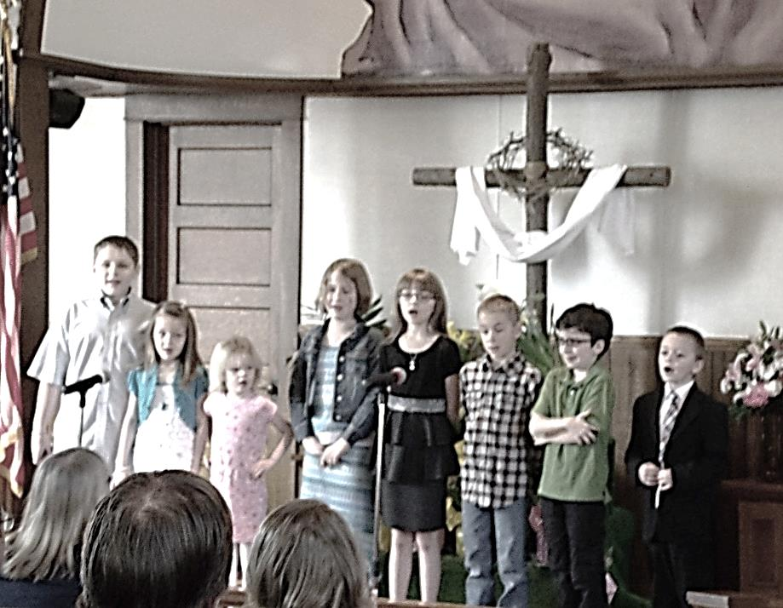

Kaleb, Kara, Jaci, RaeLynn, Rebecca, Tyler, Joe, Sean

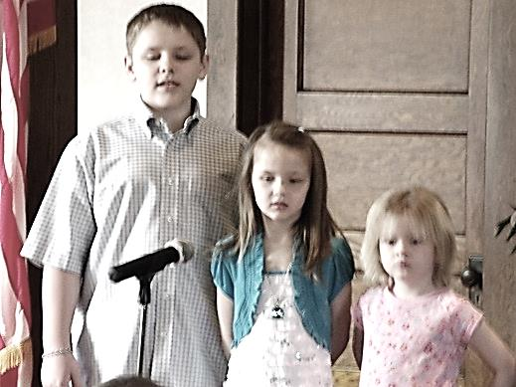

Kaleb, Kara, Jaci

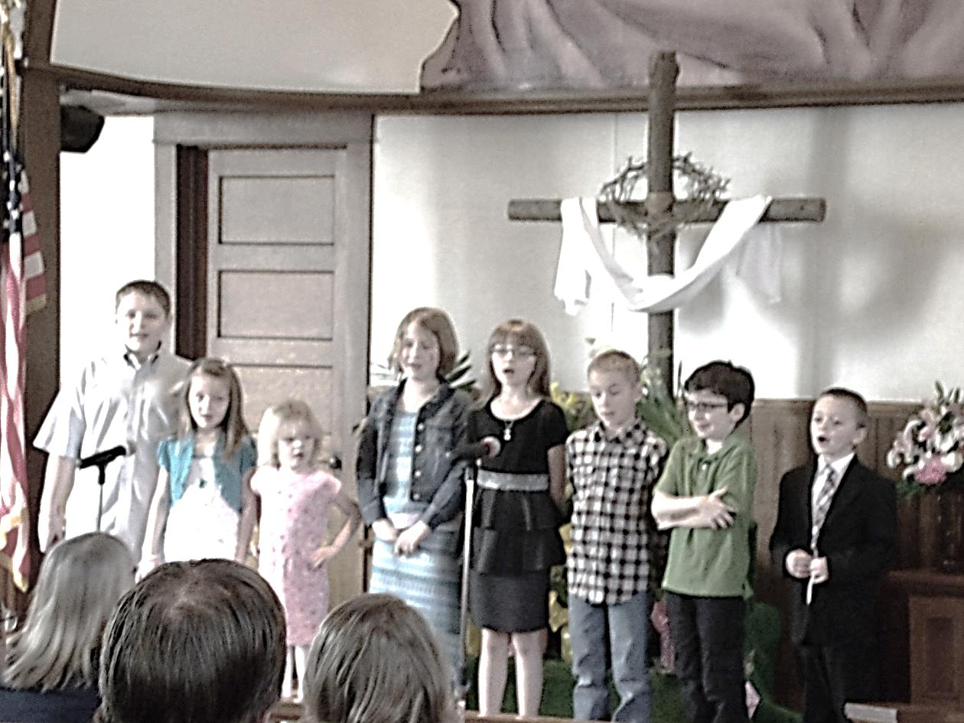

Tyler, Joe, Sean



RaeLynn, Rebecca



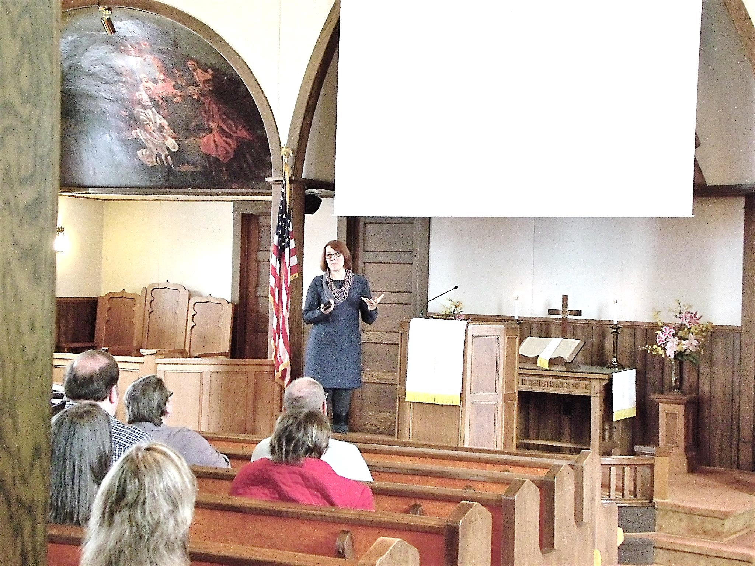

Dr. Stephanie Ashbaugh –

Our guest speaker on April 10th.

We praise God for the willingness

of Dr. Ashbaugh and

others from her Church to minister to

the people of Sierra Leone.

We thank God for blessing this

missions ministry.

For more info on donating to this

mission, see page 2.

We thank God for:

Christian Mothers

Answered prayers

Christian friends

Good test results – Pat McNutt

Denny’s business doing well

Bible Study Leaders

Sunday School Teachers

Willing workers in our Church

Blessing our 2015-2016 Kids Club



Pat McNutt

Pat VanZandt

Ron & Pat Master

Bob Jolley

Zach Rodgers

Braxton

Gavin

Sonya Mullen

Peg Benson

Bonnie Boyd

Judy Eckel

Jean Kelsey

Cathy Lutz

Virginia Beatty

Sondra Sensenbach

Eileen Yingling

Gladys Finefrock

44 people on our prayer list

Administrative Council

Joy employees – faced with Plant closure

The men and women in military service

ABC Life Center

Camp Sonrise Mountain

Expectant mothers

