Community Calendar

We will highlight events that will impact the African-American community. The Communication Domain will create and distribute information via the IMA CAT newsflash. This information will be sent out weekly, usually on Fridays.

Items for the Community Calendar must be approved by the CAT. Examples: IMA MLK Service, Juneteenth, MLK Day at Reid Park, TUSD A/A Students Awards, U of A Welcome Back Event, NAACP Banquet, Urban League Banquet and selected events of African-American concerns.
Meetings – We meet monthly at the Dunbar Pavilion - Lander’s Auditorium, Monday, 325 W. 2nd Street at 5:30 p.m. No need to sign up; show up and come willing to work. All are welcome!
Agenda – To work on an African-American Agenda that will empower our people. Once our agenda has been solidified, we will become mobilized, and then partner with the larger community so our goals will be realized. Everyone is welcome!
Newsflash – We send out a weekly newsflash in order to keep the African-American community informed of events going on in our churches and community. If you have any questions or concerns, please contact us at imatownhall@gmail.com
Social Media - Like us on Facebook – “IMA Community Action Team.”
Website - www.imatucson.com - Pastor William F. Dixon is the point of contact. He can be contacted at GraceBun2u@q.com.
Photographer – Joe Jackson is our official photographer.
Facilitator – Pastor Amos L. Lewis is the meeting facilitator. If you would like to know more about the IMA Community Action Team, please contact Pastor Lewis at Rising Star Baptist Church, 2800 E. 36th Street, Tucson, AZ 85713 or call (520) 791-3068 or email at imatownhall@gmail.com.

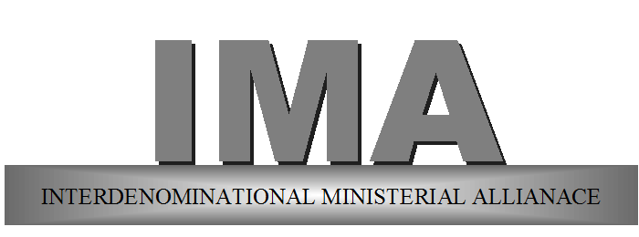

TUCSON AND VICINITY
www.imatucson.com

Dunbar Pavilion – Lander’s Auditorium
325 West 2nd Street
Tucson, Arizona 85705

IMA Community Action Team (CAT)

Monthly Meetings - Every Third Monday
Clergy at 4:30 p.m. and Community at 5:30 p.m.

Theme: “Together For Tucson”
(Eccl. 4:9-12)
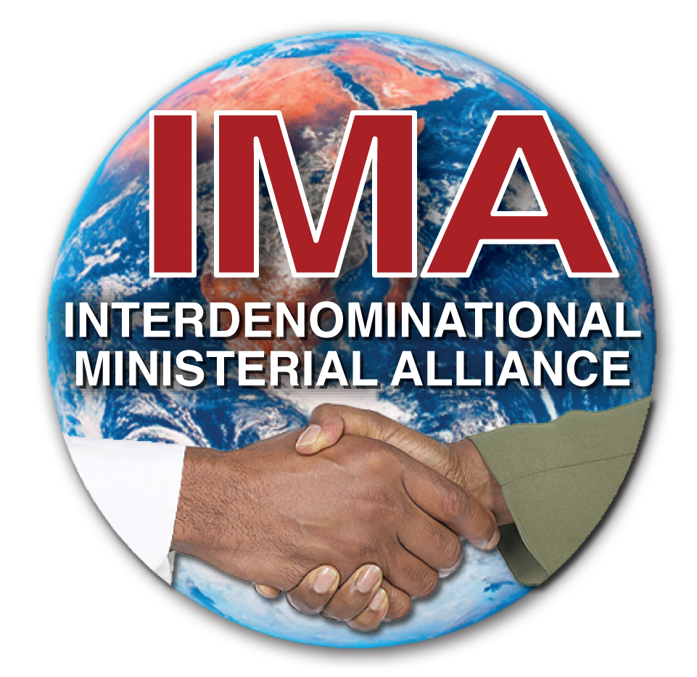

Behold how good and pleasant it is for brethren to dwell together in unity! (Psalm 133:1, KJV)

Motto: Let’s come together in love for peace and prosperity in our community.

Pastor DaMond T. Holt

IMA President

As of: May 5, 2016
IMA Community Action Team falls under the IMA. It was established in October 2014 and consists primarily of leaders and concerned citizens from the African-American community.
Purpose - To bring all the African-American organizations together in order to communicate, coordinate and collaborate so we can be more effective in addressing issues in our community.
Community Action Team (CAT) Council – The community action team council consists of the leaders from each domain. They serve as the steering committee. Domain leaders meet prior to each monthly IMA CAT meeting.
Currently we have 8 domains with Leaders and Co-leaders:
Arts and Culture – Barbea Williams Performing Company, Dunbar Pavilion Dance and Art Academy, University of Arizona Dance Professor and Kevin Hamilton of Southwest Soul Circuit
Business –Bill Madison, owner of Rainmaker Technologies, and Timothy C. Williams, Financial Investments at Edward Jones
Communication – Pastor Amos L. Lewis of Rising Star MBC and Minnette Powell, Lead Management Analyst at TPD
Criminal Justice –Rev. Bennie Baker, Executive Pastor of Rising Star MBC and Rev. Ben Davis, Jr. Minister at Grace Temple MBC
Education – Pastor E. J. McDowell of Trinity MBC and Professor at the University of Arizona, and Jimmy Hart, TUSD African American Studies
Health and Wellness – Kristina Austin, Social Worker and Cheryl Ali, former employee at Raytheon
Political Action – Deborah Embry – CEO, Tucson Urban League and Pastor D. Grady Scott of Grace Temple Baptist Church
Religion – Pastor Otis F. Brown, Jr., Siloam Freewill Church and IMA President, and Apostle Warren Anderson, Jr., Living Water Ministries
ARTS AND CULTURE - bring wholesome and cultural relevant entertainment to Tucson that will enrich the community.
BUSINESS – to empower, support, and network amongst African American owned businesses. Plus, make resources available to those seeking to become entrepreneurs.

COMMUNICATION – share information with members of the African-American community by publicizing upcoming events, issues/concerns relative to religious, political, social, economics, criminal justice/legal, business, education, and health and wellness awareness.

CRIMINAL JUSTICE – promote awareness involving disparity within the Criminal Justice System and the African-American community.

EDUCATION - develop self-help programs such as summer reading and tutoring programs for African American children in k-12 and to join with other organizations in advocating for African Americans in k-12 and higher education.

HEALTH AND WELLNESS - Provide educational materials and advocate for services that will address the unique physical, mental and spiritual needs of the African-American community especially those with a disadvantaged background by offering a holistic approach that empowers individual(s) to lead a healthy sustainable life.

POLITICAL ACTION - empower African-Americans to participate more fully in civic and political activities occurring at the local and state level. Emphasis is placed on voter education and registration as well as community mobilization around issues of social and racial justice.

RELIGION - promote camaraderie among all African-American Churches by providing public awareness of events and concerns within our community.

