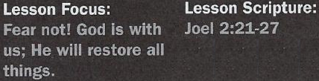
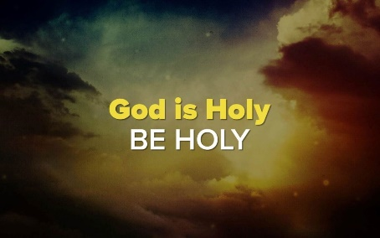

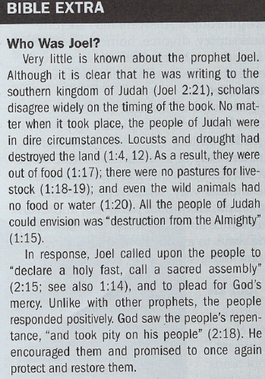

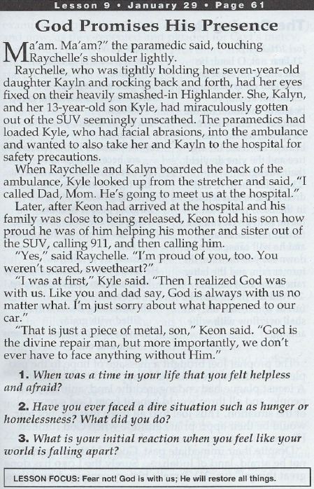

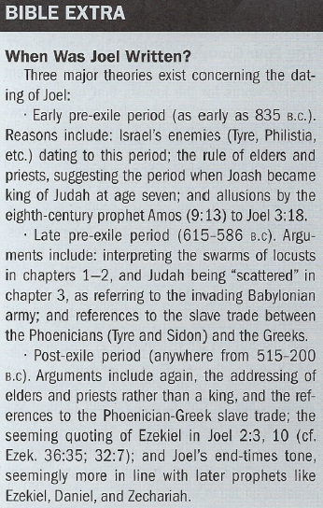

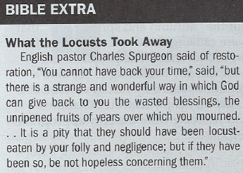

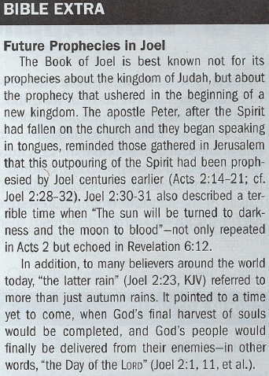

The Coming Rains - Joel 2:21-24
4. What did God tell the people of Judah in verse 21? On what did He base
this statement?
5. What had God already begun to do, according to verse 22?
6. How did God repeatedly command the people of Judah to respond,
based on what He had already done and what He promised to do?

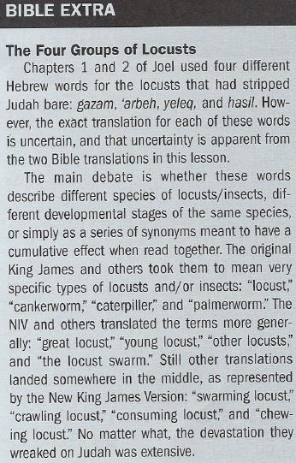
God Will Repay and Renew - Joel 2:25-27
7. What did God declare in verse 25? What else was made clear about
Judah's situation in this verse?
8. What blessings did God promise to Judah?
9. How do both verses 26 and 27 end? Why was this significant?

Suggested Answer to Question 1
For Question 1, we should discuss a time or experience when we've felt
intense fear. Examples could include an unexpected diagnosis, job loss, an
accident, or an abusive relationship. Times like these can be scary and
difficult.
Suggested Answer to Questions 2
Question 2 asks for us to recall a dire situation that we've lived through.
Answers may include bankruptcy, divorce, homelessness, etc.
We should share what steps we took to resolve the situation or how it was
reconciled.
Suggested Answer to Question 3
Question 3 challenges us to consider how we typically respond to a bad
situation. While the "Christian" answer may be to turn it over to God in
prayer, often our gut instinct leads us another way: anxiety, panic attacks,
isolation, emotional paralysis, and even substance abuse. Discuss with
students the ways to avoid these knee-jerk reactions and instead turn to
the Lord.
Suggested Answer to Question 4
God told the people of Judah not to be afraid, but rather to be glad and
rejoice, because "Surely the Lord has done great things!" (vs. 21). Despite
their volatile history, God had already provided Israel with countless
examples of His provision. Therefore, even before God blessed them yet
again, the people were to rejoice—not because of the blessings themselves,
but because of the God who provided them.
Suggested Answer to Question 5
God even addressed the beasts of the wilderness that were already benefiting from His provision:
"Do not be afraid ... for the pastures in the wilderness are becoming green. The trees are bearing their fruit; the fig tree and the vine yield their riches." This was a direct reversal of the circum-stances that had driven the people to repent. God's provision for them would be no less than
what He was giving the beasts of the field.
Suggested Answer to Question 6
In verse 21 and again in verse 23, God commanded the people of Judah to "be glad and rejoice." He was providing not only the fruit of the tree and the vine but the "autumn and spring rains" that
were causing those trees and vines to grow once more. The people of Judah were already beginning to see God's goodness, and they would soon be able to literally enjoy its fruits. Gladness
and rejoicing were the only appropriate responses.
Suggested Answer to Question 7
God recalled the locusts of Joel 1:4 that had plagued Judah. Only this time, instead of telling the people to mourn what they had lost, God promised that He would restore the fortunes of the
people that the locusts had taken away. The phrasing also made clear that this devastation had been for an extended period—"I will repay you for the years the locusts have eaten" (vs. 25).
Suggested Answer to Question 8
God promised to Judah, "You will have plenty to eat, until you are full, and you will praise the
name of the Lord your God, who has worked wonders for you" (vs. 26). God made clear that the purpose of this blessing was so "you will know that I am in Israel, that I am the Lord your God,
and that there is no other" (vs. 27).
Suggested Answer to Question 9
"[N]ever again will my people be shamed." Not only was God blessing the Israelites, but He was
also removing their disgrace. Ultimately this was an even greater blessing than the material bless-
ings God was giving to Judah. He was not only restoring the Israelites' material stature but, more
importantly, their dignity and identity as God's people.

Introduction

Several uncertainties surround the composition of the
book of Joel. The book opens by stating that what follows is
“the word of the Lord that came to Joel son of Pethuel” (Joel
1:1). The name Joel was common in the Old Testament era
(examples: 1 Chronicles 4:35; 5:4, 12; 6:33, 36; 7:3; 11:38;
15:7; 27:20; 2 Chronicles 29:12; Ezra 10:43; Nehemiah 11:9).
Beyond the prophet’s name and the name of his father, other
personal details regarding this specific Joel are unavailable to
us.
Several possibilities exist regarding the composition
date of the book of Joel. Traditional interpretations date it to
the ninth century BC. The era of King Joash (ruled 835–795
BC) is frequently listed as a possible backdrop for Joel’s
prophecy (see 2 Kings 12; 2 Chronicles 24).
However, other theories place the book in a postexilic context,
after 538 BC. If Joel wrote in this context, then he was
lamenting what had happened to Jerusalem (Joel 3:17) and
held hope for God’s vengeance against foreign aggressors
(3:1–16). Some details behind the composition of the book of
Joel may never be discovered. That fact should not dissuade
modern readers from taking seriously the prophet’s warnings and promises.
Joel directed his prophetic message to the people of Judah and the city of Jerusalem (Joel 2:21). The book opens by describing a plague of insects that destroyed the crops of Judah (1:2–12, 17–20; 2:1–11). The once fruitful land of Judah became barren by the destructive insects. Because of the land’s desolation, the people of Judah lived in famine and in want. Joel interpreted the destruction as the consequences of Judah’s sin, and he called his audience to return to the Lord and repent (2:12–14; compare 2 Chronicles 6:28–31; Amos 4:6–11).
The Lord saw the turmoil in the land and the suffering of his people. Though the people had sinned, he had compassion for them (compare Exodus 34:6; Nehemiah 9:17). The Lord was “jealous for his land” and showed “pity” on his people (Joel 2:18). He demonstrated his care by promising his people renewed sustenance (2:19) and protection from foreign enemies (2:20). His renewal would cause his people and their land to prosper. Because of his compassion, his greatness would be on display for his people and the whole world.

Conclusion

A plague of destructive insects with the accompanying feelings of terror—like the one described in this lesson’s text—might be incomprehensible to modern audiences. Therefore, the feelings of joy from God’s promised renewal might seem equally as foreign.
However, modern audiences of Joel’s prophecy can take away two applications. First, the text serves as an ancient reminder regarding a present reality: the importance of maintaining hope during seasons of suffering. Joel’s words, directed to a people in the midst of hardship, reoriented their expectations. Disaster and shame changed to flourishing and celebration, all because of God’s great work of renewal. Joel promised the people that hope was possible in the midst of disaster and suffering.
Although sin brings consequences, God will not ignore or disregard his people. Instead, God can bring joy to replace sorrow. His timetable may not be ours, and he may not immediately bring joy or fix our suffering. However, his people can take comfort in knowing his presence.
Second, this passage serves as a reminder of God’s promises to renew all creation. Joel promised that not only would the people be restored, but creation—the land and the animals—would also be restored. God’s plan of restoration is not only focused on the spiritual realm but also the physical realm (see Romans 8:18–21). All things—spiritual and physical—belong to the God who created them. Joel calls us to embrace all aspects of God’s restoration and renewal. As a result, God’s people of all eras can celebrate his presence in their midst.
