FROM THE OFFICE OF THE SENIOR PASTOR
Church Correspondence

November 16, 2022

Pastor’s Corner

Hello Mt. Zion! I greet you in the precious name of our Lord and Savior, Jesus Christ. Last Sunday we had an awesome Women’s Day service at Mt. Zion. I am thankful to the leaders of the Women’s Ministry for all their hard work.

Please keep in mind the preaching schedule below:

November 20: Rev. Pat Stone (Pastor Graham will be preaching in Children’s church)
November 27: Pastor Graham

Please remember we are Bible-Based, Christ-Centered, Discipleship-Driven, and Mission-Minded! This is the thrust of our ministry at our church! We are moving up the King’s highway! I am very excited about the future of Mt. Zion.

Please know that my wife and I are praying for you and your family! God bless and see you on Sunday! Please remember to invite, invite and invite your family and friends to our worship service!

Pastor G’s Contact Info
Cell: 513-516-3708
Email: mtzion.pastor16@gmail.com
Office Hours: Tues-Thurs 11am-4pm

From our Youth Director:

****SPECIAL ANNOUNCEMENT****
We are asking all parents/guardians of our children to have them in Children’s church to prepare for our 2022 Christmas Program. We will be giving out parts; we need our children in attendance.

Children’s Church will resume this Sunday and the 4th Sunday. Our very own Pastor Graham will lead Children’s Church this Sunday, so please meet us at the Mount so that children may hear a special message from their pastor.
~Lady A

Memory Verse: Philippians 2:13, “For it is God who works in you to will and to act in order to fulfill his good purpose” NIV

Youth Director Contact Info
Sister Aleshia Graham (Lady A)
Cell: 513-516-3707
Email: aleshia_graham@yahoo.com
Children’s Church is every 2nd, 3rd, and 4th Sunday (5th Sunday Youth Sunday)

Thanksgiving Holiday Church Hours
The church office will be closed for the holiday, beginning 12 noon Wednesday 11/23/22, and continuing through the Thanksgiving weekend.

Due to the holiday, there will be NO correspondence during the Thanksgiving week.

WOMEN’S DAY RECAP
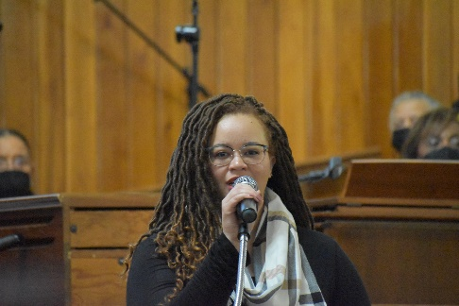
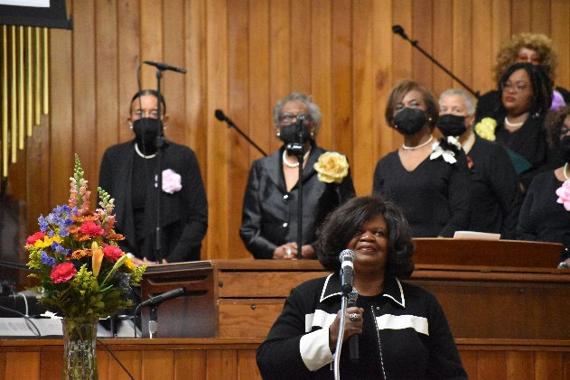
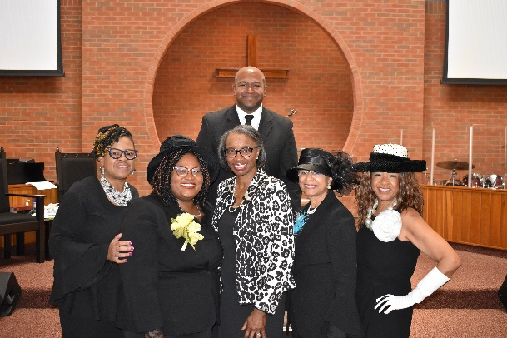

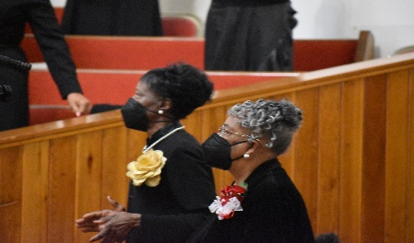

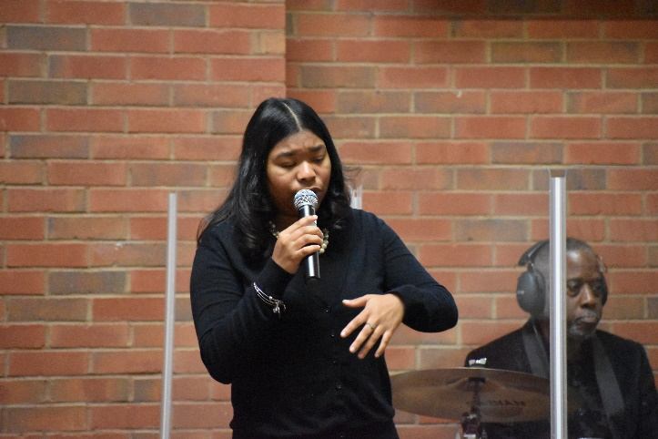
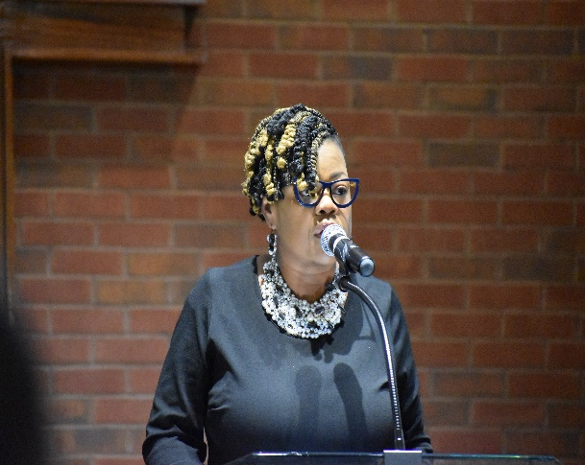
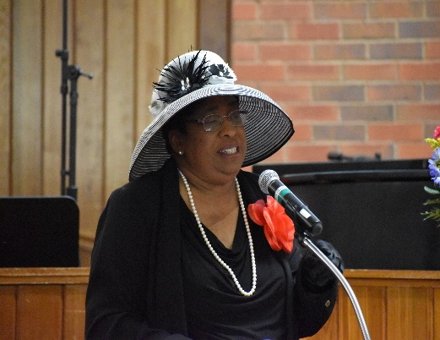

Did You Know?

For Sale
GT245 John Deere lawn tractor with grass catcher, snow blade and 4x4 utility trailer. $1,400 or best offer. If you’re interested, please contact the church office ASAP.

Trustees

Military Ministry
The military ministry stands by to support our veterans and loved ones serving on active duty. Do not hesitate to contact Bro. Shirley (513-885-1274) or Bro. Blackwell (513-671-1253).

Girl Scout Troop
Mt. Zion’s Girl Scout Troop is preparing to revamp and we need your girls! We are a multilevel troop. So we are open for grades K - 12th.
Activities in the Girl Scout Leadership Experience focus on four key areas:
Science, technology, engineering, and math (STEM)
Outdoors
Life Skills
Entrepreneurship
If interested please contact the church office @ 513-772-6230 or
Sis. Whitney Tarver @ 513-655-6816.

Kind Regards,
Whitney Tarver

Upcoming Events

- Fall Revival @ Bethel Baptist Church, Hamilton, OH, November 16, 2022, 7:00 pm
- Pre-Thanksgiving Service, November 22, 2022, 7:00 pm
- Baptism, November 27, 2022, 10:45 am
- Christmas Program, December 11, 2022, 9:15 am
- Church Conference, December 13, 2022, 7pm

Prayer Requests
We are saddened to share that our beloved, Sister Janet Coleman has passed away. Please keep Brother Lawrence Coleman and the entire Coleman and Ross families lifted in prayer. Arrangements are as follows:

Location: Quinn Chapel AME Church
10998 Southland Drive
Forest Park, OH 45240

Date: November 26, 2022

Visitation: 9:00 a.m. – 11:00 a.m.

Celebration of Life: 11:00 a.m.

Expressions of sympathy can be sent to:

Brother Lawrence Coleman, Sr.
6636 Alton Ave.
Cincinnati, OH 45213

THANK YOU

Dear Pastor Graham & My Mt. Zion Baptist Church Family,
Thank you so very much for your prayers, cards, calls with expressions of sympathy and
condolences. Most of all thanks for the love you all have showered upon the Scott family during
the passing of my children’s father and ex. husband Howard A. Scott. We love and appreciate you all.

Blessings & Love Sis. Shirley Scott & Family

Thank you for remembering to support your church financially. As a reminder you have a choice to stop by the church on Tuesdays, Wednesdays, and Thursdays between the hours of 11:00 a.m. and 4:00 p.m. to drop off your tithes and offerings. You still have the ability to use Givelify and of course your checks are still welcomed and accepted. Place your check (no cash) in a secure envelop and mail to:

Mt. Zion Baptist Church
10180 Woodlawn Blvd.
Woodlawn, OH 45215

If you are having trouble receiving Church Correspondence, please let us know and we will make every effort to ensure that you receive the correspondence. Also, if you know of any member that is not receiving the correspondence, please have them to notify the church.

Please continue to pray for those who are sick, shut-in and in nursing homes/care centers. I have attached a list of our sick and shut-in members as well as those that are in the nursing homes. Please check with the nursing home prior to your visit to ensure that they are allowing visitors. Please pray that all the residents will remain safe.

Please join us for the following weekly worship services/Bible Studies:

Wednesday Noon Bible Study (Wednesdays at 12:15 p.m.)
Teacher: Deacon Sanford Kirksey
Scripture: Judges Chapter 2
Dial in Number: (470) 480-9361

Wednesday Evening Bible Study CANCELLED Pastor in Revival
Teacher: Pastor Christopher R. Graham, Sr.
Scripture: 2 Timothy Chapter 2
Dial in Number: (470) 480-9361

Saturday Morning Bible Study (Saturdays at 10:15 a.m.)
Teacher: Steve McCullom
Scripture: John Chapter 5
Dial in Number: (470) 480-9361

Sunday School (Sunday, November 20, 2022, at 9:15 a.m.)
Sunday’s Lesson: God Is an Artist
Teacher: Minister James Walton
Study Scripture: Ephesians 2:1-10
Dial in Number: (470) 480-9361

Sunday Morning Worship Service (Sunday, November 20, 2022, at 10:45 a.m.)
Morning Message: Rev. Pat Stone
Sermon: Sharing the Bounty
Sermon Text: Nehemiah 8:8-12 NRSV
Dial in Number: (470) 480-9361
Facebook Live and YouTube is also available for this event: Mt. Zion Baptist Church Woodlawn; YouTube—Type in MtZionWoodlawn (It is case sensitive)

Saturday Evening Prayer
Receiving Prayer Requests Every Saturday Evening at 4:15 p.m.
Evening Prayer: Deacons
Dial in Number: (470) 480-9361

Monday Morning Prayer
Receiving Prayer Requests Every Monday Morning at 8:15 a.m.
Morning Prayer: Sister Deanna Kimbrough
Dial in Number: (470) 480-9361

Reminder: All mass mailings to members should come from the office. This gives us the opportunity to ensure that the congregation receives information sanctioned by the Church.

We encourage you to continue to reach out to each other to minister the Good News. Most importantly, our hope rests in the Lord Almighty, Emmanuel, God-with-Us. In the words of the Psalmist:
If you make the Most High your dwelling—even the Lord who is my refuge—then no harm will befall you, no disaster will come near your tent. (Psalm 91:9-10 NIV)

During this time of the pandemic, we are not alone! God is with us, and we have each other as members of the Body of Christ.

In His Service,

Pastor Christopher R. Graham, Sr., M. Div

