FROM THE OFFICE OF THE SENIOR PASTOR
Church Correspondence

November 9, 2022

Pastor’s Corner

Hello Mt. Zion! I greet you in the precious name of our Lord and Savior, Jesus Christ. This week we are excited to celebrate our women at Mt. Zion. We are looking forward to this Sunday as we celebrate our 95th Women’s Day at our church. I am thankful to the leaders of the Women’s Ministry for all their hard work.

Please keep in mind the preaching schedule below:

November 13: Rev. Shirley Harris (Women’s Day)
November 20: Rev. Pat Stone (Pastor Graham will be preaching in Children’s church)
November 26: Pastor Graham

Finally, to all members of Mt. Zion, if you have any questions, concerns, or suggestions, please do not hesitate to contact me or schedule a meeting.

Please remember we are Bible-Based, Christ-Centered, Discipleship-Driven, and Mission-Minded! This is the thrust of our ministry at our church! We are moving up the King’s highway! I am very excited about the future of Mt. Zion.

Please know that my wife and I are praying for you and your family! God bless and see you on Sunday! Please remember to invite, invite and invite your family and friends to our worship service!

Pastor G’s Contact Info
Cell: 513-516-3708
Email: mtzion.pastor16@gmail.com
Office Hours: Tues-Thurs 11am-4pm

From our Youth Director:

****SPECIAL ANNOUNCEMENT****
Due to Women’s Day, all children will worship in the main sanctuary. Children may sit together with Pastor Graham and youth leader Sis Sharla Ponder. Children will meet in the vestibule and will be ushered into the sanctuary together.

Children’s Church will resume on the 3rd and 4th Sunday. Our very own Pastor Graham will lead Children’s Church on the 3rd Sunday, so please meet us at the Mount so that children may hear a special message from their pastor.
~Lady A

Memory Verse: Philippians 2:13, “For it is God who works in you to will and to act in order to fulfill his good purpose” NIV

Youth Director Contact Info
Sister Aleshia Graham (Lady A)
Cell: 513-516-3707
Email: aleshia_graham@yahoo.com
Children’s Church is every 2nd, 3rd, and 4th Sunday (5th Sunday Youth Sunday)

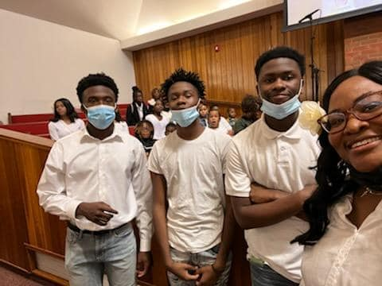
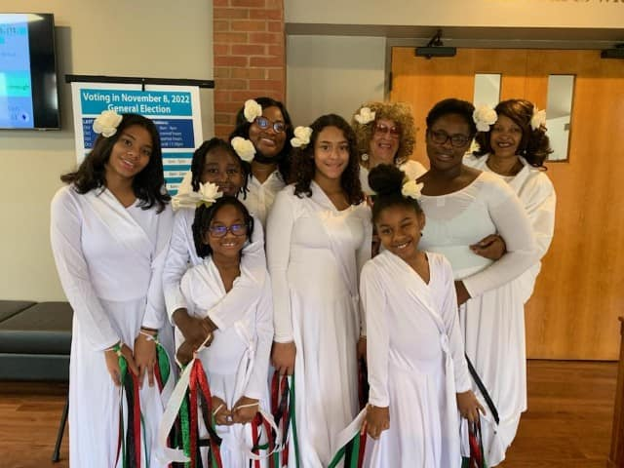

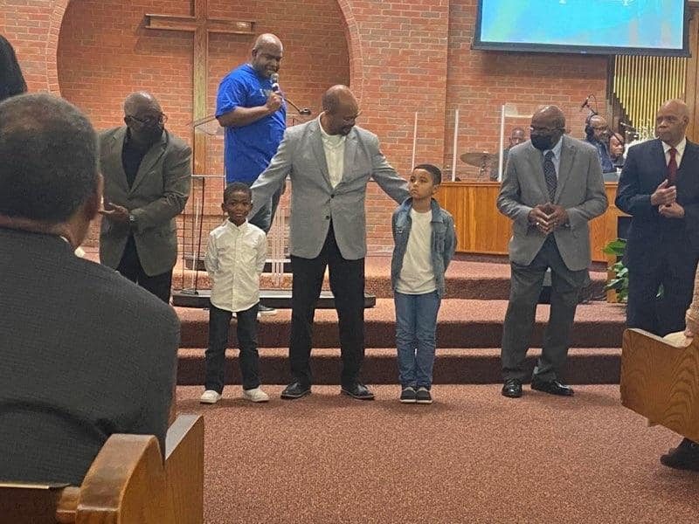

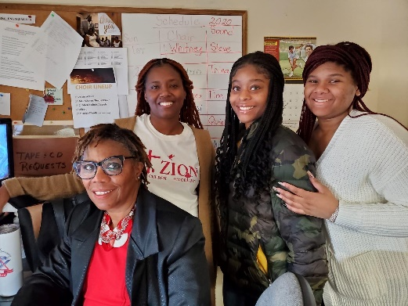

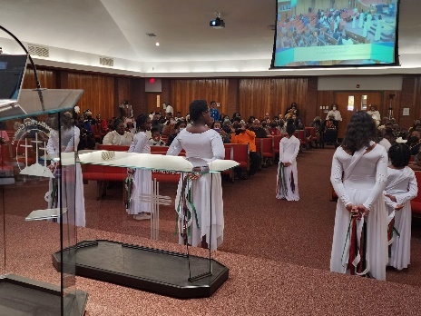

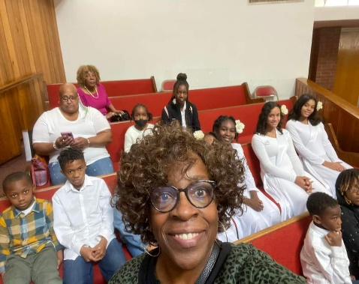

From our Minister of Music

CALLING ALL MT. ZION WOMEN!!!!!!

We are preparing a choir for women's day, Sunday, November 13th! The women's day choir will practice on THURSDAY, NOVEMBER 10TH AT 7:00 P.M. I am asking all women to sing! This will be exciting as this is the first time a full choir will sing for women's day since the pandemic!

For this message, there is no need to sign up. Please just come and God will do the rest! I look forward to a joyful time of bringing a full choir back to the sanctuary!

Bro. Eric, Minister of Music

Women’s Day
Women’s Day will be celebrated on Sunday, November 13, 2022 at 10:45 a.m. Our guest preacher this year will be Rev. Shirley Harris, co-pastor of The Rock Church in Cincinnati. Our theme is “Women Basking in the Power of the Holy Spirit.” Our theme scripture is Psalm 46:5 (NKJV)—God is in the midst of her, she shall not be moved. God shall help her, just at the break of dawn. Our Women’s Ministry Leaders are asking that the women wear black with any corsage that you already have so that we will have a rainbow of colors.

To Our Mt. Zion Family:
This is the giving season! The Women’s Ministry of Mt. Zion is soliciting donations for the Greater Cincinnati YWCA in honor of Sister Ella Miller, our Women’s Day founder. She worked diligently and tirelessly as a board member of the YMCA which had quite an impact on the youth in her community. These donations will enable the YWCA to carry out their mission of “empowering” women and enhancing their way of life.
Please get on board! Make checks payable to the Mt. Zion Baptist Church (AND PLACE YWCA ON THE MEMO LINE. YOUR CONTRIBUTION IS tax-exempt).
Blessings,
Sherlyn Beason
Patricia Gray
Co-leaders

Village of Woodlawn
The mayor of Woodlawn, Brian Poole, has appointed our Senior Pastor to serve on the recreation commission. Pastor Graham serves along with six other people to find ways to create programs for the community aimed at children. Please see the attached flyers for all events/programs at the Woodlawn Recreation Center. Please pray for our Pastor as we form a strong partnership with the Village of Woodlawn and the Woodlawn Recreation Community Center.

You Know?

Budget Team
The last day to submit receipts for this fiscal year is November 14, 2022. All receipts received after that date will be charged against the 2023 budget.

Upcoming Events

- Women’s Day Service, November 13, 2022, 10:45 am
- Fall Revival @ Bethel Baptist Church, Hamilton, OH, November 16, 2022, 7:00 pm
- Pre-Thanksgiving Service, November 22, 2022, 7:00 pm
- Baptism, November 27, 2022, 10:45 am

THANK YOU

Thank you for remembering to support your church financially. As a reminder you have a choice to stop by the church on Tuesdays, Wednesdays, and Thursdays between the hours of 11:00 a.m. and 4:00 p.m. to drop off your tithes and offerings. You still have the ability to use Givelify and of course your checks are still welcomed and accepted. Place your check (no cash) in a secure envelop and mail to:

Mt. Zion Baptist Church
10180 Woodlawn Blvd.
Woodlawn, OH 45215

If you are having trouble receiving Church Correspondence, please let us know and we will make every effort to ensure that you receive the correspondence. Also, if you know of any member that is not receiving the correspondence, please have them to notify the church.

Please continue to pray for those who are sick, shut-in and in nursing homes/care centers. I have attached a list of our sick and shut-in members as well as those that are in the nursing homes. Please check with the nursing home prior to your visit to ensure that they are allowing visitors. Please pray that all the residents will remain safe.

Please join us for the following weekly worship services/Bible Studies:

Wednesday Noon Bible Study (Wednesdays at 12:15 p.m.)
Teacher: Deacon Sanford Kirksey
Scripture: Judges Chapter 2
Dial in Number: (470) 480-9361

Wednesday Evening Bible Study (Wednesdays at 7:15 p.m.)
Teacher: Pastor Christopher R. Graham, Sr.
Scripture: 2 Timothy Chapter 2
Dial in Number: (470) 480-9361

Saturday Morning Bible Study (Saturdays at 10:15 a.m.)
Teacher: Steve McCullom
Scripture: John Chapter 5
Dial in Number: (470) 480-9361

Sunday School (Sunday, November 13, 2022, at 9:15 a.m.)
Sunday’s Lesson: Christ is Wisdom
Teacher: Sister Tina Merriweather
Study Scripture: Ephesians 1: 15-23
Dial in Number: (470) 480-9361

Sunday Morning Worship Service (Sunday, November 13, 2022, at 10:45 a.m.)
Morning Message: Rev. Shirley Harris
Sermon: Hold on, Help is on the Way
Sermon Text: Job 3:11-16; 21-26 NIV
Dial in Number: (470) 480-9361
Facebook Live and YouTube is also available for this event: Mt. Zion Baptist Church Woodlawn; YouTube—Type in MtZionWoodlawn (It is case sensitive)

Saturday Evening Prayer
Receiving Prayer Requests Every Saturday Evening at 4:15 p.m.
Evening Prayer: Deacons
Dial in Number: (470) 480-9361

Monday Morning Prayer
Receiving Prayer Requests Every Monday Morning at 8:15 a.m.
Morning Prayer: Sister Deanna Kimbrough
Dial in Number: (470) 480-9361

Reminder: All mass mailings to members should come from the office. This gives us the opportunity to ensure that the congregation receives information sanctioned by the Church.

We encourage you to continue to reach out to each other to minister the Good News. Most importantly, our hope rests in the Lord Almighty, Emmanuel, God-with-Us. In the words of the Psalmist:
If you make the Most High your dwelling—even the Lord who is my refuge—then no harm will befall you, no disaster will come near your tent. (Psalm 91:9-10 NIV)

During this time of the pandemic, we are not alone! God is with us, and we have each other as members of the Body of Christ.

In His Service,

Pastor Christopher R. Graham, Sr., M. Div

