INTRODUCTION
When the nation of Israel decided to “cohabit with the Canaanites” instead of obeying God’s command to expel them from the Promised Land, they set in motion a “vicious cycle”. Chapter 2 describes this cycle. In many respects, this “cycle of sinning” resembles the well-known cycles of addiction and abuse:
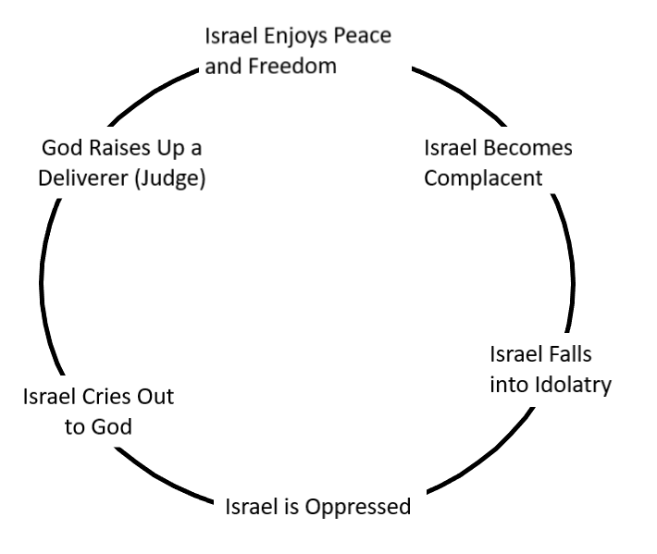
In many respects, this same cycle is played out in the lives of individual Christians; in the history of the church in general; and in the secular history of many nations. Note that the first step downwards is complacency – a condition where one’s faith and devotion become stagnant and unexciting; when self-examination is infrequent or absent; when active involvement in prayer, Bible study or ministry is neglected. Ironically, this tends to happen when “everything’s going well” and leads to a sense of SELF-satisfaction and careless living (Judges 16:15-20; Luke 12:16-19; Revelation 3:14-17). This opens us to temptations to drift ever further from the Lord, as it did for Israel.
Chapter 2 is basically an overview of the entire time of the Judges of Israel. In starts with a visit from a mysterious “angel of the Lord”. It also looks briefly back to the end of Joshua’s life.
- Read verses 1-5 Who came to visit the Israelites? What is special or significant about Him? (v.1; see also Genesis Chapter 18; Hebrews 13:2) Answer:

- What is significant about Gilgal? (v.1; see Joshua 4:1-7, 15-24)

- Describe the message that the “angel” brought to the people. (V. 1-2)

- Disobedience to the Lord’s commandments results in judgment. What did the Lord decide to do with the enemies of Israel? (v. 3)

- In what TWO ways did the people of Israel respond? (v.4-5). Why? (Note: the word “bochim” in Hebrew means “those who weep”; see also Ezra 10:1-4; Psalm 39:11-13; Jeremiah 13: 15-17; Luke 19:41-44; Philippians 3:17-19)

- Read verses 6-10. This passage shows what happened to the people of Israel after the death of Joshua, from the spiritual perspective. How long did they remain faithful to the Lord? What was the “turning point”? (v. 6-7)

- How old was Joshua when he died? (v. 8-9)

- What did Joshua and all of the people who entered the Promised Land have in common? (v.7; see also Deuteronomy 8:1-18)

- Who came along after the “Wilderness Generation” passed away? What did THEY have in common? (v. 10) Is there anything that today’s church can learn from this?

- Read verses 11-15. Without the God-fearing example of their parents, what choices did the new generation of Israel make? (v. 11-13) Answer:

- Find out as much as you can about “Baal and Ashtaroth” (v.13). What made their worship so appealing? Why might it be such a challenge to live for the Lord today?

- What was God’s response to the apostasy of Israel? (v. 14-15) Should this concern us Christians today? (See Acts 5:1-11; I Corinthians 3:16-17; 6:15-20; Hebrews 13:4; Revelation 2:18-24)

- Read verses 16-19. This passage describes the two main missions of the judge. What were they? (v. 16-17)

- WHY did the Lord intervene by raising up the judges? (v. 18; see Psalm 103:8-14; Isaiah 1:10-20; 55:6-7)

- What happened after the judge died? What does this tell us about the Israelites? How would you describe their behavior? (v. 18-19)

- Read verses 20-23. This last passage of the chapter describes the Lord’s anger and His judgment with respect to Israel. Did God destroy them? What did He do instead? Why does the Lord permit trouble in the lives of His children? (v. 21-22; see also Deuteronomy 8:1-6; Hebrews 12:1-11; James 1:1-4 I Peter 1:3-9)

CONCLUSION
The “Wilderness Generation” learned much about God during their “wilderness experience”, as they wandered through the deserts of Sinai for forty long years. They depended on the Lord for their daily bread; they depended on the Lord for victory in battles over their enemies; they depended on the Lord for guidance all along the journey. God provided shade from the burning sun by day, and light through the desert nights. Their clothes did not wear out; even their shoes were preserved throughout their sojourn. Through Moses and Aaron, they received God’s Word, and learned to obey His commandments. In short, they developed a living, day-to-day relationship with God.

This generation maintained that relationship in the Promised Land, even though they had failed to completely drive out the sinful inhabitants, as God had commanded them. Sadly, the same could not be said for their children – let’s call them the “Wealthy Generation”. They had a “second-hand” knowledge of God. They had not been eyewitnesses to His miracles; they had not experienced hunger or thirst. Rather, they had enjoyed the abundance of the land. They were brought up in prosperity and comfort. As a result, they became INDIFFERENT to God, and were attracted by the sensual appeal of the pagan gods of their Canaanite neighbors. They made a choice to follow them – and felt the consequences.

Life becomes much more complicated (and difficult) when God’s people sin. God is righteous; He must judge our sins. Thankfully, God is also merciful. Even in judgment, He expresses His compassion and love. For backsliding Israel, God’s judgment took the form of defeat and oppression by their enemies. His compassion took the form of Judges – people that God raised up to deliver them from oppression and teach them the ways of the Lord. We will meet the first of the judges in Chapter 3.

