FROM THE OFFICE OF THE SENIOR PASTOR
Church Correspondence

November 2, 2022

Pastor’s Corner

Hello Mt. Zion! I greet you in the precious name of our Lord and Savior, Jesus Christ. Wow! Can you believe it? We are now in November. I want to thank everyone that read the entire book of Proverbs. This book truly blessed me; I have more wisdom and guidance from the Holy Spirit. Continue to read his word each day and feast on God’s word as we prepare to celebrate Thanksgiving!

Last Sunday was simply amazing. I am on a spiritual high. I want to acknowledge my wife, our First Lady, who has done a great job with our youth ministry. Youth Sunday was evident that our youth are hungry for the Lord and are willing to step up to the plate when called on. I want to thank all our youth leaders who assisted Lady A. Also, the children of our church did a tremendous job. I am one proud pastor; the future looks bright for the Mt. Zion church family. The icing on the cake, God added (5) five souls to our church. We will baptize this Sunday and giving (6) six right-hands of fellowship to members who completed their New Member Classes. As you can see, God has been kind to our congregation; this is just the beginning. Get ready for what the Lord is about to do.

Please keep in mind the preaching schedule below:

November 6: Pastor Graham (Baptism and Lords Supper)
November 13: Rev. Shirley Harris (Women’s Day)
November 20: Rev. Pat Stone (Pastor Graham will be preaching in Children’s church)
November 26: Pastor Graham

Finally, to all members of Mt. Zion, if you have any questions, concerns, or suggestions, please do not hesitate to contact me or schedule a meeting.

Please remember we are Bible-Based, Christ-Centered, Discipleship-Driven, and Mission-Minded! This is the thrust of our ministry at our church! We are moving up the King’s highway! I am very excited about the future of Mt. Zion.
Please know that my wife and I are praying for you and your family! God bless and see you on Sunday! Please remember to invite, invite and invite your family and friends to our worship service!

Pastor G’s Contact Info
Cell: 513-516-3708
Email: mtzion.pastor16@gmail.com
Office Hours: Tues-Thurs 11am-4pm

From our Youth Director:

God is simply amazing! A special thank you to our families and youth leaders for an awesome Youth Sunday!!! The Mt Zion kids showed out and we are so proud. Here are a few moments captured from Youth Sunday.
~Lady A
Memory Verse: Philippians 2:13, “For it is God who works in you to will and to act in order to fulfill his good purpose” NIV

Youth Director Contact Info
Sister Aleshia Graham (Lady A)
Cell: 513-516-3707
Email: aleshia_graham@yahoo.com
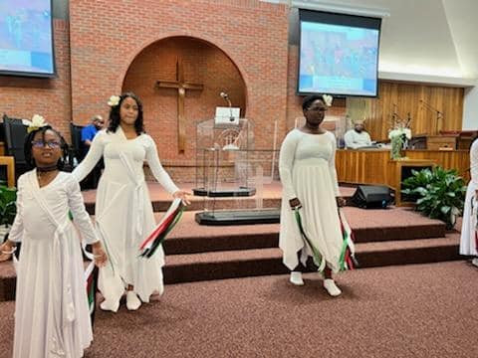
Children’s Church is every 2nd, 3rd, and 4th Sunday (5th Sunday Youth Sunday)
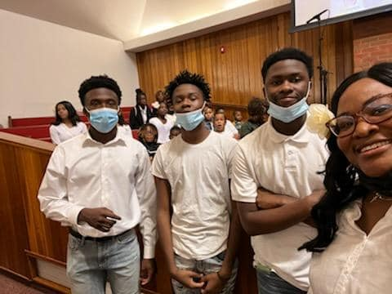
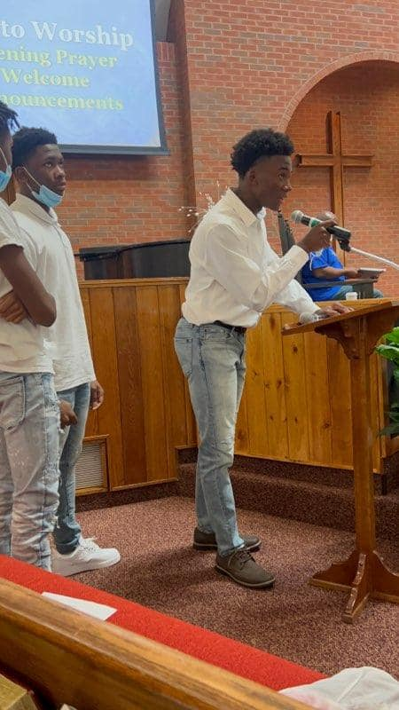

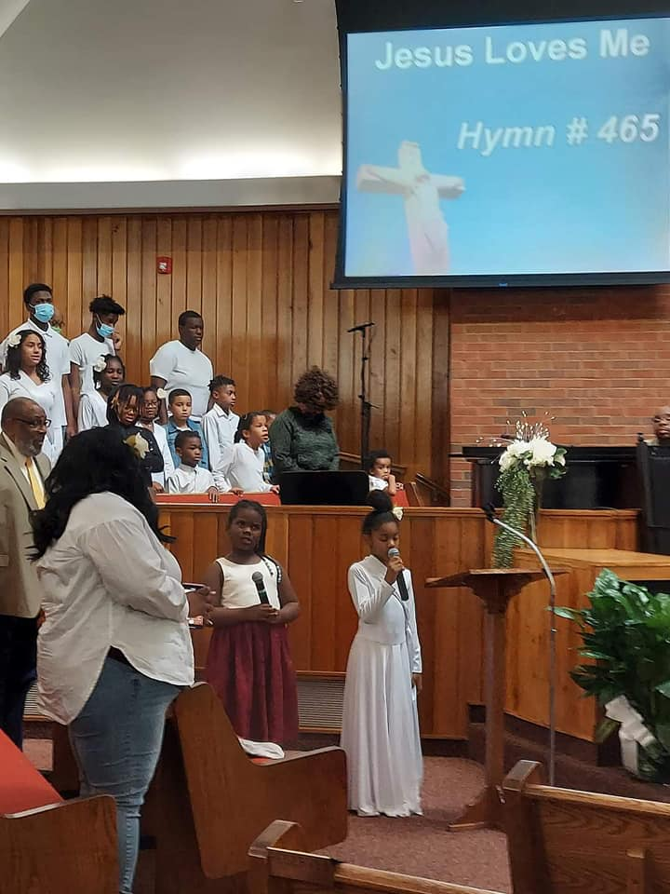

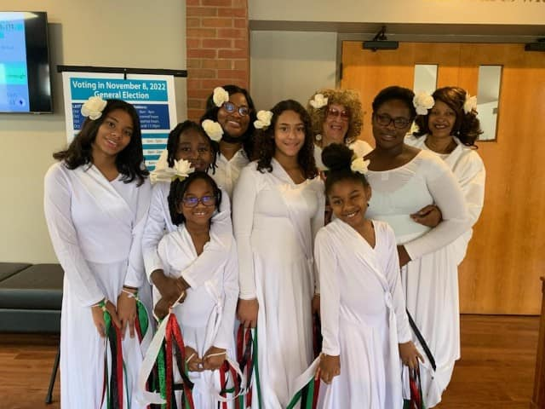

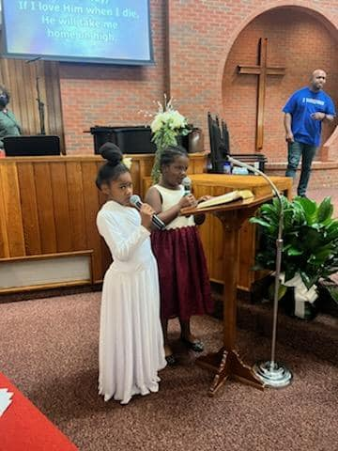

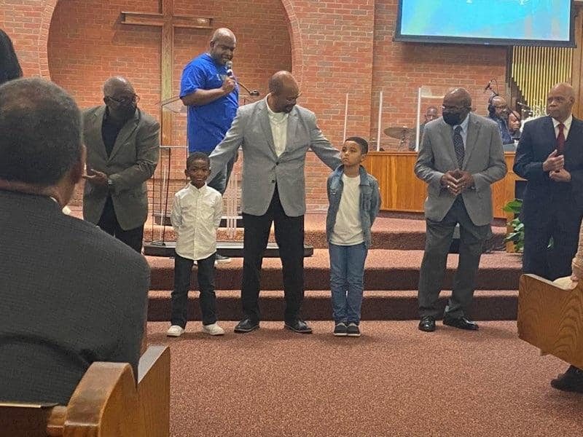

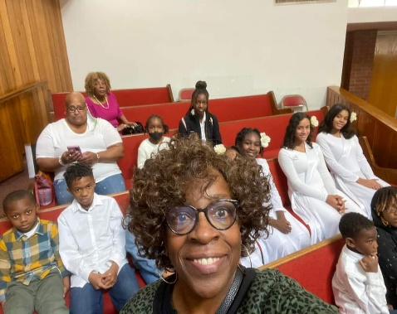
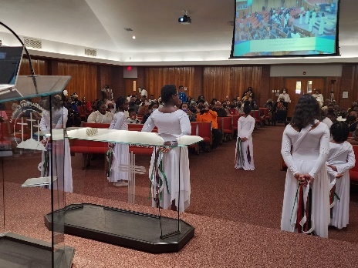
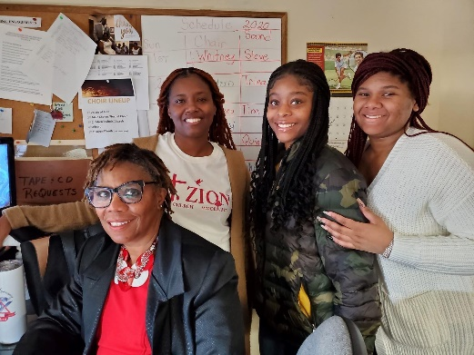

From our Minister of Music

CALLING ALL MT. ZION WOMEN!!!!!!

We are preparing a choir for women's day, Sunday, November 13th! The women's day choir will practice THURSDAY, NOVEMBER 3RD & THURSDAY, NOVEMBER 10TH AT 7:00 P.M. I am asking all women to sing! This will be exciting as this is the first time a full choir will sing for women's day since the pandemic!

For this message, there is no need to sign up. Please just come and God will do the rest! I look forward to a joyful time of bringing a full choir back to the sanctuary!

Bro. Eric, Minister of Music

Women’s Day
Women’s Day will be celebrated on Sunday, November 13, 2022 at 10:45 a.m. Our guest preacher this year will be Rev. Shirley Harris, co-pastor of The Rock Church in Cincinnati. Our theme is “Women Basking in the Power of the Holy Spirit.” Our theme scripture is Psalm 46:5 (NKJV)—God is in the midst of her, she shall not be moved. God shall help her, just at the break of dawn. Our Women’s Ministry Leaders are asking that the women wear all black with the noted accessories as listed in the attached flyer. Please see the flyer for complete attire details.

Girl Scout Troop
Mt. Zion’s Girl Scout Troop is preparing to revamp and we need your girls!
We are a multilevel troop, so grades K - 12th.
Activities in the Girl Scout Leadership Experience focus on four key areas:
- Science, technology, engineering, and math (STEM)
- Outdoors
- Life Skills
- Entrepreneurship
Please contact Sis. Whitney Tarver if interested 513-655-6816/334-552-2159.

Did You Know?

Budget Team
The last day to submit receipts for this fiscal year is November 14, 2022. All receipts received after that date will be charged against the 2023 budget.

Matthew 25 Hunger Walk
Friendly reminder, please register for the Matthew 25 Hunger Walk by November 5, 2022. Mt Zion has a team set up, so look for Mt. Zion Woodlawn Walkers when you register. (Please see flyer for more information)

Saturday Morning Bible Study
Due to our Leadership Conference, we will NOT have Bible Study on Saturday, November 5, 2022. Brother Steve McCullom will return on Saturday, November 12, 2022 @ 10:15 a.m

Leadership Training Module
Calling all leaders! We will be having a Leadership Training Module on November 5, 2022 from 8:30 am-2:00 pm. All ministry leaders are strongly encouraged to attend. Rev. Dianne Lewis-Johnson is our facilitator.

Upcoming Events

- Leadership Training Module, November 5, 2022, 8:30 am-2:00 pm
- Women’s Day Service, November 13, 2022, 10:45 am
- Fall Revival @ Bethel Baptist Church, Hamilton, OH, November 16, 2022, 7:00 pm
- Pre-Thanksgiving Service, November 22, 2022, 7:00 pm

Prayer Request
The celebration of life for Brother Eric Gray, brother of Sister Dwan Moore (Tim), will be held on Saturday, November 12, 2022, in Atlanta, Georgia. Expressions of sympathy can be sent to Sister Moore at the following address:

Mr. & Mrs. Timothy Moore

10960 Fallstone Drive

Cincinnati, OH 45246

Please continue to keep Sister Dwan and her entire family lifted in prayer.

Thank you

Dear Pastor Graham & Reverend Stone,
As well as my sisters and brothers in Christ, I just want to thank you from the bottom of my heart for your prayers, calls, cards, monetary gifts and for the love you have shown me during the passing of my husband Don.
Thank you. Thank you, Thank you!
Betty Hamilton

Mt. Zion Baptist Church,
We want to thank the members of Mt Zion who have demonstrated love and concern for our family over this year. This has been quite a journey, but with The Goodness of God, the faithful members who have prayed with and for us, and the women’s ministry members who faithfully sent cards of encouragement and gift cards for lunch or dinner. We felt the support and it really helped . The years 2020-2022 proved to be some of the most difficult years for our family , but God has been faithful to the Coleman Family and we remain grateful and thankful to our Lord and Savior for carrying us through this season of our lives.
We pray for nothing but the best for Mt Zion,
Lawrence and Janet Coleman

Mt. Zion Baptist Church,
I would like to thank everyone for all of your cards, prayers, and monetary gifts you sent after the loss of my mother and then the loss of my brother. Reading the cards have really helped me. Thank you!
I love you all,
Linda Fairbanks

Thank you for remembering to support your church financially. As a reminder you have a choice to stop by the church on Tuesdays, Wednesdays, and Thursdays between the hours of 11:00 a.m. and 4:00 p.m. to drop off your tithes and offerings. You still have the ability to use Givelify and of course your checks are still welcomed and accepted. Place your check (no cash) in a secure envelop and mail to:

Mt. Zion Baptist Church
10180 Woodlawn Blvd.
Woodlawn, OH 45215

If you are having trouble receiving Church Correspondence, please let us know and we will make every effort to ensure that you receive the correspondence. Also, if you know of any member that is not receiving the correspondence, please have them to notify the church.

Please continue to pray for those who are sick, shut-in and in nursing homes/care centers. I have attached a list of our sick and shut-in members as well as those that are in the nursing homes. Please check with the nursing home prior to your visit to ensure that they are allowing visitors. Please pray that all the residents will remain safe.

Please join us for the following weekly worship services/Bible Studies:

Wednesday Noon Bible Study (Wednesdays at 12:15 p.m.)
Teacher: Deacon Sanford Kirksey
Scripture: Judges Chapter 2
Dial in Number: (470) 480-9361

Wednesday Evening Bible Study (Wednesdays at 7:15 p.m.)
Teacher: Pastor Christopher R. Graham, Sr.
Scripture: 2 Timothy Chapter 2
Dial in Number: (470) 480-9361

Saturday Morning Bible Study CANCELLED FOR TODAY
Teacher: Steve McCullom
Scripture: John Chapter 5
Dial in Number: (470) 480-9361

Sunday School (Sunday, November 6, 2022, at 9:15 a.m.)
Sunday’s Lesson: God Picked You!
Teacher: Sister Lolly Sanders
Study Scripture: Ephesians 1: 1-14
Dial in Number: (470) 480-9361

Sunday Morning Worship Service (Sunday, November 6, 2022, at 10:45 a.m.)
Morning Message: Pastor Christopher R. Graham, Sr.
Sermon: Check Yourself Before You Wreck Yourself
Sermon Text: James 1: 12-18
Dial in Number: (470) 480-9361
Facebook Live and YouTube is also available for this event: Mt. Zion Baptist Church Woodlawn; YouTube—Type in MtZionWoodlawn (It is case sensitive)

Saturday Evening Prayer
Receiving Prayer Requests Every Saturday Evening at 4:15 p.m.
Evening Prayer: Deacons
Dial in Number: (470) 480-9361

Monday Morning Prayer
Receiving Prayer Requests Every Monday Morning at 8:15 a.m.
Morning Prayer: Sister Deanna Kimbrough
Dial in Number: (470) 480-9361

Reminder: All mass mailings to members should come from the office. This gives us the opportunity to ensure that the congregation receives information sanctioned by the Church.

We encourage you to continue to reach out to each other to minister the Good News. Most importantly, our hope rests in the Lord Almighty, Emmanuel, God-with-Us. In the words of the Psalmist:
If you make the Most High your dwelling—even the Lord who is my refuge—then no harm will befall you, no disaster will come near your tent. (Psalm 91:9-10 NIV)

During this time of the pandemic, we are not alone! God is with us, and we have each other as members of the Body of Christ.

In His Service,

Pastor Christopher R. Graham, Sr., M. Div

