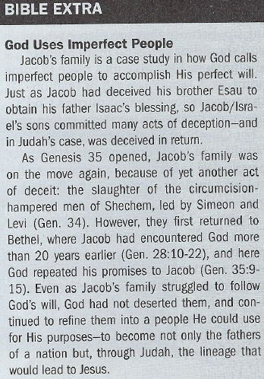
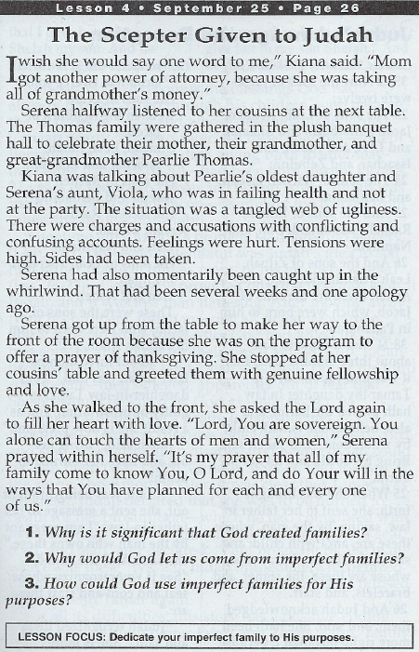

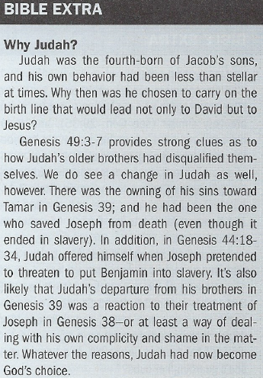

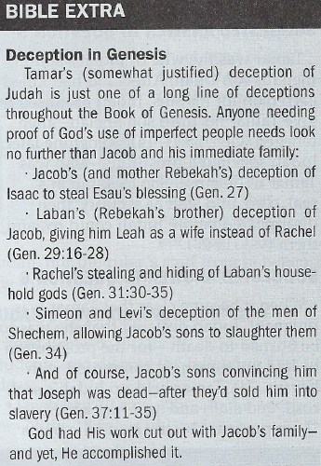

Judah's Lineage and Deception - Genesis 35:22b-26
4. What's significant about the list described in Genesis 35:22b-26?
5. Who was Tamar? What happened between Judah and Tamar?
6. How did Judah and Tamar each respond when their actions came to
light?

Judah's Scepter - Genesis 49:10-12
7. What were the circumstances surrounding Genesis 49? What did Jacob do before speaking to
Judah?
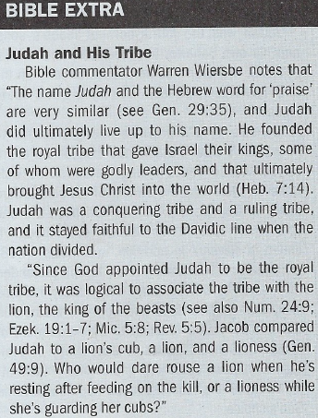
8. What did Jacob prophesy about Judah and his descendants?
9. How did Jacob conclude his prophecy over Judah?

Suggested Answer to Question 1
For Question 1, some may say that God created families because they are
needed for the safety of children growing up, because they are places where
you should be loved no matter what, and because they give us a place to
come home to. A family is a gift of relationships and belonging that mirrors
God's heavenly family He wants us to join.
Suggested Answer to Question 2
For Question 2, we all come from families made up of imperfect, broken
people. We cannot have a perfect family, but we can find a heavenly family
that is perfect.
Suggested Answer to Question 3
Question 3 leads us to think about how God can take our imperfect families
and use them for His good purposes. When everyone in the family is putting
others' needs ahead of their own, loving people despite their faults, and look-
ing to serve His purposes, God can do mighty things through families just as
He did through Jacob's very broken family.
Suggested Answer to Question 4
This passage recounts the blessings God already brought Jacob through his
children, who would become the 12 tribes of Israel—whose descendants
would inherit Canaan after Moses brought them out of Egypt. Except for
Benjamin, whom Rachel died giving birth to, all of them had been born during
Jacob's years of service to Leah and Rachel's father Laban in Paddan Aram.
Suggested Answer to Question 5
Tamar was the wife of Judah's son Er, then his son Onan. After God had
killed each man for his sins, Judah promised to give Tamar his third son
Shelah—then reneged (Gen. 38:11,14). Sometime later, Judah solicited a
prostitute—who was Tamar in disguise. She took Judah's seal, cord, and staff as security, then
disappeared before Judah could reclaim them (vss. 15-23).
Suggested Answer to Question 6
When it became clear that Tamar was pregnant, Judah declared that she was to be burned to death—for the prostitution he had unknowingly committed with her (vs. 24). Tamar held up Judah's seal, cord, and staff, and sent him a message, "I am pregnant by the man who owns these" (vs. 25). Judah immediately recognized the items, confessed his sins, and refused to sleep with Tamar again.
Suggested Answer to Question 7
Jacob was preparing to die. He gathered his family around him and pronounced both blessings
and curses on his children as he prophesied over them. He first called out his firstborn son Reuben's "defiling" of his "father's bed" with Bilhah (vs. 4), then condemned Simeon and Levi for their deceit and slaughter of the men of Shechem (vs. 7).
Suggested Answer to Question 8
Jacob blessed Judah, despite Judah's own questionable past: "Judah, your brothers will praise
you ... [and] bow down to you" (vs. 8). Even more amazingly, Jacob declared, "The scepter will
not depart from Judah, nor the ruler's staff from between his feet, until he to whom it belongs shall
come and the obedience of the nations shall be his" (vs. 10). This pointed not only to the kingship of David but to King Jesus Himself.
Suggested Answer to Question 9
Jacob pronounced material blessing over the tribe of Judah. They would one day live in a land capable of producing so much wine that Judah's descendants could wash their robes in it if they
wanted (vs. 11). In addition, "His eyes will be darker than wine, his teeth whiter than milk" (vs. 12). All of verses 11 and 12 described health and abundance for the land of Judah.
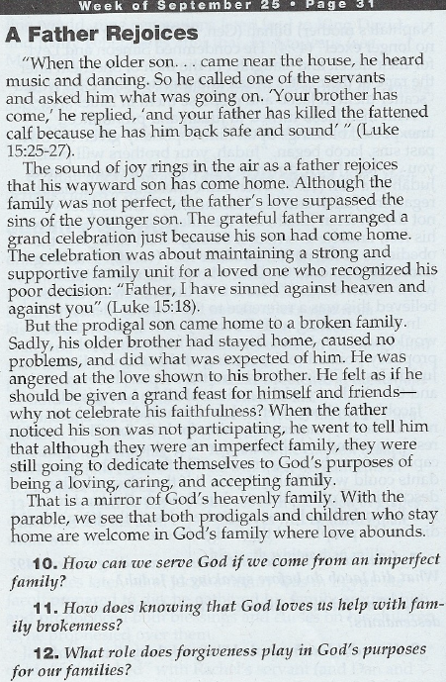
Introduction
At the beginning of the patriarchal narratives in
Genesis, God promised to make Abraham “a father of
many nations” (Genesis 17:5). From these descendants
God declared that “kings will come” (17:6; see 17:16, 20).
However, situations regarding offspring (see
Genesis 16:1; 18:13; 30:1) and family conflict (see 16:4–5;
25:19–34; 27:1–41) arose. These situations might have
led Abraham’s family to doubt God’s promises. Yet God
remained faithful, even repeating his promises (see 35:11).
Abraham’s grandson Jacob fathered 12 sons; the
descendants of these sons became the tribes of Israel.
Scripture provides two primary methods of counting the
tribes. The first method lists tribes with an inheritance of
land (see Numbers 1:5–15; 2:3–32; Joshua 13–19). Under
this method, Joseph’s sons (Manasseh and Ephraim)
were counted as tribes. The descendants of Levi were not
included in this numbering of the 12 tribes since they were
not to receive an inheritance of land (13:33).
The second method lists tribes by the name of each
tribe’s patriarch (Genesis 46:8–25; 49:3–27; Deuteronomy
27:12–14; 1 Chronicles 2:2). Under this method, the
descendants of Manasseh and Ephraim were instead
listed as the tribe of Joseph.
Through Jacob’s family, God’s promise of royalty
would come. He would choose neither Jacob’s oldest son (Reuben) nor his favorite son (Benjamin) to be the ancestor of the royal line. Rather, out of Judah would come an eternal kingdom.

Conclusion
Promises regarding the royal descendant of Judah were fulfilled in two ways. First, they were fulfilled through the Davidic monarchy. David, a descendant of Judah, ruled Israel in power given by God (see 2 Samuel 7:5–15).
David partially fulfilled the prophecy; his rule was a shadow of the royalty to come. The second way Judah’s promises were fulfilled was through the promised eternal king (2 Samuel 7:13, 16; Jeremiah 33:17; see Psalm 45:6). The Old Testament prophets looked for “a shoot … from the stump of Jesse” (Isaiah 11:1) who would gather all people (11:10–16). His rule would be one of peace and righteousness from the throne of David (9:7) and the tribe of Judah (Jeremiah 23:5–6; Micah 5:2).
The New Testament writers interpreted these promises to apply to Jesus (see Matthew 2:1–6; Luke 1:32; Hebrews 7:14). As king, Jesus would bring salvation to the world (Luke 2:29–32). His kingdom, inaugurated at his first coming, would be fulfilled in his second coming to earth (see Revelation 2:26–27; 5:5; 19:15).
Judah and his family were by no means ideal ancestors for royalty—they were marked by rivalry, strife, and dysfunction. Judah’s life, in particular, was filled with unrighteous acts. He was a wreck and an unlikely choice to be the ancestor of royalty.
However, God’s plan of redemption is transformative. He led a dysfunctional family to become the nation of Israel. From this family would emerge the Savior of the world. He turns wrecks into royals!

