FROM THE OFFICE OF THE SENIOR PASTOR
Church Correspondence

August 24, 2022

Depend Fully on Jesus
Work hard to maintain a sense of your entire dependence upon the Lord’s good will and pleasure for the continuance of your richest enjoyments. Never try to live on the old manna, nor seek to find help in Egypt. All must come from Jesus or you are undone forever. Old anointings will not suffice to impart unction to your spirit; your head must have fresh oil poured upon it from the golden horn of the sanctuary, or it will cease from its glory.

Today you may be upon the summit of the mount of God, but He who has put you there must keep you there or you will sink far more speedily than you imagine. Your mountain only stands firm when He settles it in its place; if He hides His face, you will soon be troubled. If the Savior should see fit, there is not a window through which you see the light of heaven that He could not darken in an instant. Joshua bade the sun stand still, but Jesus can shroud it in total darkness. He can withdraw the joy of your heart, the light of your eyes, and the strength of your life; in His hand your comforts lie, and at His will they can depart from you.

Our Lord is determined that we shall feel and recognize this hourly dependence, for He only permits us to pray for “daily bread,” and only promises that our strength will be equal to our days. Is it not best for us that it should be so, that we may often retreat to His throne and constantly be reminded of His love?

Oh, how rich the grace that He supplies us so endlessly and does not refrain itself because of our ingratitude! The golden shower never ceases; the cloud of blessing tarries evermore above our dwelling. O Lord Jesus, we would bow at Your feet, conscious of our utter inability to do anything without You, and in every favor that we are privileged to receive, we would adore Your blessed name and acknowledge Your unexhausted love.

Resource: https://www.truthforlife.org/resources/daily-devotionals/7/16/1/

Pastor’s Corner

Hello Mt. Zion! I greet you in the precious name of our Lord and Savior Jesus Christ! I am so excited about the great things that God is doing in our midst. As we are still moving through this pandemic, we are slowly but surely bringing back different aspects to our worship experience. First, we have relaunched our Children’s Church, brought back Altar Call, and coming in September praise team/choir will be singing during morning worship.

Please remember we are Bible-Based, Christ-Centered, Discipleship-Driven, and Mission-Minded! This is the thrust of our ministry at our church! We are moving up the King’s highway! I am very excited about the future of Mt. Zion.

Please know that my wife and I are praying for you and your family! God bless and see you on Sunday! Please remember to invite, invite and invite your family and friends to our worship service!

***Please Note: I will be out of the office on Vacation from September 1 thru September 8. Our Executive Pastor, Rev. Stone will be in charge in my absence. Please reach out to her or Deacon Kirksey if you need anything***

Pastor G’s Contact Info
Cell: 513-516-3708
Email: mtzion.pastor16@gmail.com
Office Hours: Tues-Thurs 11am-4pm

Youth Ministry Recap

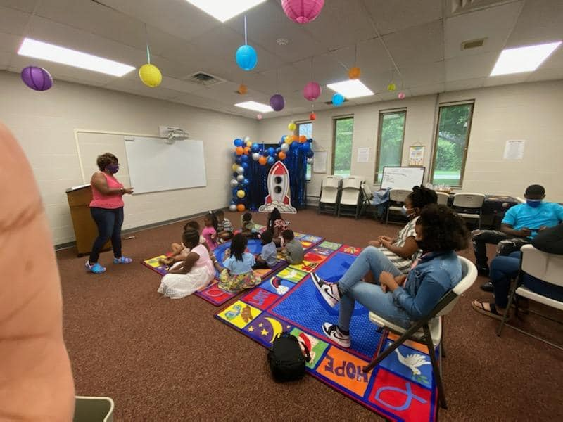

Hello all! Awesome worship once again with Mt Zion Kids!! We are in week 2 of our Blast Off Series. Our very own Sis. Diane Byrd taught the children how people can help our faith grow with the assistance of Sis. Karen Kirksey (Mark 2:1-12; Galatians 6:2). Come join the fun every 2nd, 3rd and 4th Sunday!! #MeetMeAtTheMount

Memory Verse: Psalm 119:105, “Your word is a lamp for my feet, a light on my path” NIV

~Sister Aleshia Graham

Youth Director Contact Info
Sister Aleshia Graham
Cell: 513-516-3707
Email: aleshia_graham@yahoo.com
Children’s Church is every 2nd, 3rd, and 4th Sunday

Did You Know?

Music Ministry

Praise Team is coming back! If you are interested in being on the singing rotation list, please email Bro. Eric Watford at watfore@ucmail.uc.edu. The first rehearsal will be on Thursday, August 18, 2022, at 7:00 p.m.

The Mt. Zion Credit Union annual meeting will be held on Saturday, September 17th at 1 pm. Officers will be elected and should be members of our church.

Please Note: All ACTIVE members are encouraged to attend and vote.

T-shirt Order Update

Due to a shortage in color and sizes, our T-Shirt order has been delayed. We will keep you posted.

Upcoming Events

- September 10, 2022, 10:00 am-1 pm, Final Shred Event

- September 11, 2022, 10:45 am, Seasoned Saints Day (Pastor James Wynn of Bethel Baptist Church, Guest Preacher)

- September 15, 2022, 6:30 pm-8:00 pm, Council of Ministries Meeting (In-Person)

- September 17, 2022, 1:00 pm, Mt. Zion Credit Union Annual Meeting

- September 25, 2022, 10:45 am, 153rd Church Anniversary (Pastor Maurice Byrant of Rebirth Church, Guest Preacher)

Thank You

Thank you for remembering to support your church financially. As a reminder you have a choice to stop by the church on Tuesdays, Wednesdays, and Thursdays between the hours of 11:00 a.m. and 4:00 p.m. to drop off your tithes and offerings. You still have the ability to use Givelify and of course your checks are still welcomed and accepted. Place your check (no cash) in a secure envelop and mail to:

Mt. Zion Baptist Church
10180 Woodlawn Blvd.
Woodlawn, OH 45215

If you are having trouble receiving Church Correspondence, please let us know and we will make every effort to ensure that you receive the correspondence. Also, if you know of any member that is not receiving the correspondence, please have them to notify the church.

Please continue to pray for those who are sick, shut-in and in nursing homes/care centers. I have attached a list of our sick and shut-in members as well as those that are in the nursing homes. Please check with the nursing home prior to your visit to ensure that they are allowing visitors. Please pray that all the residents will remain safe.

Please join us for the following weekly worship services/Bible Studies:

Wednesday Noon Bible Study (Wednesdays at 12:15 p.m.)
Teacher: Deacon Sanford Kirksey
Scripture: 2 Thessalonians Chapter 2
Dial in Number: (470) 480-9361

Wednesday Evening Bible Study (Wednesdays at 7:15 p.m.)
Teacher: Pastor Christopher R. Graham, Sr.
Scripture: 2 Timothy Chapter 1
Dial in Number: (470) 480-9361

Saturday Morning Bible Study (NO SATURDAY BIBLE STUDY/CANCELLED)

Sunday School (Sunday, August 28, 2022, at 9:15 a.m.)
Sunday’s Lesson: Come and Enjoy
Teacher:
Study Scripture: Revelation 22:10-21
Dial in Number: (470) 480-9361

Sunday Morning Worship Service (Sunday, August 28, 2022, at 10:45 a.m.)
Morning Message: Pastor Christopher R. Graham, Sr.
Sermon: Total Dependence: The Season of More with Less
Sermon Text: Judges 7:1-7
Dial in Number: (470) 480-9361
Facebook Live and YouTube is also available for this event: Mt. Zion Baptist Church Woodlawn; YouTube—Type in MtZionWoodlawn (It is case sensitive)

Saturday Evening Prayer
Receiving Prayer Request Every Saturday Evening at 4:15 p.m.
Evening Prayer: Deacons
Dial in Number: (470) 480-9361

Monday Morning Prayer
Receiving Prayer Request Every Monday Morning at 8:15 a.m.
Morning Prayer: Sister Deanna Kimbrough
Dial in Number: (470) 480-9361

Reminder: All mass mailings to members should come from the office. This gives us the opportunity to ensure that the congregation receives information sanctioned by the Church.

We encourage you to continue to reach out to each other to minister the Good News. Most importantly, our hope rests in the Lord Almighty, Emmanuel, God-with-Us. In the words of the Psalmist:
If you make the Most High your dwelling—even the Lord who is my refuge—then no harm will befall you, no disaster will come near your tent. (Psalm 91:9-10 NIV)

During this time of the pandemic, we are not alone! God is with us, and we have each other as members of the Body of Christ.

In His Service,

Pastor Christopher R. Graham, Sr., M. Div

