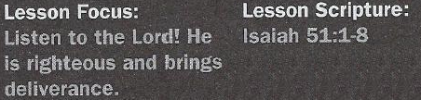
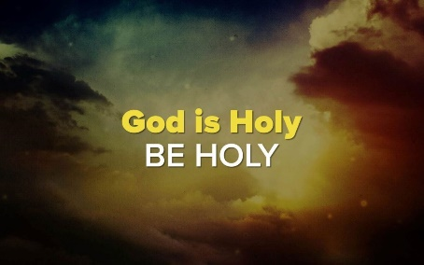

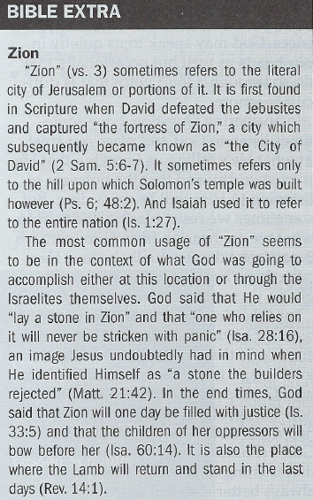

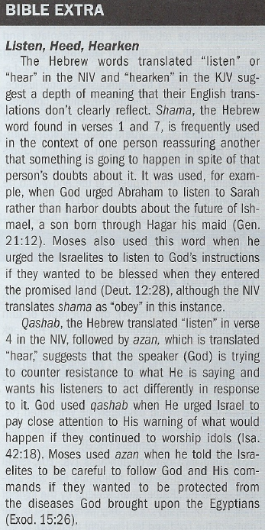

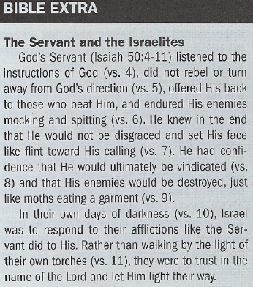

Your Land Will Be Restored - Isaiah 51:1-3
4. Who was God addressing in this passage?
5. What was He promising?
6. What did the Israelites need to remember if they had doubts about this?

My Justice Will Reign- Isaiah 51:4-6
7. What would the Israelites long for?
8. When will what they long for be realized?
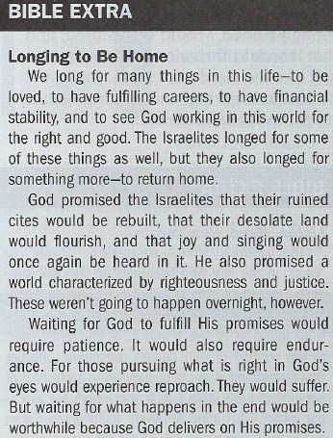
9. How certain was this?

Your Enemies Will Be Devoured - Isaiah 51:7-8
10. What would the Israelites experience as they waited to be delivered?
11. What was going to happen to their enemies?
12. How did God want His people to respond to this?

Suggested Answer to Question 1
Regarding Question 1, God speaks to us through His Word. But He also
speaks through the written or spoken words of others, through His creative
works, and through what we learn from life experiences. God may speak
to us quietly in our hearts as well but occasionally may do so through a
loud voice that is difficult to ignore.
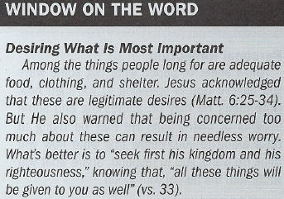
Suggested Answer to Question 2
In answering Question 2, we sometimes listen to God and place our trust
in what He's telling us knowing that He is trustworthy and that the outcome
of listening to Him will be rewarding. But sometimes we resist placing our
trust in what we are hearing from Him, perhaps because we don't actually
believe Him, or perhaps because doing so requires giving up something
we value.
Suggested Answer to Question 3
For Question 3, we would be better listeners if having faith in God was a higher priority than trusting in ourselves or in others, if we were more familiar with how God spoke to others in the past and how He speaks to people today, if we had more understanding of and trust in God's character, or if we were confident that trusting in Him and His Word is always better than not doing so.
Suggested Answer to Question 4
God was addressing those who want to do what is right in His eyes. More specifically, it was those
who would live in exile following the destruction of Israel by the Assyrians and Babylonians and who longed to return home.
Suggested Answer to Question 5
God was promising that their land, though ruined, would be restored, and that it would thrive once again and be just like the Garden of Eden. Joy, gladness, thanksgiving, and singing would return to the land as well.
Suggested Answer to Question 6
They were children of Abraham. This was the rock from which they were cut. Just as God fulfilled His promise that out of Abraham would come many, so would He fulfill His promise that He would restore their land and return them to it.
Suggested Answer to Question 7
They would long for the day when God's righteousness and justice ruled the world.
Suggested Answer to Question 8
Although God said that this would happen speedily, it would not happen in the lifetime of those living in exile. The complete fulfillment would be partially fulfilled when Jesus became a light to the nations and through His death and resurrection provided a means to be right with God. The Lord's "salvation" is beyond the limits of time and space. Final fulfillment will not happen until the end of this age.
Suggested Answer to Question 9
It was more viable than the continued existence of the heavens and earth. Although these could disappear, His salvation would endure and last forever.
Suggested Answer to Question 10
They would experience reproach; they would be insulted; their natural reaction would be to feel terrified.
Suggested Answer to Question 11
Their enemies would eventually be devoured much like what moths and worms do to a garment.
Suggested Answer to Question 12
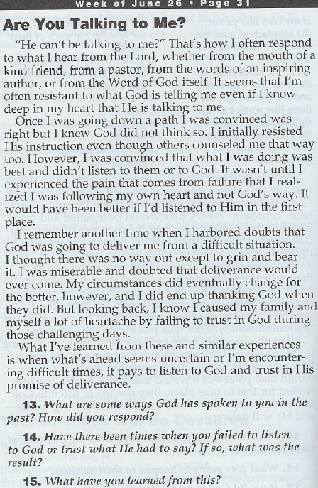
They were not to be fearful of their enemies or be terrified of their insults knowing that their afflictions were temporary and that God's salvation, once established, would last forever. Introduction
The opening lines of Charles Dickens’s A Tale
of Two Cities are easily recognized by many readers:
“It was the best of times, it was the worst of times.”
The same words could be used to describe Judah
during Isaiah’s ministry (see lesson 3 Lesson Context).
The best of times were reflected in Judah’s economic
and military prowess (Isaiah 2:7); the worst of times
were marked by the sin of idolatry and consequent
exile in Babylon (39:6–7).
In many ways, Judah’s punishment was an
indictment of their false gods and of the sins those
“gods” condoned. The people had turned from the true
God in spite of the great acts of deliverance they had
experienced as a nation, and the admonitions in the
Ten Commandments to have no other gods or graven
images (Exodus 20:3–6). And the exile did have a
purifying effect. Following the Babylonian captivity,
Jewish idolatry was never a serious problem again
(though of course other issues arose). The Jews who
returned stood firm on their faithful foundation (see
Isaiah 51:1b–2, below), no matter what foreign
invaders tried to tempt them with new gods. Though
they had suffered through the worst of times, even
better than their previous best times were still ahead.
We can also assert that Babylon was punished
for following their false gods. Had their worship been
rendered to God and concerned with justice and righteousness instead of acquisition and power, the story of the Babylonian Empire would have been very different. In Isaiah 46–47 God mocked the Babylonians’ idolatry and its associated practices (see lesson 1). The idols have to be carried, but God’s judgment would have them carried away (Isaiah 46:1). Though the people bowed to gods that they made, the God of the heavens had declared their end (46:10). Their “best of times” was about to come to a permanent close.

Conclusion
Looking to our past offers important insights: about faithfulness, examples to follow or deviate from, the people and events that have shaped us. Isaiah prepared the nation to look forward to Jesus, but we look to the past, present, and future when we look to him. The salvation work Jesus has done is the reason for our joy in the present and our hope in the future. So, when you think about whether to look to the past, present, or future, the answer is: all three! Look to Christ and his ministry, his sacrifice, his death and resurrection. Look to the body of Christ that continues to call the world to repent of sins and be reconciled to God. And look to the glorious future when God’s promises of eternal life will no longer be a hope but our present, eternal reality.

