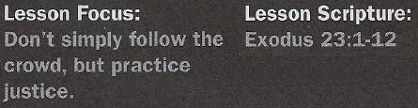

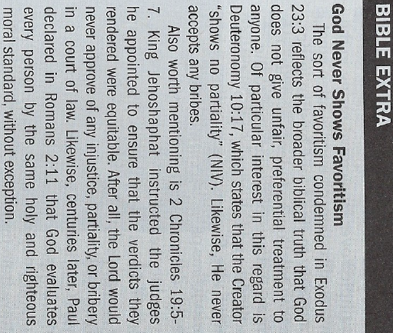

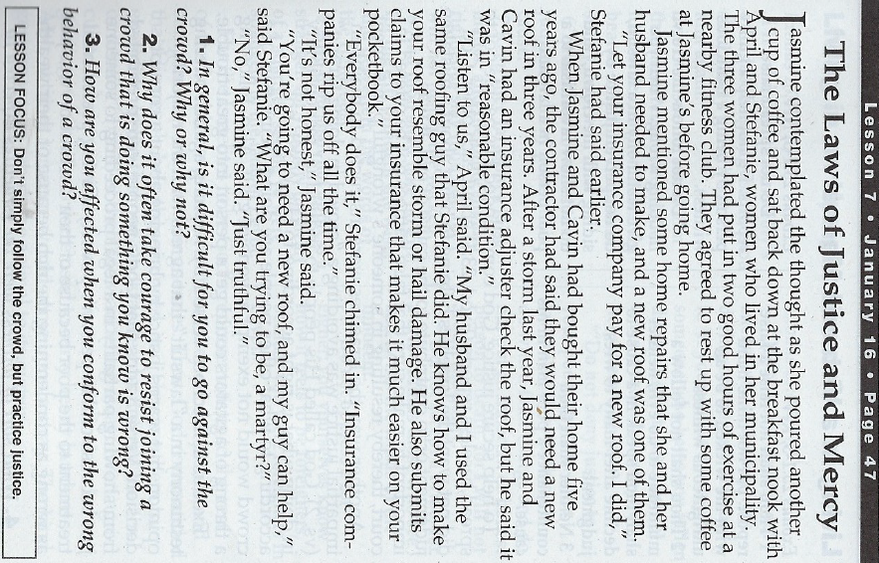

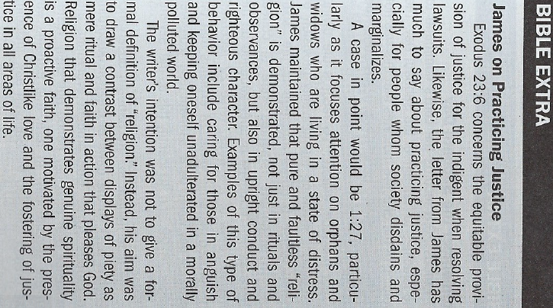

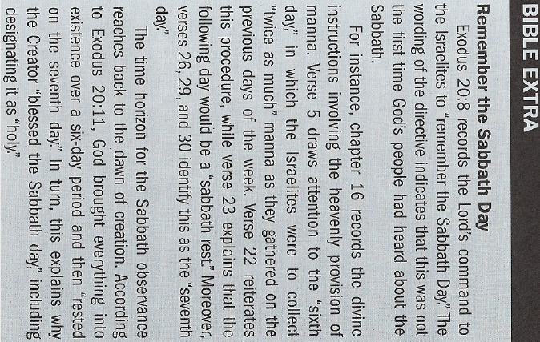

Living in a Virtuous Manner - Exodus 23:1-3
4. What sort of witness were the Israelites expected to foster?

Living in an Upright Manner - Exodus 23:4-9
5. How were the Israelites to treat their enemy's property?
6. How were the "poor" (Exod. 23:6) to be treated in a court of law?
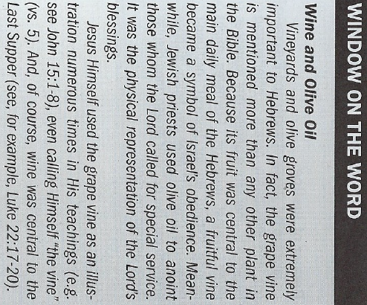
7. Upon what basis did the Lord appeal to the Israelites in their treatment
of a foreigner (Exod. 23:9)?

Observing Sabbath Regulations - Exodus 23:10-12
8. How did the Sabbath impact the Israelites' agricultural practices?
9. What place did the Sabbath occupy among the Israelites?

Suggested Answer to Question 1
Question 1 invites us to self-reflect on how a crowd affects us. Some may
find it terrifying to defy the sentiment of those they wish to please; others
may be easily inclined to dismiss any group of people; still others may
waver in their response to a crowd depending upon their mood and their
relationships with members of the group.
Suggested Answer to Question 2
Question 2 addresses the issue of uncommon fortitude. Courage is confronting wrong when there is a price to be paid. Therefore, at the cost of being trampled over by a crowd racing in the wrong direction, courage is often what is necessary to stand for Christian justice.
Suggested Answer to Question 3
For Question 3, we may discuss three ill effects of succumbing to the attitudes and behavior of a crowd that acts badly. First, its effect on those who are victims of such a crowd is so hurtful that it desensitizes members of the crowd to the feelings of others. Second, one becomes prideful, thus, distorting a proper perspective of one's self. And third, each member's relationship with God is damaged, for the longer a member participates in the actions of such a group the further that member strays from the Lord.
Suggested Answer to Question 4
Exodus 23:1 clarifies that God's people were to be honest in the testimony they gave. This included giving a factual, rather than a baseless, report. It also entailed telling the truth, rather than
lying, in a legal proceeding.
Suggested Answer to Question 5
The Lord directed His people to resist the temptation to treat their enemy's property in a vengeful, self-serving manner. Instead, as Exodus 23:4-5 indicates, the Israelites were to be compassionate
and fair-minded. This even included making sure that an antagonist's livestock received appropriate attention when it fell into any mishap.
Suggested Answer to Question 6
God commanded the Israelites neither to ignore nor shortchange the judicial process for the impoverished. Even in circumstances involving disputes between them and their rich peers, justice had to be preserved. Oppositely, the perversion of the legal system was to be resisted.
Suggested Answer to Question 7
God reminded His people that prior to the Exodus, they were foreigners in Egypt. This included being exploited by their taskmasters. The Lord wanted the Israelites to remember this harsh reality so that they would reject any impulse to oppress the foreign residents living among them.
Suggested Answer to Question 8
God wanted the Israelites' planting and harvesting of crops to fall under the Sabbath regulation. For instance, the people could pursue their normal agricultural activities for "six years" (vs. 10).
Then, during the "seventh year" (vs. 11), the Israelites were to let their fields lie fallow.
Suggested Answer to Question 9
It would be difficult to overstate the importance of the Sabbath to Israelites. Their continued observance of the seventh day of the week was central to their ongoing existence as God's chosen
people. Even their livestock, slaves, and foreigners were to heed the Sabbath injunction (Exod. 23:12).

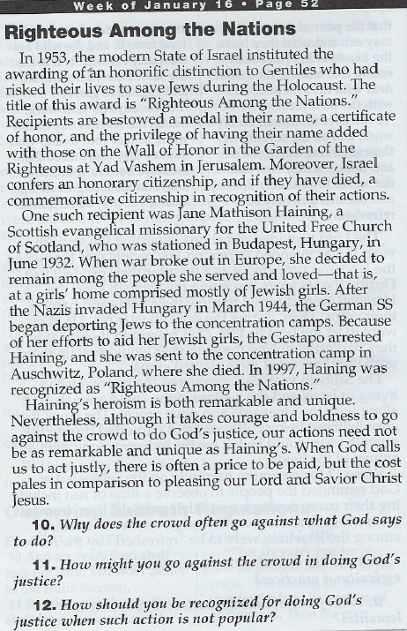

Introduction
To understand the laws under consideration in today’s text, we must pay attention to their contexts (plural). On a larger scale, Exodus 21–23 is often called the Covenant Code because it gives foundational rules for ancient Israel’s corporate life. In other words, the laws reflect how people were to conduct themselves in typical, everyday situations. This collection of laws is the basis of longer discussions in Leviticus 17–27 and Deuteronomy 12–26.
Within Exodus, the Covenant Code comes immediately after the Ten Commandments. While that shorter list includes 10 distinct laws, expressed for easy memorization, the longer list of the Covenant Code repeats itself and arranges topics more by association (“speaking of X, consider also Y”). That sort of organization appears in today’s lesson.
The sequence of the laws influence meaning. Readers should not think of them as sound bites but as a web of required behaviors that collectively reflected the character of those practicing them.
On a smaller scale, today’s text of Exodus 23:1–12 concentrates on issues of justice. Verses 1–9 fit closely with the end of chapter 22, while verses 10–12 open up a discussion of the proper use of time for worship and rest. The two major sections of the text at hand use the same sort of lock-and-key organizational technique common in Israelite legal texts and in the book of Proverbs. That is, several statements on obviously related themes follow each other. Then the topic seems to change, and then it returns to the original subject.
This pattern challenges the reader to see previously unconsidered dimensions of both the main idea on the ends of the list and a seemingly different idea wedged into the middle. In this case, Exodus 23:4–5 seems to change the subject covered in verses 1–3 and 6–8, all of which feature a courtroom setting. Verses 4–5 envision encounters out in the field or on the road. The apparent change of topics reminds the reader that lying in court does not occur in the abstract but at the expense of real people and relationships. Conversely, the text’s connection between judicial proceedings and ordinary helpfulness toward enemies reminds the reader that even the most mundane incidents of life have wider societal implications.

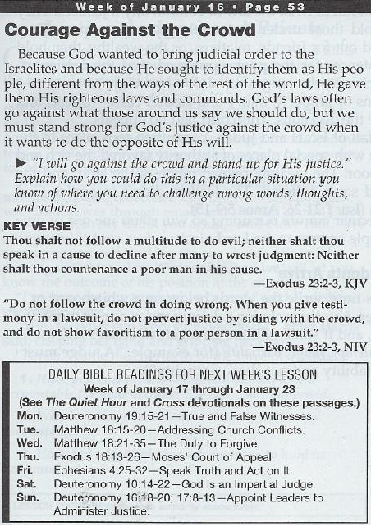

These laws apply concretely the more general command to “love your neighbor as yourself” (Leviticus 19:18). Since people tend to extend greatest love to friends and family members while treating others less favorably, the Law of Moses identifies classes of people who deserved respect in the Israelites’ interactions with them. The law does not allow for rationalizing, self-indulgence, or sanctimonious self-justification. Rather, it demanded that the Israelites take seriously their status as peers with all other human beings and as fellow subjects of their Creator. This fact is reflected in the apostle Paul’s statement that “whoever loves others has fulfilled the law” (Romans 13:8).
These laws also assumed that the Israelites wanted to be people of integrity. The Israelites should have wanted to act justly, even when pushed to do otherwise or when conflict made them want to take personal revenge. They were to have recognized their own faults and temptations to misbehavior and take steps to correct them.

Conclusion
One of the most powerful treatments of the nature of God appears in Exodus. It contains a richly layered set of stories exploring the question “What sort of God do we have in our midst?” This story lies behind all of Israel’s laws. Rather than creating a long philosophical discussion on God, the scroll of Exodus weaves together stories about divine actions and conversations around them. As it reveals a God who practices a radical commitment to mercy, Exodus does not avoid the challenges that belief in a redeemer God poses.
The 600-plus laws in the Old Testament do not address every imaginable circumstance. Even so, they lay out enough specific examples to allow thinking people to figure out how to act in situations not explicitly named. The Law of Moses invites reflection. Those following it ask questions that will shape commitments and attitudes for a lifetime.
A remarkable feature of today’s church in much of the Western world is its distance from the poorest among us. American Christians, in particular, often seem to live in a bubble. Wealth is taken as proof of God’s blessing, which can lead us to blame others for their alleged failures if they do not obtain it. We are slow to acknowledge how decisions of past generations still affect people’s lives. And those most vulnerable pay the price for that self-deception.
The Law of Moses, while aimed at the people of Israel, offers guiding principles for the church as well. Life together requires practical actions that show love for difficult people. In this way, we can fulfill the law: to love our God, and to love both neighbors and enemies, wherever they are found.

