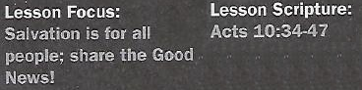

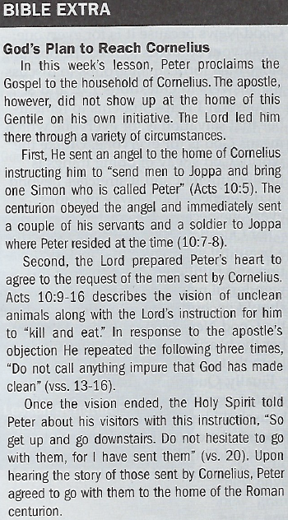
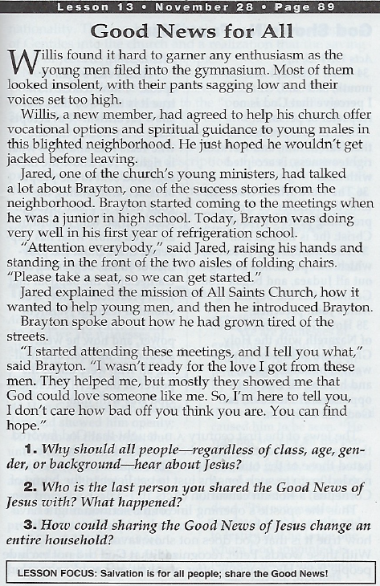

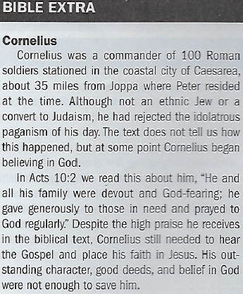

God Shows No Favoritism - Acts 10:34-36
4. How did Peter's opening comment in verse 34 represent a dramatic
shift in the thinking of the apostle?
5. Why did Peter take the time to introduce Jesus to his audience
before describing His saving work on the Cross?

The Gospel Is for Everyone - Acts 10:39-43
6. What was the significance of witnesses in regard to the Resurrection?
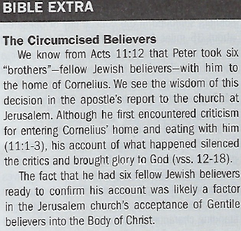
7. How does one receive the forgiveness of sins that Peter proclaimed?

The Holy Spirit Responds to Saving Faith - Acts 10:44-47
8. At what point did the Holy Spirit come upon the Gentiles gathered at the
home of Cornelius?

Suggested Answer to Question 1
Question 1 helps us to remember that salvation is for everyone which
means God is for everyone. Unlike the world, God's way of doing things is
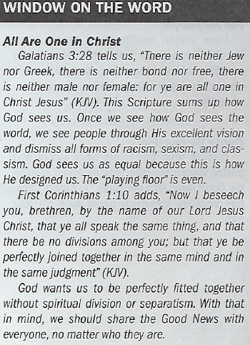
totally different and it stretches beyond all differences. God's way includes
everyone because He created everyone.
Suggested Answer to Question 2
For Question 2, we may describe a beautiful experience that included ela-
tion and fulfillment after sharing the wonderful news of salvation. This les-
son should encourage us to share the Good News more often and remem-
ber the beauty of salvation that came from that sharing.
Suggested Answer to Question 3
Finally, Question 3 challenges us to see the possibility of an entire house-
hold being saved after hearing the Gospel. Amazing things happened at a
household in Philippi, for example, and to the household of Cornelius.
Suggested Answer to Question 4
Up to the beginning of Acts 10, Peter believed that God did show favoritism
to the Jewish people as did the majority of his fellow Jews. He would never
have entered the home of Cornelius apart from the Lord working supernaturally through a vision, sending an angel to Cornelius, and the Holy Spirit telling him to go with the men that the Roman centurion had sent to him.
Suggested Answer to Question 5
While Cornelius and his household may have heard rumors about Jesus, His ministry, and death on the Cross, we can be sure they had never heard a complete or accurate account of His ministry. In order to fill in the gaps in their knowledge and correct any misunderstandings, Peter introduced
Jesus and His ministry to those assembled in Cornelius's home before moving on to sharing the Gospel with them along with their need to believe in the Savior.
Suggested Answer to Question 6
The witnesses, who included Peter, confirmed the reality of the Resurrection. They had not only seen the risen Savior, but watched Him eat and drink. Such a claim required witnesses and it's likely that Peter went into further detail about those who had seen and spent time with Jesus after
God raised Him from the dead. This was the event that confirmed the truth of the Gospel.
Suggested Answer to Question 7
Peter's words confirmed that the good news of salvation applies to everyone. One need not become a Jew first or perform good works. The forgiveness of sins is available to all who believe in
the name of Jesus. Eternal life results from an inner act of faith that trusts Christ alone for salvation.
Suggested Answer to Question 8
The Holy Spirit came upon the Gentiles at the home of Cornelius when they believed Peter's message about Jesus and the Gospel. Peter was still speaking when the Holy Spirit came upon everyone in the room. Saving faith starts with a response of the heart, but manifests itself outward in ways such as baptism.

Introduction
Today’s passage is an excerpt from a longer story that extends from Acts 10:1 to 11:18. The length of this account, which comprises more than 6 percent of the book of Acts, reflects its significance.
This turning point in history occurred after the day of Pentecost, when the apostle Peter had declared in his gospel message that “the promise is for you … and for all who are far off—for all whom the Lord our God will call” (Acts 2:39). Given Peter’s surprise in today’s passage, he may have presumed that “all who are far off” referred only to all Jews who were far off (compare addressees in James 1:1).
Our lesson text has Peter standing before a Gentile audience, poised to share the gospel. This was a huge step for Peter. To observant Jews, Gentiles were unclean pagans, who might endanger the apostles’ own religious and moral purity. Any sharing of faith beliefs by Jews to Gentiles would have been “clean” ones testifying to “unclean” ones.
But God was changing that mind-set. The correction began with two visions that occurred about 21 hours apart: the first to a Roman centurion named Cornelius (Acts 10:1–6) and the second to the apostle Peter (10:9–16). The respective locations were the cities of Caesarea Maritima and Joppa, about 30 miles apart, on the coastline of the Mediterranean Sea.

Cornelius was no ordinary Gentile. He had a track record of praying to Israel’s God and modeling generosity to his neighbors (Acts 10:2). There is no indication, however, that Cornelius had fully converted to Judaism. Luke (the author of Acts) refers to individuals like Cornelius as fearing God and/or being “devout” (10:2; 13:26; 17:4, 17). This was in contrast to “proselytes”​—​those who had converted to Judaism fully (6:5; 13:43). Even so, God, recognizing the sincerity of Cornelius’s faith, chose this man to be the starting point for extending the gospel to Gentiles.
God reached out to Cornelius by means of an angel, who instructed him to send for Peter (Acts 10:3–8). Next, God gave Peter a vision in which the apostle was commanded repeatedly to eat food forbidden to Jews (10:9–16). This conveyed a message that what had been declared unclean was no longer so.
Immediately following Peter’s vision, messengers from Cornelius arrived and invited Peter to the Gentile’s house (Acts 10:17–23). Upon arriving, Cornelius and Peter shared their experiences (10:24–33). This takes us into today’s text.

Conclusion
The scope of God’s salvation is highlighted in today’s pivotal text, when Gentiles received an outpouring of God’s Spirit as Jews had earlier. Questions remained regarding what role former identity markers of God’s people—markers such as circumcision, dietary laws, and observance of special days—would continue to play. Such questions were settled at the famous Jerusalem Council of Acts 15: these external markers were no longer essential to the people of God.
God’s plan was to spread the news of salvation through his old-covenant people, the Jews (John 4:22). Jesus was Jewish, as were his closest disciples. All people who were not Jewish were lumped into a single category: Gentiles. (Samaritans could be a complicating additional category.)
To devout Jews, Gentiles were regarded as complete outsiders unless they adhered to the Law of Moses (Exodus 12:48–49; etc.). Today’s passage overturned all this. We can do no better than allow the apostle Paul to summarize this change:

Christ Jesus … [set] aside in his flesh the law with its commands and regulations. His purpose was to create in himself one new humanity.… For through him we both have access to the Father by one Spirit.
—Ephesians 2:13–18

The good news of God’s kingdom is now available to all who believe (see Romans 1:16). We should be on the lookout for people such as Cornelius​—​individuals who may be open to hearing the gospel, but who have never had it explained.

