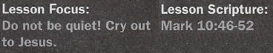

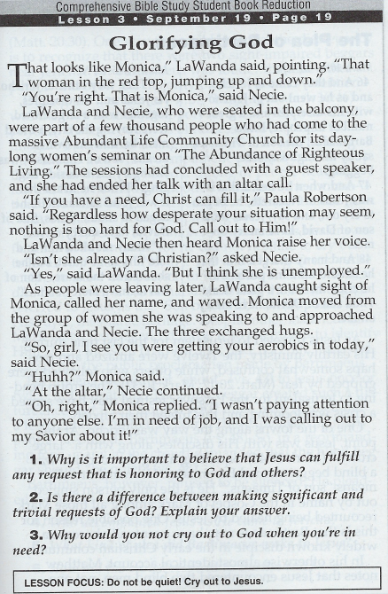

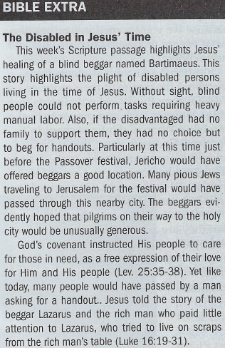

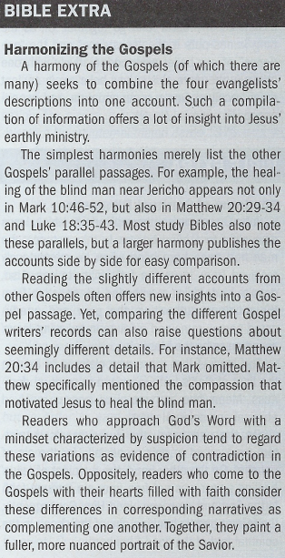

The Plea of Bartimaeus - Mark 10:46-48
4. Who accompanied Jesus as He came to Jericho?
5. What kind of plea did Bartimaeus make to Jesus?
6. How did the crowd respond to Bartimaeus?

The Healing by Jesus - Mark 10:49-52
7. How did Jesus respond to Bartimaeus?
8. What was at the heart of the Bartimaeus's request?
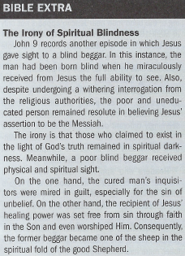
9. What word of encouragement did Jesus offer to Bartimaeus?

Suggested Answer to Question 1
For Question 1, most of us will probably believe that God can do anything;
that's where we place our faith. When we ask Him for something, we know
that the nature of our requests is important. Are we asking Him just
because we want something, or because what we are requesting honors
Him and helps others?
Suggested Answer to Question 2
Question 2 asks us to think about the nature of our requests. Perhaps we
think God only listens to "big" requests such as a prayer to heal someone.
We may think we shouldn't "bother" God with some things in our lives. But
even requests we make for ourselves can be honoring to God. A blind man
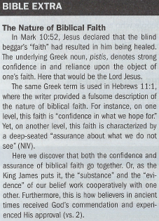
asked for his sight. He received it and God was honored.
Suggested Answer to Question 3
For Question 3, we may say that we are afraid God will not answer, per-
haps because He did not answer prayers in their past. We must boldly
bring our God-honoring requests to Jesus, and He will listen to us.
Suggested Answer to Question 4
A large and diverse group of people traveled along with Jesus (Mark 10:46).
As on nearly all occasions, there were the Twelve. There was also a size-
able throng of interested onlookers, some of whom might have included an
assortment of curious religious leaders.
Suggested Answer to Question 5
The plea Bartimaeus made did not focus on his impoverished situation.
Instead, he concerned himself with his blindness. This motivated him to
implore Jesus to be healed (Mark 10:47).
Suggested Answer to Question 6
The gaggle of people who accompanied Jesus were uncharitable in their
response to Bartimaeus. They thought he should stop his clamoring for
attention. And so, they told the beggar to "be quiet" (Mark 10:48).
Suggested Answer to Question 7
Jesus could have obliged the throng's impulse to muzzle Bartimaeus. Yet,
Jesus did not do this. Instead, He responded in a compassionate and
receptive manner to the beggar's pleadings (Mark 10:49).
Suggested Answer to Question 8
Bartimaeus could have taken advantage of the moment by imploring Jesus
for a handout. Yet, the beggar did not do this. At the heart of his request
was his sight to be restored (Mark 10:51).
Suggested Answer to Question 9
Earlier, the crowd had censured Bartimaeus for even making a sound. Now,
though, the blind beggar had Jesus' full attention. In turn, the Savior
declared that Bartimaeus had been "healed"(Mark 10:52) as result of his
"faith."

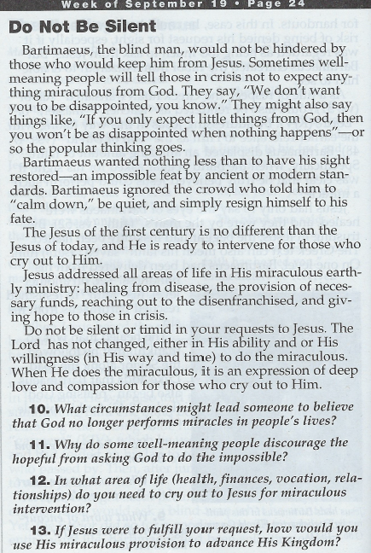

Introduction

Blindness was a familiar condition in the ancient world, with the Bible itself using some form of the word blind dozens of times. The Papyrus Ebers, an Egyptian medical text of about 1500 BC, identifies various diseases of the eyes and suggests numerous remedies. These take the form of potions​—ingredients of which are decidedly not prescribed today! In some cases, Egyptian physicians were advised to paint the mixture on the eyes of the patient, using a bird’s feather.
As with many supposed remedies, healing may have occurred in spite of the treatment and therefore given the impression of effectiveness. But from our current vantage point, there was no reliable cure for blindness in Jesus’ day and little understanding of its causes.
Many believed that blindness was a curse from God for some type of sinful behavior. The sins of the parents were thought to affect their children, causing them to be born blind (see John 9:1–2). The ancients knew that some diseases could leave a sufferer with damaged vision or blindness (see Leviticus 26:16). Such outcomes we now know may result from diseases like malaria or measles. In other cases, blindness might be the result of injury or could be progressive with age (such as cataracts or macular degeneration; the last line of Ecclesiastes 12:3 uses figurative language to describe failing eyesight).
In all cases, blindness was economically and socially debilitating. For example, blind men could not serve as priests (Leviticus 21:16–18). Those afflicted with blindness had little opportunity for employment and were reduced to begging or depending on family support to survive. The Jewish law forbade taking advantage of the blind (Leviticus 19:14; see Deuteronomy 27:18), but no amount of legal protection could restore sight. The parable of the great banquet includes blind people as among the most unfortunate (Luke 14:21; see also 14:13).
Blindness and sight in a spiritual sense are important themes in the book of Mark. When questioned on the meaning of the sower parable (Mark 4:1–20), Jesus revealed that there would be people who saw what Jesus did but would not understand the good news he brought (4:12). Later, when Jesus was in a boat with the Twelve, he chastised them for their failure to understand his person and mission, saying, “Do you have eyes but fail to see” (8:18). Mark, the author, left the question open-ended so that his readers might answer it too. In essence Mark asks: “Have you read about Jesus this far and still don’t see who he is or understand the spiritual lessons he is teaching?”

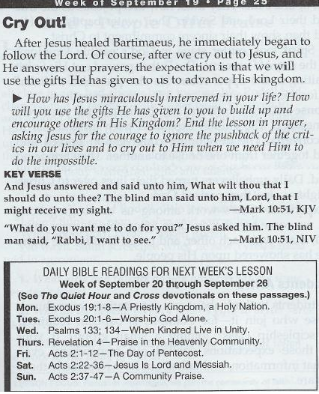

Conclusion

The restoration of a blind man’s sight was a great and merciful miracle. But in the larger context of the Gospels, Jesus encountered many who were spiritually blind, having unresponsive hearts that refused to recognize or honor him. Our journey with Jesus begins when we realize we are blind and on the side of the road, sidelined and desperate. It’s at that point when we allow Jesus to make us whole. Then we join him, joyfully walking and learning as we go. This is a timeless picture of discipleship (Matthew 16:24; John 14:6).
When we consider the necessity of faith, we learn some things about Jesus—and about ourselves. In the instance of today’s text, as in those that came before, Jesus honored faith. The faith of Bartimaeus was very simple: he believed that Jesus was willing and able to help. The man was not questioned about what he knew or believed about the coming Messiah. Neither was he queried regarding exactly what he meant when he called Jesus “Son of David” (Mark 10:47–48) or “Rabbi” (10:51). Neither his doctrines nor motives were called into account (contrast Mark 10:17–18; John 6:25–26; James 4:3).
When we are in crisis and see no relief, we may say “Lord, have mercy” without thinking about the import of these words. Yet this is a prayer, imploring God to notice our pitiful situation and provide relief. In that regard may we take a lesson from Bartimaeus, being willing to call on the Lord when the crowd has a different agenda. May the eyes of our hearts be opened to see Jesus clearly and obey him fully (see Ephesians 1:18).

