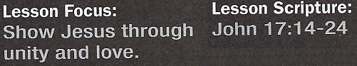
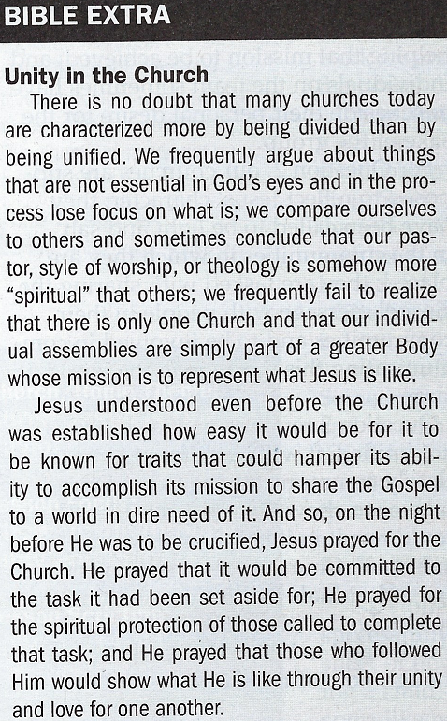

Jesus Prayed for His
disciples - John 17:14-19
4. What was the first thing Jesus prayed for at the end of the last supper He shared with His
disciples?
5. What was the second thing He prayed for?

Jesus Prayed for the Church - John 17:20-23
6. What was the third thing Jesus prayed for?
7. Why was it critical that those following Him be unified?
8. What example did Jesus provide?

Jesus Expressed His Will - John 17:24
9. What was the last thing Jesus prayed for?
10. What was required if His followers were to fulfill the purpose for
which they had been called?

Suggested Answer to Question 1
Regarding Question 1, for a team to successfully accomplish its
mission, it needs to clearly identify what that mission is; it requires a
commitment from all members of the team to do their part in helping
that mission to be achieved; and individuals on the team sometimes
have to set aside their personal desire for the sake of the group.
Suggested Answer to Question 2
For Question 2, our churches are supposed to reflect Jesus' character;
they have been called to be light and salt in the communities in which
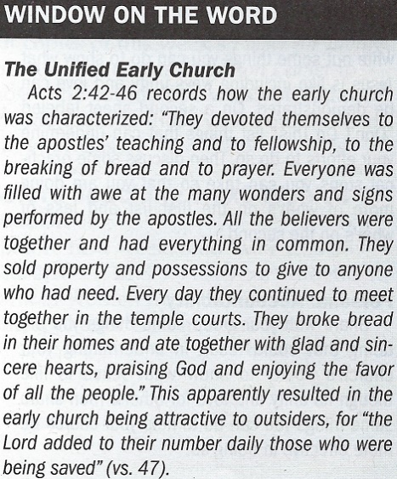
they are placed; they are tasked with sharing the Gospel message
with people in their communities and to be involved in communicating
this message to the world at large.
Suggested Answer to Question 3
Question 3 reminds us if a church is not unified, it will be difficult for it
to clearly communicate the Gospel message or to show what Jesus is
like. This could result in it being unattractive to outsiders. Churches
also need to encourage individuals and groups within it to be involved
with members of their community and to be "in the world" even though
not "of the world."
Suggested Answer to Question 4
Jesus first prayed for Himself. He knew that His mission and purpose
for coming to earth was to die so that others could live. He demon-
strated in His prayer His determination to complete this mission so that
God's purpose for Him could be fulfilled.
Suggested Answer to Question 5
Jesus then prayed for His disciples. Jesus knew what lay ahead for them would be difficult. He didn't pray that they would be removed from the world so they could escape these difficulties, however, but that they would be protected from spiritual harm in the midst of them. Jesus also prayed for their sanctification, that they would live according to His Word, and they would remain
committed to the proclamation of it.
Suggested Answer to Question 6
Jesus prayed for those who were going to follow Him. He was in fact praying for the Church, the instrument He chose to represent what He is like and to communicate the Gospel message to others. Jesus may have understood how easy it would be for churches to be characterized by divisiveness, competition, or exclusiveness and didn't want these to be the traits believers in Him are known by.
Suggested Answer to Question 7
Jesus understood that the world would know what He is like by observing what the Church is
like. If churches are not unified in both their character and message, the world will have a faulty
understanding of what Jesus is like.

Suggested Answer to Question 8
Jesus noted that He is in the Father and the Father is in Him. This is perhaps best represented
by one circle with two names rather than two with different names. There is in a sense no "He and
Me" when it comes to the Father and Jesus; there is just "We." Churches are to exemplify this same type of oneness.
Suggested Answer to Question 9
Jesus prayed that His disciples would someday see the, full extent of who He is, something that would not occur until they joined Him in eternity. Jesus was not merely asking for this to happen,
however. His prayer is perhaps best understood as Jesus willing or promising for this to be done.
Suggested Answer to Question 10
Jesus wanted them to demonstrate His character and communicate the path to eternity through their words and lives; He wanted them to show what He is like through their unity and love.

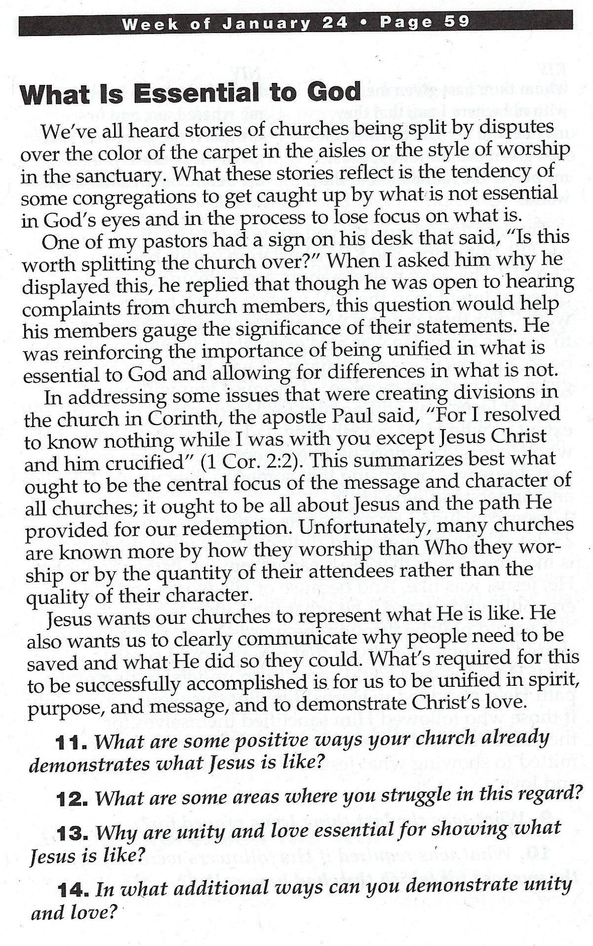

Introduction

Matthew 26:36–44; Mark 14:32–40; and Luke 22:39–46 give brief accounts of Jesus’ prayer in the Garden of Gethsemane. Their focus is on his agonized petition that he might be spared the crucifixion. John’s Gospel, by contrast, doesn’t include that prayer. Instead, it features Jesus’ lengthy and detailed prayer for his disciples.
That prayer comes at the end of a lengthy section known as the Farewell Address (John 13–17), the longest recorded speech by Jesus. After washing the disciples’ feet and dismissing Judas into the night (13:1–30), Jesus told his confused followers that he would not be with them much longer (13:33). He gave them a “new command” to be followed after his departure from the world: “As I have loved you, … love one another” (13:34).
The remainder of Jesus’ goodbye speech builds on this theme by explaining how God would express his love for the disciples (examples: John 14:8–21; 15:26–27; 16:5–15), why “the world” would hate them (example: 15:18–25), what it means for Christians to love one another, and why it was essential to do so (17:20–24).
In the opening section of the prayer (John 17:1–13), Jesus reflected on his pending death and reminded the Father that the Son’s mission would continue through the disciples. Therefore, Jesus asked his heavenly Father to equip the disciples in certain ways so they could continue his work. The form and content of that equipping is the subject of today’s text.

Conclusion

Marketing companies are becoming increasingly interested in a phenomenon known as the Streisand Effect. This term is based on the name of singer/actress Barbra Streisand, and it refers to an episode in which she was involved in 2003.
A photographer was contracted to take a series of photographs that would document patterns of coastline erosion throughout the state. When Streisand learned that these included one picture of her seaside Malibu mansion, she sued the photographer to have its posting removed. Before the lawsuit was filed, the photo in question had been downloaded only six times, including two downloads by Streisand’s own attorneys; but when the story hit the media, the picture was viewed by 420,000 curious web surfers within 30 days! This incident is now cited as a classic illustration of the principle of “psychological reactance,” which means that an attempt to suppress information tends to increase people’s desire to access and share it.
While the internet is a relatively new phenomenon on the time line of history, the Streisand Effect is not—people have always been curious to learn new information, especially when it seems to be available only to a small number of people.
The Christian apologist Tertullian (AD 160–220) realized something of a parallel to this principle in his famous observation that “the blood of the martyrs is [the] seed [of the church]” (Apology 50). Tertullian observed that public persecutions against the church by the Roman government had led even more people to become curious about the faith. Rome actually made the world aware of Christianity and thereby encouraged people to explore this new and emerging religion. Those who looked into the church’s beliefs and practices were impressed by the conviction and unity demonstrated by believers.
The result was that the church grew during periods of persecution. Against this backdrop, Jesus’ prayer raises important questions for the church today: In a world where many people do not participate in church because they think there is nothing of value there, what would happen if they actually “looked under the hood”? Would they discover that, contrary to what they have been told, the church is a place of remarkable unity and love? Would they be forced to abandon their beliefs that Christians are legalistic and thereby be drawn to the spirit of love that exists among us? Or would encounters with Christians reinforce their belief that the church is not a safe place?
Our passage for today highlights several key themes that run through John’s Gospel, two of which are particularly significant. First, Jesus stresses his own oneness with the Father. Christ demonstrated this unity through absolute obedience to God the Father in his resolve to fulfill the Father’s mission of offering salvation. Second, Jesus presented his relationship with the Father as a model for the way his disciples should relate to one another. Christians are to be completely united with both Christ and one another so that Christ’s mission can continue through the work of the church. It can’t happen any other way.

