[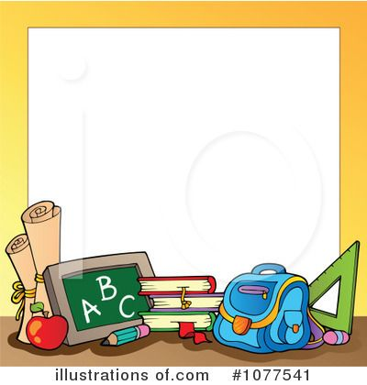](https://www.google.com/url?sa=i&source=images&cd=&cad=rja&uact=8&ved=2ahUKEwjw_YTcmIXbAhVGyoMKHf48DxwQjRx6BAgBEAU&url=https://www.pinterest.com/pin/736408976539378265/&psig=AOvVaw04rm2C3cgLkAhm6JXAzjpS&ust=1526386924215685)[](https://www.google.com/url?sa=i&source=images&cd=&cad=rja&uact=8&ved=2ahUKEwikit22moXbAhUC2IMKHXUrDLEQjRx6BAgBEAU&url=http://hanslodge.com/clipart/clipart-house-71.htm&psig=AOvVaw0r4wkDZj4o3JlEG3DMOQlY&ust=1526387404496131)

**Mt Zion Baptist Church**

**Back to School Celebration!**

[](https://www.google.com/url?sa=i&rct=j&q=&esrc=s&source=images&cd=&cad=rja&uact=8&ved=2ahUKEwiik7_cievbAhWn44MKHSIqD3oQjRx6BAgBEAU&url=http://clipartix.com/backpack-clipart-image-7726/&psig=AOvVaw18BQ2YFZ3bwPtcA9CPmfLI&ust=1529884025998578)[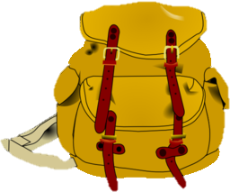](https://www.google.com/url?sa=i&rct=j&q=&esrc=s&source=images&cd=&cad=rja&uact=8&ved=2ahUKEwig4s-wievbAhUB7IMKHcVrAO8QjRx6BAgBEAU&url=http://www.i2clipart.com/clipart-backpack-a0cf&psig=AOvVaw18BQ2YFZ3bwPtcA9CPmfLI&ust=1529884025998578)[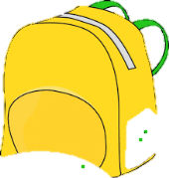](https://www.google.com/url?sa=i&rct=j&q=&esrc=s&source=images&cd=&cad=rja&uact=8&ved=2ahUKEwimu9rKievbAhVl2oMKHcT-BoQQjRx6BAgBEAU&url=http://clipartpen.com/clipart-pen/school-backpack-clipart-free-images-39183/&psig=AOvVaw18BQ2YFZ3bwPtcA9CPmfLI&ust=1529884025998578)[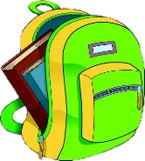](https://www.google.com/url?sa=i&rct=j&q=&esrc=s&source=images&cd=&cad=rja&uact=8&ved=2ahUKEwjL4-GfievbAhUBzIMKHc24CIwQjRx6BAgBEAU&url=http://worldartsme.com/school-backpack-clipart.html&psig=AOvVaw18BQ2YFZ3bwPtcA9CPmfLI&ust=1529884025998578)[](https://www.google.com/url?sa=i&rct=j&q=&esrc=s&source=images&cd=&cad=rja&uact=8&ved=2ahUKEwjDx9au_erbAhXl54MKHWonC3IQjRx6BAgBEAU&url=https://www.gograph.com/clipart/back-view-of-little-kids-looking-up-gg65487044.html&psig=AOvVaw18BQ2YFZ3bwPtcA9CPmfLI&ust=1529884025998578)[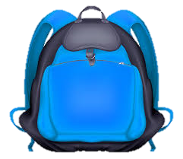](https://www.google.com/url?sa=i&rct=j&q=&esrc=s&source=images&cd=&cad=rja&uact=8&ved=2ahUKEwiuspGth-vbAhUY24MKHVgcBHMQjRx6BAgBEAU&url=http://clipart-library.com/clipart/1976325.htm&psig=AOvVaw18BQ2YFZ3bwPtcA9CPmfLI&ust=1529884025998578)[](https://www.google.com/url?sa=i&rct=j&q=&esrc=s&source=images&cd=&cad=rja&uact=8&ved=2ahUKEwjYrcjL_-rbAhUL4YMKHZHBDZUQjRx6BAgBEAU&url=http://www.clipartpanda.com/clipart_images/clip-art-of-a-school-backpack-16944414&psig=AOvVaw18BQ2YFZ3bwPtcA9CPmfLI&ust=1529884025998578)[](https://www.google.com/url?sa=i&rct=j&q=&esrc=s&source=images&cd=&cad=rja&uact=8&ved=2ahUKEwi555yl_OrbAhUM6oMKHWHWC40QjRx6BAgBEAU&url=http://www.santacruzmentor.org/home/backpack-clipart-7710/&psig=AOvVaw18BQ2YFZ3bwPtcA9CPmfLI&ust=1529884025998578)[](https://www.google.com/url?sa=i&rct=j&q=&esrc=s&source=images&cd=&cad=rja&uact=8&ved=2ahUKEwjg1526_OrbAhXk5IMKHWwDC7gQjRx6BAgBEAU&url=http://clipartix.com/backpack-clipart-image-7689/&psig=AOvVaw18BQ2YFZ3bwPtcA9CPmfLI&ust=1529884025998578)[](https://www.google.com/url?sa=i&rct=j&q=&esrc=s&source=images&cd=&cad=rja&uact=8&ved=2ahUKEwidjsjM_OrbAhWq64MKHZpVA1AQjRx6BAgBEAU&url=https://freeclipartspot.com/article/top-94-school-for-clip-art/4&psig=AOvVaw18BQ2YFZ3bwPtcA9CPmfLI&ust=1529884025998578)[](https://www.google.com/url?sa=i&rct=j&q=&esrc=s&source=images&cd=&cad=rja&uact=8&ved=2ahUKEwjcg_n6-erbAhWmyoMKHQwuDu8QjRx6BAgBEAU&url=http://aquarius.org.uk/contact/drive/&psig=AOvVaw27aGtXgq1CjBEhlLRqAcja&ust=1529883400910032)[](https://www.google.com/url?sa=i&source=images&cd=&cad=rja&uact=8&ved=2ahUKEwiM0sXyjIrbAhWO2YMKHTa1C58QjRx6BAgBEAU&url=http://clipart-library.com/blank-superman-logo.html&psig=AOvVaw3YUnBBMX8wnZSfjoLaz7Fr&ust=1526555555331178)

***Donations of only Backpacks are needed.***

***Our goal is 200***

**June 24th – July 22nd**

**Place**

**donations on table in Multipurpose Hall**

***Back Pack***

*Drive*

Mt. Zion Baptist Church, 10180 Woodlawn Blvd., Woodlawn, OH 45215

**Rev. Dr. T. Scott Swan I, - Pastor**