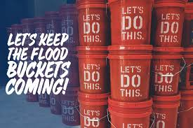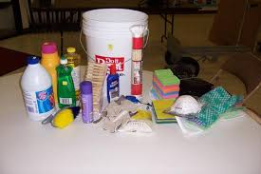

Cleaning Kit
These supplies enable people to begin the overwhelming job of cleaning up after a flood or hurricane.
Cleaning Kit Value: $65 per bucket
- 5-gallon bucket with resealable lid, All Products Liquid and in Plastic Container
  - Buckets from fast-food restaurants or bakeries can be used if washed and cleaned
  - Do not use buckets that have stored chemicals such as paint or pool cleaner
  - Advertisements on the outside are acceptable
- Liquid laundry detergent
  - One 50-oz. or two 25-oz. bottle(s) only
- Liquid household cleaner
  - 12‐16 oz. liquid cleaner that can be mixed with water
  - No spray cleaners
- Dish soap
  - 16‐28 oz. bottle any brand
- 1 can air freshener
  - Aerosol or pump
- 1 insect repellant spray
  - 6‐14 oz. aerosol or spray pump with protective cover
- 1 scrub brush
  - Plastic or wooden handle
ç

Important Notes
- All items must be new except for the actual bucket and lid.
- All cleaning agents must be liquid and in plastic containers. No powders, please.
- If you cannot find the requested size of a liquid item, use a smaller size. Including larger sizes of any item will prevent the lid from sealing.
- If all of the items on the list are not included, please put a label on the bucket indicating what has been omitted.

