FAITH CHRISTIAN ASSEMBLY

13820 Seal Beach Blvd PO Box 3444 Seal Beach, Ca 90740

Rev. Gwyn & Ginny Vaughn, Senior Pastors

Rev. Sheri Leming, Associate Pastor – Gary Leming, Business Administrator
562-598-9010 revgwynvaughn@gmail.com or www.fcachurch.net Fax 562-598-2116 ---------------------------------------------------------------------------------------------------------------------Vol. 24 No. 2 "From the Pastor's Desk..." February 2016

GINNY VAUGHN’S PIANO BOOK
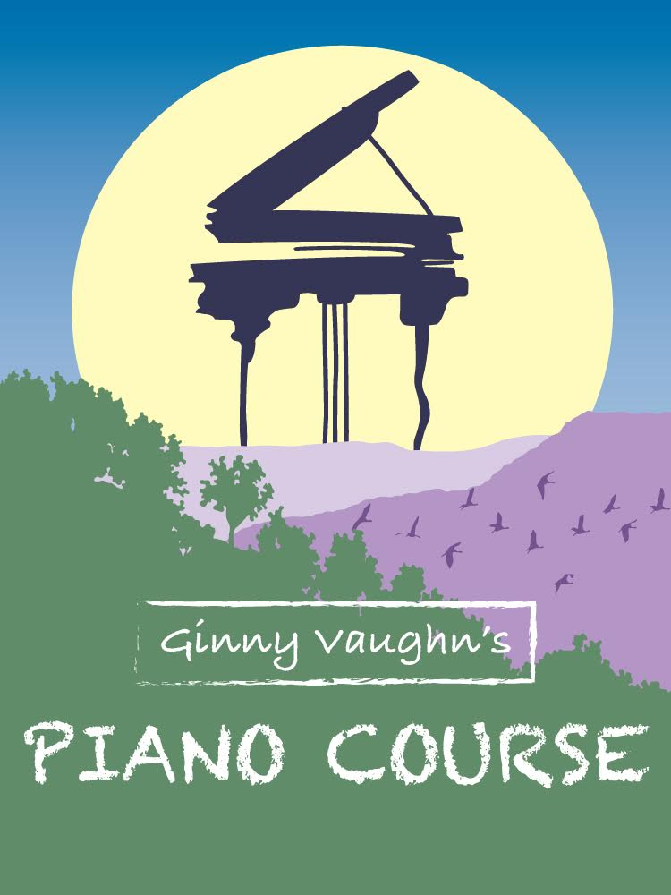
Today, I am going to depart from our normal style of newsletter and talk about something very dear to my heart. One of the goals of our ministry has been to reproduce our gifts in the lives of others. This is why I wrote the book, “Answering the Call.” I want to see others have a basic understanding in the role as a minister of the Gospel. My wife also shares the same philosophy and desires to reproduce herself in the lives of others.

So some of our current readers may think that I have a method in my madness, or something personal to promote...well we do...but it is for your profit as well as ours. Will we get rich off this? No. But anyone who becomes a musician will profit in many different ways, but in the enjoyment of making melody, even in the service of others. Keyboard players are essential in various ways. They can be a real blessing of comfort at a funeral, add to a church service for worship, and create a joyful spirit in celebration of a wedding.

We are delighted to announce that Ginny, my beloved wife, will be conducting her first Piano Seminar on February 20, 9:00 a.m. to 12:00 Noon, since the recent publication of her new book, "Ginny Vaughn's Piano Course". (Please see the enclosed brochure for more information.) For years Ginny has trained many students by using her own copy machine for the necessary printed lessons. But now her course has a more professional look.

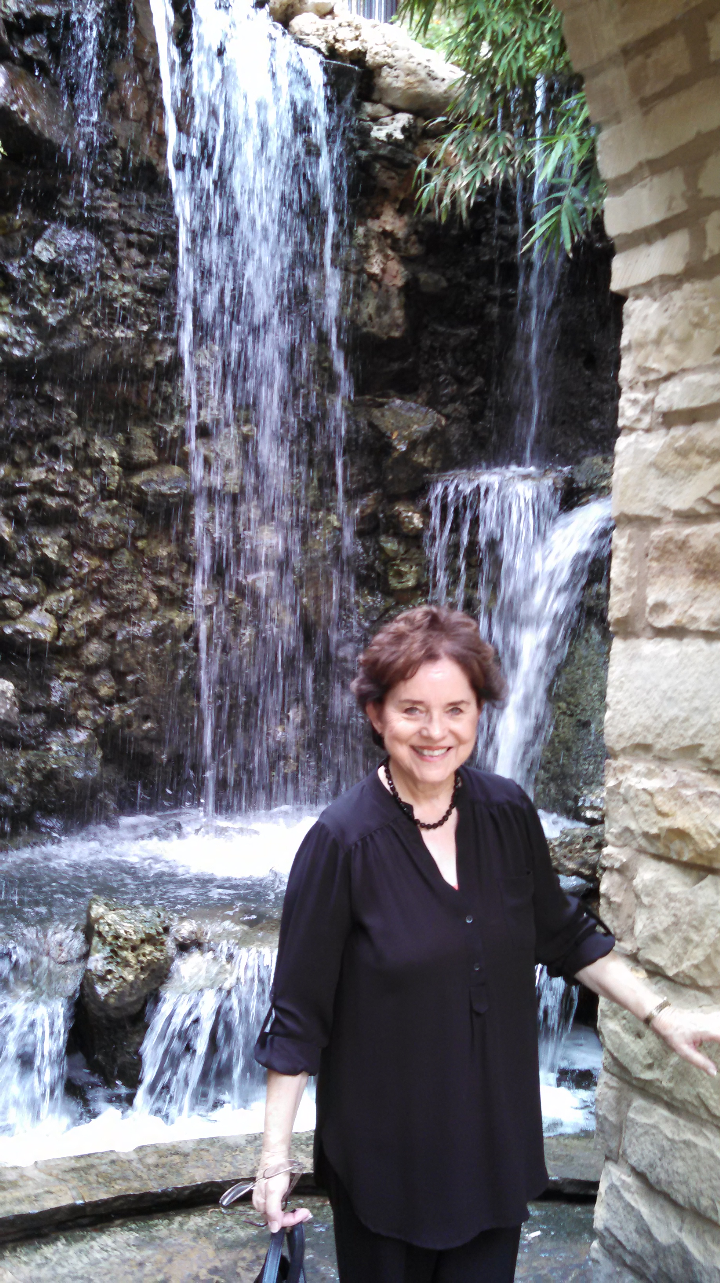
THE INSTRUCTOR

I am sure that most of our readers know that Ginny is a very gifted pianist, organist, and piano teacher who has been actively involved in the music ministry of the church most of her life. At age eleven she began taking music lessons in classical piano from a renowned musician, Dr. Peter Slack, at that time the staff pianist and organist for the popular Long Beach, CA radio station, KGER.

Dr. Slack recognized that Ginny had an inborn ear for music. He noticed how quickly she became familiar with chords, when as a child she played background accordion in her local church where her father pastored. While putting to good use her piano lessons, she was also teaching herself how to play by ear, finding the necessary chords to enhance her music. She has developed these lessons so that her students can play chorus and songs which are not written in church hymnals. As her capabilities were recognized Ginny began to be in demand by churches to train more people to become musicians.

She has produced these same lessons over the years and has taught them in churches, schools, and universities, not only here in the Unites States but in foreign countries such as the Ukraine, India, and Canada. Ginny has been able to communicate her love for God in music in countries in which she was unable to communicate her message in the language they spoke.
OBJECTIVES OF SEMINAR

The purpose of her piano course is to make piano playing easier and even more enjoyable for the person who has a great desire in joining the ranks of other musicians who take delight in having a musical talent. The student will learn techniques that will aid them in giving even the simplest melody both depth and richness.

The materials Ginny provides with this book, CD, and seminar are designed to give the potential student ideas, exercises, and formulas that will provide literally months of practice material. Also, with this seminar the student receives insight into their role as a pianist or keyboard player in a Christian, or even a secular, environment as well as the importance of their part in the church worship service.

LEARNING TOOLS

Note and non-note readers alike will receive exercises and lessons as well as a CD to be used as a refresher for the information covered in the classroom setting. The student will be able to progress at his or her own speed, regardless of their age, or previous or non-experience without forgetting the material heard and things learned at the seminar. The student will learn tips on pitching songs, so that they won't be too high or too low, as well as to how to modulate (change from one key to another, smoothly).

SEMINAR CONTENT

The seminar content will consist in finding the three basic chords of any song in any key. Lessons sheets will include examples in the keys of C, E flat, F, G, and B flat. If you can play one finger melodies such as “Jesus Loves Me” or “Mary Had A Little Lamb,” you can be taught to find these basic chords.

Exercises will be provided so that the apprentice can familiarize themselves more fully with the keyboard, locating and using more than the basic three chords to compliment the music. Examples will be given to show the most beneficial placement of these chords, creating a more melodious harmony.

For the student who reads music, but does not play by ear, formulas are included that will add fullness to the music providing the listener with a very pleasant sound. The student will also learn methods for reading chords written in current song books.

Formulas for minor, augmented diminished, seventh, and major seventh chords and suspensions. Ideas for fill-ins other than chord inversions. Tips to make piano playing smooth instead of choppy and awkward.

Ginny has received over the years many emails, cards, letters, and telephone calls from satisfied students who were delighted to have the privilege to sit in her class, seminars, and make the discovery that they too could accomplish their dream of being an accomplished musician. She had given this course in schools, universities, churches, as well as on a one-to-one basis. Of course, the student will need to be willing to practice, and apply themselves and be teachable for this to be accomplished.

During the seminar, questions or comments will not be allowed in order that all students have the opportunity to hear all they need to hear from their teacher in the three hour session. However, following the class, Ginny will be available to answer any questions if the need should arise. We never want our students to be cheated out of getting the full benefit of the seminar.

If you, or someone you know, would like to attend this up and coming Seminar, just complete the form that is enclosed with this newsletter, or call the church office for more information and reservations. You might be interested in sponsoring someone who may not be able to afford the expense of attending this Seminar. If you live outside the Los Angeles-Long Beach area, Ginny would be happy to conduct a seminar in your community as long as there are at least 10-15 students who are interested and willing to sign up for such a class.

