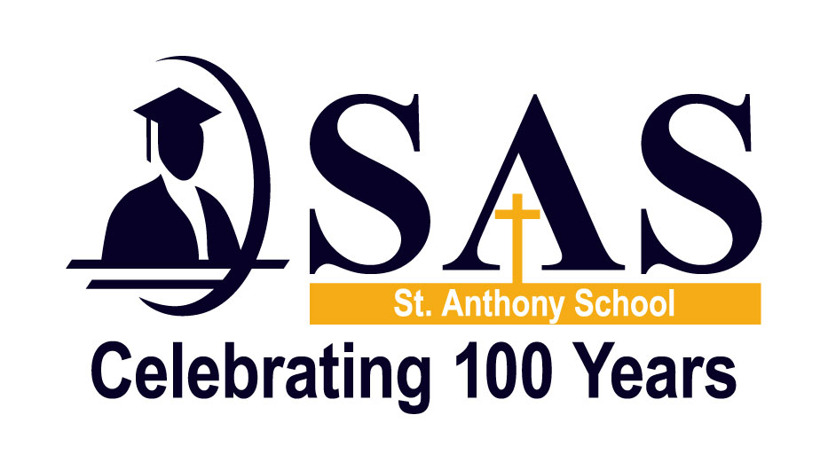

Student Parent Handbook Sign Off

I _________________________________, parent of ____________________ have read the Parent/Student Handbook for 2015-2016 and I am aware of all the policies and procedures at St. Anthony School.

__________________________________ ______________________
Parent Signature Date

HANDBOOK SIGN OFF MUST BE RETURNED TO THE CLASSROOM TEACHER BY SEPTEMBER 11, 2015

NON RELEASE OF NAME AND PHOTO

Photos of students will be published in the school newsletter, SAS website, Catholic Mirror, and on occasion the local newspaper and TV stations interviewing or taking photos of our students. IF YOU DO NOT WISH to have your child’s name or photo in either the local newspaper or TV stations, please sign and return this form to the school office by September 11, 2015

_________________________________ ______________________
Parent Signature Date

THE ABOVE SIGNATURE INDICATES THAT YOU DO NOT WANT YOUR CHILD’S NAME OR PHOTO IN THE LOCAL NEWSPAPER OR ON TV.

