March 1, 2018
Help Needed: Middle School students to sit at a table at Church this weekend (3/3 -4) to help hand out ADA pledge cards. The times for Masses are: Saturday at 4pm, Sunday at 9am and 11am and the Spanish Mass 1:00 p.m.

Please contact Darcy if your student is available.

Every Friday during Lent Middle School students may stay after school and help with setup and general assistance at the Fish Fry.
__________________________________

8th Grade Service Opportunity
Spring Break Week:
March 13th (Tuesday)
March 14th (Wednesday)
9 a.m. - 11 a.m.

Students will be stamping the church library books and putting them in alphabetical order by title. There will be an adult supervisor that will show them how to stamp the books.

Contact: Mrs. Thierer, MS Religion Teacher –dthierer@stanthonydsm.org
***********************************************************************************
Service Hour Opportunities

Ring the Bell for the Salvation Army
http://www.salvationarmy-desmoines.org/desmoines/RedKettlesPage_url

St. Vincent de Paul Thanksgiving Baskets
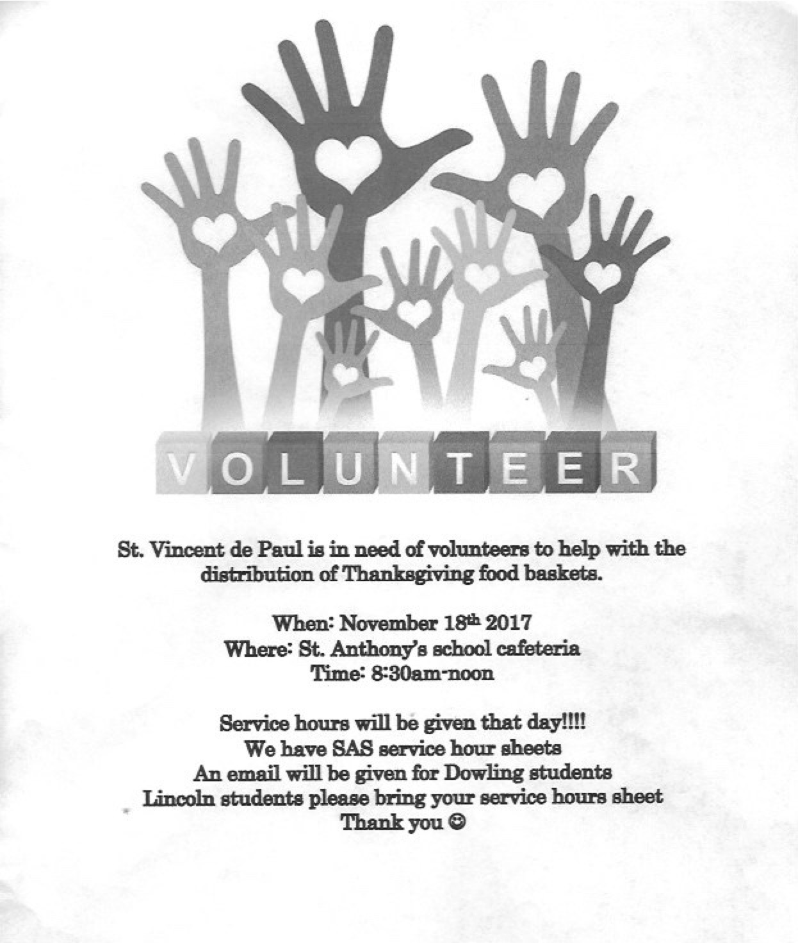

Food Bank of Iowa
Produce Sorting: Sorting our fresh produce from large bins into smaller quantity bags that are suitable for families.
SHIFTS: Wednesday, November 8th [5pm-6:30pm]

Middle School students may sign up to help but need a parent or a guardian with them (required until the age of 16 years old.)

The website for that direct link is here:http://foodbankiowa.volunteerhub.com/Events/Event/Summary.aspx?EventID=5095188

