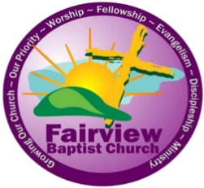

FAIRVIEW BAPTIST CHURCH
CHRISTIAN LEADERSHIP SCHOOL
Friday, November 13, 2026, 6:00pm
Saturday, November 14, 2026, 9:00a.m.
Rev. Derrick E. Walter, Sr., Senior Pastor | Mrs. Lavinnie L. Moore, Certified Dean

Course #s Course Names Instructors
1038 Survey of Proverbs Rev. Earl Bryant
1066 Women of the Old Testament Sis. Lillian House
1079 Survey of John Sis. Marcy Turner
1112 Survey of Revelation Sis. Clara Finley
4001 Basic Christian Beliefs Rev. Ray Douglas
5012 Becoming An Effective Deacon Rev. Derrick Walter, Sr.
9008 Public Speaking Sis. Debra Davis

OTHER INFORMATION:
PLACE: Fairview Missionary Baptist Church – Donald Burns Educational & Activity Center
1700 N. E. 7th Street – Oklahoma City, OK 73117 (NOTE: The Church Nursery will be open)
REGISTRATION: Register Online at www.fairviewokc.com or Onsite
TUITION: $25.00 –Online or Onsite Pay Online through Givelify with a bankcard or credit card at www.fairviewokc.com or mail payment to: Fairview Baptist Church, P. O. Box 36188, OKC, OK 73136,
CONTACT: Mrs. Lavinnie L. Moore, Christian Education Director/National Certified Dean (405-388-1419)
NOTE: The Christian Leadership School has been approved and Accredited by the Sunday School Publishing Board, Division of Christian Education of the National Baptist Convention, USA, Inc.

ONLINE REGISTRAR – Sister Rhonda Thompson
COURSE CARD COORDINATOR – Dr. Iris Copeland, Dean – Chickasaw District

