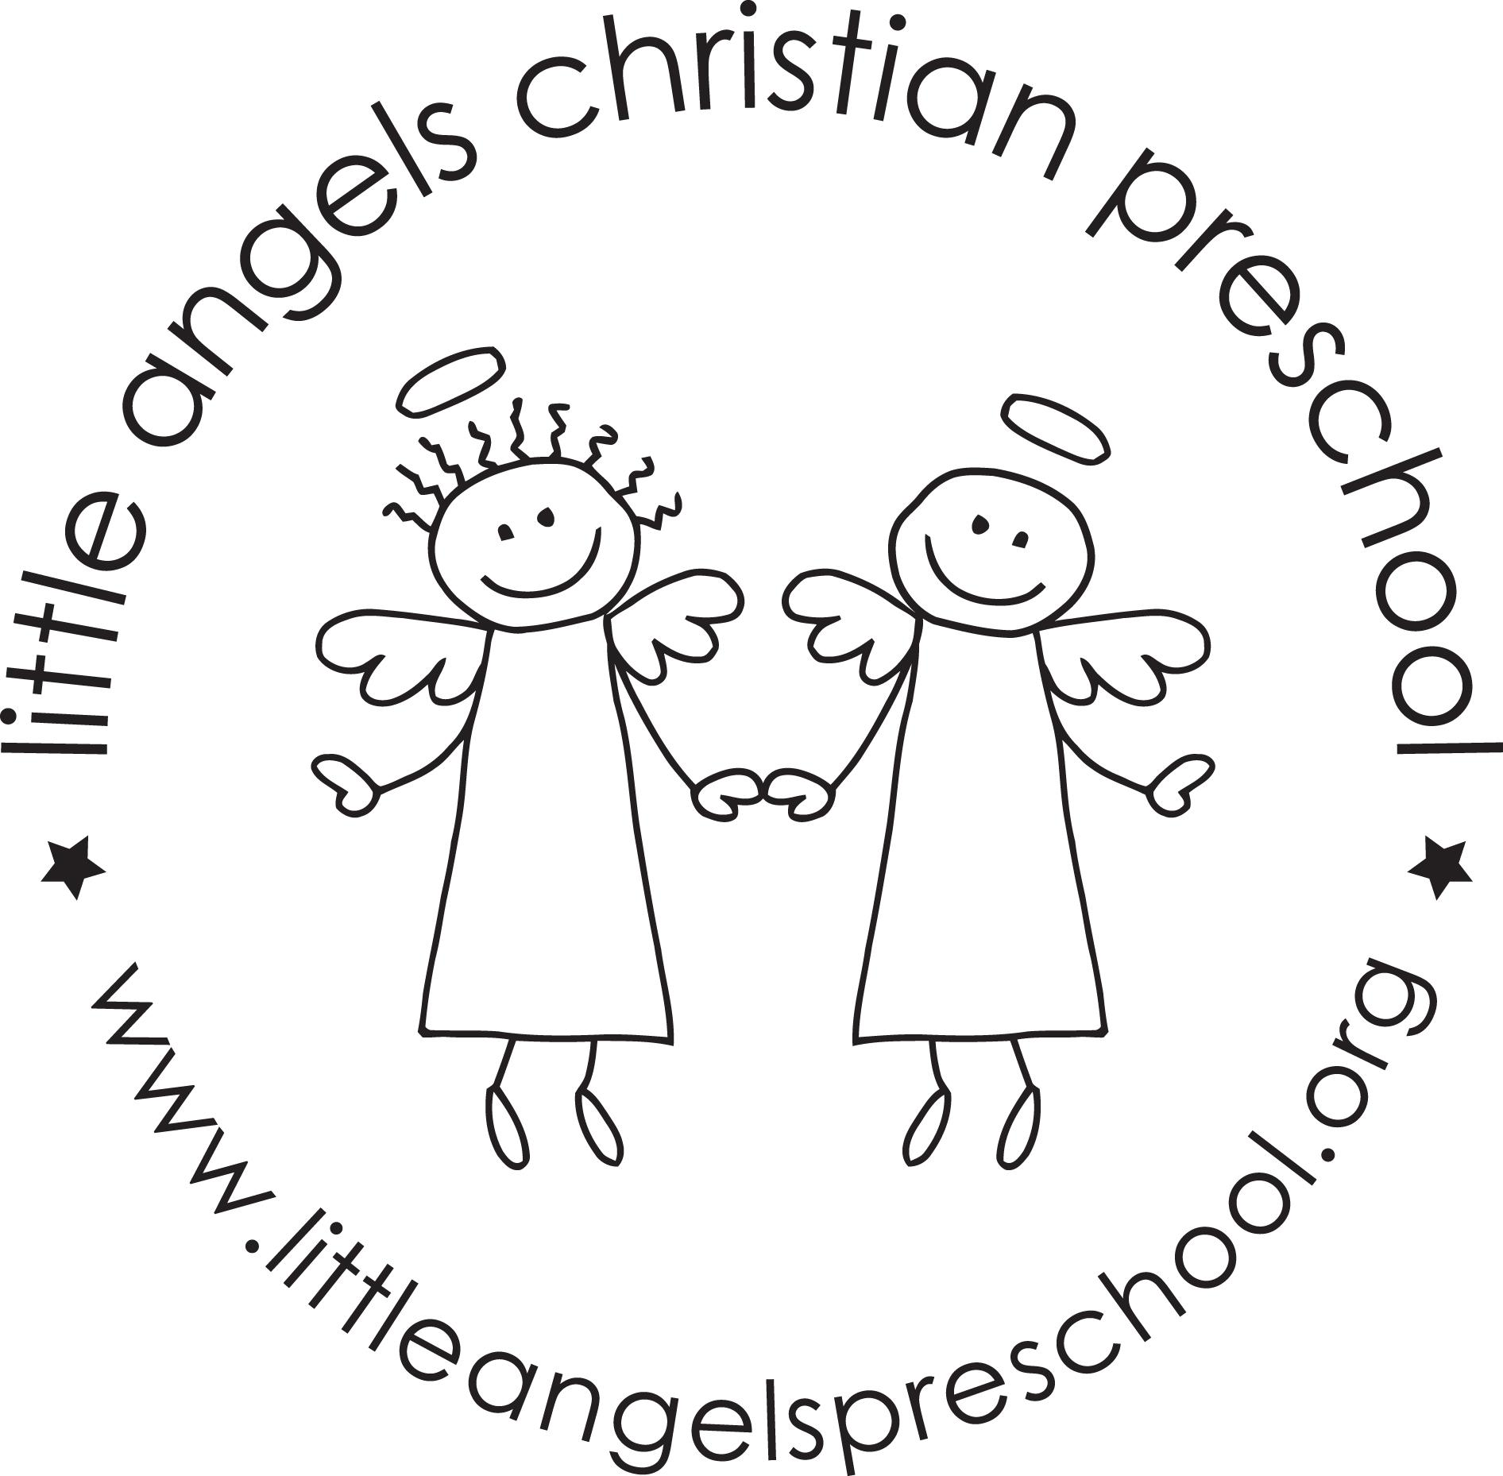

December 2024

*Toddler Newsletter – Loppnow/Tantillo*

December will be a fun month as we explore all things Christmas with the colors red and green. We’re planning lots of fun activities, music, dramatic play, art and fine motor work that involve red, green, the holiday season as well as Jesus’s birthday. We hope to have some visits this month from students that will be joining us in the new year.

Reminders:

• Please be sure to dress your child for the fluctuating weather – we love to go outside and want the children to be comfortable. Please label all outdoor items.

* **Class Christmas Party and Christmas Pajama Day Dec 17 at 11:00.** Our room parents will contact parents with further details. All are welcome to come.
* **Visit from Santa with photos Dec 20 at 11:10-11:30** . You may attend with your child if you are not enrolled in Friday class.
* **Little Angels Christmas Program Dec 12 6pm** 3s and 4s perform
* • **No school December 23-January 6. Classes resume January 7**

We wish you a happy and healthy holiday season. Thank you for sharing your children with us. They are such a joy and blessing!

Your Toddler Teachers,

Mrs. Laura Loppnow and Mrs.[Gina Tantillo](mailto:gmp2218@yahoo.com)