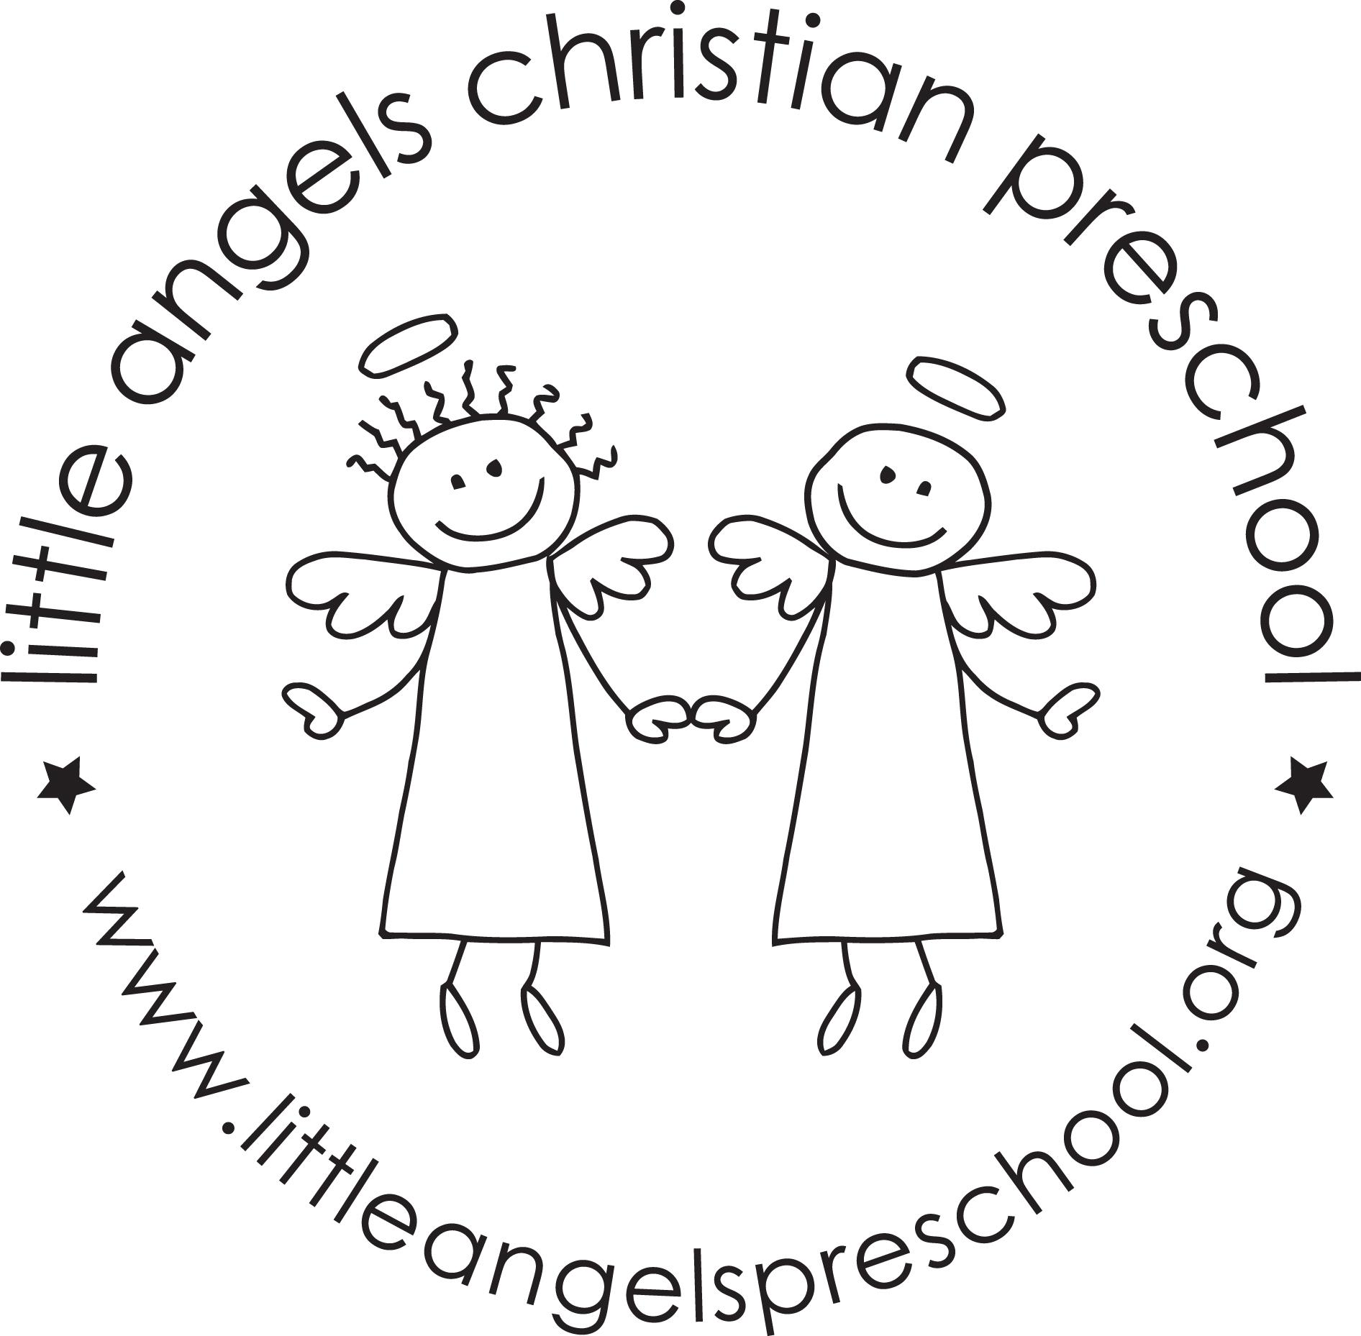

September 2024

*Toddler Newsletter – Loppnow/Tantillo*

Welcome to Little Angels Toddler Program. We are excited to also welcome Mrs. Gina Tantillo to the Little Angels staff and the toddlers room this year. This year will bring so much growth, development, learning and fun!

During the month of September we will focus on getting acquainted with your children, their personalities, and what sparks their interest. Our goal is to have them get acclimated with the daily routine and get comfortable with their teachers. We have many areas in the classroom for your little ones to explore. There is dramatic play, vehicles, dress up, babies and doll houses, small and large blocks, fine motor work manipulatives, an art easel with varied art materials, sensory table where they can explore wet and dry materials, table toys, puzzles, science exploration, nature trays and a reading area. We will also have weekly themes with books, songs, toys and activities that relate. Our themes for September include: Welcome to School, Getting to Know You, Families, Apples and Farms.

Whenever the weather permits we will enjoy stroller rides and our outdoor playground with a climber, tunnel and slides, balls and small trikes. We also have an indoor large motor room for days where the weather just isn’t suitable for going out to play.

We have an email for our classroom that will be checked before and after class. You can reach us via email at toddlers@littleangelspreschool.org.

Don’t hesitate to contact us! If you need immediate assistance during class hours please call the preschool office at: (847) 381-5490 or text us at [toddlers@littleangelspreschool.org](mailto:toddlers@littleangelspreschool.org) if you have an apple phone. We will have the Bloomz app up and running for our class soon and will communicate with you daily there.

We are looking forward to a school year filled with fun and learning for our “littlest angels!”

Your Toddler Team,

Mrs. Laura Loppnow and Mrs. Gina Tantillo

**Important dates**: Tuesday and Wednesday September 3 &4 First day of class 9-10:30am. Blessing of children in the sanctuary 9am.

Thursday, September 12 - Ice Cream Social 5:30 - 6:30 pm

Friday, October 11- Fall Fundraiser Lindy’s Landing

(Adults **only)**