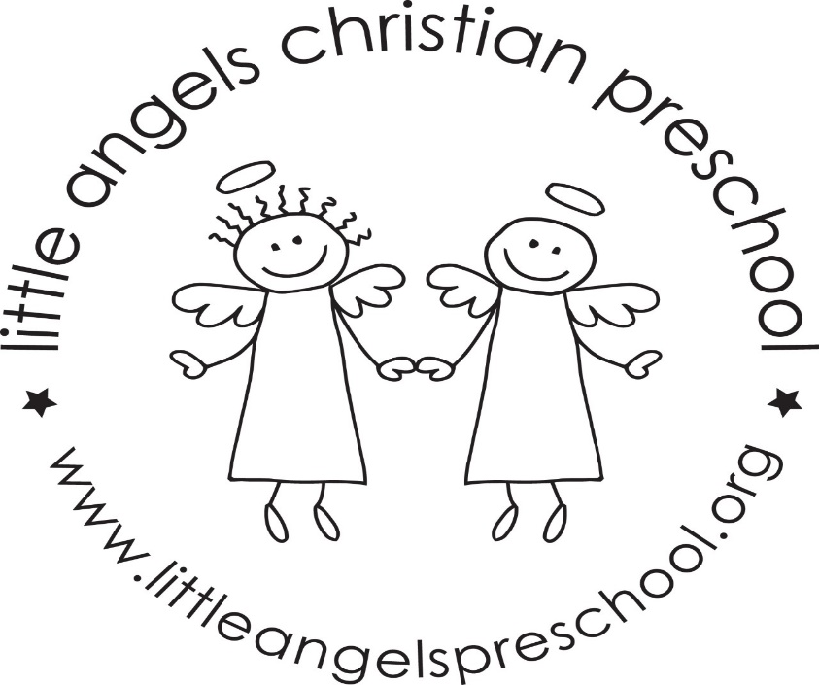
Welcome back! We hope everyone had a great spring break! We have a lot of fun things planned for the month of April.
This month our themes will be Easter, Earth Day, spring themes, and also celebrating Week of the Young Child. During the week of the Young Child we celebrate a different theme each day, beginning with Little Angels Spirit Day on Monday, PJ Day on Tuesday, Wednesday will be Wacky Wednesday, Thursday will be USA Spirit Day, and Friday will be hat day. Family Fun night will be Thursday April 11, beginning at 5:00 and ending at 6:30. Pizza will be served, and there will also be special entertainment, Tunes with Tim.
No school on April 18 and 19. We will have parent/teacher conferences on April 18. Let us know if you do not need a conference!
We will celebrate meeting all of the letter people! We will have a letter people party! The classroom will have many different letter activities and puzzles, and of course a dance party. We’ll have a special snack with letters on it (cookies).
Thank you for sharing your child with us, and if you ever have any questions we are always available!
Mrs Dreys & Mrs Gierthy

