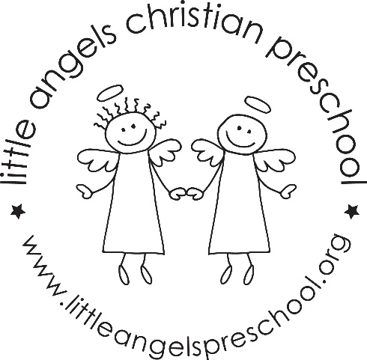

April Newsletter
Dear Parents,
Welcome back! We hope you all had an amazing spring break. We are ready for spring and looking forward to the sunshine and warmer temperatures to come. We will be taking every opportunity to get outside and enjoy the weather so please be sure to dress appropriately. We are thrilled to welcome April and dive into new, exciting themes. Here’s what we have planned for this month: transportation, jungle animals, farm animals, and “April showers, bring May flowers.”
We will explore different modes of transportation from airplanes to trains, cars to boats, and we will learn about all the ways we can travel the world. Through storytelling, art, and imaginative play we will explore the many amazing animals of the jungle and the farm! Lastly, we will explore the wonders of spring time, rain showers and spring flowers through hands-on activities at our sensory and art tables. We will also have the opportunity to plant seeds with garden tools and observe plant growth.
We have Week of the Young Child, April 8th-12th and we will celebrate our young learners with a spirit week.
Monday | Tuesday | Wednesday | Thursday | Friday
Little Angels Spirit Wear | Pajama Day | Wacky Wednesday | USA Day | Hat Day

On Thursday, April 11th, please join us for Family Fun Night featuring “Tunes with Tim” from 5:00-7:00 in the St. Michael’s Community Room. We look forward to a fun night out!
Parent-Teacher Conferences on Thursday, April 18th. Sign-up will be available on Bloomz April 2nd, at 12:00 PM.
As always, please don’t hesitate to contact us if you have any questions or concerns.
Alli Szkorla and Megan Zarling

