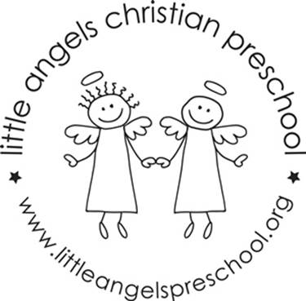
March 2023
Three-year old class newsletter

Welcome to March! We have some pretty exciting things planned this month. Mostly we will be talking about our Five senses. We have a lot of fun activities and learning involving seeing, taste, smell, touching and hearing!

We will be having in person chapel with Father Jesse on March 4 and 5th. We will continue having music with Ms Julia every Tuesday and Wednesday.

Our classroom will have beach day the week before Spring Break! On March 20th and 21st we will have our room set up for a fantastic day of fun in the ‘sun’. We will be closed for Spring Break March 22 through April 2.

We will continue meeting letter people this month, U, V and W.

Please make sure that your child has two weather appropriate changes of clothes in ziplock baggies. Also, please make sure that all items are labeled with your child's name. And remember to have them wear a jacket if the weather is cool, we will try to go outside to play, and it may be chilly.

We have an email address for our classroom. We will only check it before and after class. So, if you have something that you need us to know right away, you should call the school office: (847)381-5490. If it's something that does not need immediate attention, please feel free to use our classroom email. The address is: threes@littleangelspreschool.org

Thanks,
Anne Gierthy and Sue Dreys

