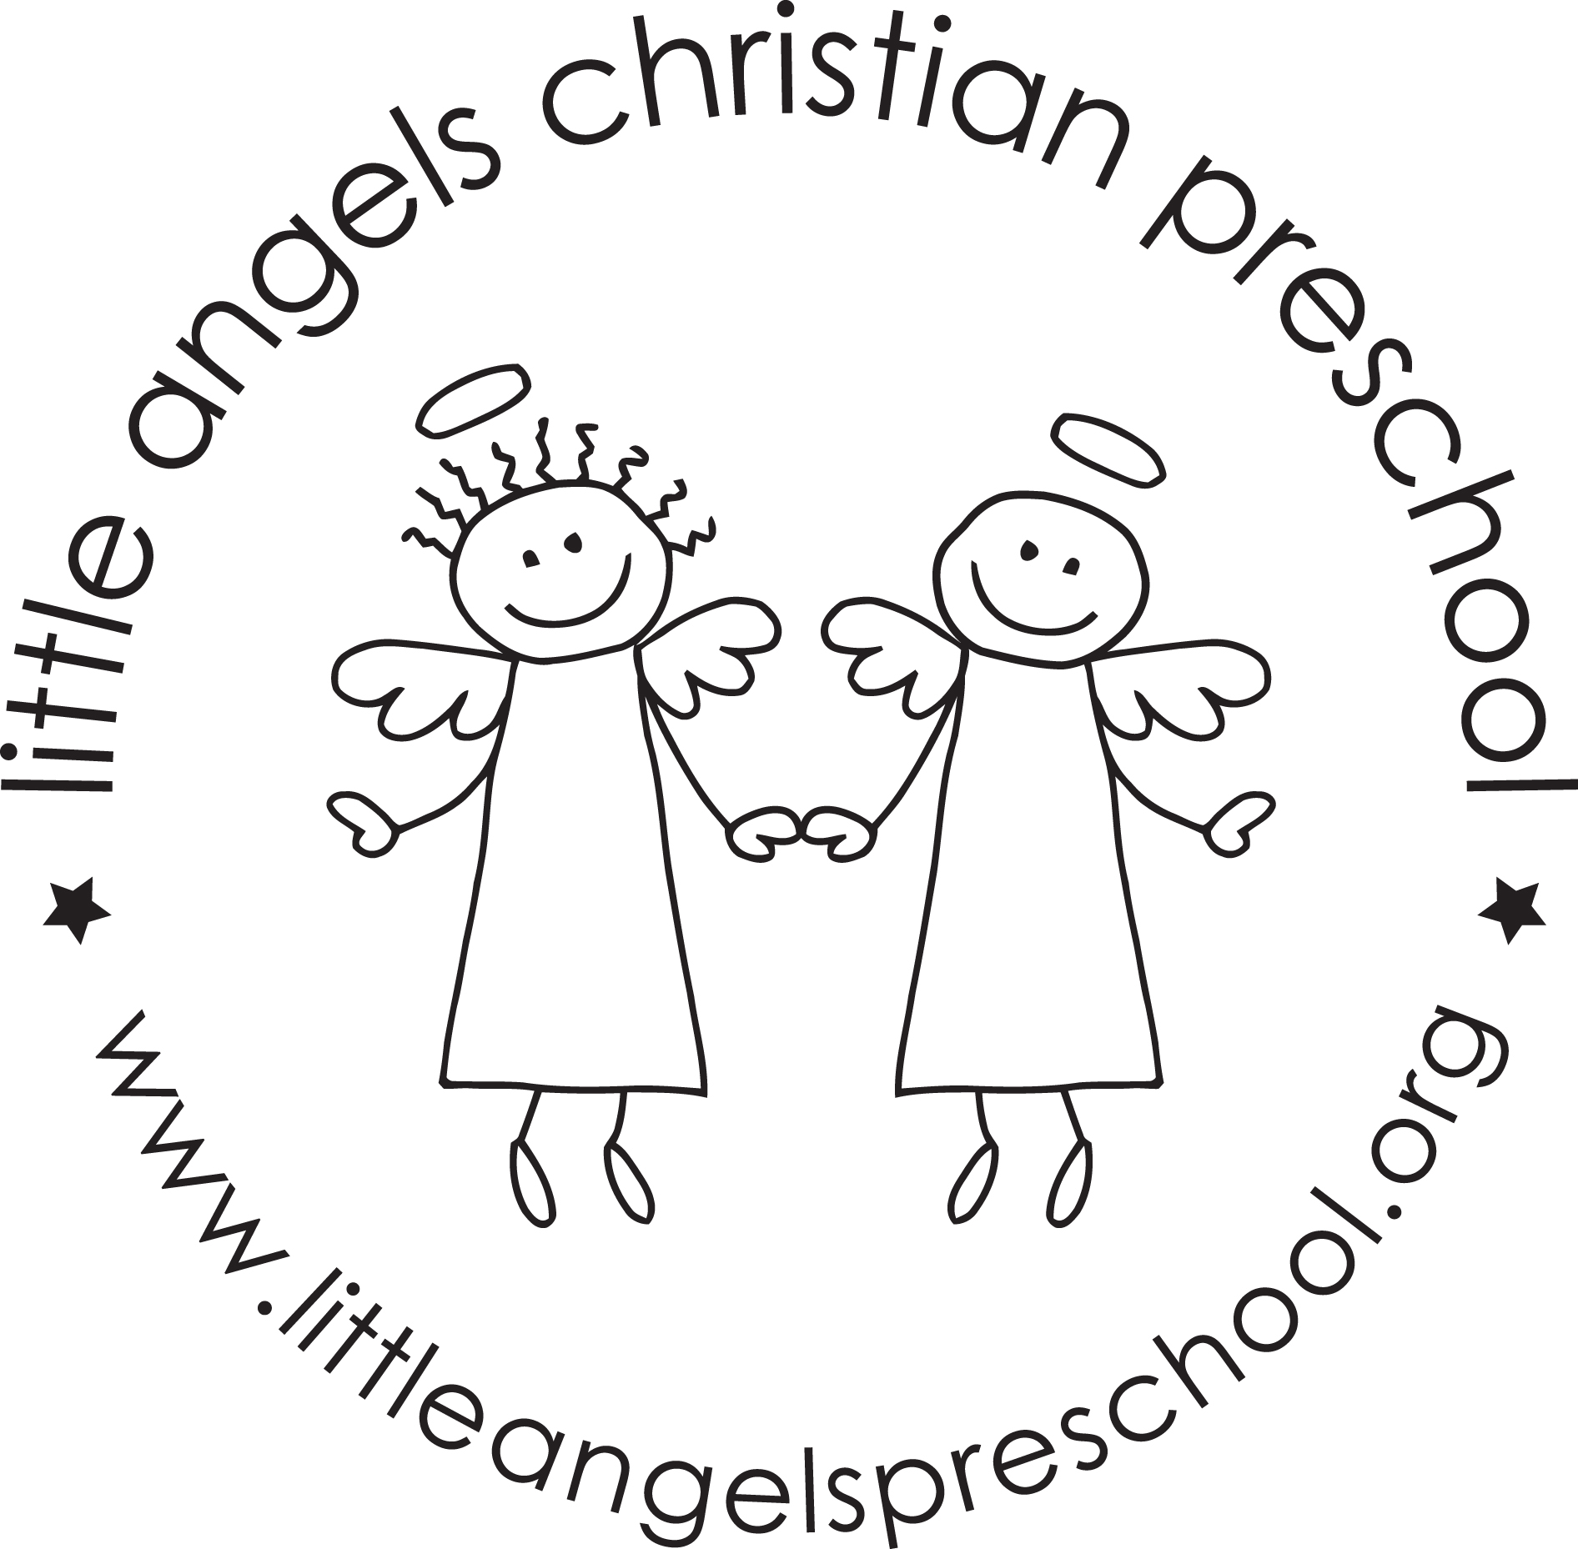

Newsletter January 2024

HAPPY NEW YEAR!!

Welcome back, we hope you all had a safe and blessed Christmas. Thank you all so much for the generous and thoughtful gifts, we really appreciate them.

For January, we have some fun activities planned for your children. Our themes will be penguins, arctic animals, snow and ice, snowmen and finishing up the month with winter wonderland.

Our art activities will include painting with ice, using brushes with glitter paint, shaving cream art and paint sticks. We have many new manipulative toys that were recently added to our classroom, so we are super excited for the kids to use them. Sensory bin will include a winter arctic jungle, making and playing with fake snow and hopefully using real snow as well! To further develop fine motor skills we will work with glue sticks, scissors, close pins and play doh. Our dramatic play area will include winter explorers, with cameras, magnifying glasses and a microscope; as well as a winter animal pet vet.

REMINDERS:
- Bring extra diapers
- Extra cold weather clothes
- Label gloves, hats and coats

No School Monday January 15th - Martin Luther King Jr Day

Looking forward to a great second half of the year!

Megan Zarling and Alli Szkorla

