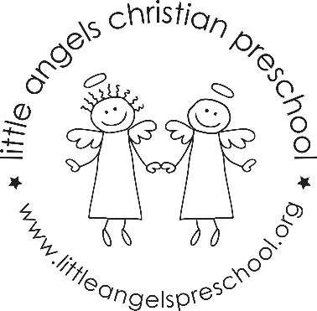

Fantastic Fours
January 2024

Dear Fantastic Fours’ Families,
Happy new year to you. Best wishes for 2023. We are looking forward to more awesome learning. January brings the beginning of many more learning challenges for our students. We will continue our morning circle time, starting with a prayer and reviewing the date, weather and letter and theme for the week.
Our Fruit of the Spirit this month is kindness symbolized by strawberries. When the children look for their fruit this month it will have both first and last names on it to promote recognition of last names.
Our daily prayer will be The Lord’s Prayer (Our Father). Our snack prayer will be God is Great adding the second verse.
Our letters this month will be D, P, B and R. Our Dramatic Play area will feature many winter activity themes as well as a Pizza Parlor for "P" week. What could be more fun to combat "Cabin Fever" than a Pajama Day and pizza making on January 17 during "P" week?
This month Art Appreciation will feature artist Vincent Van Gogh and his beautiful Starry Night. For Science each student will be growing their own crocus bulb.
Journals will be introduced this month for the children to express themselves with drawings and words. We will continue practicing writing our names beginning with a capital letter followed by lowercase letters. Math activities will include counting and numeral recognition through twenty.
It is so exciting to watch these young learners grow in knowledge and confidence in their skills. We are looking forward to a great month and New Year.
Warm winter wishes,
Dates to Remember:
Tuesday, January 9 - Classes Resume
Monday, January 15 - No School - Martin Luther King Jr. Day
Wednesday, January 17 – Pajama Day

