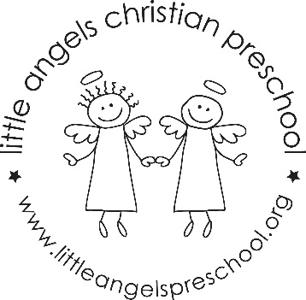
October 2023
Fantastic Fours’ Newsletter
Mrs. Clarke, Mrs. Sonnenberg and Ms. Fisher

The Fantastic Fours had a wonderful start to the new school year. The children have learned the circle time songs and jobs for each morning. We have seen many new friendships formed this past month.
The Jolly phonics sounds for the month will be E (as in egg), H, T, and I (as in inch). Our “Fruit of the Spirit” will be “Joy” symbolized by a pear. Our Dramatic Play Area will change from the Farmers Market to a Birthday Party, and then a Halloween House. We will have our first Art Appreciation Activity featuring Jackson Pollock with motion painting. We will be conducting some science experiments with eggs, pumpkins, and outdoor nature items. Our math skills will be enhanced with balance scales, number games and puzzles, and measuring. During play and table times, our small motor skills, social, and cognitive skills are being utilized with different activities and games put out each day. The daily updates sent via Bloomz will outline what those activities have been.
We look forward to meeting with you on Thursday, October 19 to discuss your child’s social-emotional adjustment to the 4’s class. This is a great time to go over any thoughts, concerns or questions you may have. Of course, we are always available before or after class if you need to talk to us.
Important Dates:
Monday, October 9: Field trip
Thursday, October 19: No Class/ Parent-Teacher Conference
Friday, October 20: No School
Halloween Party Date to be announced. Watch your email for information.

