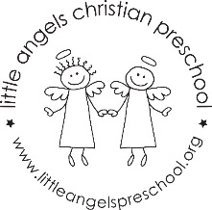 November 2023
Newsletter- Fantastic Fours
Dear Parents,

The month of November is a great time to reflect on how blessed we are. Thank you for sharing your children with us! We have enjoyed our first 2 months and see so much growth in the class already. The opening prayer for November will be “God in Heaven”. The Fruit of the Spirit is “Peace” symbolized with an orange. The Jolly Phonics letter sounds will be U (as in up), C (as in cat), O (as in on) and Q. We will have a short letter review Thanksgiving week.
Our dramatic play will be a Coffee Shop and then change into a Thanksgiving House. During the month we will color mix, look at opposites, create graphs, talk about healthy vs. unhealthy foods, plus much more. We review our letters sounds each week and it is amazing how they are connecting & recognizing the sounds!
We are looking forward to our field trip to the Marriott Lincolnshire Theater in December. Please be on the lookout for the permission slip and return it promptly.
Daily activities are always reflected in the daily Bloomz post at the end of the day.
We will continue to go outside to play, weather permitting. Please send your child to school with appropriate clothing for the varying temperatures (warm coat, hat, mittens, boots).
We are always available to discuss any concerns or questions you may have. We hope you enjoy the remainder of the Fall season!

Thank you! Mrs. Clarke, Mrs. Sonnenberg and Ms Fisher

Important Upcoming Dates:
Friday, November 3: No School
Wednesday, November 23- Friday, November 24: No School Thanksgiving Break

