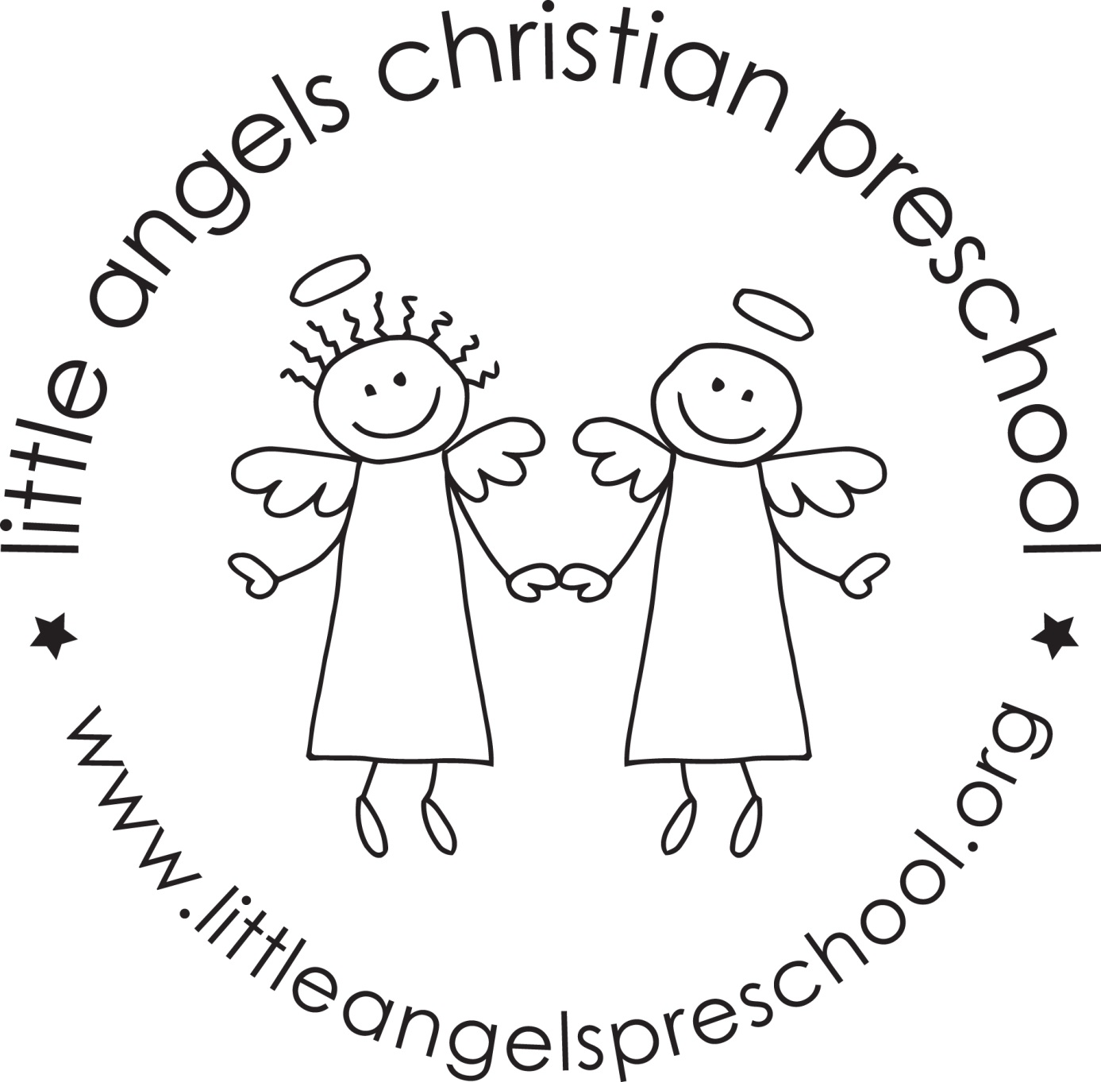 Three-year-old class November 2023
Those Halloween parties were a lot of fun….Thank you to our room parents and everyone that helped out to make the day special for the children!
Also, it was great meeting with you for the fall conferences. Please remember that we are available to you for any questions or concerns all throughout the year, not just at conference time.

It’s amazing how time flies by! Can you believe that we are two months into school and it’s already November!? We will start the month with a theme on construction and then move into land transportation. The two weeks after that we will talk about Thanksgiving and then the last week of November we will talk about Community Helpers before moving into our Christmas theme! Our dramatic play area will become a train station and we will be “making” Thanksgiving dinner in the house area. We will even have a stuffed turkey! In our art center we will explore things to paint with including toy cars and feathers. In the science area we will investigate real turkey feathers from Wisconsin turkeys and we will look at what kind of things wild turkeys eat.

We will be starting our writing table. Please be working with your child at home on writing their name as well as the proper grip of the writing instrument as we work on this at school as well. We will continue meeting our Letter People (H, I, J and K are coming up next). We will also be learning the sign language to go along with it.

Please be sure to send your child with a warm coat, hat and mittens because we will continue going outside to enjoy the brisk month of November. Also, it would help us A LOT if you would put your child’s mittens and hat inside the sleeve of their coat OR on the top shelf of the cubby. Please check to make sure that your child’s extra clothes are weather appropriate.

Thank you for being extra aware of your child’s health and not sending them when they aren’t feeling well.

Reminders:
Friday, November 3 – No School
Friday, November 10 – Fundraiser at Hampton Social
Wednesday, November 22 through Friday, November 24 – Closed for Thanksgiving

Happy Thanksgiving! Your Threes teaching team - Sue Dreys and Anne Gierthy

