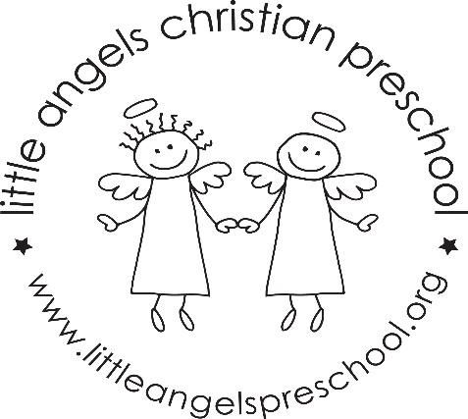
October 2023

Dear Parents,

Happy Fall!
We are very happy that all of the children are settling into our classroom routine. We hope they are enjoying preschool. This month our themes are Apples, Farms, Fall, Pumpkins and Halloween. As always we will be rotating our dramatic play area and sensory tables to fit our weekly themes. For large motor we will continue to go outdoors so please label all of their gear.

Our Fall Conferences are coming up on Thursday October 19th. There will be no school Friday October 20th. We also have our Halloween parties coming up. Please keep a look out for communications from the room parents. All parents are welcome at the parties!

Also, please check cubbies for extra fall clothes and diapers if needed- thank you!

If you ever have any questions, or any concerns please don’t hesitate to contact us.

Natalie Nuzzo and Megan Zarling

