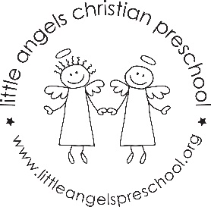
September 2023
Rainbow Room 4’s Newsletter
Mrs. Hove and Mrs. Jones

The new school year is off to a great start. We spend the first 2 weeks getting to know your child, reviewing class routines & rules, exploring the classroom, and learning class songs and prayers. We will talk about the “Fruit of the Spirit” each month, starting with “Love” symbolized by an apple. Our opening class prayer will be “God You Are With Me”.

Photos: Thank you for sending in photos. We will look at the photos with the class, and then create baby-now, family, and friends posters to display in the classroom. The kids love looking at these photos through the year!

Jolly Phonics Beginning the week of September 19, we will begin Jolly Phonics / Handwriting Without Tears letter sounds. Our first letter will be “L”, followed by “F”.

Virtual Show & Tell We will have Virtual Show & Tell each week on Wednesdays. Each child will tell the class about something that has the letter sound for that week. Example: Letter L – “lion” has the sound at the beginning a “lollipop” has the sound and at the beginning the middle, an “apple” has the sound at the end of the word. Email the Rainbow Room a photo of your child’s Show & Tell item by 8:00 AM on Wednesday. The photo will be displayed on the class Smartboard.

We will be playing outside each day, weather permitting. Children should wear comfortable play clothes that will not limit their mobility or activities and closed toe shoes they are able to walk, run and climb in. Every child should have a two changes of clothes in their cubby each day in the event an article of clothing needs to be changed.

Please check the Bloomz updates for what we do each day in class. We are looking forward to a great year!

Important dates:
Thursday, September 14: Ice Cream Social 6 PM
Wednesday, September 20: First Virtual Show & Tell – “L” Sound

