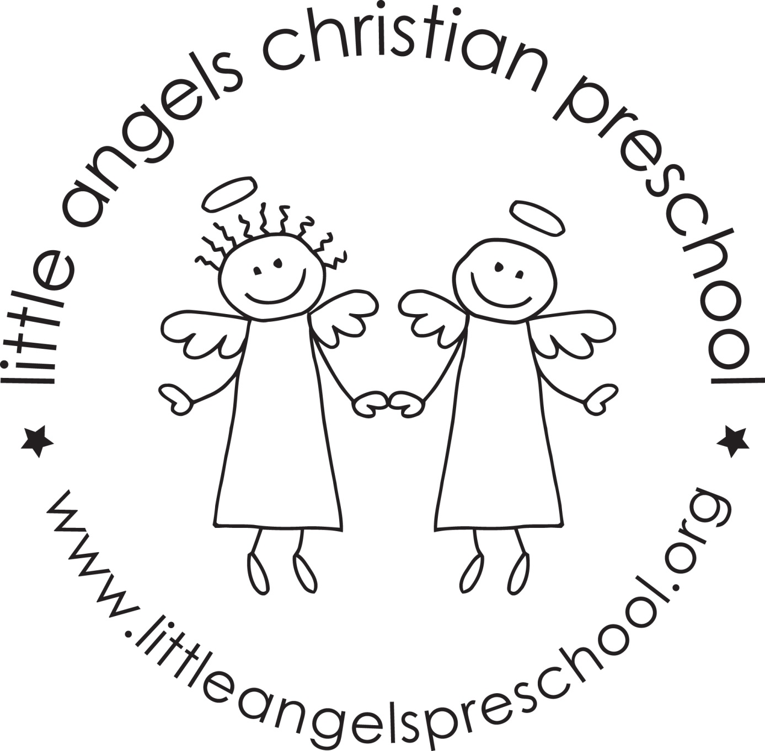 Three-year-old class January 2023

We hope that everyone had a fantastic and HEALTHY Christmas break! Thank you for all of the wonderful gifts. We appreciate your thoughtfulness very much! It’s hard to believe that it is the month of January and 2023 is here!

This month our themes will be about snow and ice.
The next couple of weeks will be very busy in our classroom. We will be working more on writing our names. We will also be cutting the photos off of our check in cards. The children will need to find their name without the photo.

We will be starting our kindness board this month as well. We will be watching the children and looking to see who is being kind. When we catch them being kind we will fill out a kindness circle and add it to the board.

We will continue to go out to the playground as weather permits. Be sure to remember hats, mittens, boots and snow pants. These can be left at school (if you have an extra set) OR you can put them in a bag and bring them back and forth to school. If the temperature (wind chill factored in) is below 25 degrees we will NOT go outside. We will also be working with the children on getting their own coat on and zipping them up as well.

Thank you for being mindful of your child’s health and keeping them home when necessary. We all appreciate it!

We are always available if you have questions, compliments or concerns.

Mark you calendars for Monday, January 16. We will be closed for MLK day.

Your Threes teaching team - Sue Dreys and Anne Gierthy

