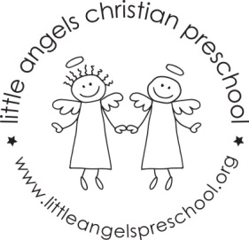
November 2022 Newsletter
Dear Parents,
The children have all settled into our classroom and we are really enjoying getting to know them. Special thanks to our room moms for making our Halloween/Fall party so much fun!
For the month of November our themes will be transportation, zoo animals and Thanksgiving! On Wednesday November 9th Thursday 10th will have a school bus visit for our theme on transport. The children will get to explore the bus while it is parked outside. We will have a car wash, crinkle paper with animals and feathers in the sensory table. Our art projects will include vehicle stampers, painting with feathers, watercolors and also making a hand cutout turkey. Our tabletop manipulative games include some vehicle puzzles, a zoo animal sort and count, feed the animal toy and Mr. Potato head pieces.
We will be reading “I’m Your Bus”, “Biscuit is Thankful” as well as learning some new flannel board stories and singing “My Little Turkey” and “The Wheels On The Bus”. Our dramatic play area will include cameras and superhero capes, a grocery store to shop for thanksgiving and baking for thanksgiving.
Reminder, there is no school on Friday November 4th and Tuesday November 8th Thanksgiving break is November 23rd – 25th.

As the weather gets colder, we will continue to go outside unless it is raining or too cold, please make sure your child’s outdoor coat is labeled with their name. Please put hats, gloves etc. into the sleeve of the coat. We are not able to look in each child’s backpack for these. Thanks!
God bless you and your family and have a blessed and safe Thanksgiving.
Martha Carroll and Maggie Killick

