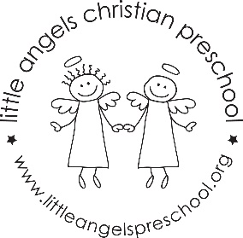2’s OCTOBER 2022 NEWSLETTER

Welcome to October!
We are very happy that all of the children are settling into our classroom routines. We hope they are enjoying preschool. This month our themes are Apples, Farm, Leaves, Fall, Pumpkins and Halloween. We have new group time games, stories and songs. We will be changing up the dramatic play area weekly. Our art activities include finger painting, animal prints and pumpkin painting. For large motor we will continue to go outdoors so please label all of their gear.
Our Fall conferences are coming up on the morning of October 20th. There is no school on Friday the 21st. We also have our Halloween parties coming up. More to follow from the room parents.
Don’t forget to check out our Shutterfly page!
If you ever have any questions or concerns please do not hesitate to let us know!

