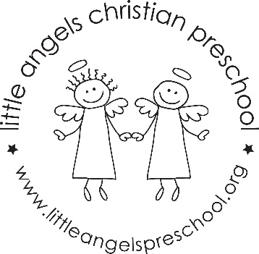
October 2022
Fantastic Fours’ Newsletter
Mrs. Clarke, Mrs. Sonnenberg, Mrs. Bauer

The Fantastic Fours had a wonderful start to the new school year. The children have quickly learned the circle time songs and jobs for each morning. We have seen many new friendships formed this past month.
We will be going on a field trip to the Garoon Science Park on Wednesday, October 12. Please dress your child for the weather. We will be outside all morning.
The Jolly phonics sounds for the month will be E (as in egg), H, T, and U (as in up). Our “Fruit of the Spirit” will be “Joy” symbolized by a pear. Our Dramatic Play Area will change from the Farmers Market to a Birthday Party, and then a Halloween House. We will have our first Art Appreciation Activity featuring Jackson Pollock with action painting. We will be conducting some science experiments with eggs, pumpkins, and outdoor nature items. We will begin working on writing our names with lowercase letter. During play and table times, our small motor skills, social, and cognitive skills are being utilized with different activities and games put out each day. The daily updates sent via Shutterfly will outline what those activities have been.
We look forward to meeting with you on Thursday, October 20 to discuss your child’s social-emotional adjustment to the 4’s class. This is a great time to go over any thoughts, concerns or questions you may have. Of course, we are always available before or after class if you need to talk to us.
Our class Halloween party will be held on Halloween Day, Monday, October 31 at 10:30 AM. The parade will be at 11:15. We are so happy that parents can join us in the classroom for the party this year.
Important Dates:
Wednesday, October 12: Field Trip- Bus leaves at 9AM.
Thursday, October 20: No Class/ Parent-Teacher Conference
Friday, October 21: No School
Monday, October 31: Halloween Party 10:30 parents are welcome to attend.

