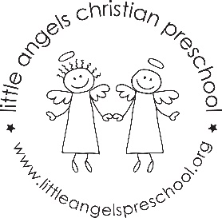
September 2022
Fantastic Fours’ Newsletter
Mrs. Clarke, Mrs. Sonnenberg, Mrs.Bauer

Welcome to a new school year! We have never been so excited to start the year. The first 2 weeks will be spent getting to know your child, reviewing class routines & rules, exploring the classroom, and learning class songs and prayers. We will talk about the “Fruit of the Spirit” each month, starting with “Love” symbolized by an apple. Our opening class prayer will be “God You Are With Me”.

Photos: In getting to know your child, we would like to have a baby photo, a current photo, a family photo, a friends photo, and a pet photo – if you have a pet. We will look at the photos with the class, and then create a baby/now, family, and friends poster or photo album to display in the classroom. The kids love looking at these photos through the year! We would like these photos by Sept 13.

Jolly Phonics Beginning the week of September 19, we will begin Jolly Phonics / Handwriting Without Tears letter sounds. Our first letter will be “L”, followed by “F”.

Virtual Show & Tell We will have Virtual Show & Tell each week on Wednesdays. Each child will tell the class about something that has the letter sound for that week. Example: Letter L – “lion” has the sound at the beginning a “lollipop” has the sound and at the beginning the middle, an “apple” has the sound at the end of the word. Email the Fantastic Fours a photo of your child’s Show & Tell item by 8:30 AM on Wednesday. The photo will be displayed on the class Smartboard.

We will be playing outside each day, weather permitting. Children should wear comfortable play clothes that will not limit their mobility or activities, and closed toe shoes they are able to walk, run and climb in. Every child should have two changes of clothes in their cubby each day in the event that an article of clothing needs to be changed.

Please check the Shutterfly updates for what we do each day in class. We are looking forward to a great year!

Important dates:
September 13: Photos are due
September 15: Ice Cream Social 5:30-6:30
September 21: First Virtual Show & Tell – “L” Sound
September 23: Fall Fundraiser

