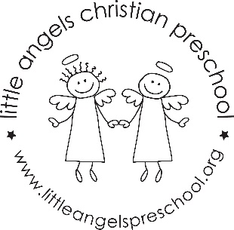
September
Three-year-old class
Newsletter

Welcome to the Little Angels Three-year-old class! We are excited about the school year and can’t wait to get to know you and your child. We have been busy preparing the classroom and planning fun activities.
During the month of September we will spend time getting to know each other and our new room. We will talk with the children about their unique qualities and their family structure within our theme “All about me”! We will explore emotions and talk about the diversity of our families. At the end of the month our theme will be “Friends”. We will have fun table games using pictures of the children.
Each month you will be able to go onto our website to read our classroom newsletter. We will also be posting a parent letter from our Creative Curriculum materials (which is what we use to develop our themes and activities). These parent letters will explain the benefits of each area in our classroom. September is the only month that you will receive this printed newsletter. Please check out our website at the beginning of each month to see the newsletters for the rest of the school year. You can go to: www.littleangelspreschool.org and select “enrolled families”, “class pages” and then pick the threes class.
Please make sure that your child has two weather appropriate changes of clothes and diapers/pull-ups if still needed. Also, please make sure that all items are labeled with your child’s name. We also ask that your child has at least two extra masks.
We have an email address for our classroom. We will only check it before or after class. So, if you have something that you need us to know right away you can send a text to our class ipod: threes@littleangelspreschool.org You can call the school office at 847-381-5490 BUT it’s usually easier to just send us a text. If it’s something that does not need immediate attention please feel free to use our classroom email: threes@littleangelspreschool.org
Please be watching your email for an invite to our class Shutterfly account. This is where we will post daily information about our day as well as important reminders. We will also post pictures of the children engaged in play, doing art, using table toys, etc…
We are looking forward to having a great year with you and your child!
Your Three-year-old teaching team: Sue Dreys and Anne Gierthy

