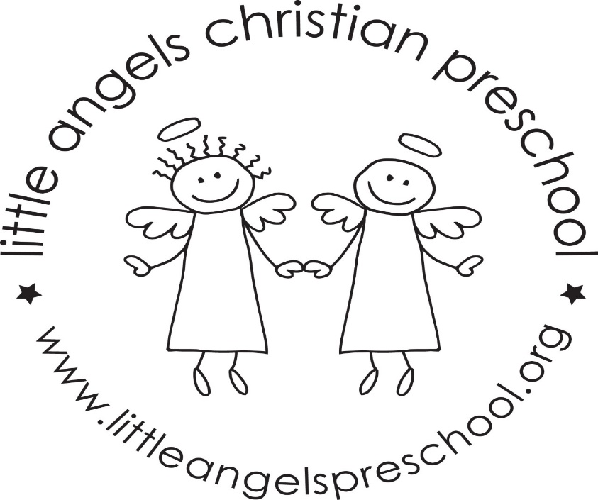

Wow, we cannot believe we are in the last month of school already. We have a lot of fun things planned for the month of May.

This month our themes will be spring themes, as well as a week the kids get to choose their favorite toys, art and activities to do. We will have school pictures with Emily Hernandez the first week in May. Senorita Kimes will be in our classroom to talk to the kids about next year having Spanish in the 4’s classroom. Our last days of school are May 25 & 26. On May 27 we will have an all school picnic at Langendorf park.

Thank you for sharing your child with us, and if you ever have any questions we are always available!

Mrs Dreys & Mrs Gierthy