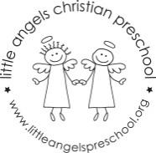
May 2022
Toddler Newsletter – Loppnow/Katzbeck/Newman

Hello Toddler families! It is hard to believe summer is fast approaching and we have only a few weeks left in our school year. It seems too soon for us to see your little ones moving on already. We get sentimental when we see pictures from the beginning of the year and can’t believe how much the toddlers have grown! We’ve so enjoyed them and appreciate the support and partnership you’ve shown the Toddler classroom this year!

We look forward to more fun this month exploring themes like on the farm, camping, picnics, dinosaurs, insects and summer. We will also try to bring back some of the toddlers’ favorite activities, toys, songs etc. from this year. Enjoy your May and Happy Mother’s day to our fabulous toddler moms!

Dates to Remember:
School Pictures,
Wednesday May 25, last day for Mon/Wed children
Thursday May 26, last day for Tues/Thurs childrenFriday May 26, all school picnic, 11am – 1pm, Langendorf Park

Your Toddler Teachers,
Laura, Lynda and Jenn

